**Config Jenkins to “MSBuild” Project(Visual Studio Console App)**

* <http://localhost:8080/>
* Jenkin Plugin & Job folder :: C:\ProgramData\Jenkins\.jenkins\workspace
* User Name :: pradeepsingh1983
* Pass :: Q1w2e3r4PKS$
* Video :: <https://youtu.be/uC7vajbnZS4>
* Dashboard >> Manage Jenkins Plugin >>
  + Available/Installed plugins :: MSBuild Plugin
  + Tools >> MSBuild Installation >> Name :: MsBuild
  + Tools >> MSBuild Installation >> Path to MS Build :: C:\Program Files\Microsoft Visual Studio\2022\Professional\Msbuild\Current\Bin

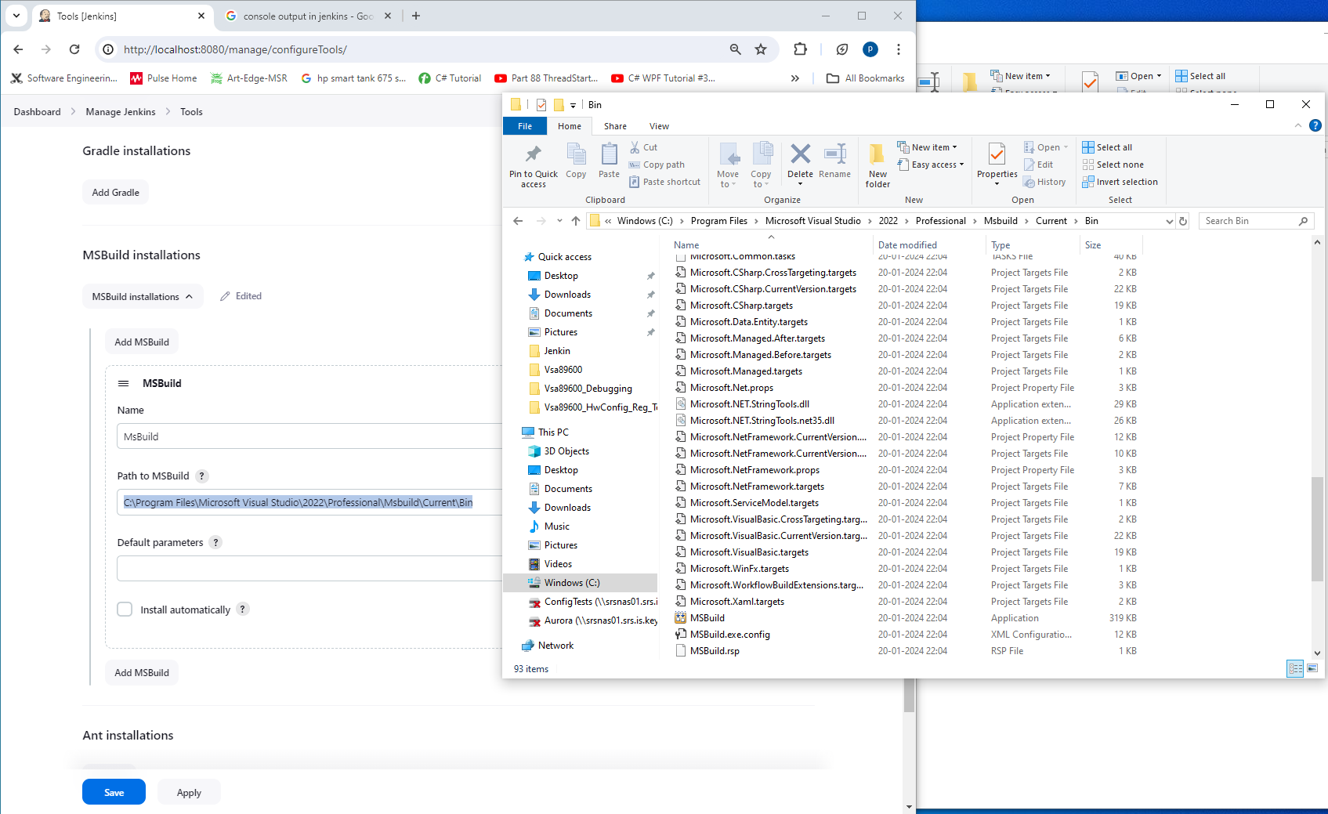

* Create a project >> Configure >> Source Code Management >>
  + Git >> Git Repo Path(<https://github.com/singh10021983/C-JenkinCode.git>)
  + Git >> Branches Specifier >> */master

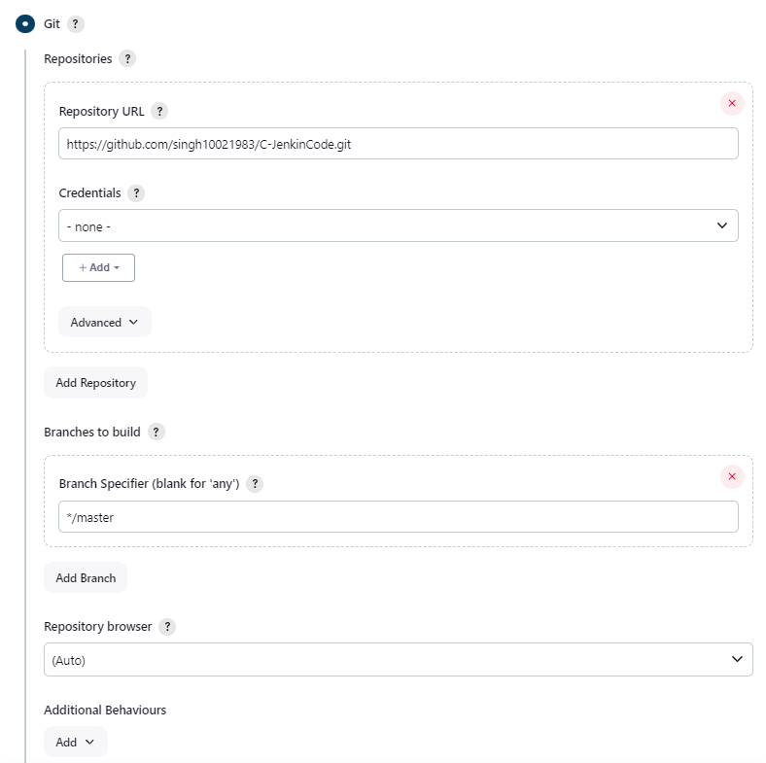

* Build Steps >> MSBUILD Version :: MsBuild
* MSBuild Build File :: C:\ProgramData\Jenkins\.jenkins\workspace\JenkinMsBuildProject\ArrayTestProject\ArrayTestProject.csproj

