**10_Auto Trigger Jenkins Job Using GitHUb WebHook**

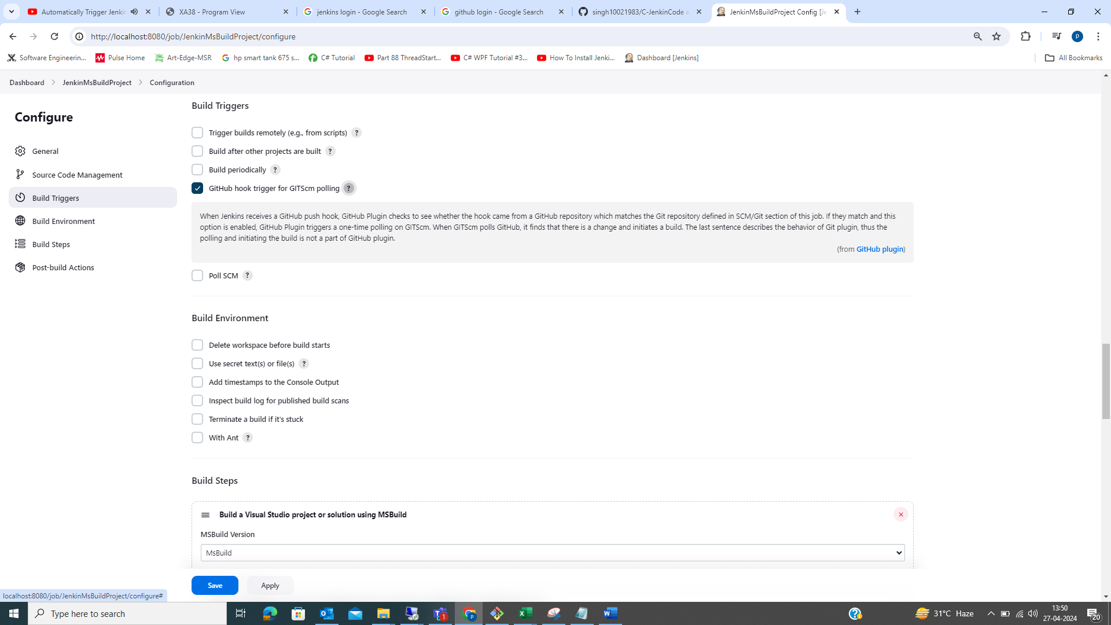

Go Git Repo

**Ngrok SW** >> To update “localhost” address value in jenkin to a proper “web address”.

ngrok is a cross -platform application that enables developer to expose a local development server to the internet with minimal effort.

This SW is against “Keysight Policy” so do not run on Keysight laptop

Get the version :: ngrok – version

Run ngrok :: ngrok.exe http 8080

<https://ngrok.com/download>

Ngrok Login Details

User :: pradeepsingh1983

Password :: Q1w2e3r4PKS$

Gmail for ngrok :: pradeepjenkin1983@gmail.com

C:\Users\singh035\Downloads\ngrok-v3-stable-windows-amd64>ngrok config add-authtoken

2fg0UgQOscFLNOLvJrWRs1hmXIZ_6R1ptb1d1A87SzUHVfwxd

Authtoken saved to configuration file: C:\Users\singh035\AppData\Local/ngrok/ngrok.yml

