Systematic Literature Review

Abhay Singh

Table of Contents

# Bibliometrix Analysis using R

* Bibliometrix (<https://www.bibliometrix.org/>) allows R users to import a bibliography database generated using SCOPUS and Web of Science stored either as a Bibtex (.bib) or Plain Text (.txt) file.
* The package has simple functions which allows for descriptive analyses as shown in table-1 to table-3.
* The analysis can also be easily visualised as shown in figure-1.

library(bibliometrix) #load the package  
library(pander) #other required packages  
library(knitr)  
library(kableExtra)  
library(ggplot2)  
# use scopuscollection data from the package Manuscripts  
# including the term 'bibliometrics' in the title. Period:  
# 1975 - 2017 Database: SCOPUS Format: bibtex  
data("scopusCollection")  
file1 = data("scopusCollection")  
# M=convert2df(file='insert  
# filename',format='bibtex',dbsource = 'scopus')#convert the  
# data to data frame

## Descriptive Analysis

# Descriptive analysis  
M = scopusCollection #just to reuse the other code  
res1 = biblioAnalysis(M, sep = ";")  
s1 = summary(res1, k = 10, pause = FALSE, verbose = FALSE)  
  
d1 = s1$MainInformationDF #main information   
d2 = s1$MostProdAuthors #Most productive Authors   
d3 = s1$MostCitedPapers #most cited papers   
pander(d1, caption = "Summary Information")

Summary Information

|  |  |
| --- | --- |
| Description | Results |
| MAIN INFORMATION ABOUT DATA |  |
| Timespan | 1975:2017 |
| Sources (Journals, Books, etc) | 280 |
| Documents | 487 |
| Average years from publication | 11.6 |
| Average citations per documents | 10.36 |
| Average citations per year per doc | 0.7799 |
| References | 12245 |
| DOCUMENT TYPES |  |
| article | 417 |
| book | 12 |
| conference | 58 |
| DOCUMENT CONTENTS |  |
| Keywords Plus (ID) | 1436 |
| Author’s Keywords (DE) | 722 |
| AUTHORS |  |
| Authors | 949 |
| Author Appearances | 1187 |
| Authors of single-authored documents | 162 |
| Authors of multi-authored documents | 787 |
| AUTHORS COLLABORATION |  |
| Single-authored documents | 184 |
| Documents per Author | 0.513 |
| Authors per Document | 1.95 |
| Co-Authors per Documents | 2.44 |
| Collaboration Index | 2.6 |

## Productive Authors

pander(d2, caption = "Most Productive Authors", table.split = Inf)

Most Productive Authors

|  |  |  |  |
| --- | --- | --- | --- |
| Authors | Articles | Authors | Articles Fractionalized |
| BORNMANN L | 13 | BORNMANN L | 6.75 |
| KOSTOFF RN | 8 | HOLDEN G | 4.25 |
| GLNZEL W | 7 | WHITE HD | 4.00 |
| HOLDEN G | 7 | MARX W | 3.42 |
| MARX W | 7 | ATKINSON R | 3.00 |
| HUANG L | 5 | NA | 3.00 |
| HUMENIK JA | 5 | GLNZEL W | 2.67 |
| LARIVIRE V | 5 | KIRBY A | 2.50 |
| LEYDESDORFF L | 5 | PERITZ BC | 2.50 |
| ZHANG X | 5 | SMITH DR | 2.50 |

## Most cited papers

pander(d3, caption = "Most Cited Papers")

Most Cited Papers

|  |  |  |
| --- | --- | --- |
| Paper | TC | TCperYear |
| DAIM TU , 2006, TECHNOL FORECAST SOC CHANGE | 331 | 22.07 |
| BORGMAN CL , 2002, ANNU REV INF SCI TECHNOL | 312 | 16.42 |
| WEINGART P, 2005, SCIENTOMETRICS | 208 | 13.00 |
| NARIN F, 1994, SCIENTOMETRICS | 169 | 6.26 |
| CRONIN B, 2001, J INF SCI | 160 | 8.00 |
| HOOD WW , 2001, SCIENTOMETRICS | 144 | 7.20 |
| HICKS D , 2015, NATURE | 130 | 21.67 |
| CHEN Y-C , 2011, SCIENTOMETRICS | 129 | 12.90 |
| D’ANGELO CA , 2011, J AM SOC INF SCI TECHNOL | 81 | 8.10 |
| GLNZEL W , 2006, SCIENTOMETRICS | 78 | 5.20 |

## Information Plots

p1 = plot(res1, pause = FALSE)

## Summary Plot-1 (Most Porductive Authors)

library(ggplot2)  
theme_set(theme_bw())  
p1[[1]] + theme_bw()

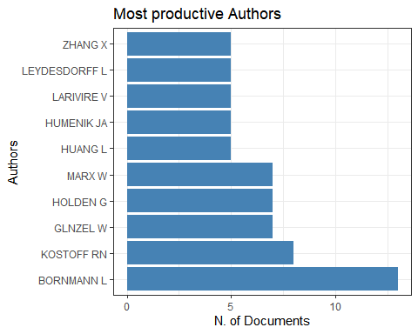 ## Summary Plot-2 (Most Productive Countries)

p1[[2]]

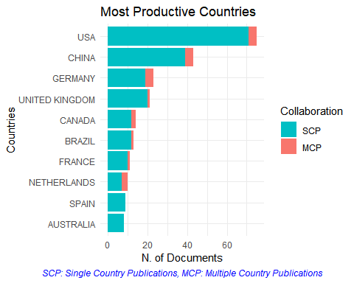

## Summary Plot-3 (Annual Scientific Production)

p1[[3]]

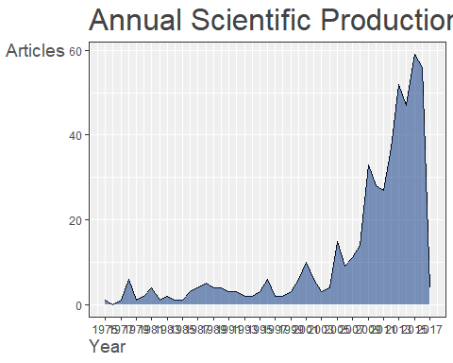 ## Summary Plot-4 (Average Article Citation)

p1[[4]]

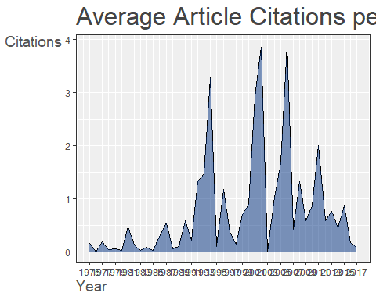 * A graph for author statistics over time can also be produced.

* Figure-1 shows a graph of top 10 authors over time. The information from these plots can be easily extracted to summarise them in a table.

topAU = authorProdOverTime(M, k = 10, graph = TRUE)

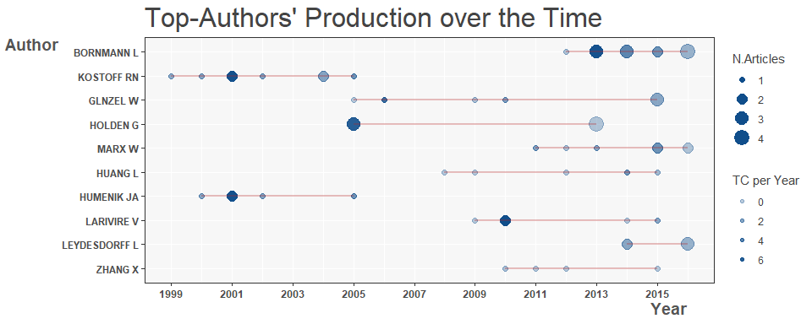

* The package also facilitates various network analysis like, co-citation analysis, coupling analysis, collaboration analysis or co-occurrence analysis. Figure-2 shows a key word co-occurrence plot

M <- metaTagExtraction(M, Field = "AU_CO", sep = ";")  
NetMatrix <- biblioNetwork(M, analysis = "collaboration", network = "countries",   
 sep = ";")  
# Plot the network  
net = networkPlot(NetMatrix, n = dim(NetMatrix)[1], Title = "Country Collaboration",   
 type = "circle", size = TRUE, remove.multiple = FALSE, labelsize = 0.7,   
 cluster = "none")

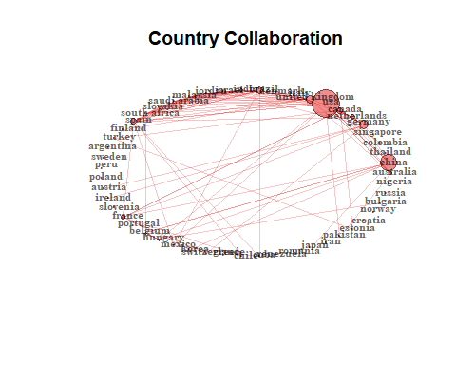

Figure 1: Country Collaboration

* Bibliometrix provides another useful function to plot a Sankey diagram to visualise multiple attributes at the same time. For example, figure-9 provides a three fields plot for Author, Author Keywords and Cited References.

threeFieldsPlot(M, fields = c("DE", "AU", "CR"))

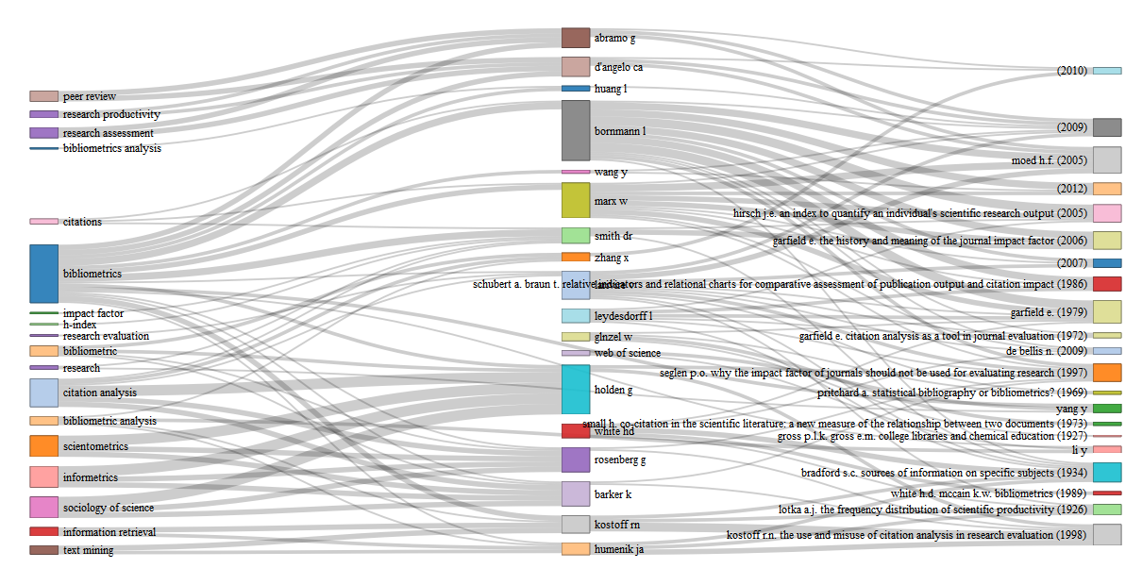

## Co-word Analysis

* Analysis of the conceptual structure among the articles analysed.
* Bibliomentrix can conduct a co-word analysis to map the conceptual structure of a framework using the word co-occurrences in a bibliographic database.
* The analysis in Figure-2 is conducted using the Correspondence Analysis and K-Means clustering using Author’s keywords. This analysis includes Natural Language Processing and is conducted without stemming.

library(gridExtra)  
CS = conceptualStructure(M, field = "DE", method = "CA", minDegree = 4,   
 clust = 5, stemming = FALSE, labelsize = 10, documents = 10,   
 graph = FALSE)  
  
grid.arrange(CS[[4]], CS[[5]], CS[[6]], CS[[7]], ncol = 2, nrow = 2)

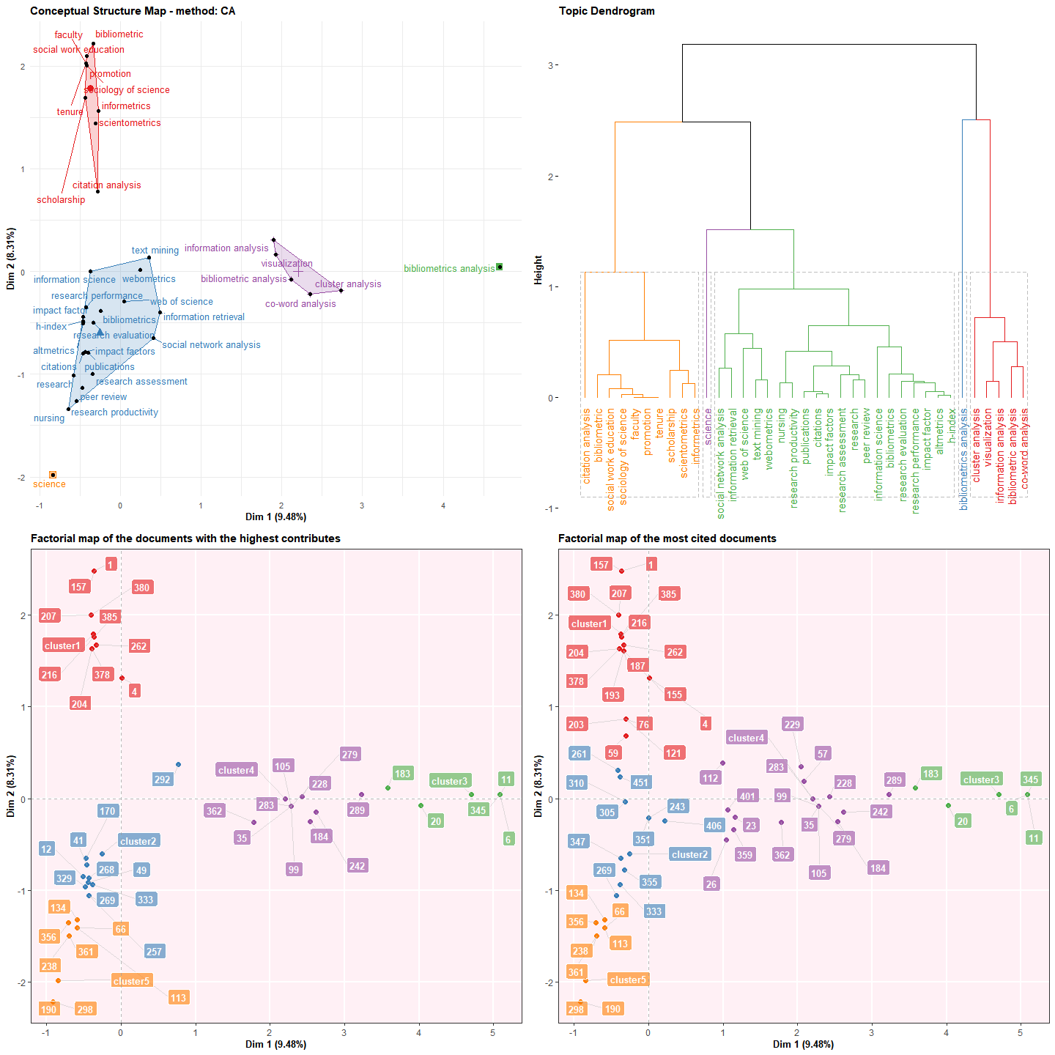

Figure 2: Conceptual Structure

## Author collaboration network

NetMatrix <- biblioNetwork(M, analysis = "collaboration", network = "authors",   
 sep = ";")  
net = networkPlot(NetMatrix, n = 20, Title = "Author collaboration",   
 type = "auto", size = 10, size.cex = T, edgesize = 3, labelsize = 0.6)

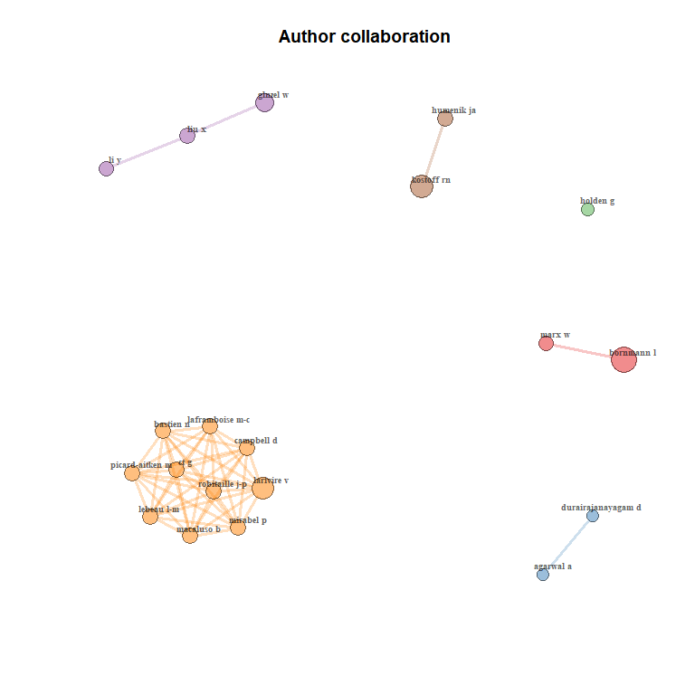

# There is a gui too!

biblioshiny()

This concludes the example. There are various online sources to take this further