Medical Insurance Cost Prediction using Regression in IBM SPSS Modeler
Project Documentation
Team Members: Achyut Kumar Pathak, Mousumi Guin, Arya Singh

1. Project Overview
This project predicts medical insurance charges using a regression model developed in IBM SPSS Modeler. The objective is to estimate insurance costs based on demographic and health-related factors such as age, sex, BMI, number of children, smoking status, and region.

2. Problem Statement
Insurance companies need accurate methods to estimate medical expenses for customers. This project uses machine learning regression to predict insurance charges and support pricing, risk assessment, and forecasting.

3. Dataset Description
Field | Type | Role | Description
age | Continuous | Input | Age of insured person
sex | Nominal | Input | Gender
bmi | Continuous | Input | Body Mass Index
children | Continuous | Input | Number of dependents
smoker | Nominal | Input | Smoking status
region | Nominal | Input | Geographic region
charges | Continuous | Target | Insurance cost to predict

4. Why Regression is Used
The target variable (charges) is continuous numerical data. Therefore, regression is the appropriate machine learning technique for predicting insurance costs.

5. SPSS Modeler Workflow
The workflow imports the dataset, performs preprocessing, partitions data into training and testing sets, builds a regression model, applies the model on test data, and evaluates performance.
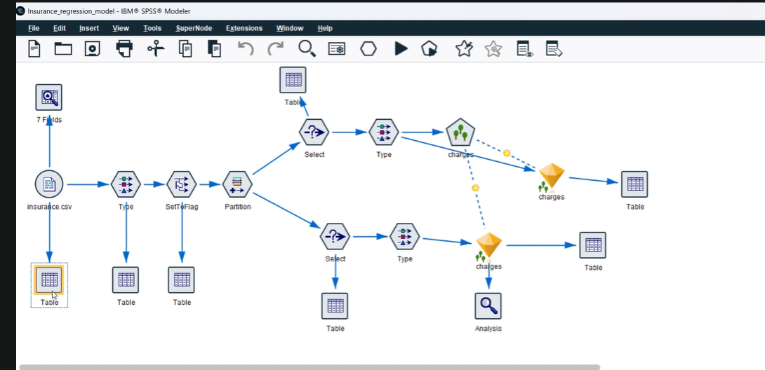
Figure 1: IBM SPSS Modeler Stream

6. Node-wise Explanation
Source Node: Imports insurance.csv dataset.
Data Audit Node: Checks data quality, missing values, and summaries.
Type Node: Defines field types and roles.
SetToFlag Node: Converts categorical values into machine-readable flags.
Partition Node: Splits data into 80% training and 20% testing.
Select Node (Training): Filters training records.
Regression Node: Builds the linear regression model.
Select Node (Testing): Filters testing records.
Model Nugget: Applies trained model to unseen data.
Table Node: Displays actual and predicted values.
Analysis Node: Evaluates model performance and prediction quality.

7. Model Training and Testing
The dataset is randomly partitioned into 80% training data and 20% testing data. The regression model is trained on the training dataset and validated on the testing dataset.

8. Results and Interpretation
The model generates predicted insurance charges. Actual charges and predicted charges are compared to evaluate accuracy and effectiveness.

9. Key Insights
• Smokers generally have higher insurance charges.
• Higher BMI increases medical risk and cost.
• Insurance charges tend to increase with age.
• Combining demographic and health variables improves prediction quality.

10. Real-World Applications
The model can be used for insurance premium estimation, customer risk assessment, policy pricing, underwriting support, and automated quotation systems.

11. Conclusion
This project successfully demonstrates medical insurance cost prediction using regression in IBM SPSS Modeler. The model provides a practical example of machine learning for real-world business applications.

