1. Design a web template that has a grid with provision for one live instructional video, space to show live video of the student listening to it and his emotions status .

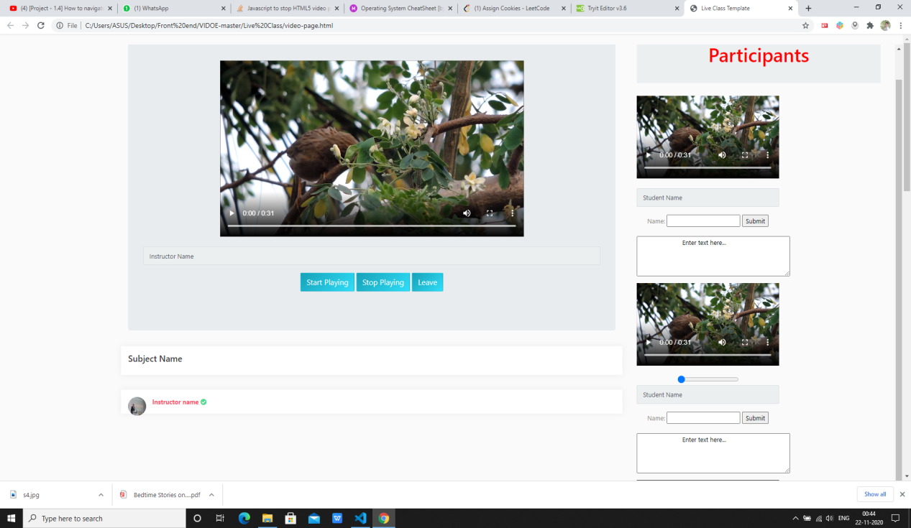

1. Design a simple form and connect to backend database:

