WARcry

Motivate Games

Version #1

All work Copyright © 2012 by Motivate Games.

All rights reserved.

Avneet Singh

Feb 2, 2015

**Table of Contents**

**Version History**

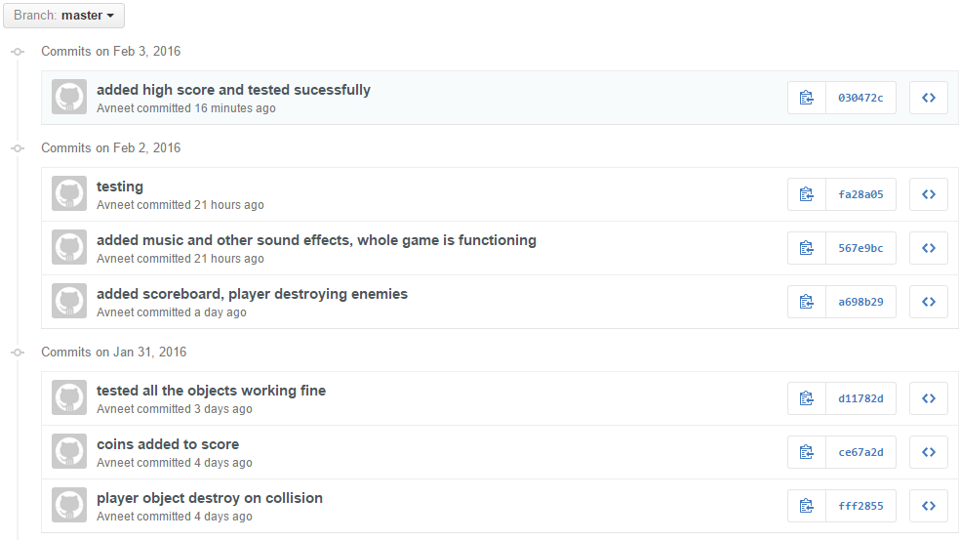

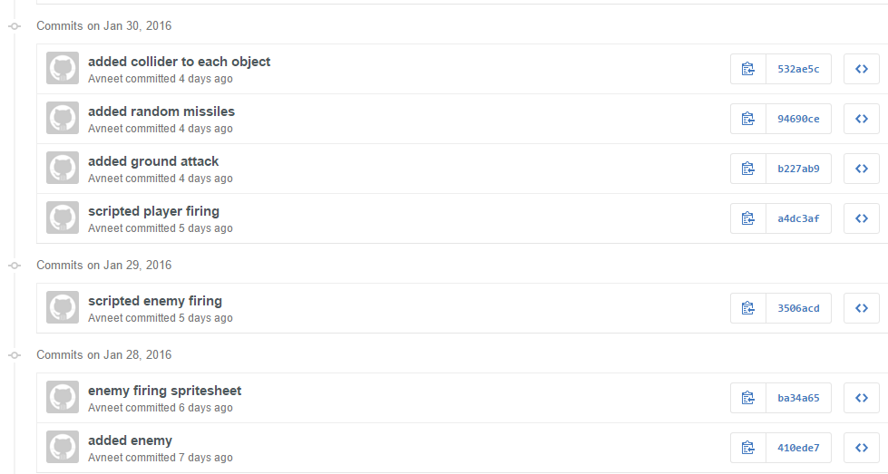

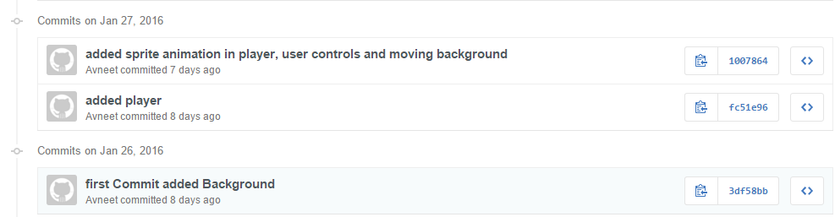

1. **Game Overview**

*The goal of the game is to destroy all enemies. Move the player to avoid collisions and aim towards the enemy to get hit by the bullet.*

1. **Game Play Mechanics**

*(how does your game work?)*

*Player moves up, down , right and left using arrow keys on the keyboard.*

1. **Camera**

*(Point of View)*

1. **Controls**

*(Which keys does your game use? Does it use the mouse or a joystick?)*

1. **Saving and Loading**

*(Does your game include saving and loading? When? How?)*

1. **Interface Sketch**

*(What does the game interface look like? Provide a screen shot or sketch)*

1. **Menu and Screen Descriptions**

*(Include additional screen shots and accompanying descriptions for any menus and additional screen)*

1. **Game World**

*(Describe Your Game Environment)*

1. **Levels**

*(Describe Each of your game levels)*

1. **Game Progression**
2. **Characters**

*(Describe Your game avatar if applicable)*

1. **Non-player Characters**

(Describe Any Computer controlled Allies and how they work)

1. **Enemies**

*(Describe computer-generated enemies and boss monsters)*

1. **Weapons**

*(Describe any weapons available to the user)*

1. **Items**

*(Describe any in-game items that can help or hinder the user)*

1. **Abilities**
2. **Vehicles**
3. **Script**
4. **Scoring**
5. **Puzzles/Mini-games**
6. **Bonuses**
7. **Cheat Codes**
8. **Sound Index**

*(Include an index of all your sound clips)*

1. **Story Index**

*(Outline your game story here)*

1. **Art / Multimedia Index**

*(Include an index of all your graphic and video assets here)*

1. **Design Notes**

*(Include additional design notes here)*

1. **Future Features**

*(Include any future features that are planned to be implemented)*