Heroku with Node.js

1.Assuming that you have a free Heroku account, any code editor. Make sure Node.js, git and npm installed locally or globally.

2. install the Heroku Command Line Interface (CLI)

Once installed, you can use the heroku command from your command shell.

Example: Heroku login

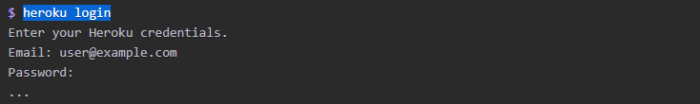

3. clone the sample application so that you have a local version of the code that you can then deploy to Heroku

Example: git clone <https://github.com/heroku/node-js-getting-started.git>

git clone https://github.com/heroku/node-js-getting-started.git

$ cd node-js-getting-started

4.Copy/paste some file from this repository into your local project which you just cloned in the above step.

Example: Package.json, Package-lock, index.js, views folder

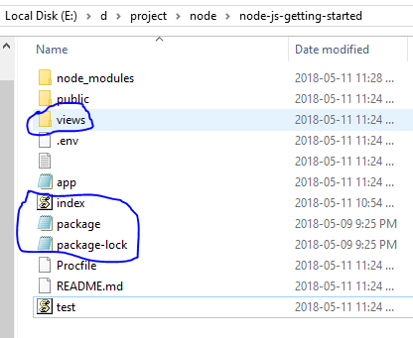

5.Deploy the App

Run the following command:

Npm install

Npm install cool-ascii-faces

Heroku create

Git add .

Git commit -m “init commit”

Git push Heroku master

Heroku ps:scale web=1

Heroku local