TestCases

1. Create account with valid details.   
     
   Expected Result: Account should get created successfully.

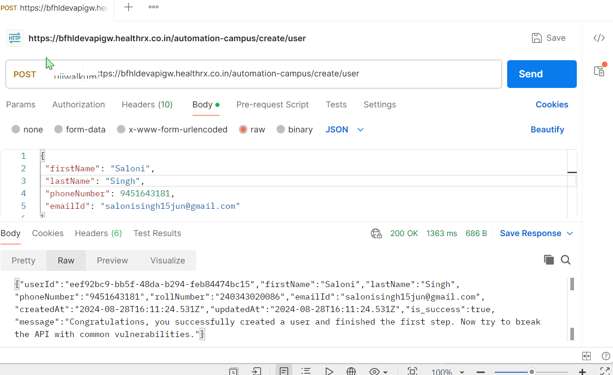

1. Create user with same phone number.  
     
   Expected Result: Account should not get created with same phone number again.  
     
    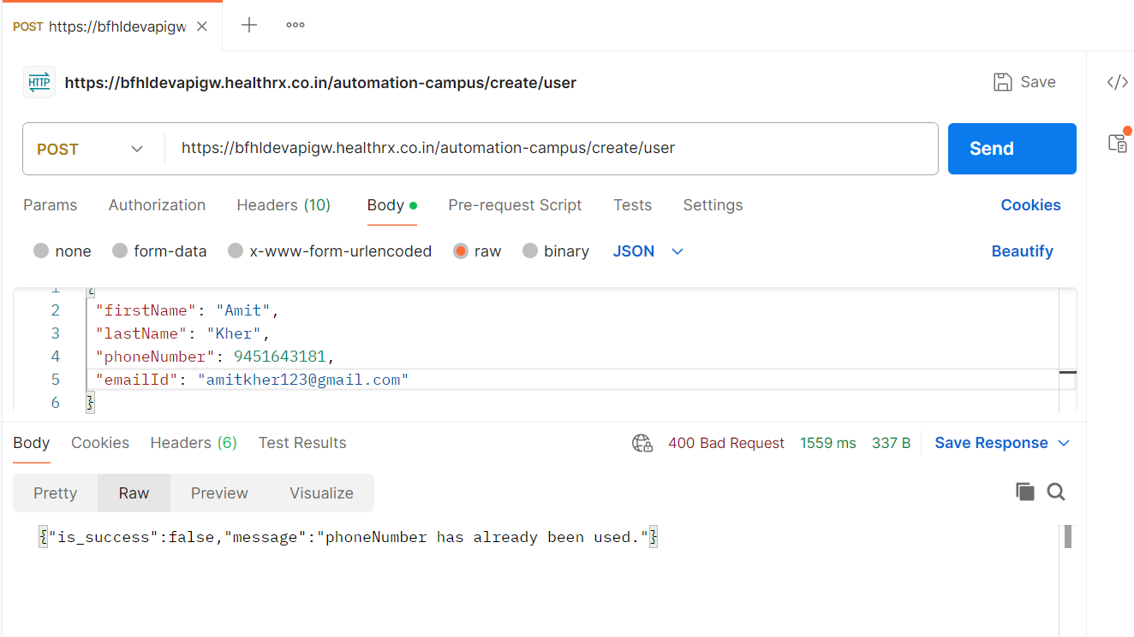

1. Create user with same first name, last name and email id but different phone number.  
     
   Expected Result: 