## **Web Application Programming and Hacking**

### **WAPH Hackathon 1 – Cross-site Scripting Attacks and Defenses**

**Instructor Name : Dr. Phu Phung**

**Student Name : Arnab Singh**

**Email: singha105@udayton.edu**



**_________________________________________________________________________**

### **Overview**

This project was part of the Web Application Programming and Hacking course aimed at building a professional portfolio website using HTML, CSS, Bootstrap, JavaScript, and public Web APIs. I developed a responsive resume website hosted on GitHub Pages. Throughout the project, I learned how to structure web content, apply dynamic effects, interact with APIs, and implement user tracking and cookies for interactivity.  
  
_________________________________________________________________________  
  
**General Requirements**

#### **Personal Website on GitHub**

* Created index.html with personal details: name, photo, contact, education, experience, skills.
* Used Bootstrap for responsive layout.
* Website deployed successfully on GitHub Pages.

***Screenshot:* Homepage with name visible**.  


#### **WAPH Introduction Page**

* Created waph.html to introduce the course and related projects.
* Linked from sidebar or additional section in main page.

***Screenshot:* Page showing WAPH intro and overview of labs/projects.**

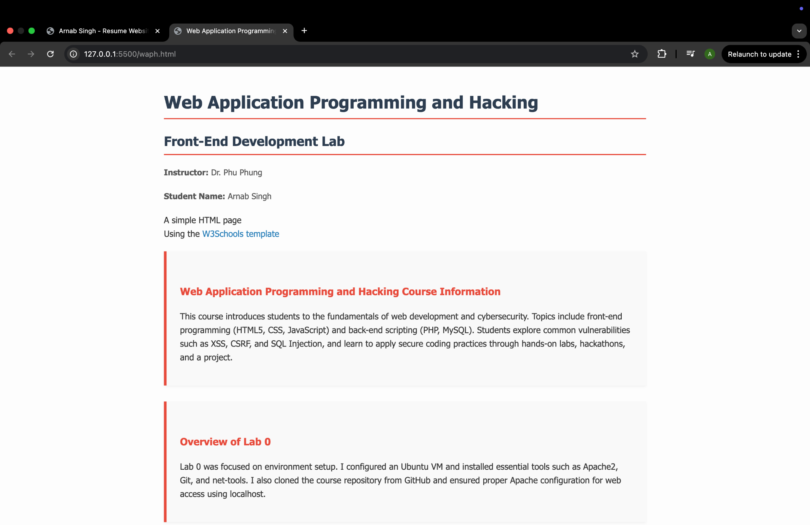

### **Non-Technical Requirements**

* **Bootstrap 4.5 is used as the main CSS framework to ensure a responsive and professional layout.**
* **Layout and design are clean, consistent, and recruiter-friendly.**
* **Google Fonts used:**
  + **Oswald for headings**
  + **Open Sans for body text**
* **Consistent use of font sizes, padding, spacing, and color palette across all sections.**
* **Sidebar is fixed for easy navigation; main content area is scrollable and neatly segmented.**
* **Target audience: Potential employers, professors, and technical reviewers.**

### **Technical Requirements – JavaScript Features**

#### **JavaScript Features (20 pts total)**

* **Digital Clock**
  + **Tool: Luxon.js**
  + **Displays current Ohio (EST) time and updates in real-time**
  + **Placed under "Additional Tasks" section**
* **Analog Clock**
  + **Tool: Plain JavaScript with <canvas>**
  + **Custom design, live-rendered clock hands, accurate second-by-second motion**
  + **Also in the "Additional Tasks" section**
* **Show/Hide Email**
  + **Tool: jQuery**
  + **A button toggles your email visibility, protecting it from spam bots**
  + **Located under your name in the header section**
* **Dark Mode Toggle**
  + **Tool: Plain JavaScript**
  + **Floating moon/sun button in the top-right corner**
  + **Button remembers theme using localStorage**
  + **Dark mode also updates colors for sidebar, highlights, and progress bars**
  + **Border color of the button set to yellow for visibility**

**Screenshot 1: Clocks**

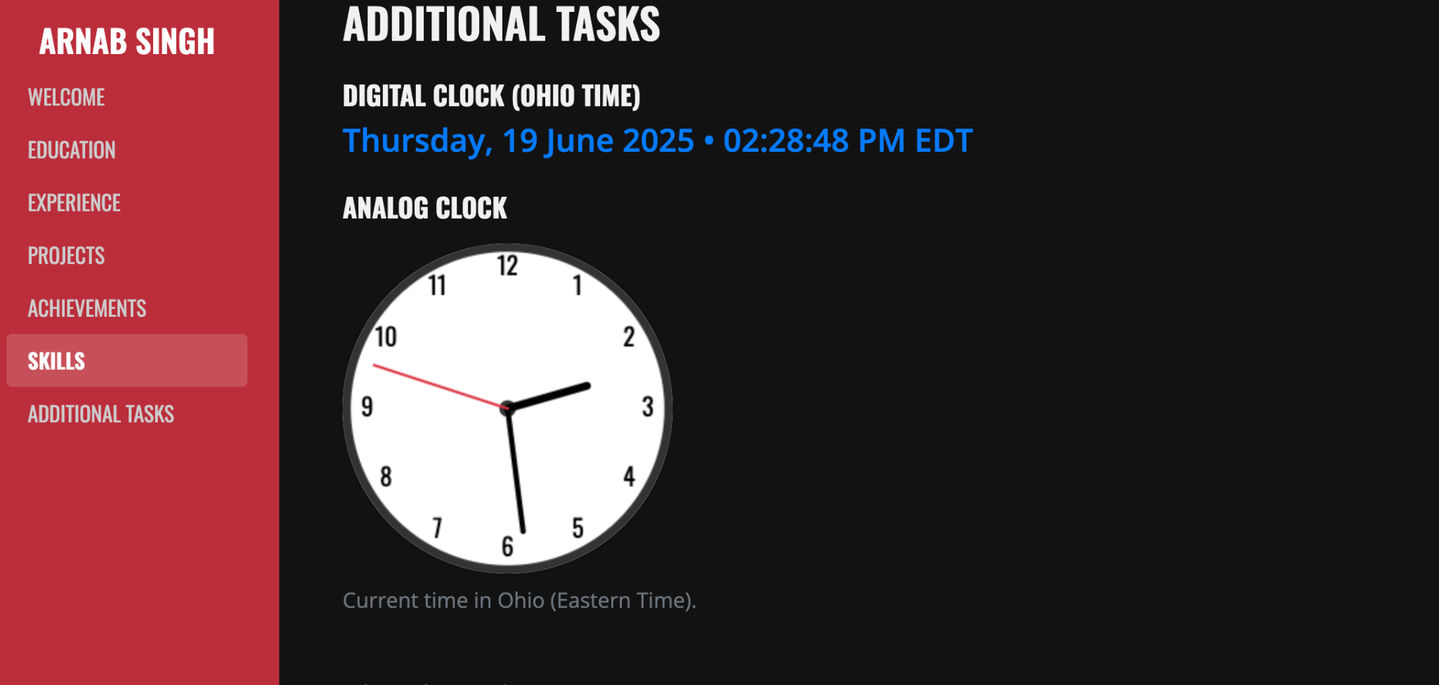

***Digital and Analog clocks built using JavaScript and Luxon***

**Screenshot 2: Show/Hide Email**



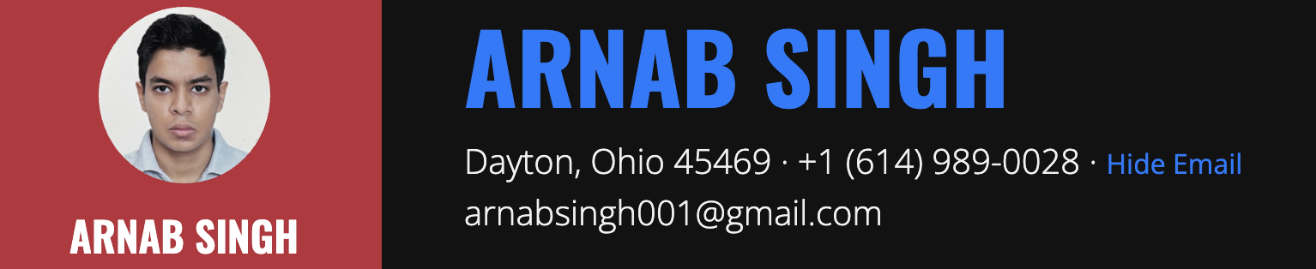

***Email visibility toggled using jQuery***

**Screenshot 3: Dark Mode Active**

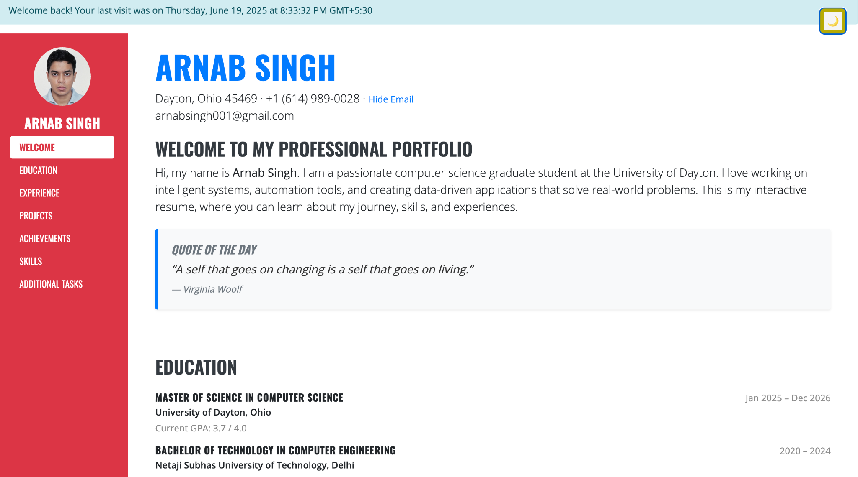



***Light / Dark mode UI with sidebar and theme toggle button***

### **Public API Integrations (20 pts)**

#### **JokeAPI Integration – 10 pts**

* Integrated theJokeAPI to **fetch and display a new joke every 60 seconds**.
* The joke is placed inside a **Bootstrap card** under the “Additional Tasks” section.
* The API call uses fetch() and updates the card content dynamically.
* Adds a fun, engaging real-time element to the page.

**Code Snippet Example:**

fetch('https://v2.jokeapi.dev/joke/Any')

**Screenshot 1 - The joke section while a joke is displayed:**

  
***Live joke fetched using JokeAPI (updates every 60 seconds)***

* I also integrated the xkcd API to fetch and display the Comic of the Day. This comic is automatically updated and displayed as an image. It brings a fun visual aspect to the page, making the user experience more interactive and enjoyable. Like the joke section, a disclaimer is shown here as well.

**Screenshot 2 - The comic of the day section while a comic is displayed:**

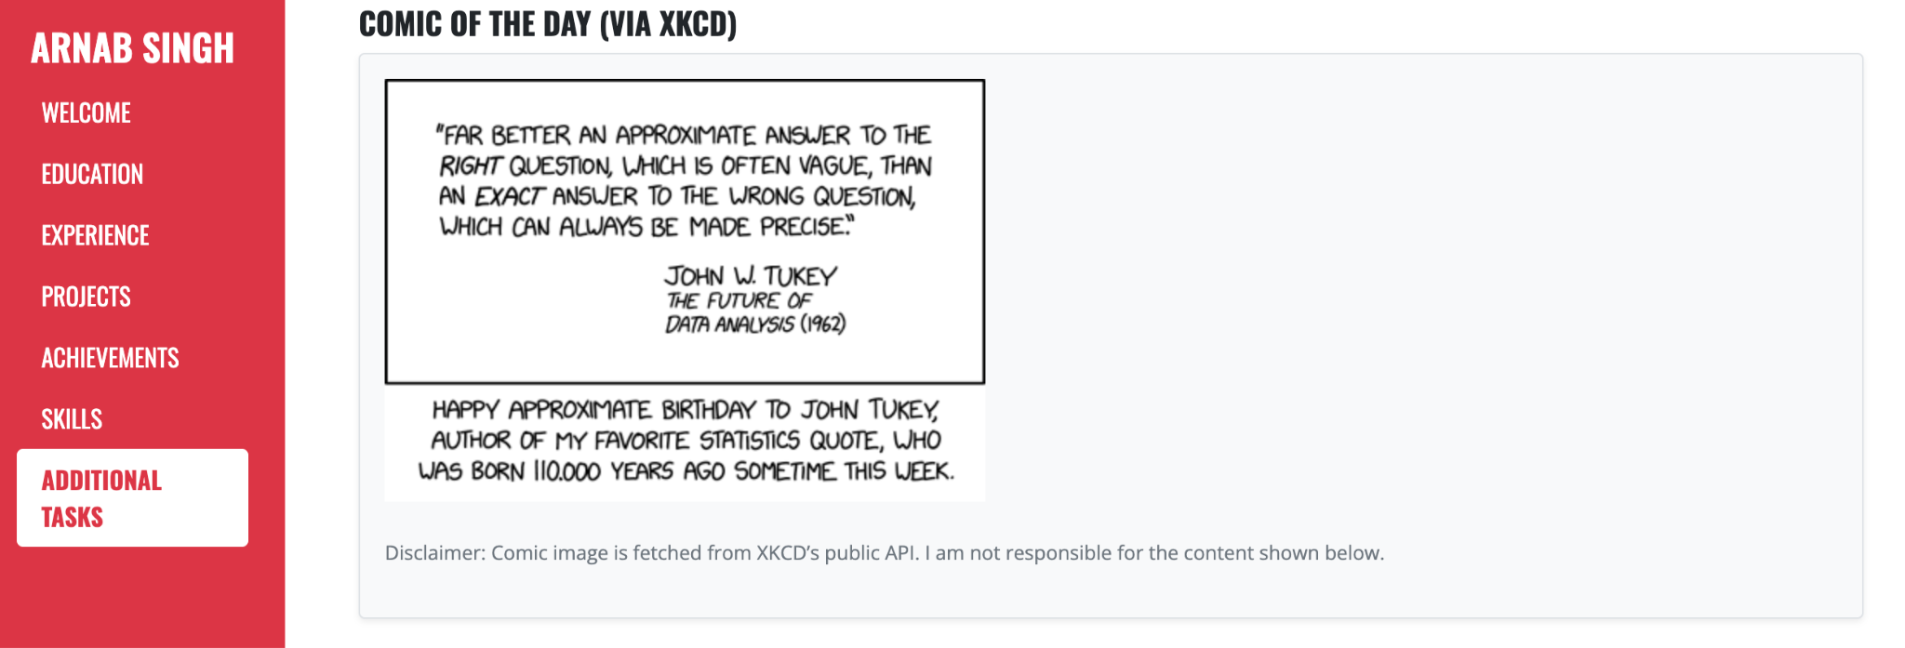

***Live comic fetched using xkcd API.***

#### **Weather API Integration – 10 pts**

* Used **WeatherBit API** to fetch and display **live weather in Dayton, OH**.
* Displays temperature and condition inside a styled card under “Additional Tasks”.
* API is fetched via fetch() and the data is dynamically inserted into the page.
* API key used: eb676bdc8fd54856b81184229251906

**Code Snippet Example:**

fetch(`https://api.weatherapi.com/v1/current.json?key=${weatherAPIKey}&q=${city}&aqi=no`)

**Screenshot - The weather box when the data is visible:**

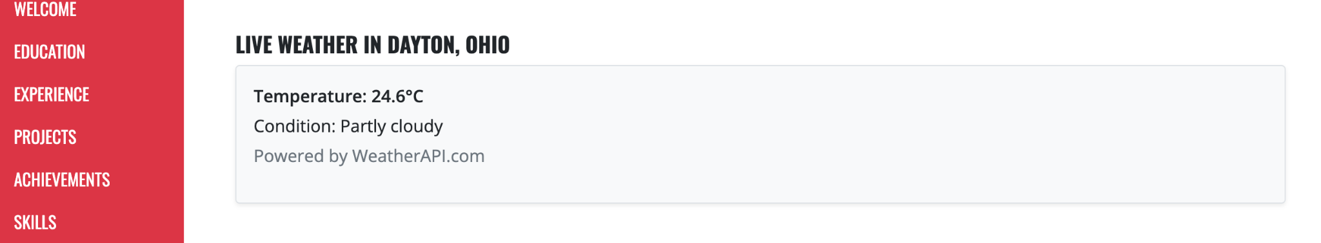  
***Live Dayton weather data powered by WeatherBit API***

#### **Disclaimer for API Use (Mandatory)**

**Disclaimer added below APIs**:

*“The content below is generated using third-party public APIs. I am not responsible for their accuracy or availability.”*

This fulfills the requirement to **clearly state responsibility disclaimer** for any public data.

### **Page Tracker (5 pts)**

#### **Google Analytics (Optional Tracker)**

* **Google Analytics** was integrated using gtag.js script inside the <head> section.
* Tracks visits, sessions, and interactions for the deployed site.
* Set up via Google Analytics Console with proper stream ID (e.g., G-XXXXXXX).

**Screenshot - Google Analytics details** :

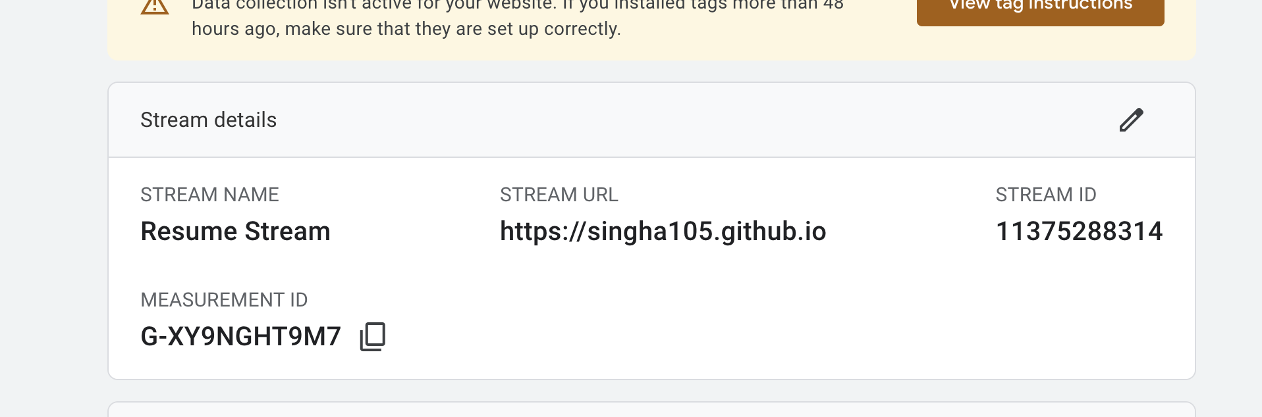  
***Google Analytics Web Stream setup for page tracking***

### **FlagCounter – Visible Visitor Counter Widget (5 pts)**

* Embedded a **FlagCounter** widget that shows:  
  + Total visitor count
  + Country flags
  + Medium flag size
  + White background
* **Visible directly on the page**, does not require an external dashboard to check.

**Screenshot - FlagCounter** :

  
***Live visitor tracker widget from FlagCounter.com***

#### 

#### 

#### **JavaScript Cookies**

* On first visit: shows “Welcome to my homepage for the first time!”
* On repeat visit: shows “Welcome back! Your last visit was Sunday, June 23, 2025, 8:30 PM (IST)”.

***Screenshot -* Cookie popup message visible :  
**