VIJAY DAIRY
User Manual
Daily operations guide with screenshots
Everything shop staff need to manage products, create invoices and read the dashboard.
Version 2.0
20 September 2026
Node.js · Express · Supabase (PostgreSQL) · React

Contents
1. Introduction
2. Signing in and out
3. The Dashboard
4. Managing products
4.1 Viewing and searching · 4.2 Adding · 4.3 Editing and deleting
4.4 Importing products from CSV · 4.5 Updating stock from CSV
5. Creating an invoice
6. Invoice history
7. Sharing invoices — the public link
8. Business settings and appearance
9. Daily routine and good practice
10. Frequently asked questions
11. If something goes wrong
12. Quick reference

1. Introduction
Vijay Dairy is a web application for running the day-to-day business of a dairy shop. From any modern browser you can keep a product catalogue, track stock, create and share invoices, and see how sales are performing.

1.1 What you can do
- Dashboard — this week's revenue, monthly and daily charts, top products and low-stock alerts.
- Products — add and edit items, import a whole catalogue from a spreadsheet, and keep stock up to date.
- Invoices — create a bill in seconds, sell by quantity or by rupee amount, print it, download a PDF, or send it on WhatsApp.
- Settings — shop name, address, phone, GSTIN, invoice footer, stock tracking and a colour theme.

1.2 Finding your way around
After you sign in, every screen has the same layout. The green sidebar on the left is the main menu; the top bar shows today's date and who is signed in.
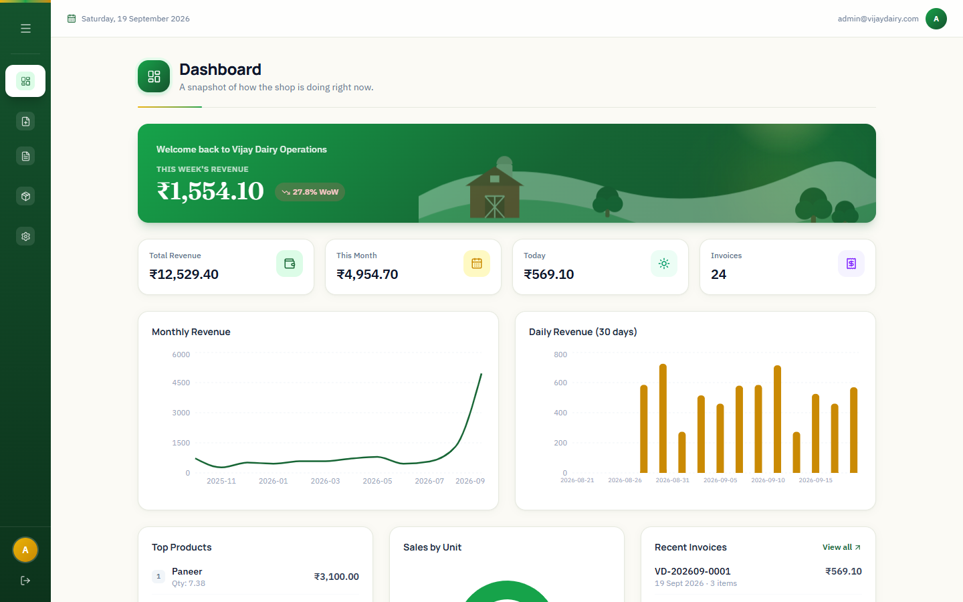
Figure 1 — The main layout: sidebar (left), top bar (top) and the page content
Sidebar icon (top to bottom) | Opens | Use it to…
Grid | Dashboard | See how the shop is doing right now.
Document with plus | Create Invoice | Make a new bill.
Receipt | Invoices | Find, preview, print, share or delete past bills.
Box | Products | Manage the catalogue and stock.
Cog | Settings | Shop details, stock tracking and theme.
Arrow leaving a box (bottom) | Log out | End your session.

TIP — Menu
The ☰ button at the top of the sidebar collapses or expands the menu. When the menu is collapsed, hover over an icon to see its name.

1.3 Quick start for a new shop
1 Sign in with the e-mail and password given to you (Section 2).
2 Open Settings and enter the shop name, address, phone and GSTIN (Section 8).
3 Open Products and add your items, or import them all from a CSV file (Section 4).
4 Open Create Invoice, add items and save your first bill (Section 5).
5 Check the Dashboard — your first sale appears immediately (Section 3).

2. Signing in and out
Open the app address in your browser. You will see the sign-in page. Type the e-mail and password that your administrator gave you and click Sign in.
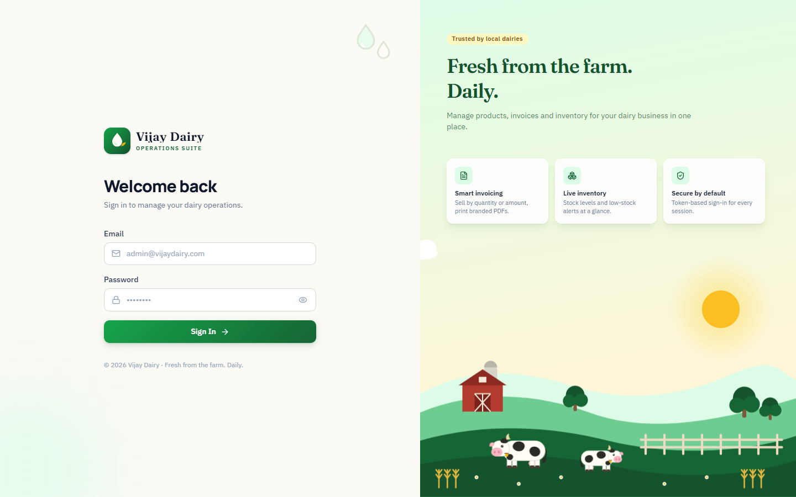
Figure 2 — The sign-in page

2.1 If the details are wrong
A message appears on the form and no session is created. Check for typing mistakes, caps lock and extra spaces, then try again.
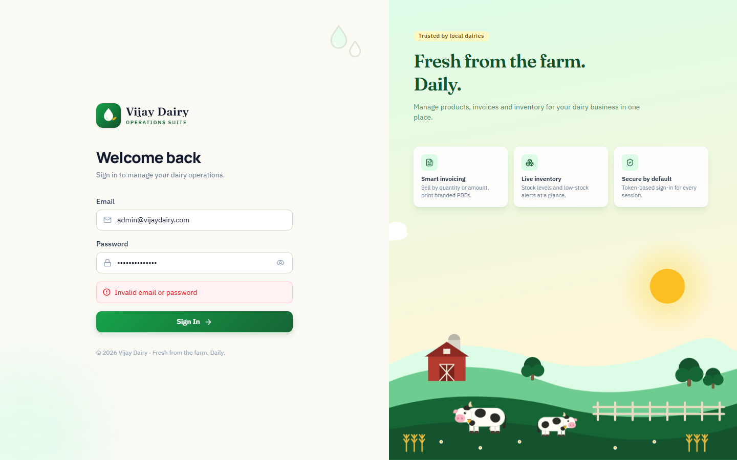
Figure 3 — Sign-in error message

2.2 Staying signed in
- You stay signed in when you reload the page or close and reopen the tab, until you log out or the session expires (12 hours by default).
- After the session expires you are taken back to the sign-in page automatically. Nothing you saved is lost.

2.3 Logging out
Click the log-out icon at the very bottom of the sidebar. Always log out on a shared or public computer.
IMPORTANT — Passwords
Do not share your password or write it near the till. If you think someone else knows it, ask your administrator to change it.

3. The Dashboard
The Dashboard is the first screen after you sign in. It answers "how are we doing?" at a glance and refreshes every time you open it.
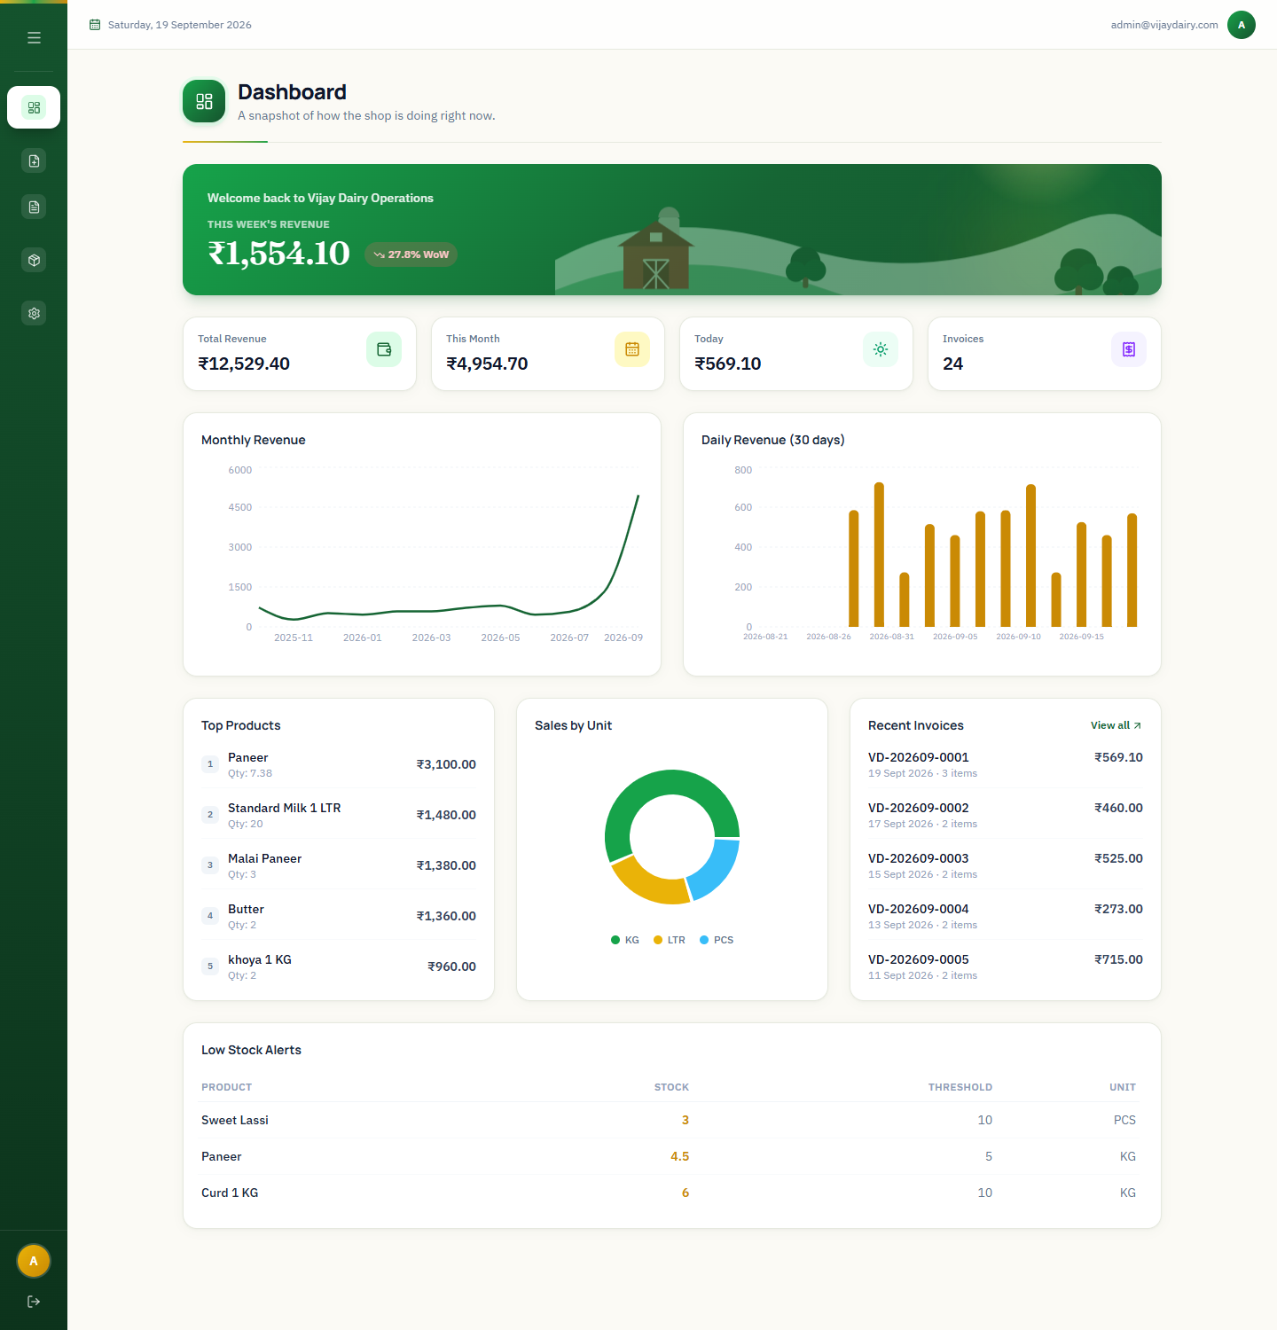
Figure 4 — The Dashboard (sample data)
Panel | What it shows
Welcome banner | This week's revenue (Monday to today) and the percentage change compared with last week (WoW = week over week). A green arrow means sales are up; a red arrow means they are down.
Total Revenue | The total of all invoices on record.
This Month | Revenue since the 1st of the current month.
Today | Revenue for today.
Invoices | How many invoices are on record.
Monthly Revenue | A line chart of the last 12 months. Hover over a point to see the exact month and amount.
Daily Revenue (30 days) | A bar chart of the last 30 days. Hover over a bar for the amount.
Top Products | The five products that earned the most revenue, with quantity sold.
Sales by Unit | Revenue split between litre (LTR), kilogram (KG) and piece (PCS) products.
Recent Invoices | The five newest invoices. View all opens the full list.
Low Stock Alerts | Products at or below their alert level. Appears only when Inventory Tracking is on (Section 8).

NOTE — Empty charts
A new installation shows "No data yet" in the charts until the first invoice is saved.
NOTE — Time zone
Dates and periods on the Dashboard are calculated in UTC. A sale made very late at night in India can therefore count towards the next day's bar.

4. Managing products

4.1 Viewing and searching
Click Products in the sidebar. The table lists every item with its unit and price and, when Inventory Tracking is on, the current stock.
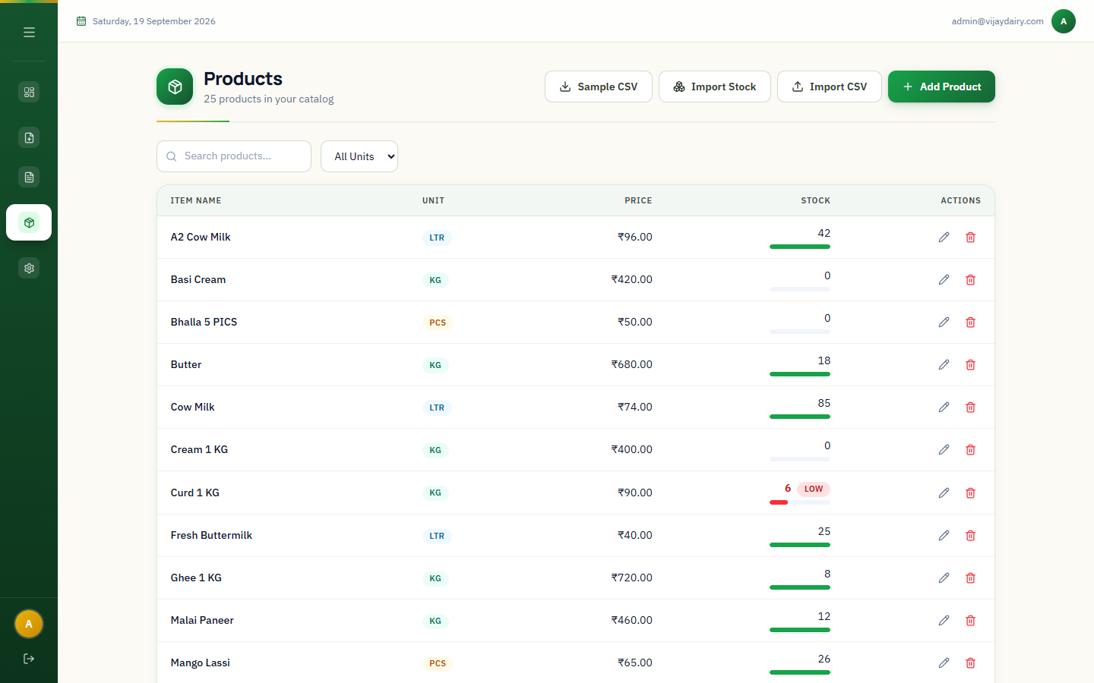
Figure 5 — The product list
- Use the search box to find a product by name.
- Use the unit drop-down to show only LTR, KG or PCS items.
- The stock bar is green when stock is healthy. A red bar with a LOW badge means stock is at or below the alert level you set.
- The buttons at the top right are Sample CSV, Import Stock, Import CSV and Add Product.

4.2 Adding a product
1 Click Add Product.
2 Enter the Item Name and Price (both required) and choose the Unit: LTR (litre), KG (kilogram) or PCS (piece).
3 If Inventory Tracking is on, also enter Current Stock and Low Stock At — the level at which the product is flagged as low.
4 Click Save.
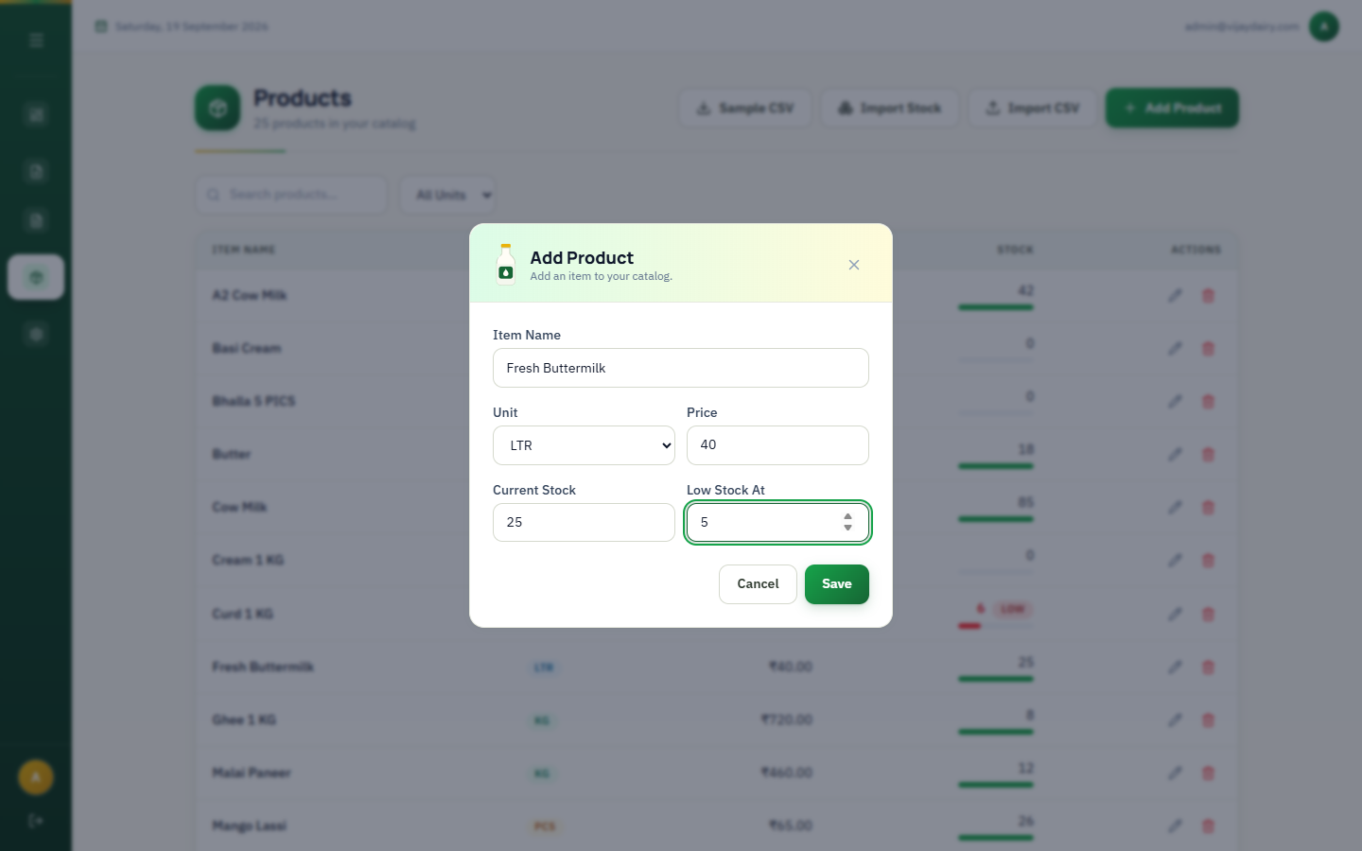
Figure 6 — The Add Product dialog
IMPORTANT — Unique names
Product names must be unique, ignoring capital letters. Adding "paneer" when "Paneer" already exists shows an error.

4.3 Editing or deleting a product
- Click the pencil icon on a row to change its name, unit, price or stock levels.
- Click the trash icon to delete a product. You are asked to confirm, and deleting cannot be undone.
- Old invoices are not affected by edits or deletions: each invoice keeps the name, unit and price that applied when it was made.

4.4 Importing products from CSV
If you have many products, prepare them in a spreadsheet and import them in one go.
1 Click Sample CSV (or open Import CSV and click Download sample CSV) to get a ready-made template.
2 Fill in one product per row, then save the file as CSV (comma-separated).
3 Click Import CSV, drop the file onto the box (or click it to browse) and click Import.
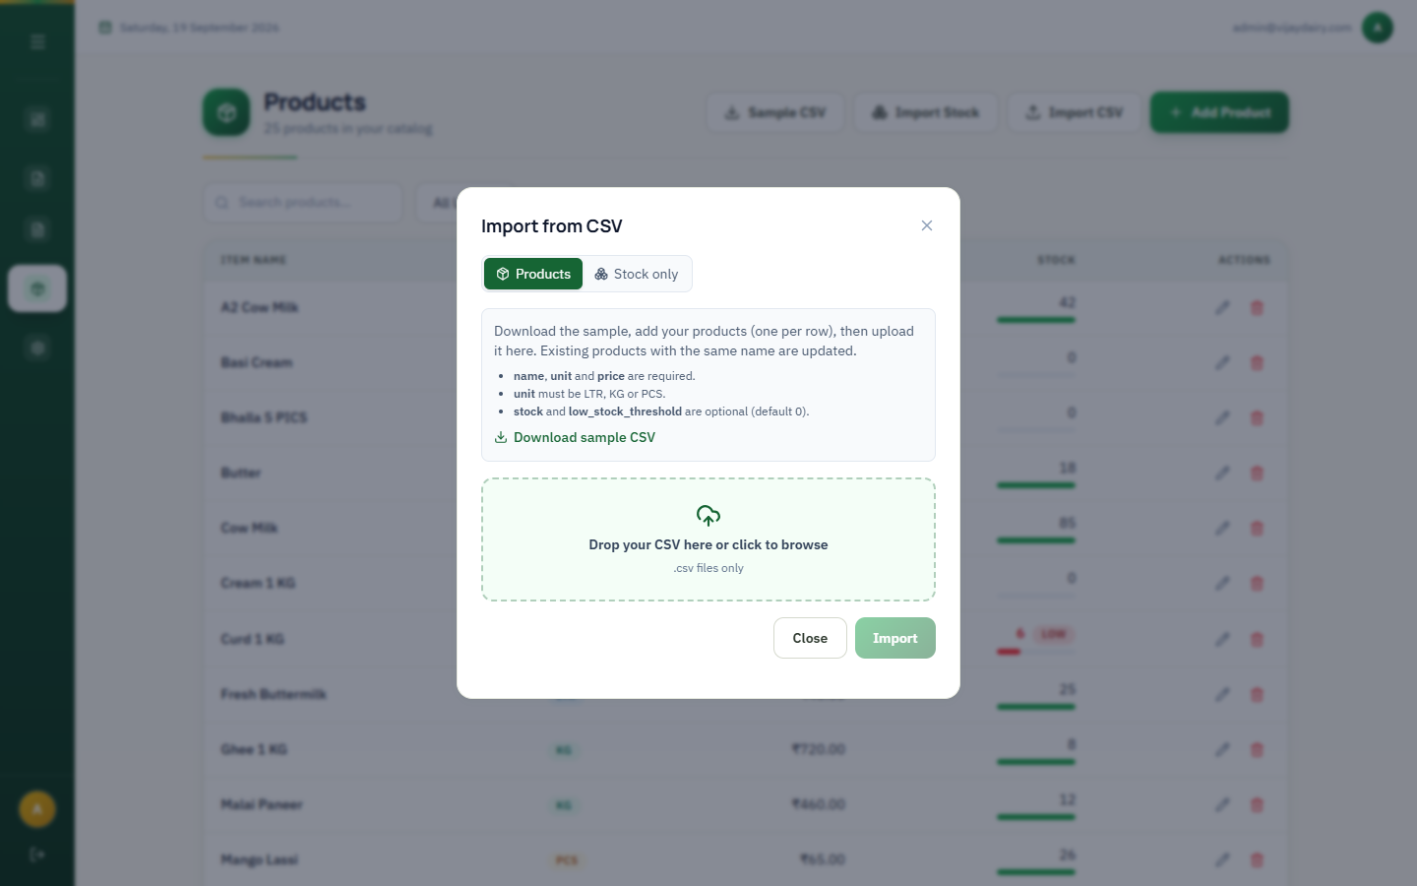
Figure 7 — Import CSV: the Products tab
Column | Required | Notes
name | Yes | Existing products with the same name (any capitalisation) are updated; new names are created.
unit | Yes | LTR, KG or PCS.
price | Yes | Number, zero or more. Thousands separators such as 1,200 are accepted.
stock | No | Defaults to 0.
low_stock_threshold | No | Defaults to 0 (no low-stock alert).

When the import finishes, a result panel shows how many products were created and updated. Any row with a problem is listed with its row number and the reason, and the rest of the file is still imported.
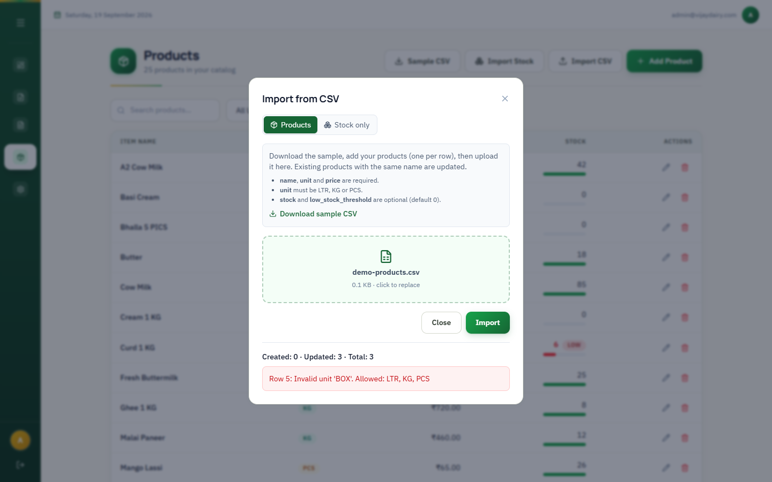
Figure 8 — Import result: 3 created, and one row skipped because its unit is invalid
TIP — Excel
Files saved from Excel with semicolon or tab separators are recognised automatically. Blank rows at the end of the sheet are ignored.

4.5 Updating stock from CSV (Import Stock)
Use this when a delivery arrives or after a stock count. It changes only stock levels — never names, prices or units — and it never creates new products.
1 Click Import Stock (or open Import CSV and choose the Stock only tab).
2 Choose how the numbers are applied: Add to stock (the value is added to what you have; a negative number subtracts) or Replace stock (the value becomes the new stock).
3 Click Download CSV with my products to get a file already listing your products, fill in the stock column, and save it.
4 Drop the file in the box and click Import.
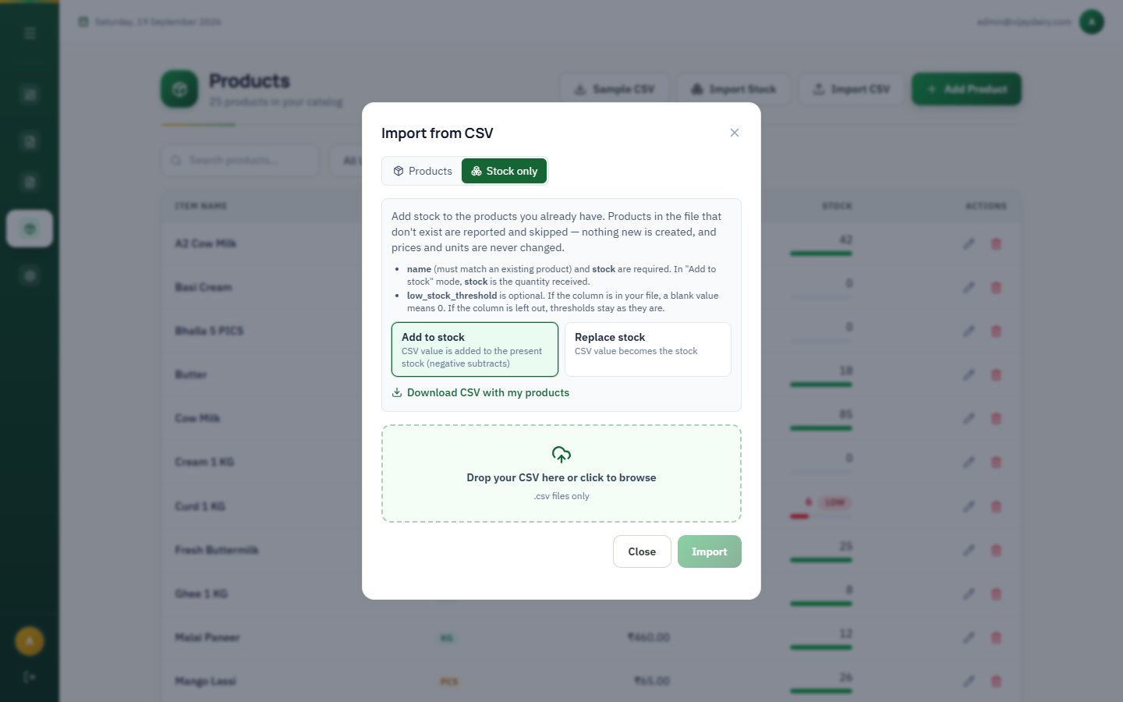
Figure 9 — Import Stock, with the Add / Replace choice
Column | Required | Notes
name | Yes | Must match an existing product.
stock | Yes | Received quantity (Add mode) or the new total (Replace mode).
low_stock_threshold | No | If the column is in your file, a blank cell sets the alert level to 0. If you leave the column out, alert levels are unchanged.

Products that are not found, invalid numbers, and rows that would make stock negative are skipped and listed in the result panel; all other rows are applied.

5. Creating an invoice
Click Create Invoice in the sidebar. The page has three areas: Quick Add and Add Item at the top left, the items table below them, and the Summary on the right.
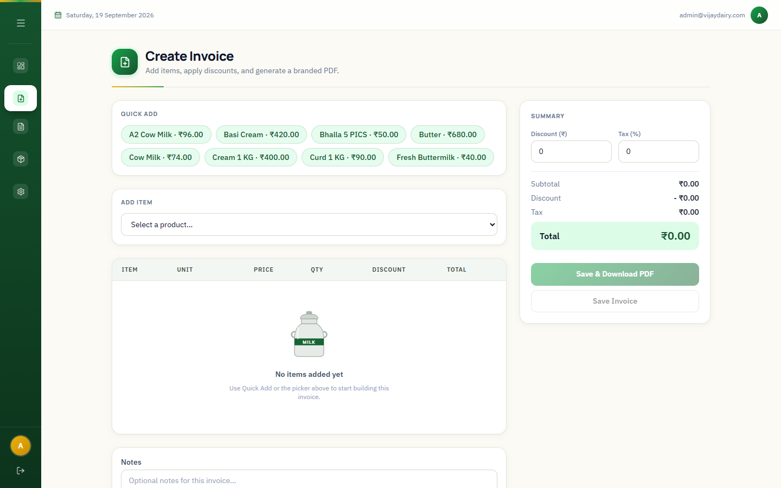
Figure 10 — A new, empty invoice

5.1 Adding items
- Quick Add: click a green chip to add one unit of that product straight away. Clicking the same chip again increases the quantity.
- Add Item: choose a product from the drop-down, enter how much, and click Add.

Selling by quantity or by amount
For products sold by weight or volume (KG and LTR) you can choose how to enter the sale:
Mode | You enter | The app works out | Example
By Quantity | How much (e.g. 1.5) | The price of that quantity | 1.5 L of A2 Cow Milk at ₹96 → ₹144.00
By Amount | The rupees the customer pays | The quantity to weigh out | ₹250 of Paneer at ₹420/kg → 595 g

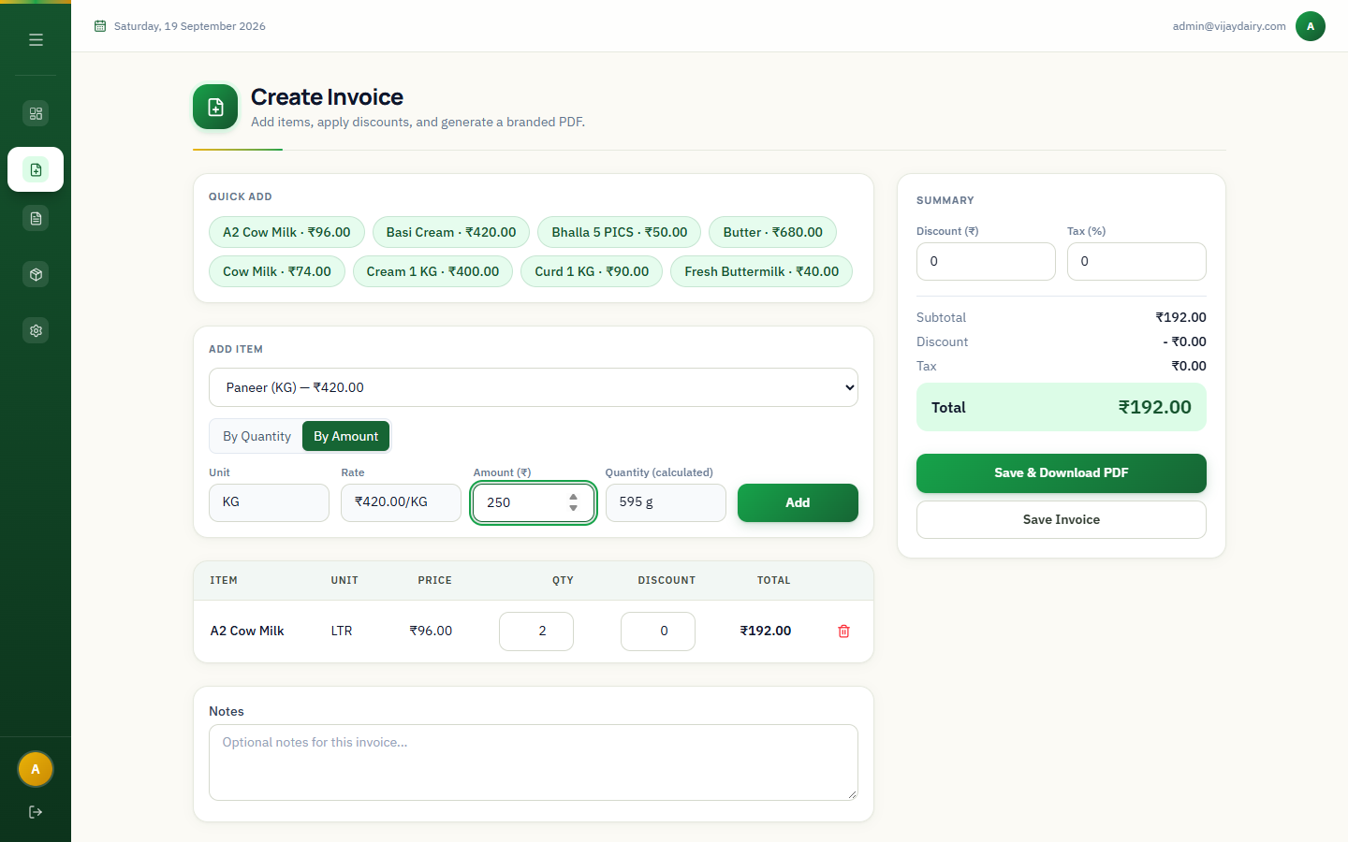
Figure 11 — By Amount: entering ₹250 shows the calculated quantity (595 g)
- Quantities are rounded to three decimals (grams or millilitres); amounts to two decimals (paise).
- PCS products can only be sold By Quantity, in whole numbers.
- A product whose price is ₹0 cannot be sold By Amount.
- Adding the same product in the same mode twice merges into one line; a different mode stays on a separate line.

5.2 Adjusting and completing the invoice
1 In the items table change a Qty (or amount) or give a per-line Discount in rupees. The line total updates instantly. Use the red trash icon to remove a line.
2 Type any Notes for the invoice (for example "Home delivery").
3 In the Summary, enter an invoice-level Discount (₹) and a Tax (%) if needed. Subtotal, Discount, Tax and Total update live.
4 Click Save Invoice, or Save & Download PDF to also download a PDF copy immediately.
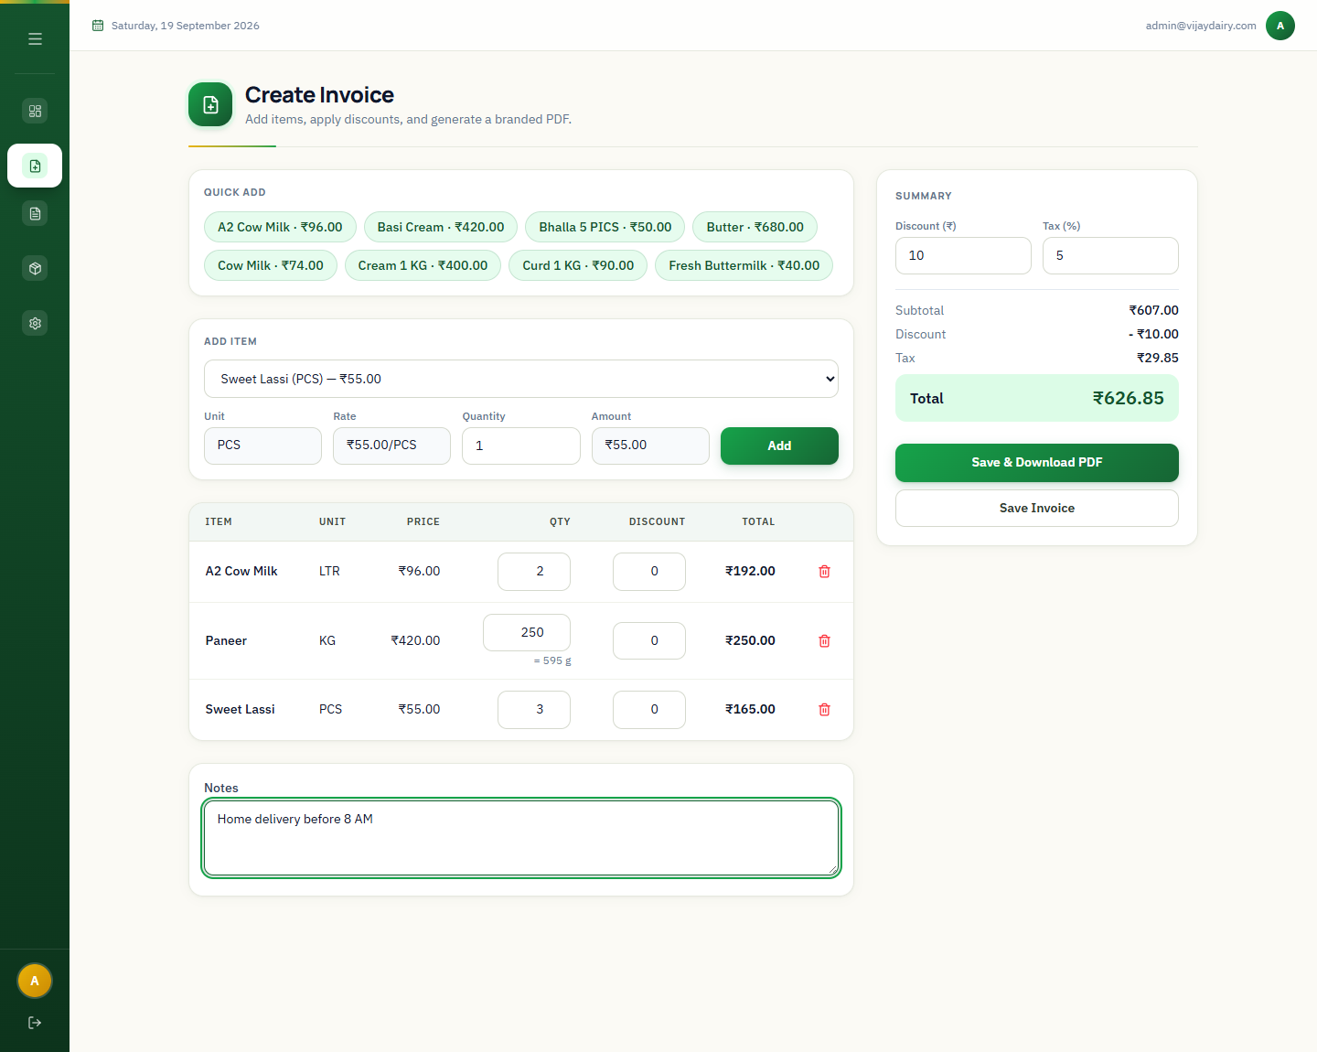
Figure 12 — A completed invoice: three items, ₹10 discount, 5% tax
Summary line | How it is calculated
Subtotal | Sum of all line totals (each line = amount minus its own discount).
Discount | The invoice-level discount you entered.
Tax | (Subtotal − Discount) × Tax %.
Total | Subtotal − Discount + Tax, rounded to paise.

NOTE — What happens when you save
The invoice gets the next number in the form VD-YYYYMM-#### (for example VD-202609-0001). If Inventory Tracking is on, the sold quantities are deducted from stock automatically. An invoice needs at least one item.
IMPORTANT — No editing
A saved invoice cannot be edited. If you made a mistake, delete it (Section 6) and create a new one — but note that deleting does not put the stock back.

6. Invoice history
Click Invoices to see every saved invoice, newest first (the list shows the latest 1,000).
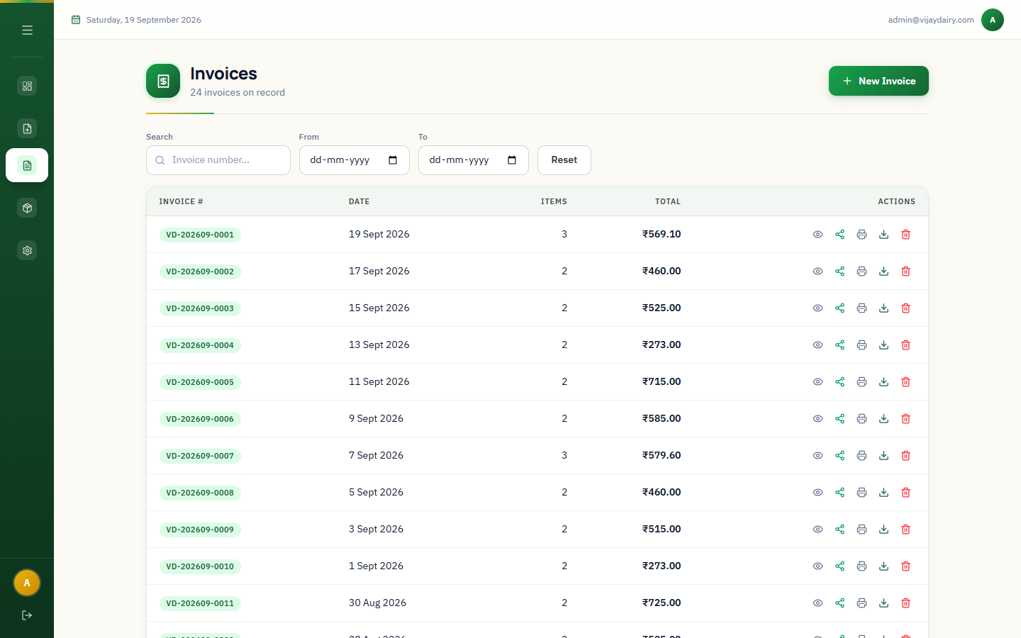
Figure 13 — The invoice list

6.1 Finding an invoice
- Type part of an invoice number in Search.
- Use the From and To dates to show a period.
- Click Reset to clear all filters.

6.2 What each icon does
Icon | Action | Result
Eye | Preview | Opens a summary with the line items and totals.
Share | WhatsApp | Opens WhatsApp with a ready message containing the total and the public link to the invoice.
Printer | Print | Opens a print-friendly page and the browser's print dialog.
Download arrow | Download | Saves a branded PDF named after the invoice number.
Red trash | Delete | Permanently removes the invoice after you confirm. Stock is not restored.

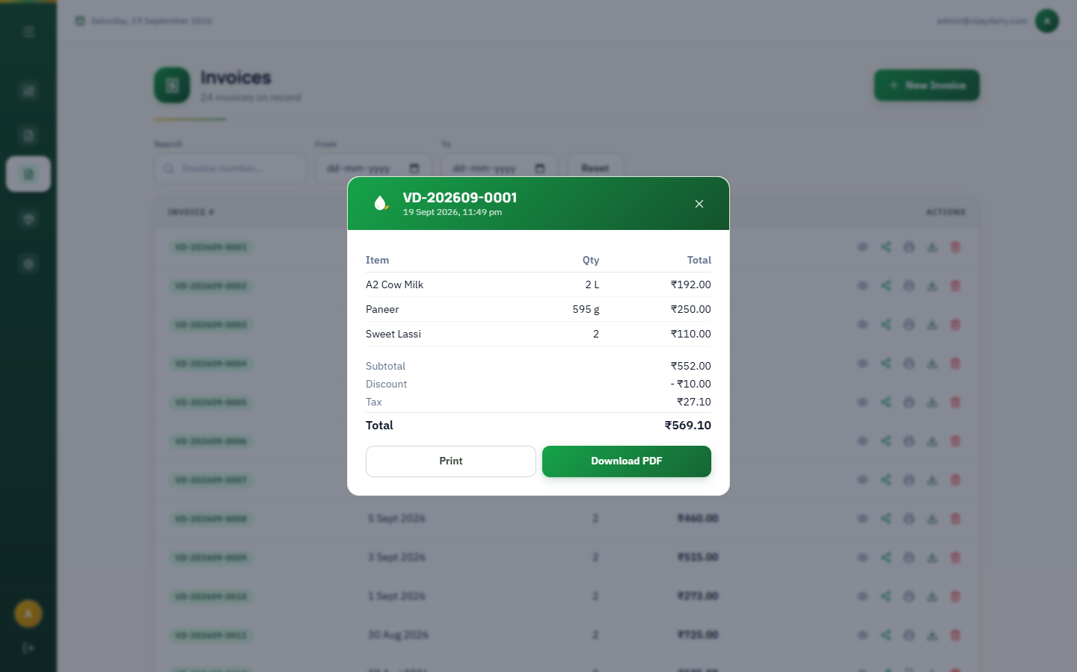
Figure 14 — Invoice preview with Print and Download PDF

7. Sharing invoices — the public link
Every invoice has its own web address in the form https://your-domain/invoice/<id>. This is the link sent by the WhatsApp button. Anyone who has the link can see the invoice — shop details, items and totals — without signing in.
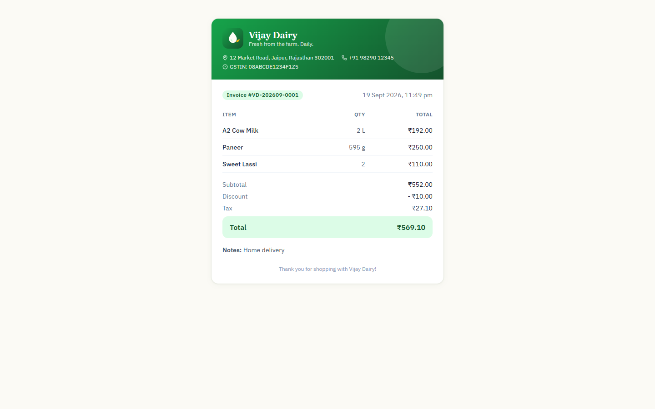
Figure 15 — What the customer sees when they open the link
- The page is read-only: nothing can be changed from it.
- It does not show anything about your stock or settings beyond the shop details printed on the bill.
- The link is long and cannot be guessed, but it does not expire. Only send it to the customer it belongs to.

8. Business settings and appearance
Click Settings to control what appears on invoices and how the app looks. Changes take effect immediately after you click Save Settings.
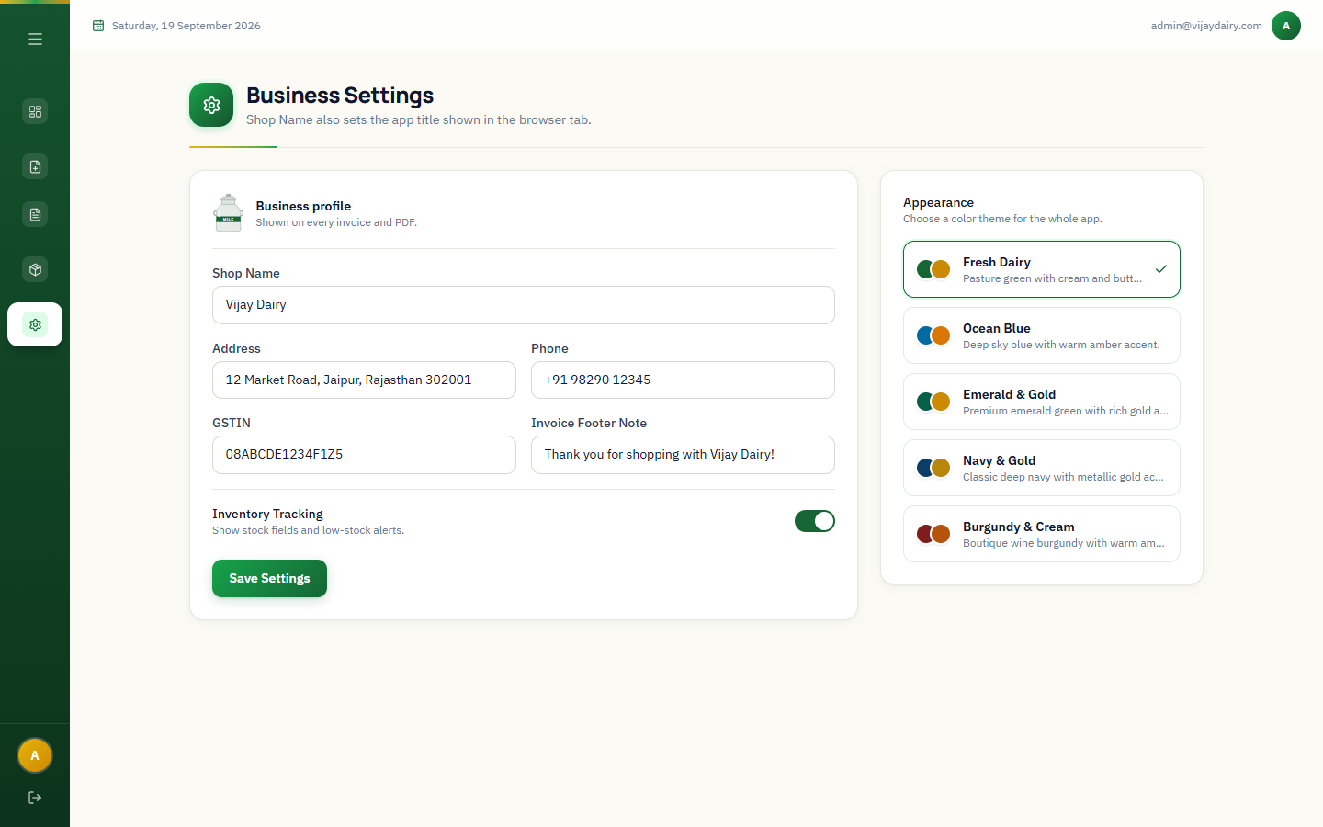
Figure 16 — Business Settings
Field | Purpose
Shop Name | Required. Printed as the main heading on invoices and PDFs, and shown in the browser tab title.
Address | Printed under the shop name.
Phone | Printed in the contact line.
GSTIN | Printed in the contact line when provided.
Invoice Footer Note | Printed at the bottom of every invoice. If left empty it reverts to "Thank you for your business!".
Inventory Tracking | Switch on to track stock: the Products screen shows stock and low-stock alerts, the Dashboard shows Low Stock Alerts, and saving an invoice deducts stock. Switch off if you do not track stock.

8.1 Appearance
On the right of the Settings page, choose a colour theme for the whole app: Fresh Dairy (default), Ocean Blue, Emerald & Gold, Navy & Gold or Burgundy & Cream. The choice applies to this browser.

9. Daily routine and good practice
When | What to do
Start of day | Sign in and glance at the Dashboard — check Low Stock Alerts and order what is running out.
When goods arrive | Use Import Stock → Add to stock so quantities are correct before selling.
During the day | Create invoices as you sell. Use Quick Add for your best sellers and By Amount for "₹100 of paneer" requests.
End of day | Compare Today on the Dashboard with your cash. Log out.
Weekly / monthly | Review Top Products and the monthly chart. Update prices in Products when your rates change — old invoices keep their old prices.
After a stock count | Use Import Stock → Replace stock to set the real quantities.

- Keep product names consistent (e.g. always "Paneer", not "paneer 1kg"); the importer matches on name.
- Set a sensible Low Stock At level for fast-moving items so alerts are useful, and leave it at 0 for items you do not track.
- Log out on shared devices, and never share your password.

10. Frequently asked questions

Why can't I see the Stock column or stock fields?
Inventory Tracking is off. Turn it on in Settings.

Why did my CSV import skip a row?
Each row is checked on its own. An empty name, an invalid unit (only LTR, KG and PCS are allowed) or a missing/negative price makes that one row fail; it is listed in the result and the other rows are still imported.

Can I edit an invoice after saving it?
No. You can preview, print, download, share or delete it. To correct a mistake, delete it and create a new invoice.

Does deleting an invoice put the stock back?
No. Deleting removes the invoice permanently but does not return the sold quantities. Correct the stock with Import Stock or by editing the product.

Can I sell by rupee amount instead of weight or volume?
Yes, for KG and LTR products: choose By Amount, type the rupees, and the quantity is calculated. PCS items are always sold by quantity.

What happens to old invoices if I change or delete a product?
Nothing. Each invoice stores its own copy of the name, unit and price from the moment it was made.

Can the stock go below zero?
Yes. The app does not block a sale when stock is short; it simply records the negative number so you can correct it.

Why does the Dashboard total look different from my books?
The Dashboard counts the latest 1,000 invoices, uses UTC for days and months, and includes discounts and tax as saved. Use the Invoices list for exact records.

Can two people use the app at the same time?
Yes. Everyone signs in with the same administrator account, so changes made by one person appear for others when they reload the page.

11. If something goes wrong
What you see | What to try
"Invalid email or password" | Retype carefully (check caps lock). If it still fails, ask your administrator to confirm the account.
You are suddenly on the sign-in page | Your session expired. Sign in again; nothing saved is lost.
A page shows a network or "Something went wrong" message | Check your internet connection and reload. If it continues, tell your administrator — the server may be down.
Import says "Missing required columns" | The first row of the CSV must contain the column names (name, unit, price for products; name, stock for stock). The message lists the columns that were found.
Import says "Only .csv files are accepted" | Save your spreadsheet as CSV (not .xlsx) and try again.
A product cannot be added: "Name Not Available" | A product with that name already exists. Search for it and edit it instead.
The PDF or print does not show the shop address | Fill in the address, phone and GSTIN in Settings and save.
The public invoice link says the invoice was not found | The invoice was deleted, or the link was copied incompletely.

TIP — Getting help
When you report a problem to your administrator, note the screen, what you clicked and the exact message shown. A screenshot helps.

12. Quick reference

Units
Unit | Meaning | Sell By Quantity | Sell By Amount | Quantity precision
LTR | Litre | Yes | Yes | 3 decimals (ml)
KG | Kilogram | Yes | Yes | 3 decimals (g)
PCS | Piece | Yes (whole numbers) | No | Whole numbers

CSV column names
Import | Required columns | Optional columns
Products (Import CSV) | name, unit, price | stock, low_stock_threshold
Stock only (Import Stock) | name, stock | low_stock_threshold

Where things are
I want to… | Go to
See today's and this week's sales | Dashboard
Make a bill | Create Invoice
Reprint, share or download a bill | Invoices → icons on the row
Change a price | Products → pencil icon
Record newly received stock | Products → Import Stock
Change shop name, address or footer | Settings
Switch stock tracking on or off | Settings → Inventory Tracking
Change the colour theme | Settings → Appearance

