VIJAY DAIRY
Installation & Deployment Guide
Enterprise step-by-step edition
Install, configure, secure and operate Vijay Dairy on Node.js and Supabase.
Version 2.0
20 September 2026
Node.js · Express · Supabase (PostgreSQL) · React

Document control
Item | Detail
Document | Vijay Dairy — Installation & Deployment Guide
Version / status | 2.0 — Released
Date | 20 September 2026
Applies to | Vijay Dairy 2.x: React frontend, Node.js (Express) API, Supabase PostgreSQL
Audience | IT administrators, DevOps and implementation engineers
Companion documents | User Manual · System Architecture reference

Version | Date | Change
1.0 | Aug 2026 | Local development setup on the original .NET + PostgreSQL stack.
2.0 | 20 Sep 2026 | Re-platformed on Node.js + Supabase. Enterprise edition: prerequisites, verification, production deployment, security hardening, operations and troubleshooting.

Contents
1. Introduction
2. Solution overview
3. Prerequisites
4. Pre-installation checklist
5. Step-by-step installation
Part A — Create the Supabase database
Part B — Get the source code
Part C — Install and start the backend
Part D — Install and start the frontend
Part E — First sign-in and smoke test
6. Configuration reference
7. Production deployment
8. Security hardening checklist
9. Operations and maintenance
10. Verification and acceptance tests
11. Troubleshooting
12. Appendices

1. Introduction

1.1 Purpose
This guide takes an administrator from an empty machine to a running, verified Vijay Dairy installation, and then describes how to deploy it to production, harden it, back it up and keep it healthy. Every step states what to do and what result to expect, so each stage can be signed off before moving on.

1.2 Scope
- In scope: creating the Supabase database, installing and configuring the Node.js API and the React frontend, first login, production deployment behind a reverse proxy, security hardening, backup/restore, upgrades and troubleshooting.
- Out of scope: using the application day to day (see the User Manual) and the internal design of the code (see the System Architecture reference).

1.3 Conventions used
Convention | Meaning
monospace text | A command, file name, setting or value to type or check exactly.
<placeholder> | A value you must replace with your own (for example <project-ref>).
Expected result | What you should see when the step worked. If you do not see it, stop and use Section 11.
NOTE / IMPORTANT / SECURITY | Call-out boxes: background information, a common pitfall, or a security-relevant instruction.

IMPORTANT — Commands
Commands are shown for a Bash-style shell (Linux, macOS, Git Bash). On Windows PowerShell use curl.exe instead of curl, and copy instead of cp. Where the syntax differs materially, both forms are shown.

2. Solution overview
Vijay Dairy is a single-shop dairy operations system: product catalogue, invoicing, stock, a revenue dashboard, business settings and public invoice links. It has three tiers.
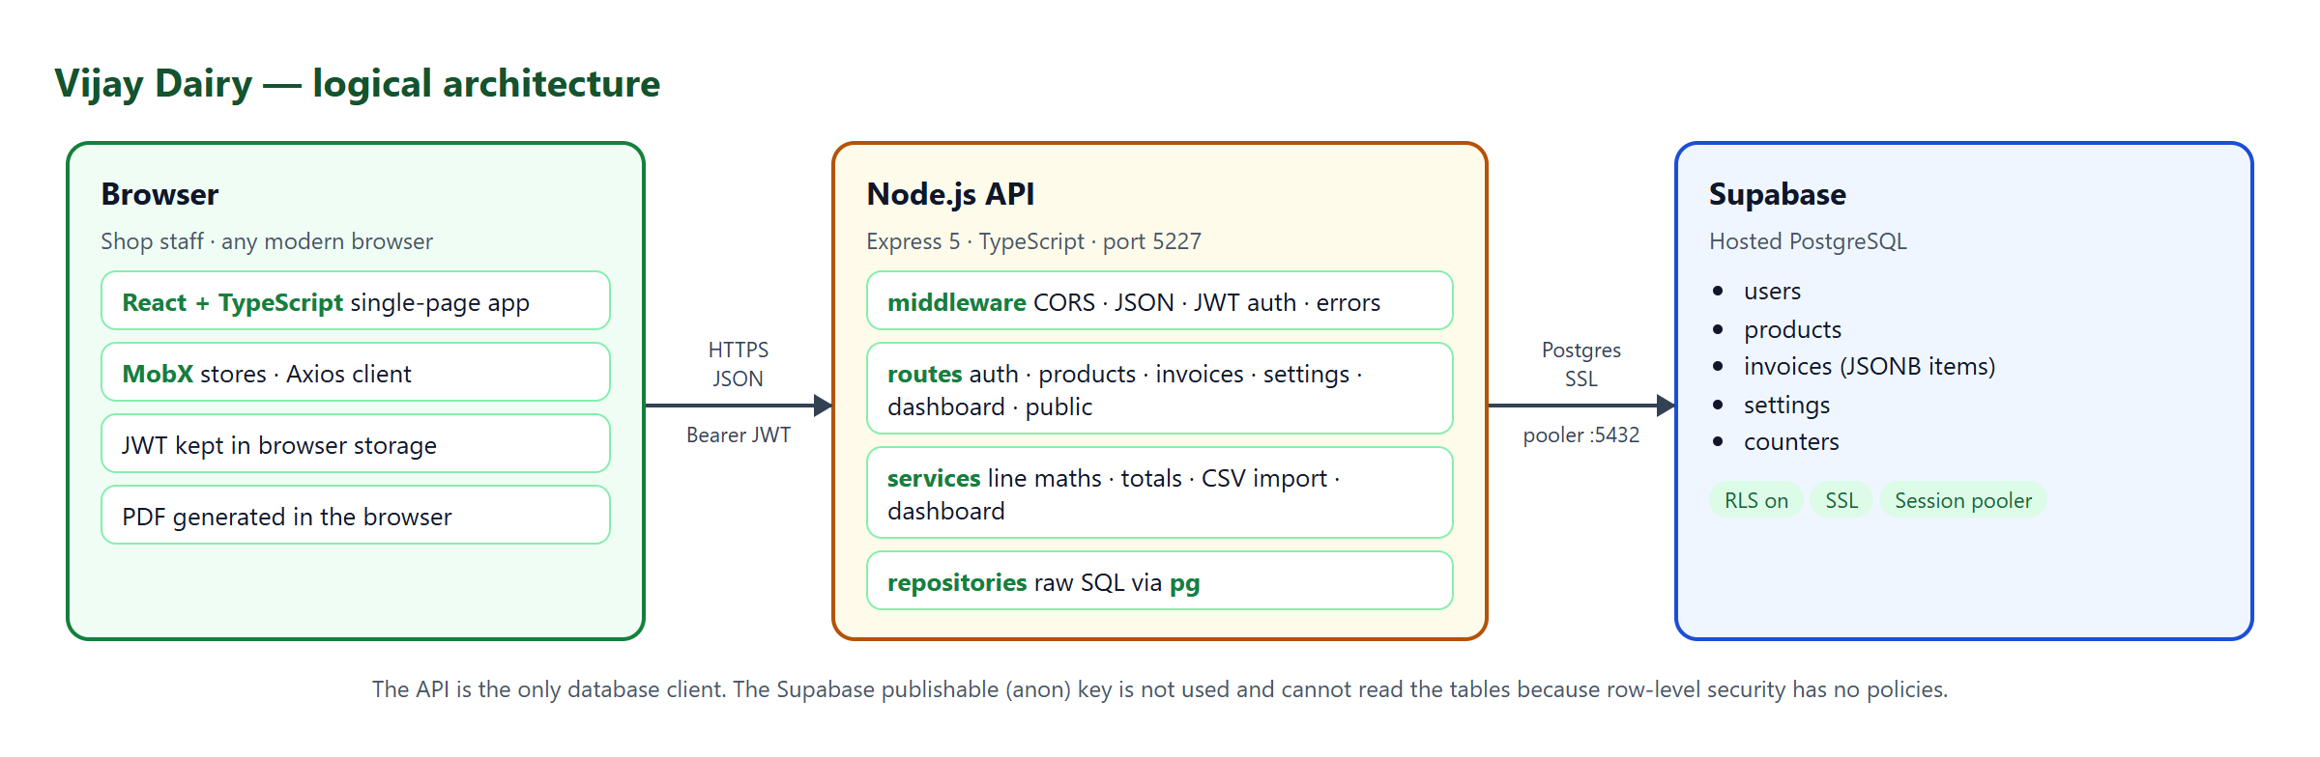
Figure 1 — Logical architecture

2.1 Components
Component | Technology | Folder | Role
Frontend | React 18, TypeScript, MobX, Tailwind, Vite | Frontend/ | Browser single-page app. Generates invoice PDFs in the browser.
API | Node.js, Express 5, TypeScript, pg | Backend/ | Authentication (JWT), business rules, CSV import, dashboard queries.
Database | Supabase (hosted PostgreSQL) | Backend/supabase/schema.sql | Stores users, products, invoices, settings and counters.

2.2 Ports and protocols
From → To | Port | Protocol | Notes
Browser → Frontend (dev) | 5173 (or next free) | HTTP | Vite dev server. Production uses static files behind HTTPS.
Browser → API | 5227 | HTTP/JSON | Dev: direct to VITE_API_URL. Production: HTTPS through the reverse proxy on 443.
API → Supabase pooler | 5432 (session mode) | PostgreSQL over SSL | IPv4-reachable. Use this instead of the IPv6-only direct host.

2.3 What is stored where
- Supabase: all business data. Invoice line items are stored as JSONB on the invoice row. The admin password is stored as a bcrypt hash.
- Browser: only the JWT and basic user info (in local storage; obfuscated in production builds). Invoice PDFs are created client-side and are not stored on the server.
- API server: no business data. It holds configuration secrets in Backend/.env.

3. Prerequisites

3.1 Software
Software | Version | Used for | Check with
Node.js | 22 LTS or later (developed and tested on 24) | Running and building the API and frontend | node -v
npm | Bundled with Node.js | Installing dependencies | npm -v
Git | Any recent version | Getting the source code | git --version
Modern browser | Current Chrome, Edge, Firefox or Safari | Using the app | —
Nginx (production) | Any current stable | HTTPS reverse proxy and static hosting | nginx -v
PM2 or systemd (production) | PM2 5+ / any systemd | Keeping the API running | pm2 -v

All libraries used by the project are open source (MIT, BSD or Apache-2.0 licences); no paid runtime components are required. Supabase offers a free tier that is sufficient to start with.

3.2 Accounts and access
- A Supabase account (supabase.com) with permission to create a project.
- Read access to the project Git repository (or a copy of the source folder).
- For production: a domain name, a server or VM you administer (Linux recommended) and a TLS certificate (for example from Let's Encrypt).

3.3 Network requirements
- Outbound TCP 5432 (and optionally 6543) from the API host to *.pooler.supabase.com.
- Outbound HTTPS 443 to the npm registry during installation.
- Inbound 443 (and 80 for certificate issuance / redirect) to the reverse proxy in production. Do not expose port 5227 publicly.
IMPORTANT — IPv6
Supabase's direct database host (db.<project-ref>.supabase.co) resolves only to an IPv6 address on the free tier. Many corporate and home networks have no IPv6 route, which produces ENOTFOUND errors. This guide therefore always uses the Session pooler connection string, which works over IPv4.

3.4 Sizing (guidance)
A single shop is a light workload. A 1 vCPU / 1 GB RAM server comfortably runs the API and Nginx. The API keeps no state in memory, so it can be restarted or replicated freely.

4. Pre-installation checklist
Complete this checklist before starting Part A. Record the answers; you will need them during configuration.
# | Item | Value / status
1 | Node.js 22+ installed (node -v) | ☐
2 | Git installed and repository accessible | ☐
3 | Supabase account created | ☐
4 | Supabase region chosen (closest to the shop / server) | ________________
5 | Database password generated and stored in a password manager | ☐
6 | Admin e-mail address decided (default admin@vijaydairy.com) | ________________
7 | Strong admin password decided (12+ characters) | ☐
8 | Production domain name (if deploying) | ________________
9 | Outbound 5432 to Supabase pooler allowed by the firewall | ☐

5. Step-by-step installation
Follow the parts in order. Each part ends with a verification so a fault is caught where it occurs.

Part A — Create the Supabase database
Step A1 Create the project. Sign in to supabase.com, click New project, choose your organisation, name it (for example vijay-dairy), set a strong Database password, and select a Region. Click Create new project.
Expected result: after about two minutes the project dashboard opens.
SECURITY — Password
Store the database password now. Supabase cannot show it again (you can only reset it under Project Settings → Database).
Step A2 Create the tables. Open SQL Editor → New query. Paste the entire contents of Backend/supabase/schema.sql and click Run.
Expected result: "Success. No rows returned". The script is idempotent (CREATE ... IF NOT EXISTS), so running it again is safe.
Step A3 Verify. Open Table Editor. You should see five tables — users, products, invoices, settings, counters — each marked with the RLS (row-level security) badge. settings and counters already contain one row each.
Step A4 Copy the connection string. Click Connect at the top of the dashboard, choose Session pooler, and copy the URI. It looks like this:
postgresql://postgres.<project-ref>:<password>@aws-0-<region>.pooler.supabase.com:5432/postgres

Replace <password> with the database password. If the password contains special characters, URL-encode them:
Character | @ | : | / | # | ? | % | space
Encoded as | %40 | %3A | %2F | %23 | %3F | %25 | %20

NOTE — Not needed
The Supabase project URL and publishable (anon) key are not used. The API talks to Postgres directly and the tables are protected by row-level security, so the public key cannot read them.

Part B — Get the source code
Step B1 Clone the repository (or unpack the source archive) to the machine that will run the software:
git clone <repository-url> VijayDairy2
cd VijayDairy2
Expected result: the folder contains Backend/, Frontend/, Documents/ and README.md.
Step B2 Check Node.js:
node -v # v22.x or later
npm -v

Part C — Install and start the backend
Step C1 Install dependencies (exact versions from the lock file):
cd Backend
npm ci
Expected result: completes without errors; node_modules/ appears.
Step C2 Create the environment file from the template:
# Bash / Git Bash / macOS / Linux
cp .env.example .env

# Windows PowerShell
copy .env.example .env
Step C3 Generate a JWT secret (works on every platform):
node -e "console.log(require('crypto').randomBytes(48).toString('base64'))"
Step C4 Edit `Backend/.env` and set at least the values below (full list in Section 6):
Setting | Value to enter
DATABASE_URL | The Session pooler string from Step A4, with the password filled in and URL-encoded.
JWT_SECRET | The random value from Step C3.
ADMIN_EMAIL | The administrator sign-in e-mail.
ADMIN_PASSWORD | A strong password. If left empty, no admin user is created.
CORS_ORIGINS | Comma-separated browser origins allowed to call the API. Development default: http://localhost:5173,http://localhost:5175.

SECURITY — .env
Backend/.env contains the database password, JWT secret and admin password. It is git-ignored — never commit, e-mail or paste it into chat or tickets.
Step C5 Run the automated tests (optional but recommended):
npm test
Expected result: all test files pass (line-calculation rules, CSV importers and API contract). No database connection is needed for the tests.
Step C6 Start the API in development mode:
npm run dev
Expected result: the console shows these lines. The first appears only on the very first start, when the admin user is created:
Seeded admin user admin@vijaydairy.com
Vijay Dairy API listening on http://localhost:5227
Step C7 Verify the API. In a second terminal:
curl -i http://localhost:5227/api/auth/me # PowerShell: curl.exe -i ...
Expected result: HTTP/1.1 401 Unauthorized with an empty body. That proves the API is running and protecting its routes. To prove the database connection, sign in in Part E.

Part D — Install and start the frontend
Step D1 Install dependencies (open a new terminal):
cd Frontend
npm ci
Step D2 Check the API address. In development the browser calls the API directly at VITE_API_URL, set in Frontend/.env.development:
VITE_API_URL=http://localhost:5227/api
Change it only if the API runs on a different host or port. It must end with /api.
Step D3 Start the dev server:
npm run dev
Expected result: Vite prints a Local URL, normally http://localhost:5173/. If that port is busy it picks the next free one (5174, 5175, …).
IMPORTANT — CORS
The origin printed by Vite (scheme + host + port) must appear in CORS_ORIGINS in Backend/.env. 5173 and 5175 are allowed by default. If the app shows network errors in the browser console, add the origin and restart the API.

Part E — First sign-in and smoke test
Step E1 Open the Vite URL in a browser. The Sign in page appears.
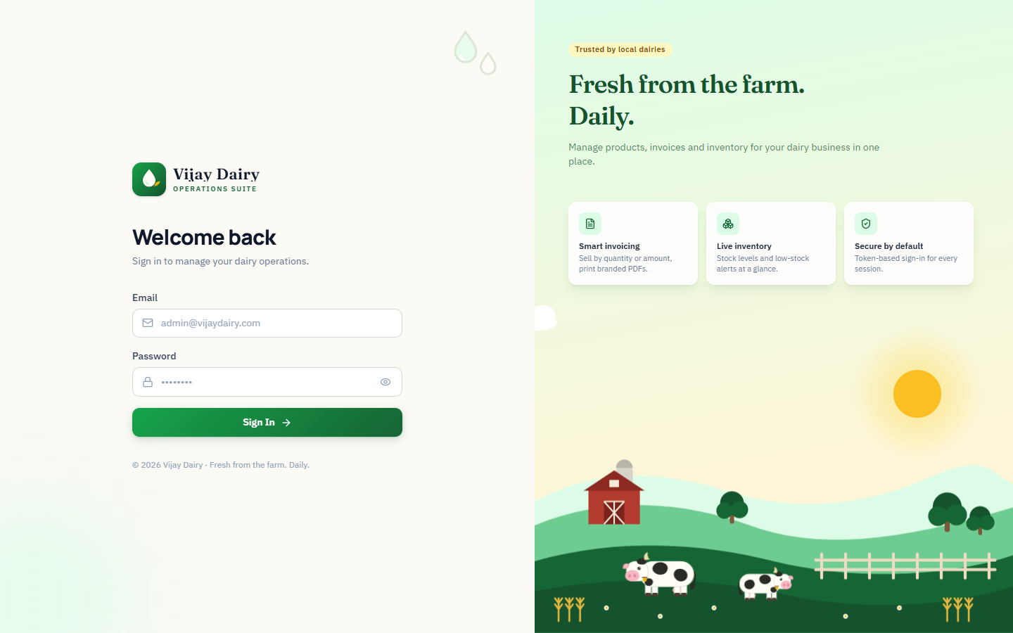
Figure 2 — Sign-in page
Step E2 Enter the ADMIN_EMAIL and ADMIN_PASSWORD from .env and click Sign in.
Expected result: the Dashboard opens. On a new installation the totals are ₹0 and charts show "No data yet".
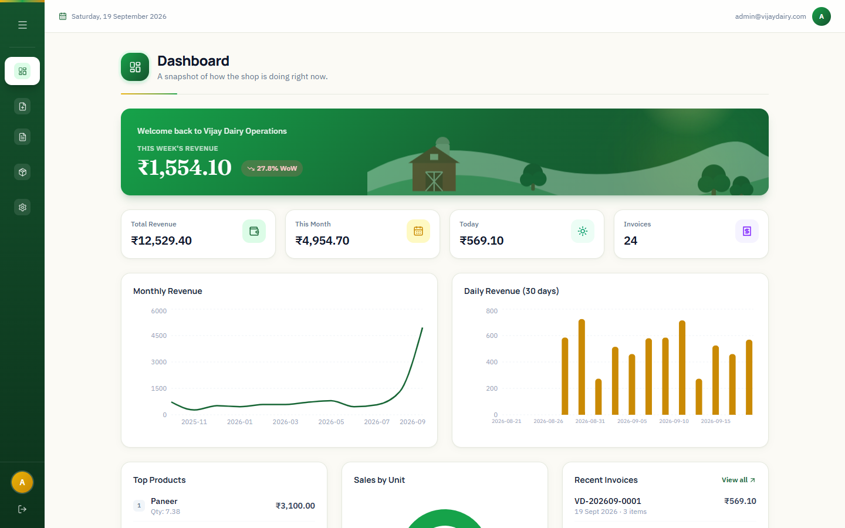
Figure 3 — Dashboard after a successful sign-in (shown with sample data)
Step E3 Configure the business. Open Settings, enter the shop name, address, phone and GSTIN, choose whether to turn on Inventory Tracking, and click Save Settings.
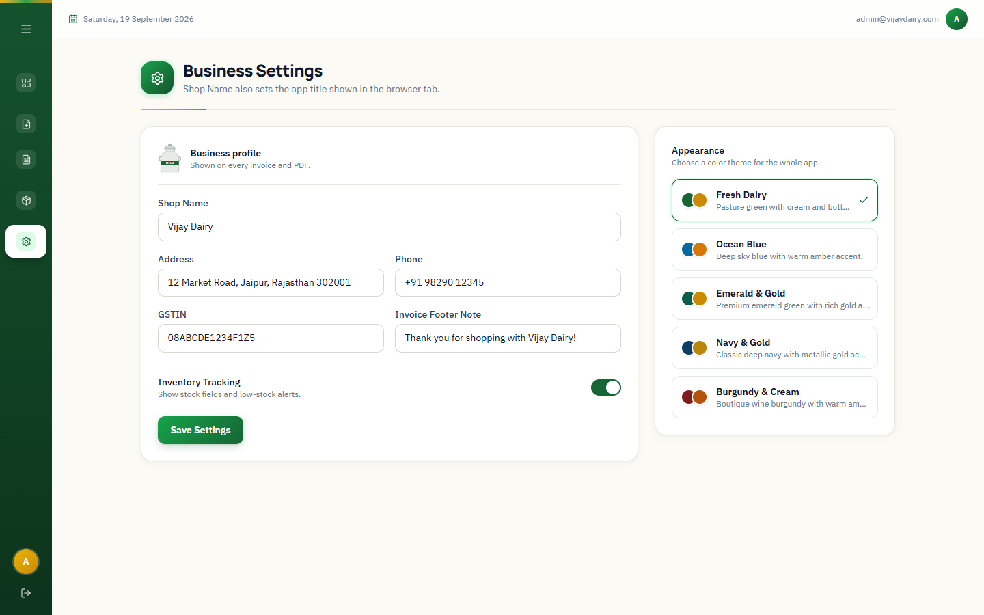
Figure 4 — Business Settings
Step E4 Load the product catalogue. Open Products → Import CSV, choose Documents/products_import.csv and click Import.
Expected result: the result panel reports the number of products created and no errors.
Step E5 Create a test invoice. Open Create Invoice, add an item, click Save Invoice, then open Invoices and confirm it appears with a number such as VD-YYYYMM-0001.
Step E6 Test the public link. In Invoices, use the share icon (or open /invoice/<invoice-id> in a private window). The invoice should display without signing in.
TIP — Sign-off
When E1–E6 pass, the installation is functionally verified. Run the full acceptance list in Section 10 before go-live.

6. Configuration reference

6.1 Backend — Backend/.env
Variable | Required | Default | Description
DATABASE_URL | Yes | — | PostgreSQL connection string (Supabase Session pooler). Startup fails if empty.
DATABASE_SSL | No | true | Set to false only for a local non-SSL Postgres.
JWT_SECRET | Yes | — | HS256 signing key. Use 48+ random bytes. Changing it signs everyone out.
JWT_ISSUER | No | VijayDairy | Token issuer claim, validated on every request.
JWT_AUDIENCE | No | VijayDairyClients | Token audience claim, validated on every request.
JWT_EXPIRY_HOURS | No | 12 | Session lifetime. Tokens cannot be revoked earlier (see Section 8).
ADMIN_EMAIL | No | admin@vijaydairy.com | E-mail of the admin created at startup if it does not exist.
ADMIN_PASSWORD | For first run | — (no admin created) | Password for the seeded admin. Only used when the admin does not yet exist.
ADMIN_NAME | No | Admin | Display name of the seeded admin.
CORS_ORIGINS | Production | http://localhost:5173,http://localhost:5175 | Comma-separated list of allowed browser origins.
PORT | No | 5227 | TCP port the API listens on.

NOTE — Admin seeding
Changing ADMIN_PASSWORD later does not change an existing admin's password — seeding only creates a missing user. To reset a password, delete the row from the users table (Supabase Table Editor) and restart the API with the new ADMIN_PASSWORD.

6.2 Frontend — Frontend/.env.development and .env.production
Variable | Development | Production | Description
VITE_API_URL | http://localhost:5227/api | /api (same origin) or https://api.example.com/api | API base URL. Must end with /api. Baked into the bundle at build time.
VITE_PUBLIC_URL | empty | empty, or /sub-path/ | Base path the assets are served from.
VITE_SECURE_STORAGE_ACTIVE | false | true | Obfuscates the stored session data in the browser. Obfuscation is not encryption.

IMPORTANT — Build-time values
Vite inlines VITE_* values when you run npm run build. Changing them requires a rebuild and redeploy of Frontend/dist. Never put secrets in these files.

7. Production deployment
The recommended topology puts Nginx in front of everything: it terminates TLS, serves the built frontend, and forwards /api to the Node process. Serving both from one domain avoids CORS entirely.
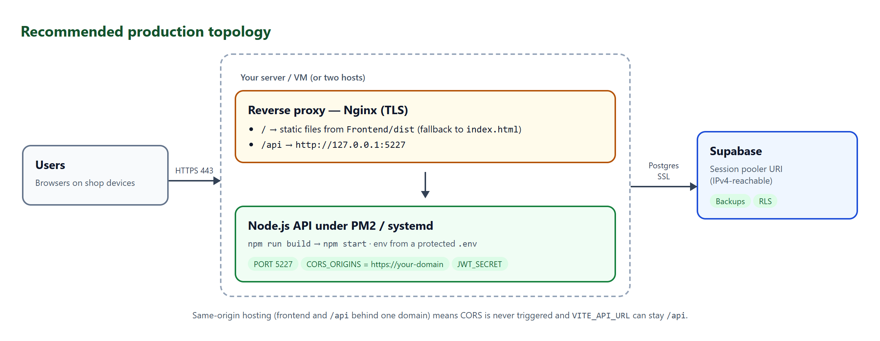
Figure 5 — Recommended production topology

7.1 Build the API
cd Backend
npm ci
npm run build # compiles TypeScript to Backend/dist
npm start # node dist/index.js (foreground test)
npm start reads Backend/.env from the current directory, so run it from the Backend folder. On the production server set CORS_ORIGINS to your real origin (for example https://dairy.example.com), a fresh JWT_SECRET, and a strong ADMIN_PASSWORD.

7.2 Keep the API running (choose one)

Option 1 — PM2 (Linux, macOS, Windows)
npm install -g pm2
cd Backend
pm2 start dist/index.js --name vijay-dairy-api
pm2 save
pm2 startup # follow the printed command to start on boot
pm2 logs vijay-dairy-api

Option 2 — systemd (Linux)
Create /etc/systemd/system/vijay-dairy-api.service:
[Unit]
Description=Vijay Dairy API
After=network-online.target

[Service]
WorkingDirectory=/opt/VijayDairy2/Backend
ExecStart=/usr/bin/node dist/index.js
EnvironmentFile=/opt/VijayDairy2/Backend/.env
Restart=always
RestartSec=5
User=vijay
NoNewPrivileges=true

[Install]
WantedBy=multi-user.target
sudo systemctl daemon-reload
sudo systemctl enable --now vijay-dairy-api
sudo systemctl status vijay-dairy-api
Protect the environment file: sudo chown vijay:vijay Backend/.env && sudo chmod 600 Backend/.env.

7.3 Build and publish the frontend
Step 1 Set VITE_API_URL=/api in Frontend/.env.production (same-origin hosting) or the full API URL.
Step 2 Build:
cd Frontend
npm ci
npm run build # type-checks, then writes Frontend/dist
Step 3 Copy the contents of Frontend/dist to the web root, for example /var/www/vijay-dairy.

7.4 Nginx reverse proxy with HTTPS
Example site configuration (/etc/nginx/sites-available/vijay-dairy). Replace the domain and certificate paths.
server {
listen 80;
server_name dairy.example.com;
return 301 https://$host$request_uri;
}

limit_req_zone $binary_remote_addr zone=login:10m rate=5r/m;

server {
listen 443 ssl http2;
server_name dairy.example.com;

ssl_certificate /etc/letsencrypt/live/dairy.example.com/fullchain.pem;
ssl_certificate_key /etc/letsencrypt/live/dairy.example.com/privkey.pem;

root /var/www/vijay-dairy;
index index.html;

add_header X-Content-Type-Options nosniff always;
add_header X-Frame-Options DENY always;
add_header Referrer-Policy strict-origin-when-cross-origin always;

# Rate-limit sign-in attempts
location = /api/auth/login {
limit_req zone=login burst=5 nodelay;
proxy_pass http://127.0.0.1:5227;
proxy_set_header Host $host;
proxy_set_header X-Forwarded-For $proxy_add_x_forwarded_for;
proxy_set_header X-Forwarded-Proto $scheme;
}

location /api/ {
client_max_body_size 10m; # CSV uploads
proxy_pass http://127.0.0.1:5227;
proxy_set_header Host $host;
proxy_set_header X-Forwarded-For $proxy_add_x_forwarded_for;
proxy_set_header X-Forwarded-Proto $scheme;
}

# Single-page app: unknown paths (for example /invoice/<id>) fall back to index.html
location / {
try_files $uri $uri/ /index.html;
}
}
sudo ln -s /etc/nginx/sites-available/vijay-dairy /etc/nginx/sites-enabled/
sudo nginx -t && sudo systemctl reload nginx
IMPORTANT — SPA fallback
The try_files ... /index.html line is essential. Without it, public invoice links (/invoice/<id>) and page refreshes return 404.

7.5 All-in-one on Netlify (frontend + serverless API)
Netlify can host the whole application with no separate API server. The React build is served as static files and the same Express API runs as a Netlify Function at /api on the same domain. Supabase remains the database. Because everything is on one origin, CORS is not needed and VITE_API_URL is simply /api.
NOTE — How it works
The repository contains netlify.toml (build settings and redirects) and netlify/functions/api.ts (a two-line entry that loads Backend/src/serverless.ts). /api/* is rewritten to the function; every other path falls back to index.html. The API code is unchanged — it is the same app you run locally.

Step 1 — Prepare the database connection
- In Supabase choose Connect → Transaction pooler and copy the URI (port 6543). Serverless functions open many short-lived connections; the transaction pooler is designed for that.
- Replace <password> with the database password and URL-encode special characters (@ → %40).

Step 2 — Create the Netlify site
2.1 In Netlify choose Add new site → Import an existing project, connect GitHub and select the repository. Branch to deploy: main.
2.2 Leave every Build settings field empty — Base directory, Build command, Publish directory and Functions directory. Their values come from netlify.toml in the repository and take priority.
2.3 Open Environment variables → Add environment variables and add the values below. Mark the secrets as secret.
Variable | Value | Secret
DATABASE_URL | Supabase Transaction pooler URI (port 6543), password URL-encoded | Yes
PG_POOL_MAX | 1 (one database connection per function instance) | No
JWT_SECRET | 48+ random bytes (Step C3 command in Part C) | Yes
ADMIN_EMAIL | Administrator sign-in e-mail | No
ADMIN_PASSWORD | Strong password for the first admin | Yes
JWT_ISSUER, JWT_AUDIENCE, ADMIN_NAME | Optional — defaults are fine | No
VITE_API_URL | /api | No — this is baked into the public bundle
VITE_SECURE_STORAGE_ACTIVE | true | No

SECURITY — Never use VITE_
Anything named VITE_* is copied into the public JavaScript bundle and can be read by every visitor. Keep DATABASE_URL, JWT_SECRET and ADMIN_PASSWORD without that prefix.
2.4 Click Deploy. The first deploy installs both projects, builds the frontend and bundles the function (about 2–3 minutes).

Step 3 — Verify the deployment
- https://<your-site>.netlify.app/api/auth/me in a browser returns an empty 401 — the function is running.
- The sign-in page loads and the admin account works. The very first request after a deploy also creates the admin user (seeding is done lazily by the function) and can take a few seconds.
- Refresh a page such as /products, and open a public link /invoice/<id> — neither should give a 404.
- Run the acceptance tests in Section 10 against the Netlify address.

Behaviour and limits to know about
- Cold starts: the first request after a quiet period takes roughly half a second to a second longer.
- Distance to the database: Netlify Functions run in a US region by default; a Supabase project in another region (for example Tokyo) adds about 150–200 ms per query, so saving an invoice can take around a second. A Supabase project in a nearer region improves this.
- Limits: function time limit (about 10 s by default) and a 6 MB request size. CSV imports and normal use are far below both.
- Free tier: both Netlify and Supabase have free plans that comfortably cover one shop. Check netlify.com/pricing for current allowances. Supabase free projects pause after about a week of inactivity and must be resumed from the dashboard.
- Secrets: change environment variables in Netlify, then trigger a new deploy for them to take effect.

Alternative — frontend on Netlify, API elsewhere
If you prefer a long-running API server, deploy Backend to any Node host (build npm ci && npm run build, start npm start) and set VITE_API_URL to that address with the /api suffix and CORS_ORIGINS on the API host to your Netlify address. In that case remove the /api/* redirect from netlify.toml.

7.6 Go-live verification
- https://dairy.example.com/ shows the sign-in page over a valid certificate.
- Sign in works, and Section 10 acceptance tests pass against the production URL.
- curl -i https://dairy.example.com/api/auth/me returns 401 (no token).
- The API port 5227 is not reachable from outside the server.

8. Security hardening checklist
# | Control | How | Done
1 | Strong, unique secrets | JWT_SECRET from 48 random bytes; admin password 12+ characters; database password from a password manager. | ☐
2 | Rotate any password that was shared | If the database or admin password was ever pasted into chat, e-mail or a ticket, reset it (Supabase: Project Settings → Database → Reset password; update DATABASE_URL). | ☐
3 | Secrets stay out of git | .env is git-ignored. Confirm with git status and git ls-files | grep .env (must show only .env.example). | ☐
4 | HTTPS only | TLS on the reverse proxy, HTTP → HTTPS redirect, HSTS if appropriate. | ☐
5 | Lock down CORS | CORS_ORIGINS lists only the real production origin(s); no wildcard. | ☐
6 | Private API port | Bind/firewall port 5227 to localhost; only Nginx is public. | ☐
7 | Sign-in rate limiting | The application has no built-in lockout; use the limit_req block in Section 7.4 (or a WAF). | ☐
8 | Row-level security stays on | All five tables show the RLS badge and have no policies. Do not add anon policies. | ☐
9 | Least-privilege server | Run the API as a non-root user; chmod 600 on .env; NoNewPrivileges in systemd. | ☐
10 | Dependency hygiene | Run npm audit on Backend and Frontend before each release and apply fixes. | ☐
11 | Backups verified | A restore has been tested (Section 9.1). | ☐
12 | Change the default admin e-mail | Set ADMIN_EMAIL to a real, monitored address before the first start. | ☐

Known limitations to be aware of
- Logout is client-side. JWTs cannot be revoked; a stolen token works until it expires (JWT_EXPIRY_HOURS, default 12 h). Shorten the lifetime for higher-risk environments.
- Single administrator role. Every signed-in user has full access; there are no per-role permissions in the UI or API.
- Public invoice links are unguessable but not expiring. Anyone holding a link can view that invoice. It never exposes inventory settings.
- Stock can go negative when invoices are saved with inventory tracking on, and deleting an invoice does not return stock.

9. Operations and maintenance

9.1 Backup and restore
The database is the only stateful component. Check which automatic backups your Supabase plan includes, and in every case keep an independent, scheduled logical backup.
# Backup (custom format, compressed). Use the Session pooler URI.
pg_dump "postgresql://postgres.<ref>:<encoded-password>@aws-0-<region>.pooler.supabase.com:5432/postgres" \
--no-owner --no-privileges -Fc -f vijay-dairy-$(date +%F).dump

# Restore into an empty Supabase project or database
pg_restore --no-owner --no-privileges -d "<target-connection-string>" vijay-dairy-2026-09-20.dump
- Schedule the backup daily (cron / Task Scheduler), keep at least 14 days, and copy files off the server.
- Test a restore into a scratch project at least once per quarter and after any major upgrade.
- Also back up Backend/.env (encrypted) — without JWT_SECRET you cannot reproduce the configuration, and losing DATABASE_URL locks you out until reset.

9.2 Upgrading to a new version
1 Announce a short maintenance window and take a database backup (9.1).
2 Get the new code: git pull (or unpack the new release).
3 Backend: cd Backend && npm ci && npm test && npm run build.
4 If the release notes mention schema changes, run the updated Backend/supabase/schema.sql in the SQL Editor (it is idempotent) or the provided migration.
5 Restart: pm2 restart vijay-dairy-api (or sudo systemctl restart vijay-dairy-api).
6 Frontend: cd Frontend && npm ci && npm run build, then replace the web-root contents with the new dist.
7 Run the smoke tests in Section 10.

9.3 Rollback
- Check out the previous Git tag/commit, rebuild the backend and frontend, restart, and republish dist.
- If a schema change must be undone, restore the pre-upgrade backup into the database (9.1). Application-only rollbacks need no database change.

9.4 Monitoring and logging
What | How
API liveness | External check on GET /api/auth/me expecting 401 (no token) — any other status or a timeout means the API or proxy is down.
Application logs | PM2: pm2 logs vijay-dairy-api; systemd: journalctl -u vijay-dairy-api -f. Unexpected errors are logged to the console; clients only see a generic "Something Went Wrong".
Database health | Supabase dashboard → Reports / Logs (connection counts, slow queries, storage).
Proxy logs | Nginx access.log / error.log (watch for 5xx and repeated 429/401 on /api/auth/login).
Certificates | Monitor certificate expiry; automate renewal (certbot timer).

9.5 Routine tasks
Frequency | Task
Daily | Verify the backup ran and the file size is plausible.
Weekly | Review error logs and failed sign-in attempts.
Monthly | npm audit; apply security updates; check Supabase usage limits.
Quarterly | Restore test; rotate JWT_SECRET (signs everyone out) and review who holds the admin password.

10. Verification and acceptance tests
Run these after installation and after every upgrade. Record the result and the tester's initials.
# | Test | Expected result | Pass
1 | Open the app URL | Sign-in page loads over HTTPS (production). | ☐
2 | Sign in with a wrong password | Error message appears; no session is created. | ☐
3 | Sign in with the admin account | Dashboard opens; user shown top-right. | ☐
4 | Reload the page | Still signed in (session persists). | ☐
5 | Settings → change shop name → Save | Success; new name shows in the browser tab title. | ☐
6 | Products → Add Product | Product appears in the list; duplicate name is rejected. | ☐
7 | Products → Import CSV with one bad row | Good rows imported; bad row listed with a reason. | ☐
8 | Products → Import Stock (Add, then Replace) | Stock changes as described; unknown products are reported. | ☐
9 | Create Invoice (by quantity and by amount) | Invoice saved with number VD-YYYYMM-####; totals correct. | ☐
10 | Inventory on: stock after invoice | Sold quantities are deducted from stock. | ☐
11 | Invoices → Preview / Print / Download PDF | Each works; PDF shows shop details and totals. | ☐
12 | Open the public invoice link in a private window | Invoice visible without signing in; no inventory info. | ☐
13 | Dashboard | KPIs, charts, top products and low-stock alerts reflect the data. | ☐
14 | Log out, then browse to /products | Redirected to the sign-in page. | ☐
15 | GET /api/auth/me without a token | HTTP 401. | ☐

11. Troubleshooting
Symptom | Likely cause | Resolution
ENOTFOUND db.<ref>.supabase.co on start or first request | The direct host is IPv6-only and your network has no IPv6. | Use the Session pooler URI (Step A4) in DATABASE_URL.
password authentication failed for user "postgres" | Wrong database password, or password not URL-encoded. | Reset the password in Supabase; URL-encode special characters (@ → %40); restart the API.
Tenant or user not found | Wrong project ref or wrong pooler region/host. | Copy the pooler string again from Connect → Session pooler.
JWT_SECRET is required / DATABASE_URL is required on start | Missing values in Backend/.env, or the file is not in the working directory. | Create/complete .env; run the command from the Backend folder.
Sign-in always says "Invalid email or password" | Admin was never seeded (empty ADMIN_PASSWORD), or the password differs from the seeded one. | Set ADMIN_PASSWORD, delete any existing admin row, restart. Look for "Seeded admin user" in the log.
Browser console: CORS error / network error | Frontend origin missing from CORS_ORIGINS, or Vite chose another port. | Add the exact origin (with port) to CORS_ORIGINS and restart the API.
Everything returns 401 after a restart | JWT_SECRET changed, or token expired. | Sign in again. Keep JWT_SECRET stable between restarts.
EADDRINUSE 5227 | Another process (an old API copy) holds the port. | Stop it, or change PORT and VITE_API_URL together.
/invoice/<id> or a page refresh gives 404 in production | Web server lacks the single-page-app fallback. | Add try_files $uri $uri/ /index.html; (Section 7.4).
CSV import: every row is an error | Wrong header names or encoding. | Headers must include name,unit,price; units are LTR, KG, PCS; save as UTF-8 CSV (semicolon/tab separators are auto-detected).
CSV upload rejected with 413 (proxy) | Nginx body-size limit. | Set client_max_body_size 10m; on /api/.
npm start fails with "Cannot find module dist/index.js" | The backend was not built. | Run npm run build in Backend first.
Dashboard totals look too low on a busy system | The dashboard summarises the latest 1,000 invoices. | Known limitation; see Section 8.

12. Appendices

Appendix A — Command cheat sheet
Task | Command (run in folder)
Install backend deps | npm ci (Backend)
Run backend in dev (auto-reload) | npm run dev (Backend)
Run backend tests / type-check | npm test / npm run typecheck (Backend)
Build and run backend | npm run build && npm start (Backend)
Install frontend deps | npm ci (Frontend)
Run frontend in dev | npm run dev (Frontend)
Build frontend for production | npm run build → Frontend/dist
Preview the production build | npm run preview (Frontend)

Appendix B — API endpoints
All routes are under /api. Every response uses the envelope { error, statusCode, messageId, messageText, data }. Only sign-in and the public invoice are anonymous.
Method | Path | Auth | Purpose
POST | /auth/login | No | Sign in; returns JWT and user.
GET | /auth/me | Yes | Current user (validates the token).
POST | /auth/logout | Yes | Acknowledges logout (client discards token).
GET / POST | /products | Yes | List / create products.
PUT / DELETE | /products/{id} | Yes | Update / delete a product.
POST | /products/bulk-import | Yes | CSV product import (multipart field file).
POST | /products/stock-import?mode=ADD|SET | Yes | CSV stock import.
GET / POST | /invoices | Yes | List / create invoices.
GET / DELETE | /invoices/{id} | Yes | Get / delete an invoice.
GET / PUT | /settings | Yes | Read / update business settings.
GET | /dashboard/stats | Yes | Dashboard figures.
GET | /public/invoices/{id} | No | Public invoice + shop details.

Appendix C — Repository layout
VijayDairy2/
Backend/
src/ index, app, config, db, envelope, errors
middleware/ JWT auth, key normalisation, error handler
routes/ auth, products, invoices, settings, dashboard, public
services/ line maths, invoice totals, CSV import, dashboard
repositories/ SQL access (pg)
supabase/schema.sql Database schema (run in Supabase SQL Editor)
tests/ Automated tests
.env.example Configuration template
Frontend/
src/ React app (modules, stores, helpers)
.env.development Dev settings
.env.production Production build settings
Documents/ Guides and sample CSV
README.md

Appendix D — Uninstalling
- Stop the API (pm2 delete vijay-dairy-api or systemctl disable --now vijay-dairy-api) and remove the Nginx site.
- Export any data you need (Section 9.1), then delete the Supabase project (Project Settings → General → Delete project).
- Delete the VijayDairy2 folder and any stored copies of .env.

Appendix E — Glossary
Term | Meaning
JWT | JSON Web Token — the signed sign-in token sent as Authorization: Bearer <token>.
Session pooler | Supabase's IPv4-reachable connection endpoint that multiplexes database connections.
RLS | Row-level security — Postgres feature that blocks table access unless a policy allows it. Enabled here with no policies.
CORS | Browser rule limiting which websites may call the API; controlled by CORS_ORIGINS.
SPA | Single-page application — needs the web server to return index.html for unknown paths.
Envelope | The standard JSON wrapper { error, statusCode, messageId, messageText, data } on every API response.

