# System Requirements

1. Windows 10 and Later
2. 64-bit Intel architecture
3. 8 GB and above (for good performance)
4. Intel I5 and above (for good performance)
5. Python 3.12.0 and Later
6. Python Packages
   * Requests

Run below command in command prompt to install this package:  
 py -3.12 -m pip install requests

* Tkinter

Run below command in command prompt to install this package:

py -3.12 -m pip install tk

* ttkthemes

Run below command in command prompt to install this package:

py -3.12 -m pip install ttkthemes

# Dependency Requirements

1. Python Packages (requests, tk & ttkthemes)

2. Access to Jenkins app

# Build Instructions

## Requirements

1. Python >= 3.12.0
2. Python Packages (requests, tk & ttkthemes)
3. Access to Jenkins app
   1. Login to Jenkins: Access your Jenkins instance using the provided URL, typically in a web browser.
   2. Navigate to Your Account: Once logged in, locate and click on your account name or profile icon. This is usually found in the top-right corner of the Jenkins interface.
   3. Access Account Configuration: In the dropdown menu or page that appears after clicking on your account name, look for an option labeled "Configure".
   4. Generate API Token: Within the account configuration settings, you should find an option to create an API token.
   5. Copy Token Value: After generating the token, a unique alphanumeric string will be displayed. This is your API token. Copy this token value to a secure location as it will be needed for authentication purposes.
   6. Set JENKINS_API_TOKEN environment variable with the api token value you just copied in the above step.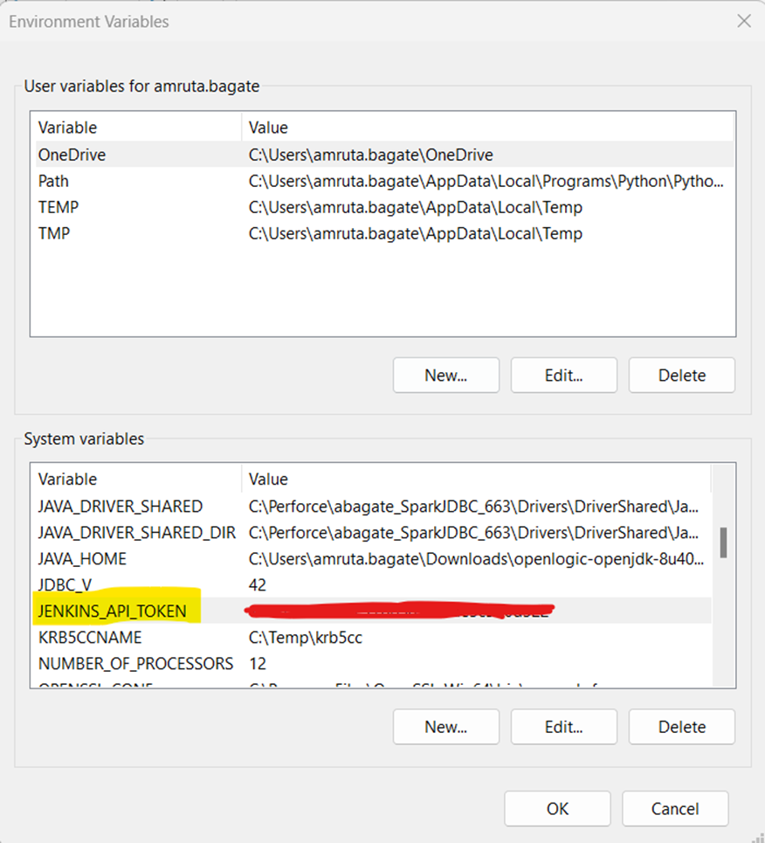

## Project Setup

1. Download the project.
2. Go to the folder containing the project and run the following command in the command prompt:

python TestJenkins_GUI.py

Alternatively, you can run it in any suitable IDE such as PyCharm, Visual Studio Code, or IDLE.

1. Give inputs such as Jenkins username and the URLs of the functional tests you want to compare. 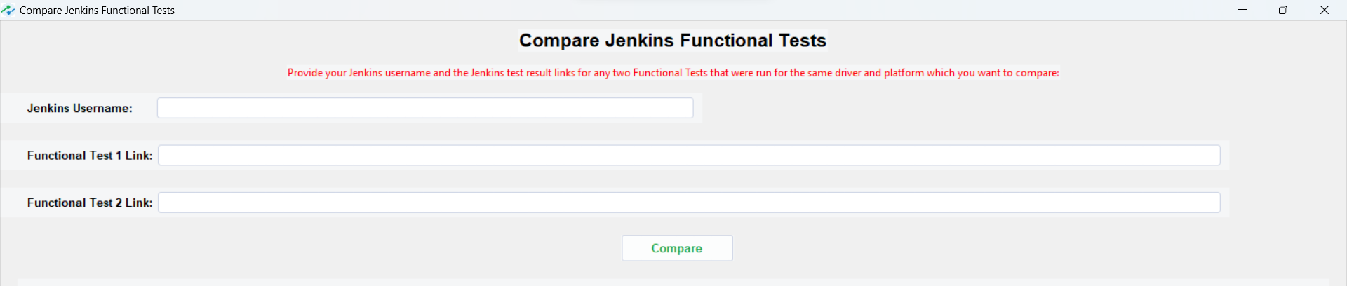
2. Check output on GUI or check output.txt file created in the same folder for further analysis. 