**The 20 Hour of Learning anything**

* Study shows it will take minimum of **10,000 hrs of practice** (which is about 5 yr of time) to become expert in any field, any subject, expert in any professional skill like professional athletic, chess board champion, or we can say to get to the Top of any field you need to practise for at least 10,000 hr.
* Many Research found that skill acquisition has a below graph

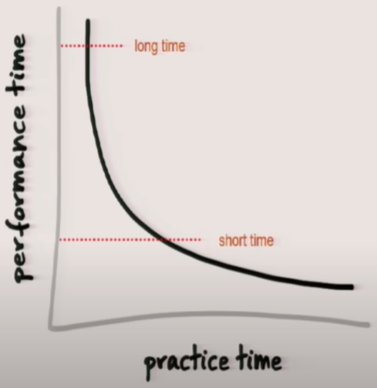

Your performance is directly proportional to your early practice

* Study found that with little bit of practice people will become expert in field

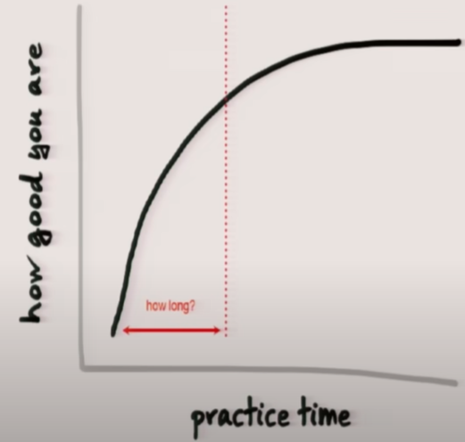

The graph above illustrates that when we begin learning something, initial progress comes quickly with even a small amount of practice. Early improvements are rapid, but as we approach a certain threshold, achieving expert-level mastery requires significantly more time and effort.

* So, the question is what is that ‘Early level of time, how long it is?’
* Answer is first **20hr** is enough to learn anything, 20 hr is the shortest time for learning something, because the early level of improvement is very fast.
* **“20 hr is doable which is 45 min. per day for next one month”**
* You can go from knowing nothing about any ability to mastering it in 20 hours of careful, focused practice, and you'll be amazed(astounded) at how good you are.

There are 4 Simple Steps to Rapid Skill acquisition

1. **Deconstruct the Skill -** This means deciding exactly what you want to be able to do once you finish practicing.
   1. Break the skill into smaller parts. Most skills are made up of different smaller skills that need to be learned together.
   2. The more we break the skill down, the easier it will be to figure out which parts will help us reach our goal.
   3. Finally, by practicing these smaller skills in 20 hours, we can improve quickly and effectively in the least amount of time.
2. **Learn enough to Self-Correct** – This means gathering 3 to 5 resources on what you're trying to learn, such as books, YouTube videos, or online courses.

* The key point is to avoid using these resources as a way to **procrastinate** on practicing. For example, collecting 20 books on the topic and deciding to start practicing only after finishing them all is pure procrastination.
* You only need to learn enough so you can begin practicing and make corrections or adjustments on your own as you go.

1. **Remove Practice Barrier -** This means eliminating distractions like TV, the internet, and social media. It also requires some willpower to avoid these distractions while practicing.
2. **Practice at least 20 hr –** This means committing to 45 minutes of practice each day for the next month.
   1. Most skills have a frustration barrier, where you may feel like you're not improving or that you know nothing. To overcome this, promise yourself to practice for at least 20 hours, no matter what.
   2. You need to push through that initial frustration and continue practicing long enough to see real progress and results.

**Conclusion – The biggest barrier to learning something new isn't intellectual or about the learning process—it's emotional. We fear looking stupid, feeling like we know nothing, or experiencing failure. However, by committing to 20 hours of focused practice, you can overcome these fears and learn whatever you set your mind to.**