Week 1 :
# Personal Introduction Program
Project Overview
This is a beginner Python project that takes user input (name, age, hobby) and displays a friendly welcome message.

Objectives
- Learn how to use input()
- Store values in variables
- Display output using print()

Setup Instructions
1. Install Python
2. Download this repository
3. Run:
python personal_intro.py

Project Structure
- personal_intro.py → main program
- README.md → project documentation
- requirements.txt → dependencies

What I Learned
- Taking input from users
- Using variables
- Formatting output
- Basic Python syntax

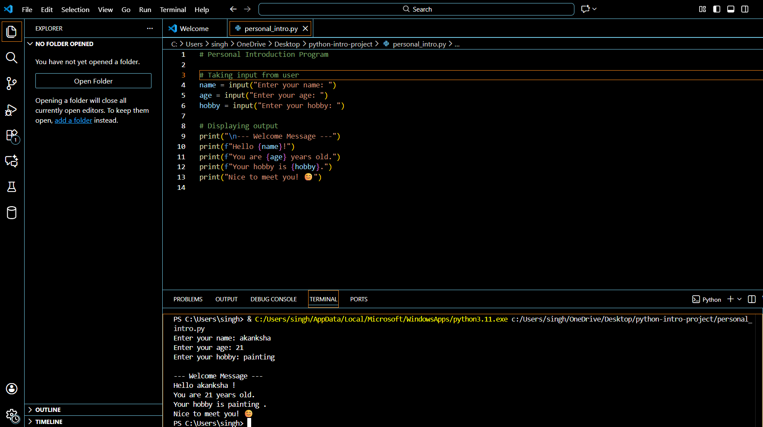
Requirements Met
- ✔ Used input()
- ✔ Used variables
- ✔ Used print()

Week 2:

test_cases.txt
95 → A
85 → B
72 → C
65 → D
40 → F
120 → Invalid
-5 → Invalid
abc → Invalid
Screenshort:
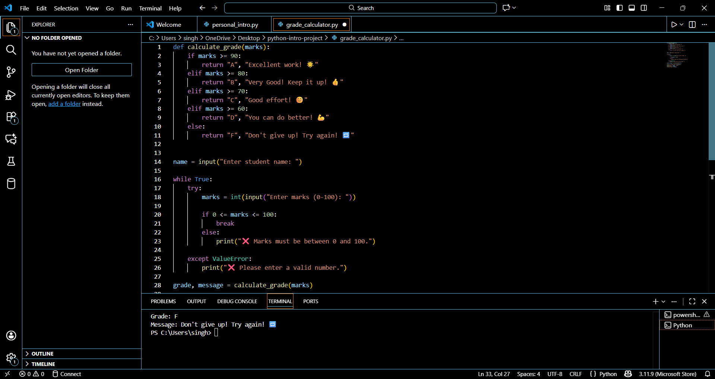
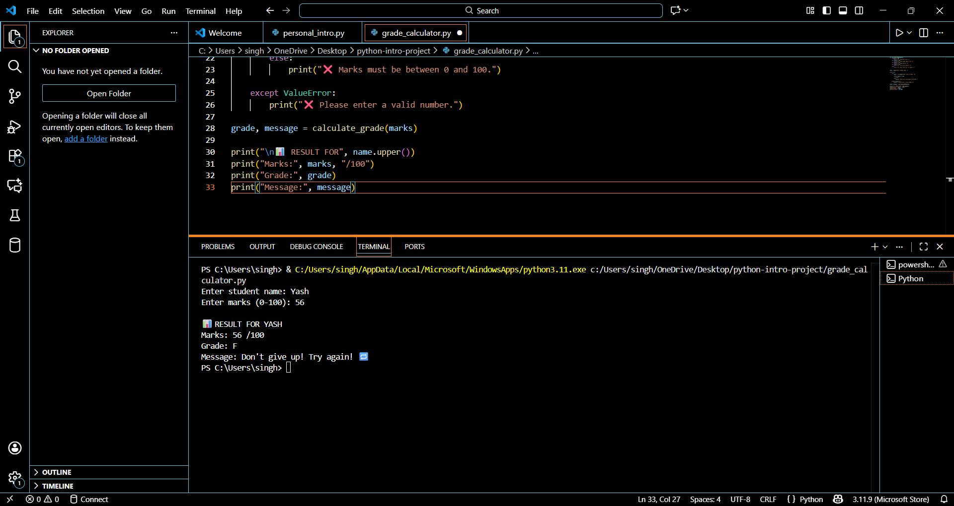

🎓 Student Grade Calculator

📌 Project Overview
The Student Grade Calculator is a simple Python program that takes a student's marks as input and assigns a grade (A–F) along with an encouraging message.
This project demonstrates fundamental programming concepts such as:
Decision making (if-elif-else)
Loops (while)
Functions
Input validation
Error handling

🎯 Objectives
Build a program that calculates grades based on marks
Ensure valid user input (0–100 only)

Provide encouraging feedback for each grade

Practice structured and reusable coding using functions
Handle invalid inputs using loops and exceptions

⚙️ Setup & Installation

🔹 Requirements
Python 3 installed

🔹 How to Run
Download or clone the project:
git clone https://github.com/your-username/grade-calculator.git
Navigate to the folder
Run the program:
python grade_calculator.py

🧠 Grading Logic Explained
The grading system is based on the following conditions:
Marks Range | Grade
90–100 | A
80–89 | B
70–79 | C
60–69 | D
0–59 | F

Logic Implementation:
If marks ≥ 90 → Grade A
Else if marks ≥ 80 → Grade B
Else if marks ≥ 70 → Grade C
Else if marks ≥ 60 → Grade D
Else → Grade F

🧩 Functions Used

🔹 calculate_grade(marks)
This function:
Takes marks as input
Determines grade using if-elif-else
Returns:
Grade (A–F)
Encouraging message
Example:
grade, message = calculate_grade(85)

🏗️ Code Structure Explanation
grade_calculator.py
│
├── Function Definition
│ └── calculate_grade(marks)
│
├── Input Section
│ ├── Get student name
│ └── Get marks using while loop
│
├── Validation
│ ├── Ensure marks are between 0–100
│ └── Handle invalid input using try-except
│
└── Output Section
├── Display grade
└── Display message

🔁 Input Validation & Error Handling
A while loop ensures the program keeps asking until valid input is given
try-except handles non-numeric input
Example:
try:
marks = int(input("Enter marks: "))
except ValueError:
print("Invalid input")

🖥️ Sample Output
Enter student name: Priya
Enter marks (0-100): 85

📊 RESULT FOR PRIYA:
Marks: 85/100
Grade: B
Message: Very Good! Keep it up! 👍
📸

🚀 Conclusion
This project successfully demonstrates basic Python programming concepts by combining:
Decision making
Looping
Functions
Error handling
It is a great beginner-level project for understanding real-world problem solving using Python.

💡 Future Improvements
Add multiple students support
Save results to a file
Create GUI version using Tkinter
Add percentage and subject-wise grading

