# Personal Introduction Program
Project Overview
This is a beginner Python project that takes user input (name, age, hobby) and displays a friendly welcome message.

Objectives
- Learn how to use input()
- Store values in variables
- Display output using print()

Setup Instructions
1. Install Python
2. Download this repository
3. Run:
python personal_intro.py

Project Structure
- personal_intro.py → main program
- README.md → project documentation
- requirements.txt → dependencies

What I Learned
- Taking input from users
- Using variables
- Formatting output
- Basic Python syntax

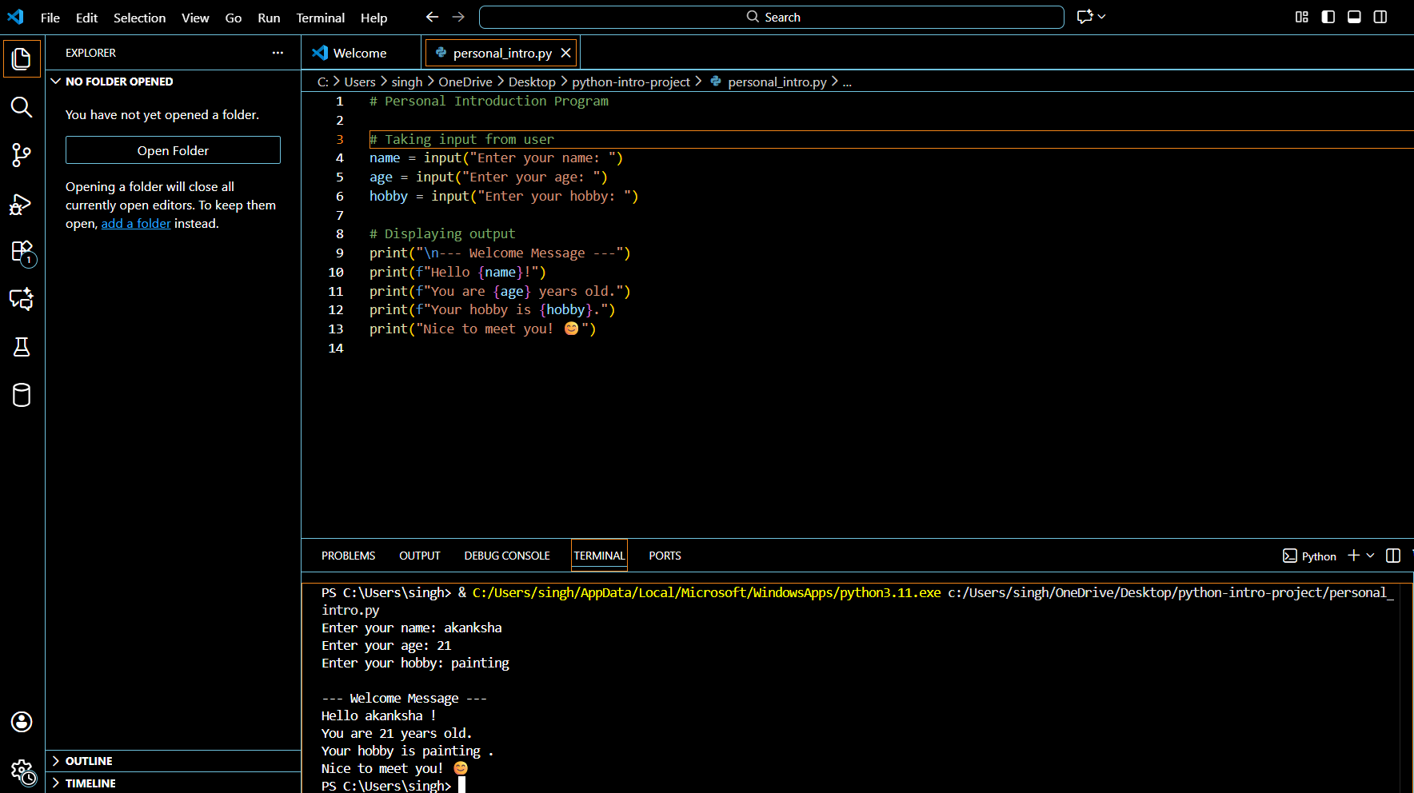
Requirements Met
- ✔ Used input()
- ✔ Used variables
- ✔ Used print()

