Example 1: Weather Forecast of Pune City for Last 2 Weeks (14 Days)
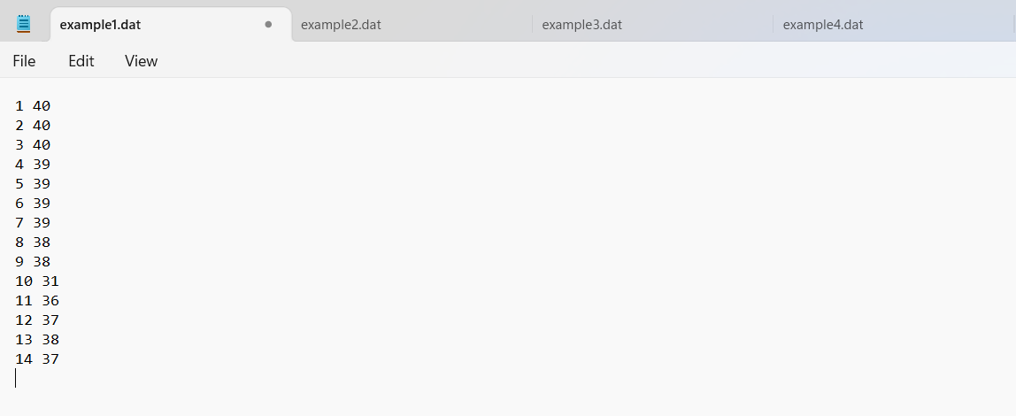
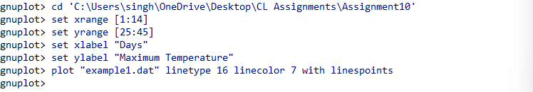
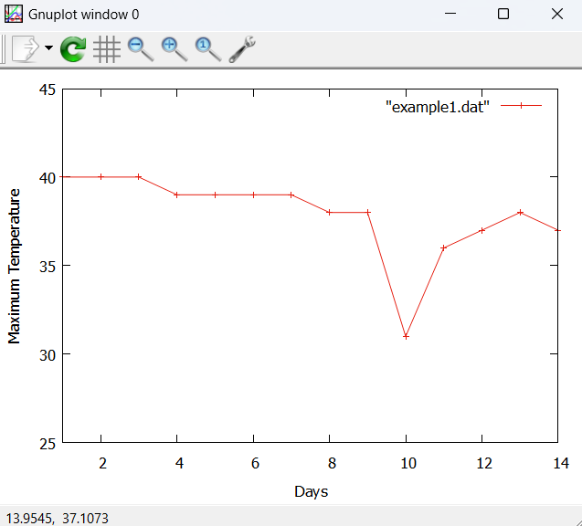

Example 2: Dollar to Rupee Conversion Data for the Last Month
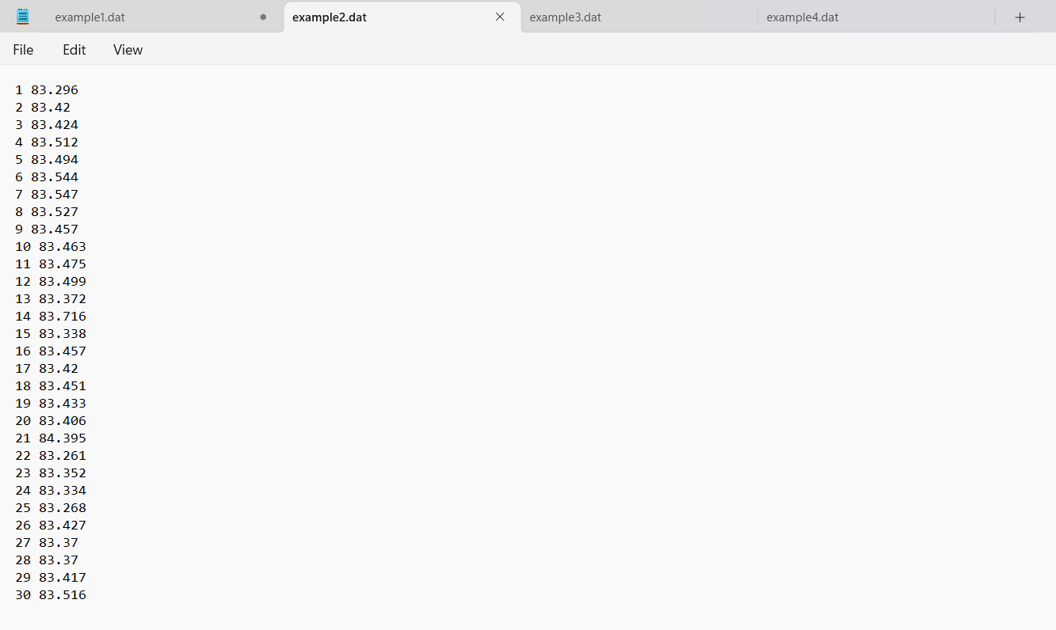
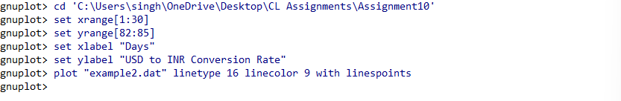

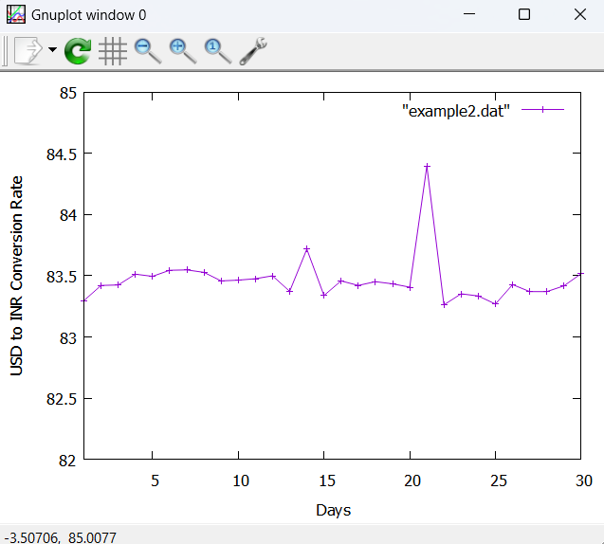
Example 3: Stock Prediction Data for Next Two Weeks (14 Days)

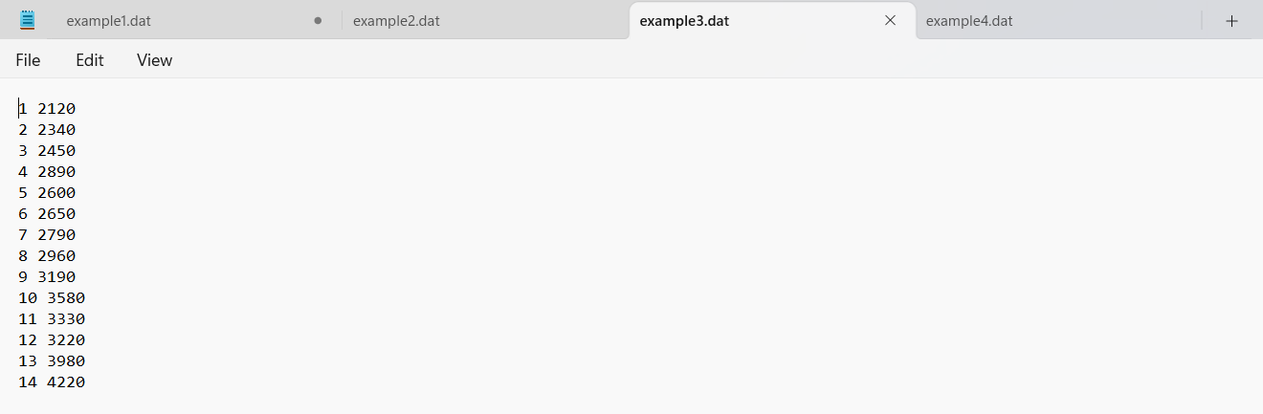
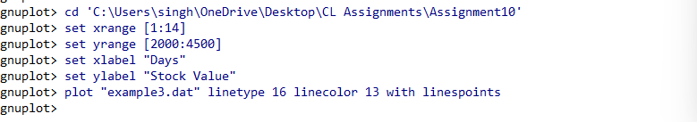
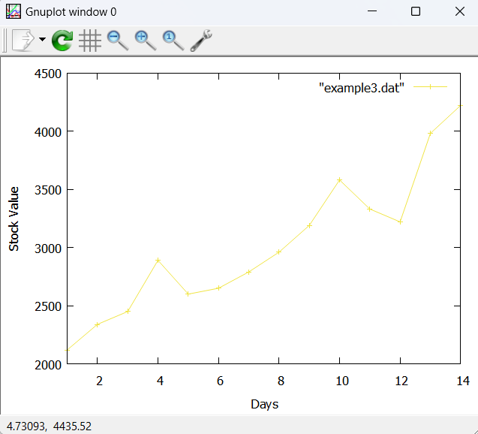

Example 4: Sales Forecast of Water Heater for 12 Months (1 Year)

