Description

Intended User

Features

User Interface Mocks

Screen 1

Screen 2

Key Considerations

How will your app handle data persistence?

Describe any corner cases in the UX.

Describe any libraries you’ll be using and share your reasoning for including them.

Describe how you will implement Google Play Services.

Next Steps: Required Tasks

Task 1: Project Setup

Task 2: Implement UI for Each Activity and Fragment

Task 3: Your Next Task

Task 4: Your Next Task

Task 5: Your Next Task

**GitHub Username**: singhalankit

DietManager

# Description

Our app with provide a feature for diet conscious people where in they can find the nutrient values in the food product they are consuming or going to consume. This will help them to control their diet and at the same time they can have a balanced diet by knowing their nutrient contents.

# Intended User

This is an app for diet conscious people, they have the raw food material with them but not sure which food item to prepare that can take care of their nutrition value.

# Features

* API call
* Saves information
* Display detail result returned from API call.

# User Interface Mocks

These can be created by hand (take a photo of your drawings and insert them in this flow), or using a program like Photoshop or Balsamiq.

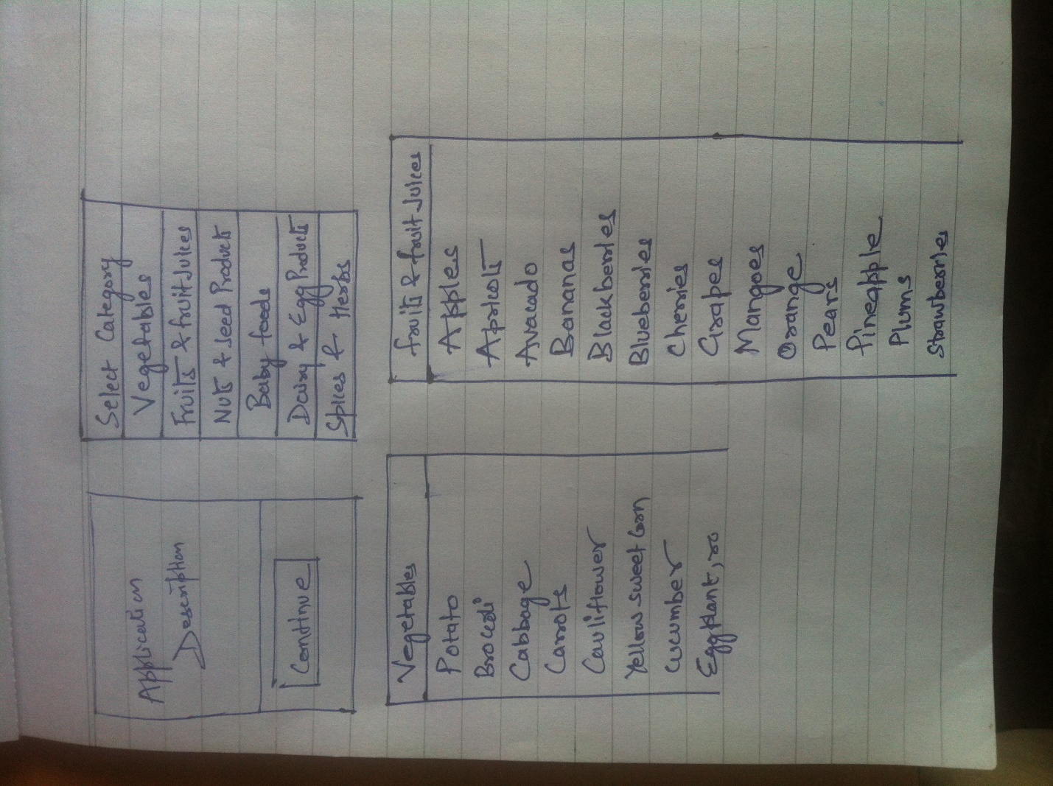

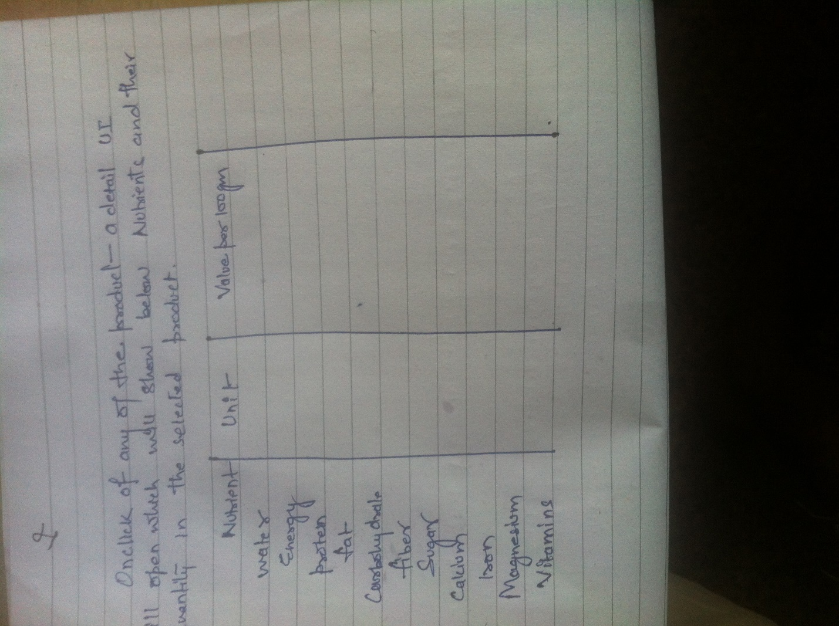

Add as many screens as you need to portray your app’s UI flow.

Screen1 – it will show the application description and a continue button for user to click on once they are ready to use.

Screen2 – this screen will show users the different categories, they can select any one of them and then they will be directed to

Screen3 – this screen will show them the food items under that category, user can select any of them and they will be directed to final screen

Screen4 – this screen will show user different nutrients value in the food item they selected on screen3.

# Key Considerations

### How will your app handle data persistence?

I will be creating a new content provider to store the data fetched from API call and display it on the UI.

### Describe any corner cases in the UX.

Every screen will have an option of returning back to the screen2, which will show users different categories.

### Describe any libraries you’ll be using and share your reasoning for including them.

### Describe how you will implement Google Play Services.

# Next Steps: Required Tasks

This is the section where you can take the main features of your app (declared above) and decompose them into tangible technical tasks that you can complete incrementally until you have a finished app.

## Task 1: Project Setup

I am not planning to use any external library as of now, so not much of set up is required.

## Task 2: Implement UI for Each Activity and Fragment

In total there will be 4 screen in the app so 4 layouts will be needed

## Task 3: Your Next Task

Build a content provider to store and retrieve data fetched from API call.

## Task 4: Your Next Task

## Task 5: Your Next Task

Add as many tasks as you need to complete your app.

**Submission Instructions**

1. After you’ve completed all the sections, download this document as a PDF [ File → Download as PDF ]
2. Create a new GitHub repo for the capstone. Name it “**Capstone Project**”
3. Add this document to your repo. Make sure it’s named “**Capstone_Stage1.pdf**”