LPG GAS DETECTOR

OBJECTIVE:

* Detect Gas Leakage (like LPG leak, Butane leak, Methane leak) or any such petroleum based gaseous substance that can be detected using MQ5 Sensor.
* Setup an SMS based Alert Mechanism and send 3 SMS (3 alert messages) to 2 specified mobile numbers (input inside the arduino program)
* A control command passed to the GSM module leads to the triggering of stepping motors (through internal mechanism) which close the valves.

LOOP-

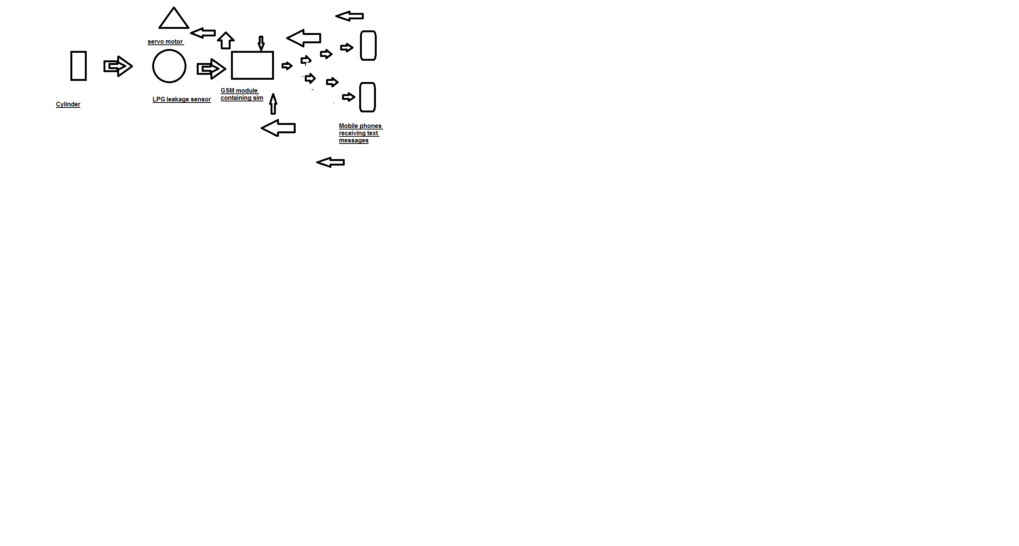

CIRCUIT DIAGRAM- GAS LEAKAGE DETECTOR USING ARDUINO WITH GSM MODULE:

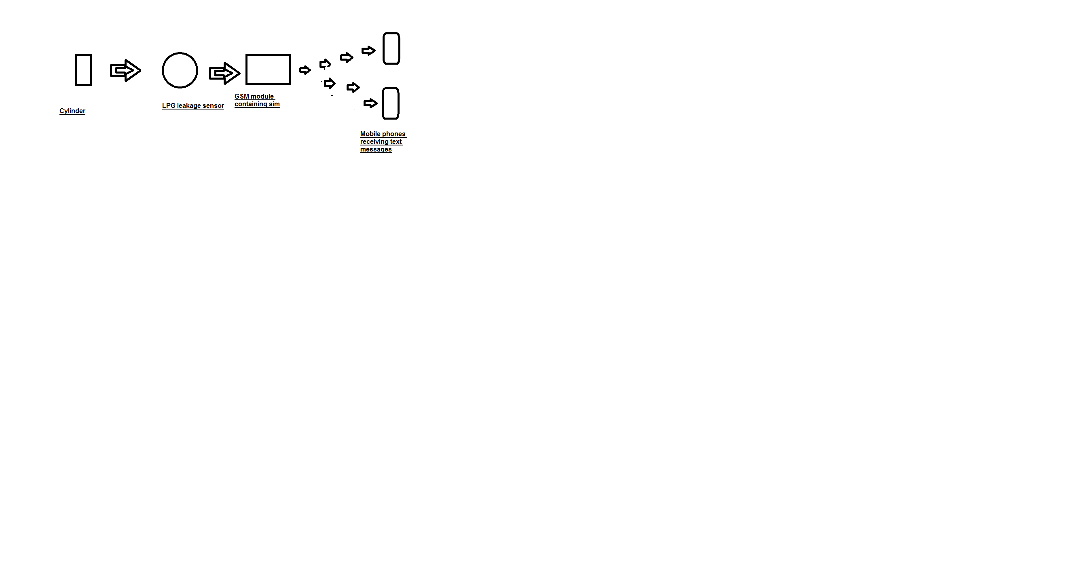

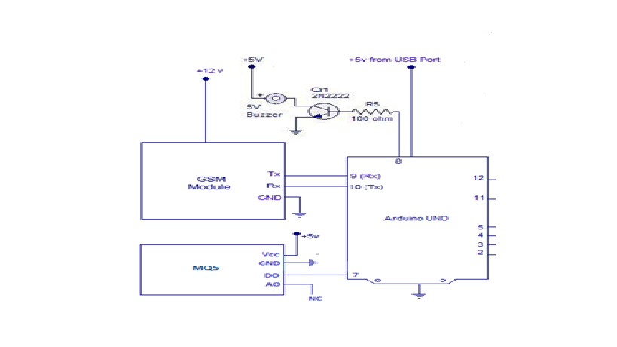

INTERFACING MQ5 SENSOR TO ARDUINO:

MQ5 module has two output possibilities – an analog out (A0) and a digital out (D0). The ***analog out*** can be used to detect Gas leakage and to measure volume of Gas leakage (by doing proper calculation of the sensor output inside program) in specific units (say ppm). The***digital out***can be used to detect Gas leakage and hence trigger an alert system (say a sound alarm or an sms activation etc). The ***digital out***gives only two possible outputs – High and Low (hence its more suited for detection of gas leak than to measure volume of gas presence).

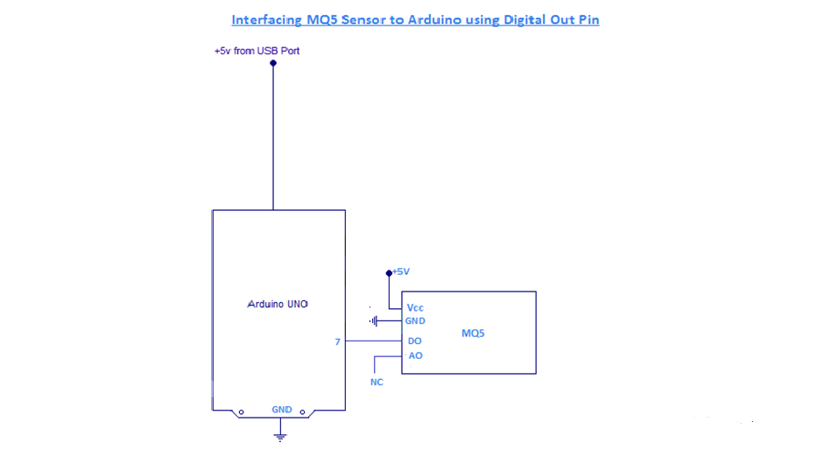

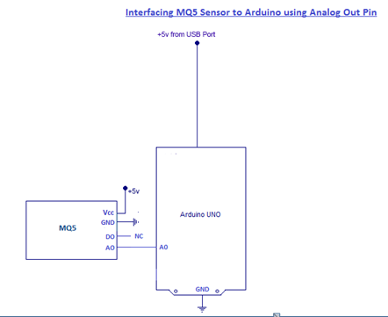

INTERFACING GSM MODULE TO ARDUINO :

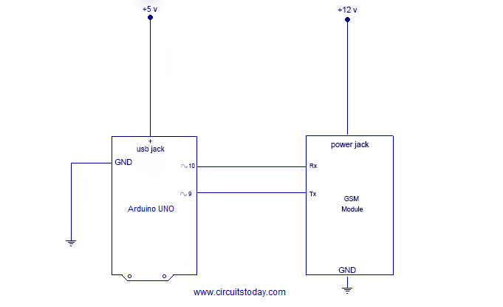

INTERFACING STEPPER MOTOR DRIVER TO ARDUINO-

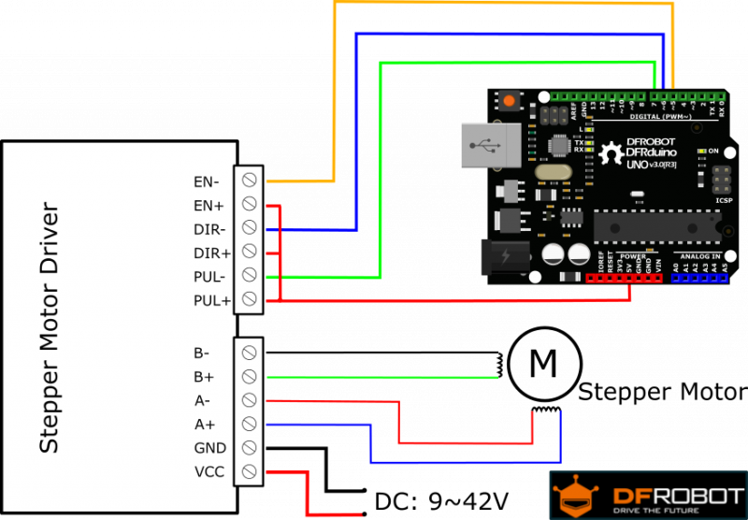

WORKING:

* LEAKAGE DETECTION :

There are three possible locations for leakage .

1. At the cylinder valve .
2. At the stove valve.
3. Intermediate leakages in gas pipes.

Among these the leakages at the cylinder valve and stove valve can be counted.

A MQ5 gas detector is installed at the above mentioned locations which senses any leakage that may occur. MQ5 sends signals to the Arduino when there is a leakage.

* GENERATION OF ALERT MESSAGE AND BUZZER :

On receiving the input signal from MQ5 sensor, Arduino sents signal to the GSM module which in turn sends 3 ALERT SMSs to two specified mobile numbers (preloaded in Arduino). Simultaneously another signal is sent to a BUZZER attached to the Arduino .

* CONTROL SIGNAL GENERATION :

On receiving the ALERT SMS , the receiver may send a control command to the GSM module.The GSM module conveys this command to Arduino which triggers the stepping motors connected to it. The stepping motors in turn close the valves at the two potential locations of leakage .

* STEPPING MOTORS MECHANISM :

The shaft of the stepper motor is connected to the cylinder’s regulator knob, that hets closed on receiving signal from gsm module.