



**Graduate Rotational Internship Program**

**TOPIC - CLOUD COMPUTING**

**SUBMITTED BY - ANAND PRATAP SINGH**

**B.Tech(3rd Year,CSE)**

**E-Mail - taps453@gmail.com**

***Cloud Computing***

**Cloud computing is the on-demand availability of [computer](https://en.wikipedia.org/wiki/Computer" \o "Computer) [system resources](https://en.wikipedia.org/wiki/System_resource" \o "System resource), especially data storage ([cloud storage](https://en.wikipedia.org/wiki/Cloud_storage" \o "Cloud storage)) and [computing power](https://en.wikipedia.org/wiki/Computing_power" \o "Computing power), without direct active management by the user. The term is generally used to describe [data centers](https://en.wikipedia.org/wiki/Data_center" \o "Data center) available to many users over the [Internet](https://en.wikipedia.org/wiki/Internet" \o "Internet). cloud computing allows [enterprises](https://en.wikipedia.org/wiki/Company" \o "Company) to get their applications up and running faster, with improved manageability and less maintenance.**

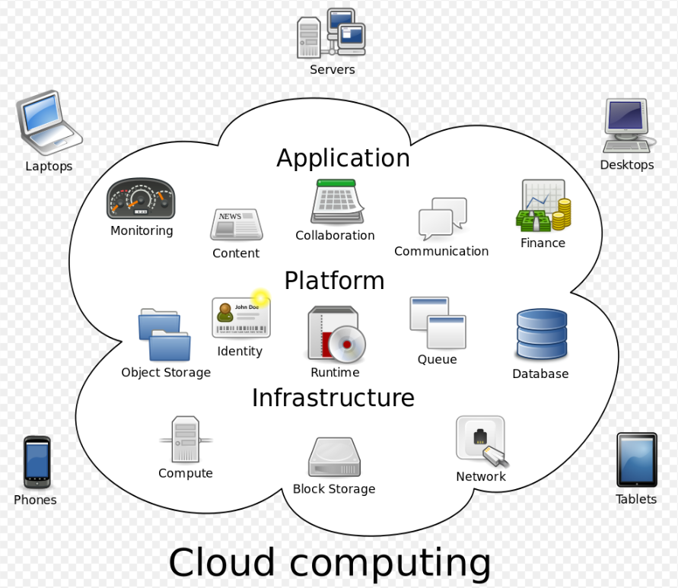

**Cloud providers typically use a "pay-as-you-go" model, which can lead to unexpected [operating expenses](https://en.wikipedia.org/wiki/Operating_expense" \o "Operating expense) if [administrators](https://en.wikipedia.org/wiki/Network_administrator" \o "Network administrator) are not familiarized with cloud-pricing models. The availability of high-capacity networks, low-cost computers and storage devices as well as the widespread adoption of [hardware virtualization](https://en.wikipedia.org/wiki/Hardware_virtualization" \o "Hardware virtualization), [service-oriented architecture and](https://en.wikipedia.org/wiki/Service-oriented_architecture" \o "Service-oriented architecture)[autonomic](https://en.wikipedia.org/wiki/Autonomic_computing" \o "Autonomic computing)**

**[architecture](https://en.wikipedia.org/wiki/Service-oriented_architecture" \o "Service-oriented architecture) and [utility computing](https://en.wikipedia.org/wiki/Utility_computing" \o "Utility computing) has led to growth in cloud computing.**

****Cloud Computing Service Models :****

1. **Infrastructure as a Service (IaaS)**  
   **2. Platform as a Service (PaaS)**  
   **3. Software as a Service (SaaS)**

**Infrastructure as a Service (IaaS):**

The IaaS layer offers storage and infrastructure resources that is needed to deliver the Cloud services. It only comprises of the infrastructure or physical resource. Top IaaS Cloud Computing Companies: Amazon (EC2), Rackspace, GoGrid, Microsoft, Terremark and Google.

**Platform as a Service (PaaS):**

PaaS provides the combination of both, infrastructure and application. Hence, organisations using PaaS don’t have to worry for infrastructure nor for services. Top PaaS Cloud Computing Companies: Salesforce.com, Google, Concur Technologies, Ariba, Unisys and Cisco.

**Software as a Service (SaaS):**

In the SaaS layer, the Cloud service provider hosts the software upon their servers. It can be defined as a in model in which applications and softwares are hosted upon the server and made available to customers over a network. Top SaaS Cloud Computing Companies: Amazon Web Services, AppScale, CA Technologies, Engine Yard, Salesforce and Windows Azure.

****Cloud Computing Deployment Models :****

**1. Private Cloud  
2. Public Cloud  
3. Hybrid Cloud  
4. Community Cloud**

****Private Cloud:****

The cloud infrastructure is operated solely for an organisation. In simple words we can say that such cloud models are dedicated to a third party who wish to use. It may be managed by the Cloud Computing provider or any other third party.

****Public Cloud:****

 The cloud infrastructure is made available to the general public or a large industry group and is owned by the Cloud providers.

****Hybrid Cloud:****

 It’s a combination of two or more clouds (private, community or public).

****Community Cloud:****

This cloud infrastructure is shared by several organisation.

**Cloud Computing Service Provider Companies :**

1 - Amazon Web Services

2 - Microsoft Azure

3 - Google Cloud Platform

4 - Oracle Cloud

5 - IBM Cloud

6 - VMware

7 - DigtialOcean

8 - Alibaba Cloud

9 - OpenNebula

10 - Dell Cloud

11 - Kamatera

12 - LiquidWeb

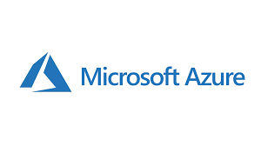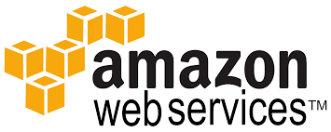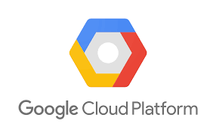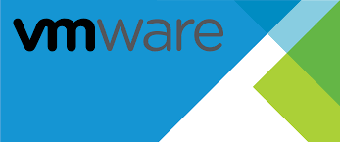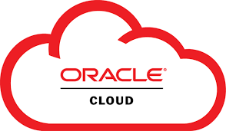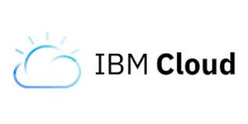

**AWS (**Amazon Web Services ) : -****

* The AWS service is provided by the Amazon that uses distributed IT infrastructure to provide different IT resources available on demand. It provides different services such as infrastructure as a service (IaaS), platform as a service (PaaS) and packaged software as a service (SaaS).
* Amazon launched AWS, a cloud computing platform to allow the different organizations to take advantage of reliable IT infrastructure.

****Services Provided By AWS : -****

* Compute
* Storage
* Database
* Migration
* Network and Content Delivery
* Management Tools
* Security & Identity Compliance
* Messaging

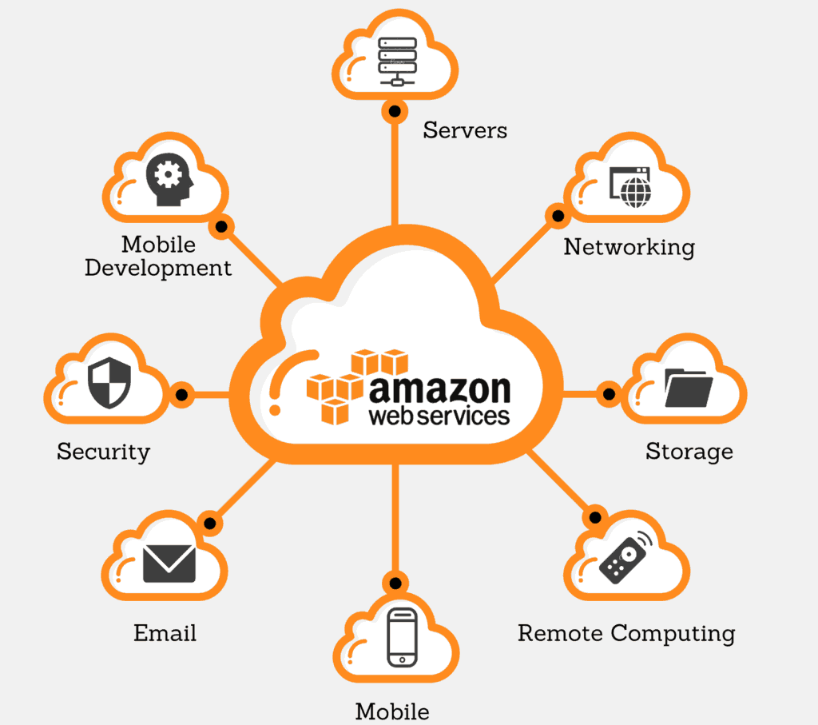

****Each Domain contains Various Services --****

**Compute** domain includes services related to compute workloads, it includes the following services:

* EC2 (Elastic Compute Cloud)
* Lambda
* Elastic Beanstalk
* Amazon LightSail

**Storage**domain includes services related data storage, it includes the following services:

* S3 (Simple Storage Service)
* Elastic Block Store
* Amazon Glacier
* AWS Snowball

**Database**domain is used for database related workloads, it includes the following services:

* Amazon Aurora
* Amazon RDS
* Amazon DynamoDB
* Amazon RedShift

**Networking and Content Delivery** domain is used for isolating your network infrastructure, and content delivery is used for faster delivery of content. It includes the following services:

* Amazon Route 53
* AWS CloudFront

# **EC2 (Amazon Elastic Compute Cloud) :**

* Amazon EC2 is a web service that provides resizable compute capacity in the cloud.
* Amazon EC2 reduces the time required to obtain and boot new user instances to minutes rather than in older days, if you need a server then you had to put a purchase order, and cabling is done to get a new server which is a very time-consuming process. Now, Amazon has provided an EC2 which is a virtual machine in the cloud that completely changes the industry.
* You can scale the compute capacity up and down as per the computing requirement changes.
* Amazon EC2 changes the economics of computing by allowing you to pay only for the resources that you actually use. Rather than you previously buy physical servers, you would look for a server that has more CPU capacity, RAM capacity and you buy a server over 5 year term, so you have to plan for 5 years in advance. People spend a lot of capital in such investments. EC2 allows you to pay for the capacity that you actually use.

## **Advantages of AWS :**

### 1) Flexibility

### 2) Cost-effectiveness

### 3) Scalability/Elasticity

### 4) Security

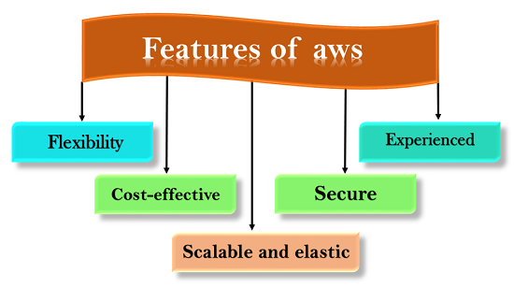

## **Microsoft Azure**

Azure is a cloud computing platform which was launched by Microsoft in February 2010. It is an open and flexible cloud platform which helps in development, data storage, service hosting, and service management. The Azure tool hosts web applications over the internet with the help of Microsoft data centers.

It enables the fast development of solutions and provides the resources to complete tasks that may not be achievable in an on-premises environment. Azure Services like compute, storage, network, and application services allow us to put our effort into building great solutions without worrying about the assembly of physical infrastructure.

## **How Azure works :**

It is essential to understand the internal workings of Azure so that we can design our applications on Azure effectively with high availability, data residency, resilience, etc :

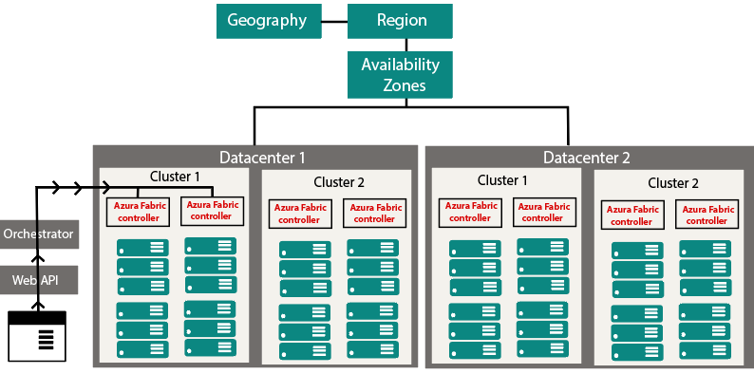

## Azure Services:

**1--> Compute services:**It includes the Microsoft Azure Cloud Services, Azure Virtual Machines, Azure Website, and Azure Mobile Services, which processes the data on the cloud with the help of powerful processors.

**2--> Data services :** This service is used to store data over the cloud that can be scaled according to the requirements. It includes Microsoft Azure Storage (Blob, Queue Table, and Azure File services), Azure SQL Database, and the Redis Cache.

**3--> Application services:**  It includes services, which help us to build and operate our application, like the Azure Active Directory, Service Bus for connecting distributed systems, HDInsight for processing big data, the Azure Scheduler, and the Azure Media Services.

**4--> Network services :**It helps you to connect with the cloud and on-premises infrastructure, which includes Virtual Networks, Azure Content Delivery Network, and the Azure Traffic Manager.

## **Types of Azure Clouds :**

There are mainly three types of clouds in Microsoft Azure are:

1. PAAS
2. SAAS
3. IASS

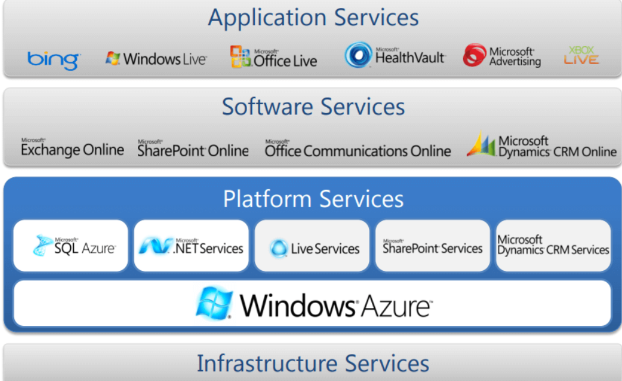

### **Azure as IaaS :**

IaaS(Infrastructure as a Service) is the foundational cloud platform layer. This Azure service is used by IT administrators for processing, storage, networks or any other fundamental computer operations. It allows users to run arbitrary software.

### **Azure as PaaS :**

PaaS is a computing platform which includes an operating system, programming language execution environment, database or web services. This Azure service is used by developers and application providers.

### **Azure As SaaS :**

SaaS (Software as a Service) is software which is centrally hosted and managed. It is a single version of the application is used for all customers. You can scale out to multiple instances. This helps you to ensure the best performance in all locations. MS Exchange, Office, Dynamics are offered as a SaaS

## **Azure Domains (Components) :**

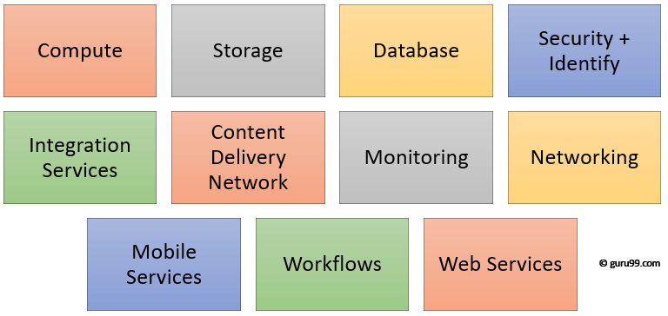

## **Applications of Azure**

Microsoft Azure is used in a broad spectrum of applications like:

* Infrastructure Services
* Mobile Apps
* Web Applications
* Cloud Services
* Storage, Backup, and Recovery
* Data Management
* Media Services

**Google Cloud**

## ***What Is Google Cloud Platform?***

Google Cloud is a suite of Cloud Computing services offered by Google. The platform provides various services like compute, storage, networking, [Big Data](https://intellipaat.com/blog/tutorial/big-data-and-hadoop-tutorial/" \t "https://intellipaat.com/blog/what-is-google-cloud/_blank), and many more that run on the same infrastructure that Google uses internally for its end users like Google Search and YouTube.

Google server hasn’t gone down in years. So, if you are planning to run your application on the Google Cloud infrastructure, then you can be assured of your applications being safe and secure.

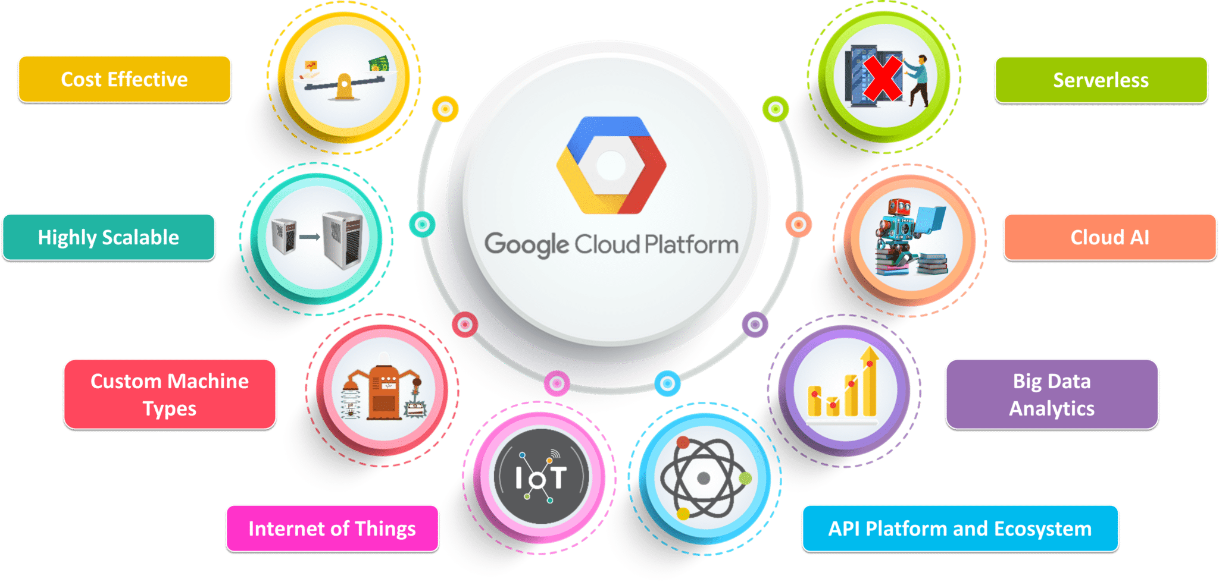

## ****What are Google Cloud Platform (GCP) Services?****

* ****Compute****
* ****Networking****
* ****Storage and Databases****
* ****Big Data****
* ****Machine Learning****
* ****Identity & Security****
* ****Management and Developer Tools****

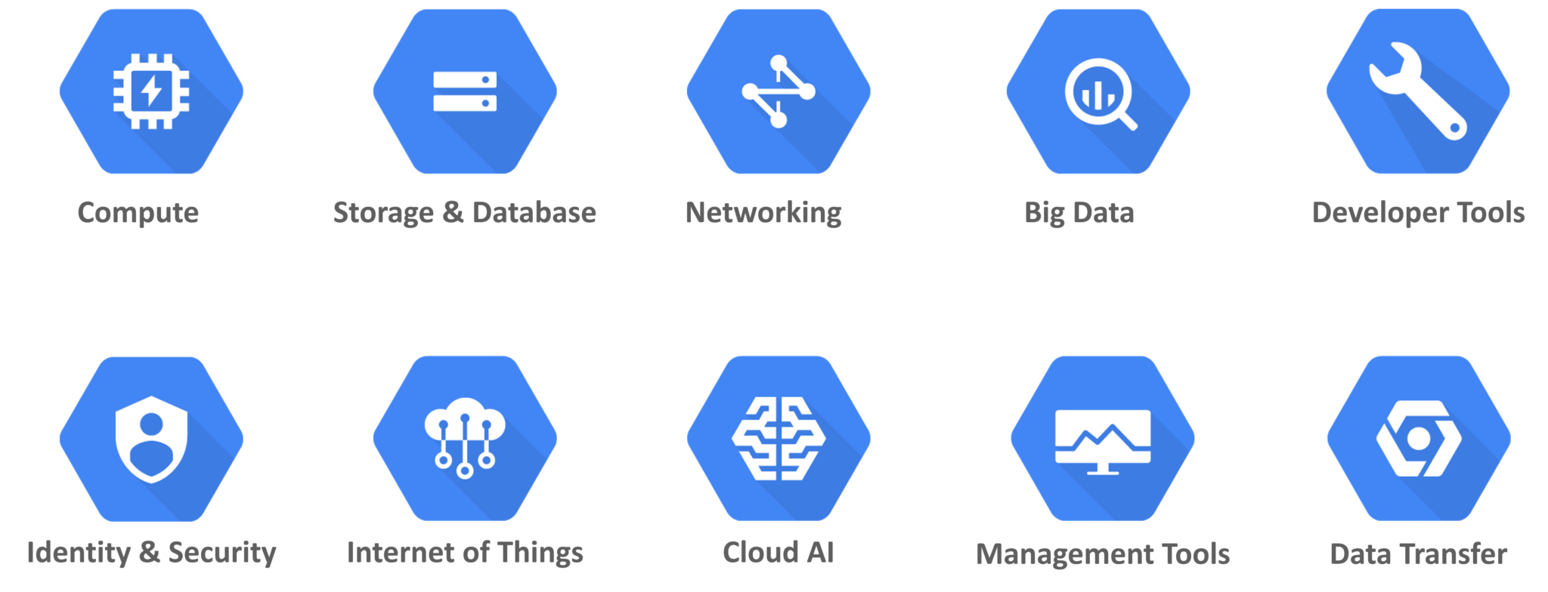

### ****Compute Services :****

* Google Compute Engine
* Google App Engine
* Google Kubernetes Engine
* Google Cloud Container Registry
* Cloud Functions

****Networking:****

* Google Virtual Private Cloud (VPC)
* Google Cloud Load Balancing
* Content Delivery Network
* Google Cloud Interconnect
* Google Cloud DNS

### ****Storage Services :****

* Google Cloud Storage
* Cloud SQL
* Cloud Bigtable
* Google Cloud Datastore
* Persistent Disk

****Big Data:****

* Google BigQuery
* Google Cloud Dataproc
* Google Cloud Datalab
* Google Cloud Pub/Sub

****Cloud AI:****

* Cloud Machine Learning
* Vision API
* Speech API
* Natural Language API
* Translation API
* Jobs API

**Identity & Security:**

* Cloud Resource Manager
* Cloud IAM
* Cloud Security Scanner
* Cloud Platform Security

**Management Tools:**

* Stackdriver
* Monitoring
* Logging
* Error Reporting
* Trace
* Cloud Console

**Developer Tools:**

* + Cloud SDK
  + Deployment Manager
  + Cloud Source Repositories
  + Cloud Test Lab

## **Why Google Cloud?**

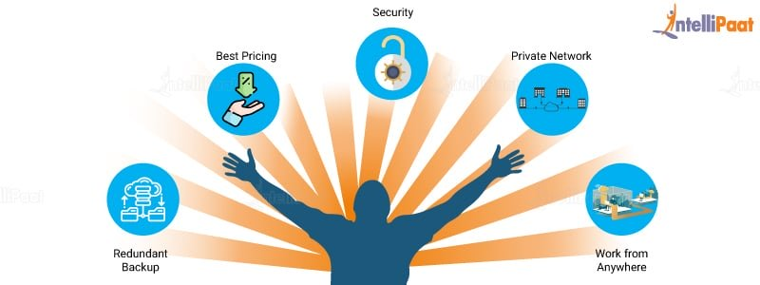

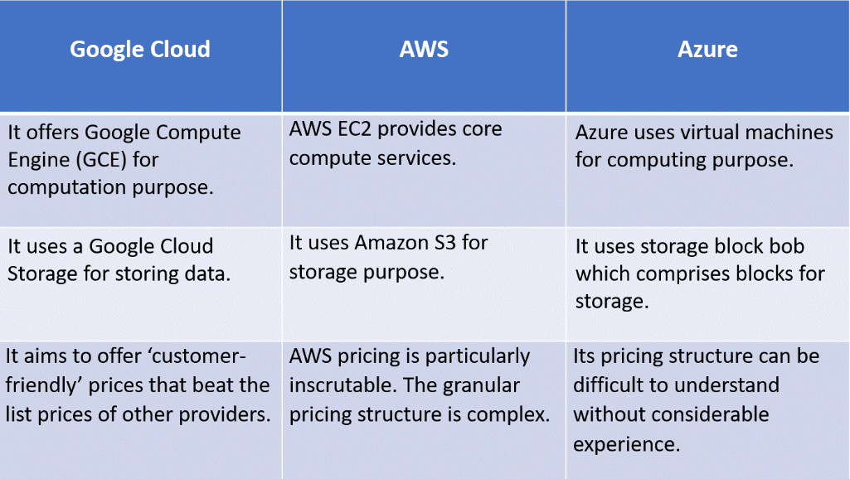

**THANK YOU..🙂🙂**