Lab 1: INTRODUCTION

Basic commands
Following are some basic Linux commands. To know more about them use: man <command> . Start with man man.
- Make a new directory: mkdir <dirname>
- Remove directory if it is empty else throw an error: rmdir <dirname>
- Copy file: cp <source> <destination>
- Create a new file: touch <filename>
- Delete a single file: rm <filename>
- Delete a whole folder: rm -r <foldername>
- Change working directory: cd <path>
- Move to parent directory: cd .. and Move to previous directory: cd -
- List contents of a folder: ls
- Print current directory: pwd

Some More (utility) Commands. Study about them
- top : top provides a continuous collective view of the system and operating system state.
- ps : The ps command is used to view the processes running on a system. It provides a snapshot of the processes along with detailed process information like process-id, cpu usage, memory usage etc.
- lsof : lsof is used to list open files. It lists details of the file itself and details of users, processes which are using the files..
- iostat: is a command useful for monitoring and reporting CPU and statistics related to devices. iostat creates reports that can be used to change system configuration for better balance the input/output between physical disks. For example, the command reports total activity and rate of activities (read/write) to each disk/partition, can be configured to monitor continuously (after every specified interval).
- qstrace: strace is a diagnostic and debugging tool used to monitor the interactions between processes and the Linux kernel. The tool traces the set of functions (system calls / calls of the Application Binary Interface) and signals (events) used by a program to communicate with the operating system
Useful References
- Unix tutorial for the beginners ( Go through Tutorial 1 and Tutorial 2. Others are optional)
- Basic linux commands (optional)

Exercises

- In this question, we will understand the hardware configuration of your working machine using the /proc filesystem. Understand the /proc filesystem in Linux. The /proc file system is a mechanism provided by Linux for the kernel to report information about the system and processes to users. The /proc file system is nicely documented in the proc man page. You can access this document by running the command man proc on a Linux system. Understand the system-wide proc files such as meminfo and cpuinfo, and per-process files such as status and stat. System related proc files are available in the directory /proc/, and process related proc files are available at /proc/<process-id>/
Collect the following basic information about your machine using the /proc file system and answer the following questions:
- How many CPU and cores does your machine have?: 8 cpu, 4 cores each
- What is the frequency of each processor? Near to1397.120 Mhz
- How much memory does your machine have? 14254872 kB
- How much of it is free and available? What is the difference between them? : 3554000 kB, 8448228 kB, AVAILABLE MEMORY = how much memory is readily available for new processes without swapping. It includes: MemFree, Page Cache, Buffers, Reclaimable Slab
- What is the total number of user-level processes in the system?
- What is the total number of forks and context switches since the system booted up?

- Open a terminal and type the top command. Now start a browser, open multiple tabs (some including videos) and observe the effect of cpu and memory usage of the browser process from the top display.

- In this question, we will understand the difference between a CPU and I/O bound program and I/O bound program. Compile the programs cpu.c and io.c given to you and execute both of them. Both programs run an infinite loop. Now open another terminal, run the top command and answer the following questions about these processes.
- What are the PIDs of these processes?
- Compare the CPU and memory usage of these processes.
- Consider the two programs memory1.c and memory2.c given to you. Compile and run them one after the other. Both programs allocate a large array in memory. One of them accesses the array and the other doesn’t. Both programs pause before exiting to let you inspect their memory usage. You can inspect the memory used by a process with the ps command. In particular, the output will tell you what the total size of the “virtual” memory of the process is, and how much of this is actually physically resident in memory. You will learn later that the virtual memory of the process is the memory the process thinks it has, while the OS only allocates a subset of this memory physically in RAM. Compare the virtual and physical memory usage of both programs, and explain your observations. You can also inspect the code to understand your observations.
- In this question, you will compile and run the programs disk.c and disk1.c given to you. These programs read a large number of files from disk, and you must first create these files as follows. Create a folder disk-files and place the file foo.pdf in that folder. Then use the script make-copies.sh to make 5000 copies of the same file in that folder, with different filenames. The disk programs will read these files. Now, run the disk programs one after the other. For each program, measure the utilization of the disk while the program is running. Report and explain your observations. You will find a tool like iostat useful for measuring disk utilization. Also read through the code of the programs to help explain your observations.
Note: modern operating systems store recently read files in a cache in memory (called disk buffer cache) for faster access to the same files in the future. In order to ensure that you are making observations while actually reading from disk, you must clear your disk buffer cache between multiple runs of disk.c. If you do not clear the disk buffer cache between successive runs of disk.c, you will be reading the files not from disk but from memory. Look up online for commands on how to clear your disk buffer cache, and note that you will need superuser permissions to execute these commands.

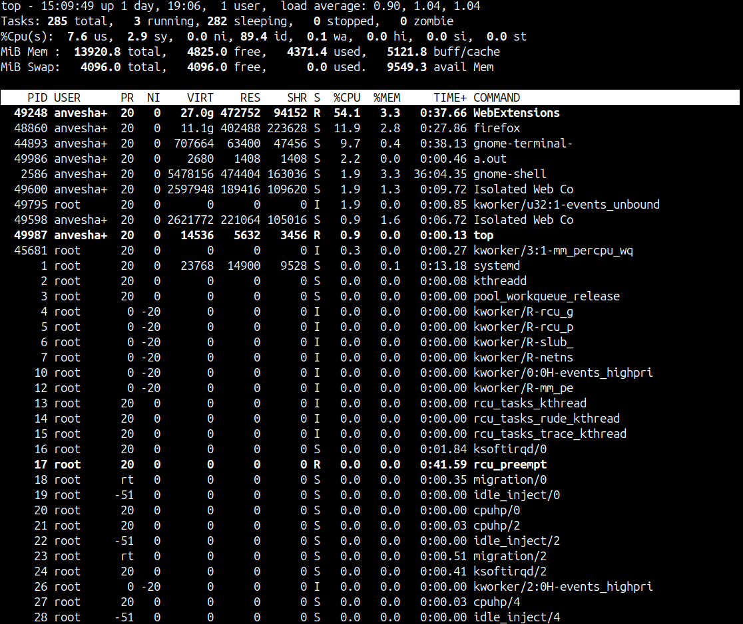
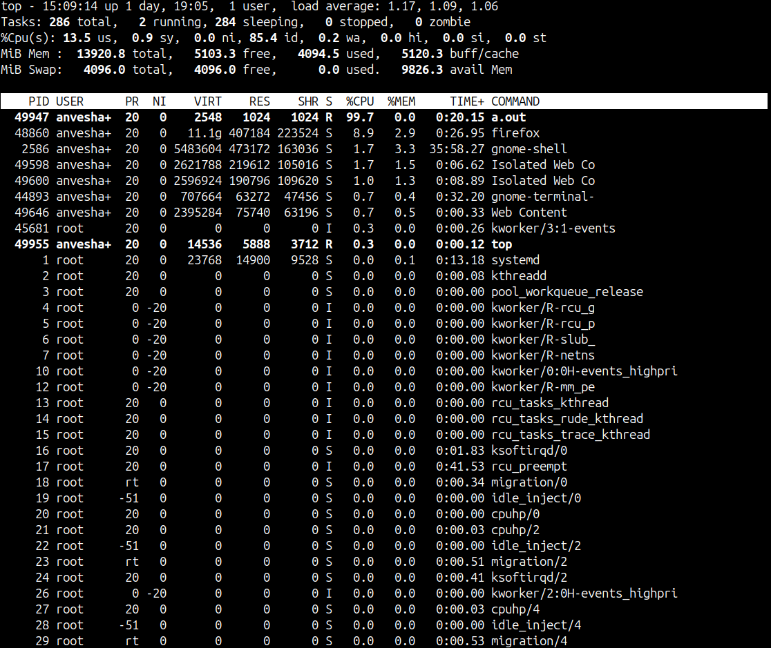
ANSWER 3 :
Cpu.c
io.c
ANSWER 4 :
Virtual memory is a memory management technique used by operating systems to give the appearance of a large, continuous block of memory to applications, even if the physical memory (RAM) is limited.
Paging divides memory into small fixed-size blocks called pages. When the computer runs out of RAM, pages that aren’t currently in use are moved to the hard drive, into an area called a swap file. The swap file acts as an extension of RAM.

Memory1.c
____________________________________________________________________________
PID USER PR NI VIRT RES SHR S %CPU %MEM TIME+ COMMAND
56716 anvesha+ 20 0 6468 5376 1408 S 0.0 0.0 0:00.01 a.out

%MEM %CPU
56716 a.out 0.0 0.0 6472 5376 05:30
____________________________________________________________________________
Memory2.c
____________________________________________________________________________
PID USER PR NI VIRT RES SHR S %CPU %MEM TIME+ COMMAND
57172 anvesha+ 20 0 6468 5376 1408 S 0.0 0.0 0:00.00 a.out

%MEM %CPU
57172 a.out 0.0 0.0 6468 5376 00:44
____________________________________________________________________________

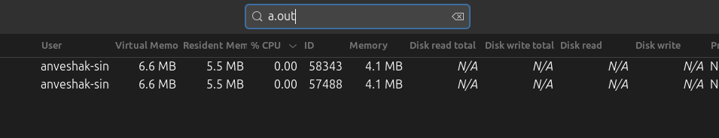
(Resident Memory = non Swapped memory)

OBSERVATION: no difference visible

ANSWER 5:

DISK.c
cat /proc/66918/io
rchar: 70531078288
wchar: 0
syscr: 17299674
syscw: 0
read_bytes: 0
write_bytes: 0
cancelled_write_bytes: 0

DISK1.c
cat /proc/66946/io
rchar: 21143687639
wchar: 0
syscr: 5186073
syscw: 0
read_bytes: 0
write_bytes: 0
cancelled_write_bytes: 0

DISK.c reads and processes significantly more data than DISK1.c, as evidenced by the higher rchar and syscr values.

EXPLANATION

disk1.c

file_no = 0;
bzero(dest_file_name, FNAME_SIZE);
sprintf(dest_file_name, "disk-files/foo%d.pdf", file_no);

disk.c

file_no = rand() % MAX_FILE_NO; //random calls all the time
bzero(dest_file_name, FNAME_SIZE);
sprintf(dest_file_name, "disk-files/foo%d.pdf", file_no);

