ASSIGNMENT 2 OPERATING SYSTEMS (R3)

1. Study simple built-in commands of bash shell in Linux like man, cd, ls, pwd, echo, cat, grep, ps, htop, etc. You may refer to man (manual) pages of these commands by using the bash command – man command-name.
$ ls -l
total 60
drwxr-xr-x 5 anveshak-singh anveshak-singh 4096 Aug 12 21:24 BurpSuiteCommunity
drwxr-xr-x 5 anveshak-singh anveshak-singh 4096 Aug 8 14:08 Desktop
drwxr-xr-x 3 anveshak-singh anveshak-singh 4096 Aug 12 22:16 Documents
drwxr-xr-x 2 anveshak-singh anveshak-singh 4096 Aug 13 14:11 Downloads
drwxrwxr-x 21 anveshak-singh anveshak-singh 4096 Aug 8 21:04 FAMILY

$ pwd
/home/anveshak-singh

$ echo "hello"
hello

$ ps
PID TTY TIME CMD
32222 pts/0 00:00:00 bash
32385 pts/0 00:00:00 ps

$ cat file
I love Football

$ grep oo file -n
1:I love Football

2. Study the functionality of fork system call and different variants of wait system call from the man pages. Create a child process using fork API call and print IDs of parent and child processes, also use wait system call to block parent process until child completes
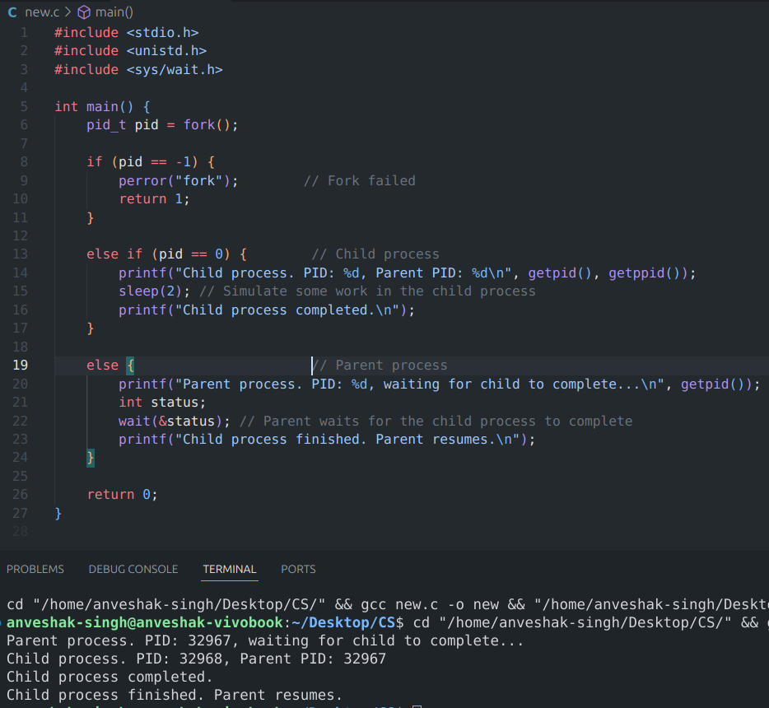
3. Study all the variants of exec system call from the man pages to understand various exec system calls thoroughly. Use any variant of the exec system call to execute a shell command or any other executable.

Current process image is overwritten with a new process image (which is passed as argument to exec). The current process is ended and the new process takes same PID, environment and file descriptor.

Int execl()
int execlp()
int execcle()
int execv()
int execvp()
int execvpe()

4. Study the concept of standard I/O streams (STDIN, STDOUT and STDERR) from the man pages. Try redirecting the standard output (STDOUT) to write the output of an executable to an external file

In Unix-like operating systems, there are three standard streams associated with every process: STDOUT (0), STDIN (1), STDERR (2)
ls > file → stdout redirect to file
ls >> file → append output to file
ls non_existing_file 2> error.txt → redirecting stderr to file
ls /non_existing_directory > output.txt 2>&1 → redirect stdout, stderr to single file

5. Understand the concept of background execution in Linux shell by studying the SHELL GRAMMER section (especially ‘Lists’ subsection) from the bash man page (given in the references). Then implement the serial and parallel execution of multiple child processes by manipulating wait system call. Serial execution can be achieved when parent waits before creating successive child processes. Parallel execution can be achieved when parent doesn’t wait before creating successive child processes

6. Understand the concept of signals and signal handling in Linux and study various signals that the OS and processes can use to communicate with each other. Study the signal system call to understand how to override default behavior for signals and how to write custom signal handlers. Then try implementing signal handling for some standard signals

Signals are software interrupts that are sent to a process to notify it of various events like termination requests, illegal memory access, or timers expiring.

They can be called using the following system call.
void (*signal(int sig, void (*handler)(int)))(int);
int sig = SIGINT, SIGSEGV etc.

SIGINT: Interactive attention signal. Generally generated by the application user.
SIGSEGV: Invalid access to storage
SIGFPE: Erroneous arithmetic operation, such as zero divide

