Supermarket Branch Performance Analysis
Data Analytics Project Report
Prepared by: Khomdram Sanahal
Dataset: Supplied Supermarket Sales Dataset | 500 transactions

1 Project Purpose
This dashboard compares branches and cities, tracks branch sales over time, and identifies practices worth replicating. The goal is to turn transaction data into practical recommendations rather than a collection of unrelated charts.

2 Dataset and Quality Checks
The dataset contains 500 transactions and 13 fields: invoice ID, date, branch, city, customer type, gender, product, category, quantity, unit price, payment, rating, and sales. There are no missing values or duplicate rows. Sales equals Quantity multiplied by Unit Price for every record.

3 Dashboard Output
The dashboard provides KPI cards and filterable visual analysis. It is built in Python with Streamlit, pandas, and Plotly.
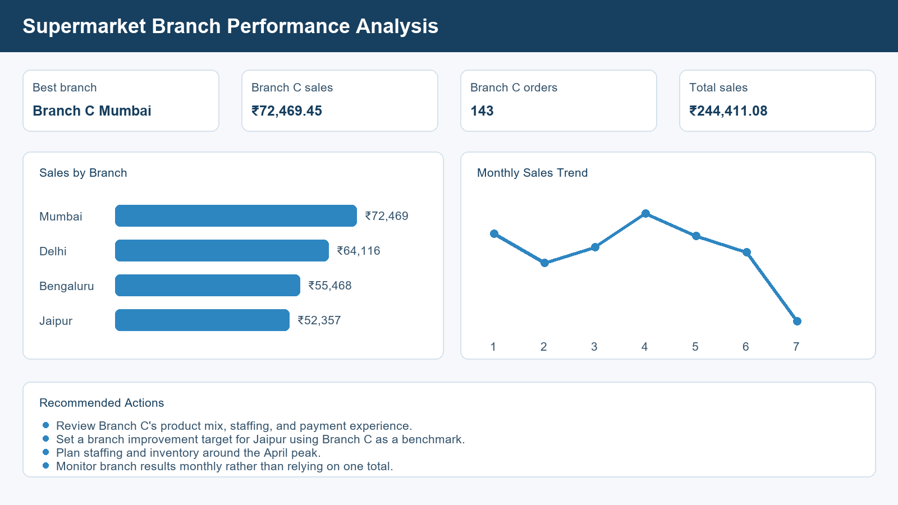
Figure 1. Dashboard overview using the full dataset

4 Key Findings
Analysis area | Finding
Leading branch | Branch C in Mumbai generated ₹72,469.45 from 143 orders.
Second-ranked branch | Branch B in Delhi generated ₹64,116.26.
Lowest total sales | Branch A in Jaipur generated ₹52,357.08.
Peak month | April generated the highest total sales at ₹52,569.77.
Business implication | Branch C operating practices should be studied and selectively replicated.

5 Recommended Actions
- Review Branch C's product mix, staffing, and payment experience.
- Set a branch improvement target for Jaipur using Branch C as a benchmark.
- Plan staffing and inventory around the April peak.
- Monitor branch results monthly rather than relying on one total.

6 How to Run the Dashboard
Install dependencies with `python -m pip install -r requirements.txt`, then run `streamlit run Khomdram_Sanahal_SupermarketBranchAnalysis.py`. The dataset is included in the data folder. README.md contains the project overview, repository contents, and setup steps.

7 Conclusion
This branch and city performance analysis demonstrates a focused use of the supplied supermarket data. Its findings support decisions on stock, operations, promotion, and customer experience.

