**Pre-Requisite:**

PowerShell 7

Azure Subscription

**Agenda:**

1. Create APIM Service In Azure
2. Create Product In The APIM Service
3. Create User Group In the APIM Service
4. Add Product To User Group
5. Create API In APIM Service
6. Add API’s To Product
7. Add Policies In The Product
8. Add Policies In the API’s
9. Add Operations (CRUD) To The API’s

Step1: Execute the given commands one by one in PowerShell (If installed PowerShell in your local system)

Install-module Az -AllowClobber -Force

Import-module Az

If you are using PowerShell environment with [Azure Cloud Shell](https://docs.microsoft.com/en-us/azure/cloud-shell/overview). Azure Cloud Shell is a browser-based shell environment that comes with the Az module installed and Enable-AzureRM compatibility aliases enabled, You don’t need to execute the above commands and also skip Step2.

Step2: Execute the command given to Connect to your Azure Account.

**Connect-AzAccount**

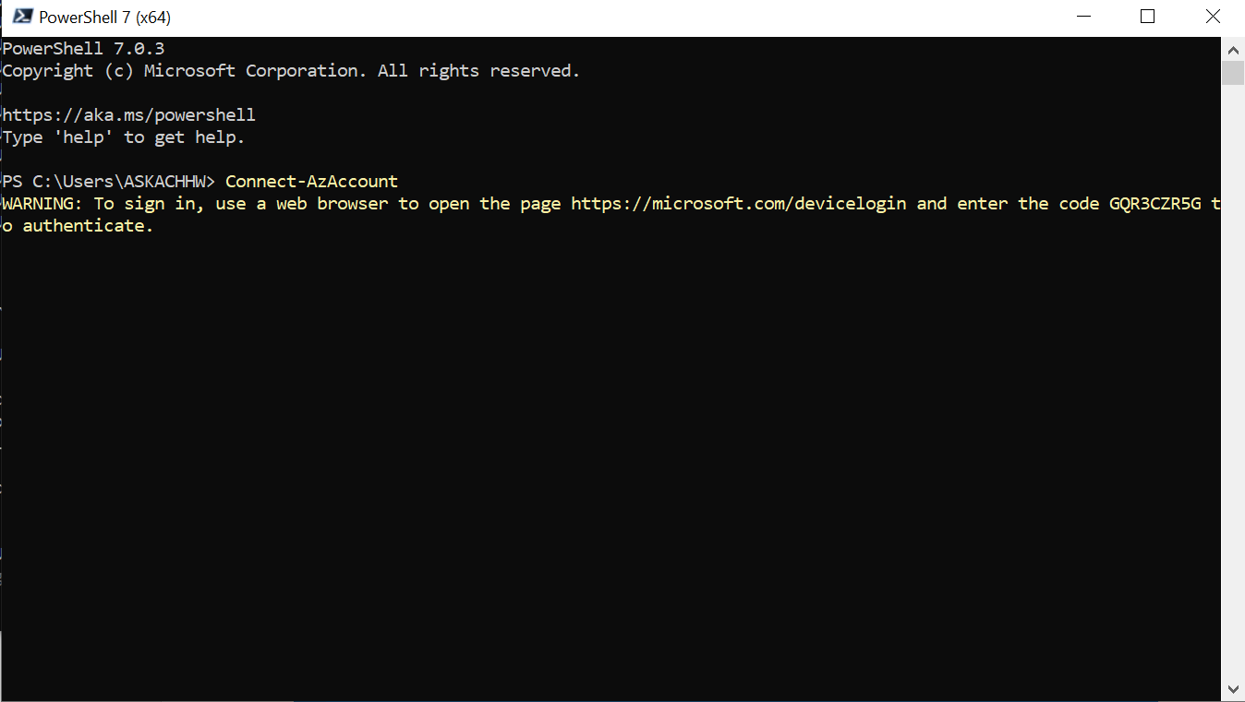

Copy the page url and access it in browser, it will ask code to be enter, Enter the code from the console.

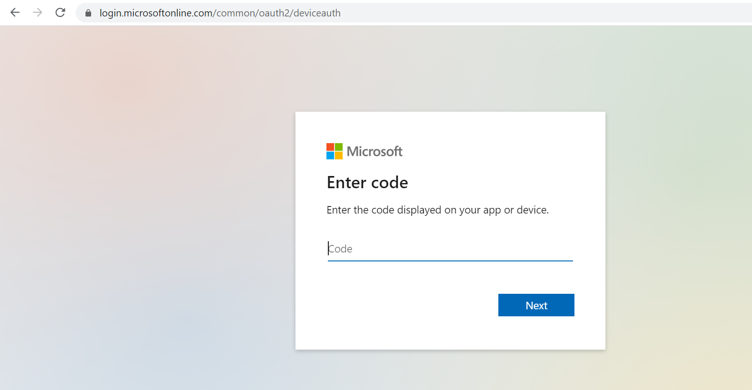

Connect to your Azure Account

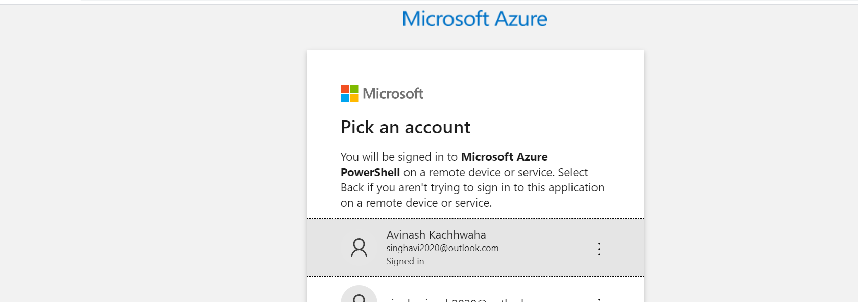

Step3: Create API with Policies using script.

1. Open the **CreateAPIMServiceAllMicroservices.txt** and replace the details.

Subscription id

Your azure mail id,

Location

Organization

$subscriptionId = "4eda8ef1-7525-49f9-9b47-b88f1eb27512"

$adminEmail = "singhavi2020@outlook.com"

$location = "Central US"

$organisation = "OFSS"

1. Copy and paste the script into the PowerShell console.

It will take around 15-20 min to execute all the commands.

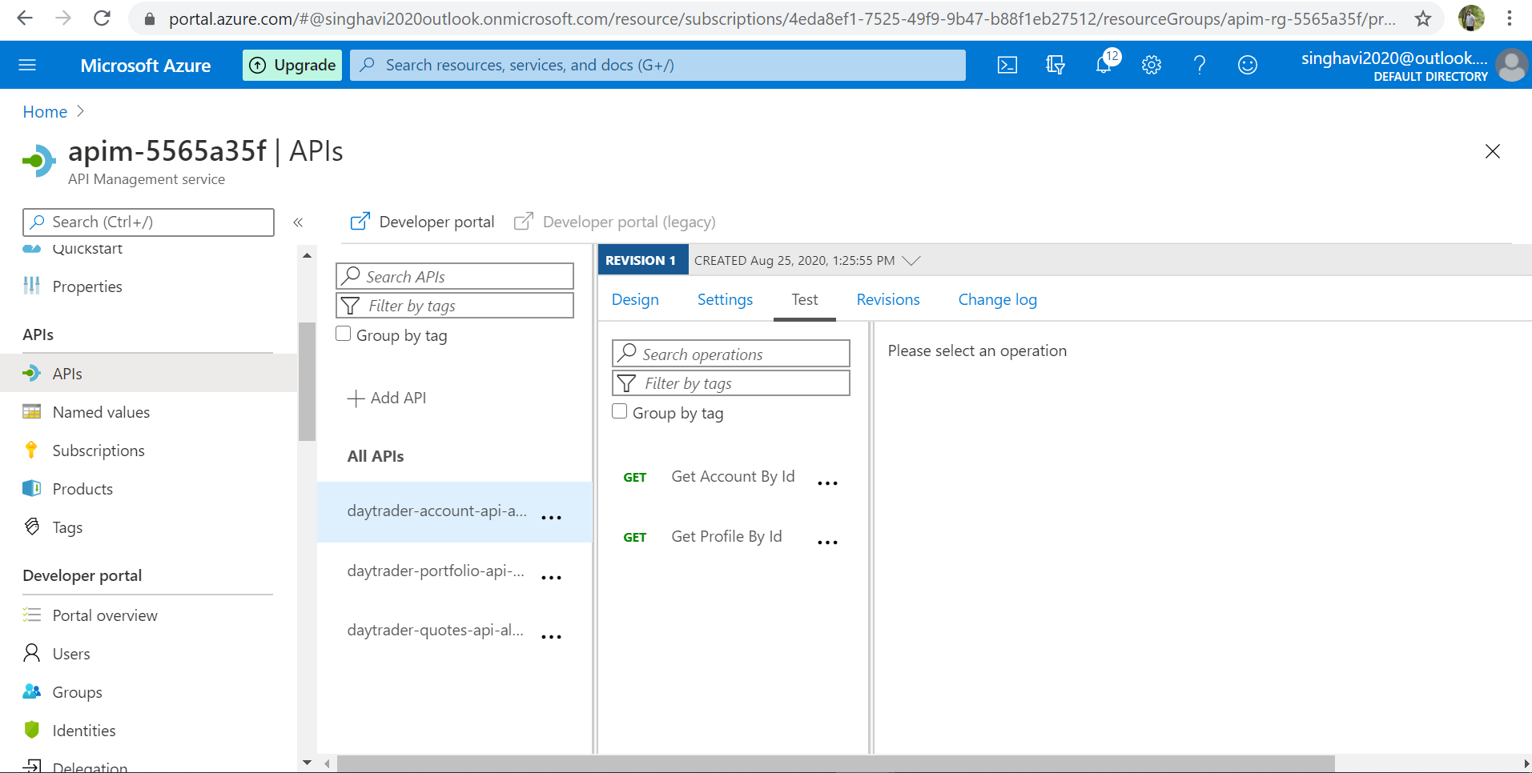

Verify your policies added to the api

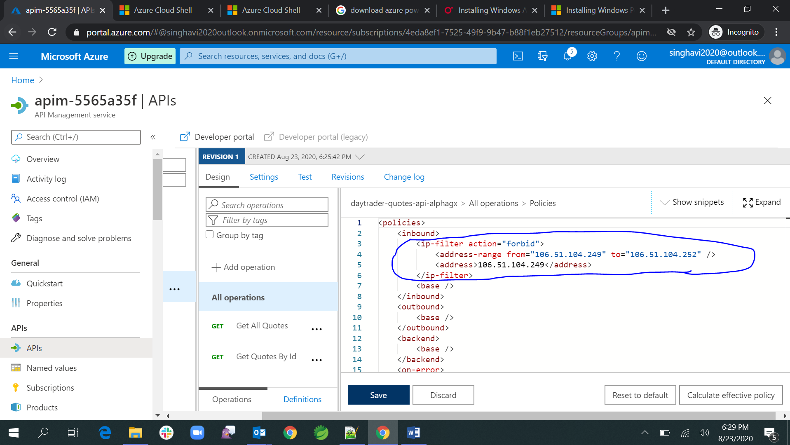

Verify the product added to the APIM service

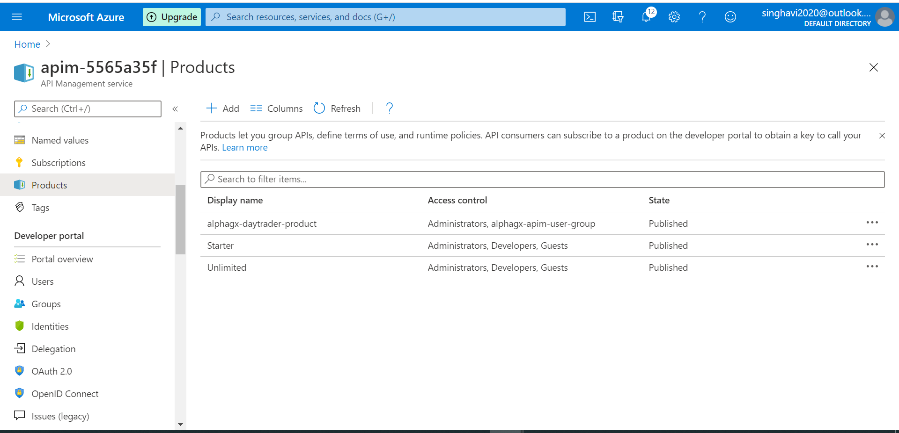

Verify the api is added to the product.

