**To establish connection between two or many different jobs and pass the parameters upstream-downstream without using master slave connection, what we do is we can take help of “Parameterized remote trigger plugin”.**

* Step : 1
* First we need to go Jenkins->login->Configuration
* Screenshot 1.1

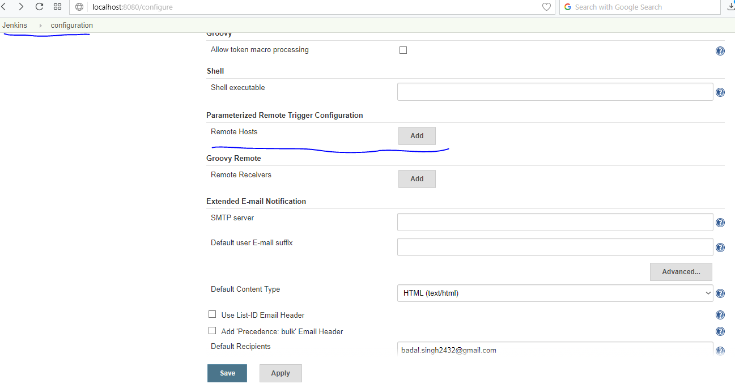

* Step2 :
* Then we need to navigate to “Parameterized remote trigger plugin”
* Screenshot 2.1 and Screenshot 2.2 below for reference

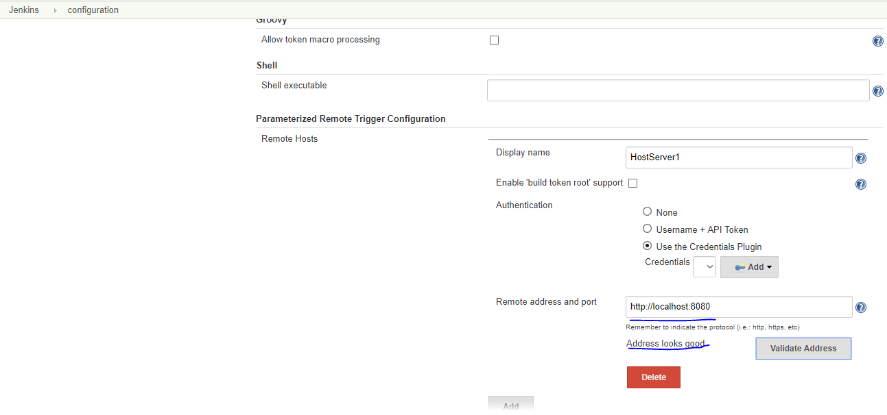

* Screenshot 2.1 : After passing the correct hostserver name it validates the remote address and port, in my case it successfully validated and allowed to connect securely.
* Let’s add one more hostserver(hosted locally i.e used apache tomcat server localhost:9090)

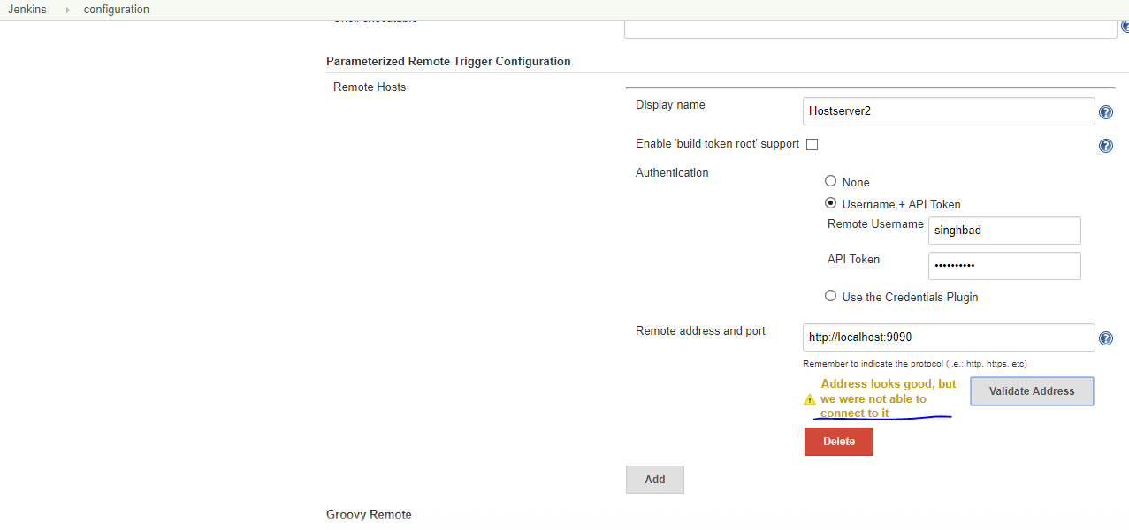

* Screenshot 2.2 :

Second Hostserver2 is connected this time using username+API Token

* Address provided was <http://localhost:9090>, address was fine.
* Step 3: After successful configuration, we need to go to one created jenkin job in my case I have one jenkin job “ JenkinDemo”
* After selecting jenkin job we need to go to configure option

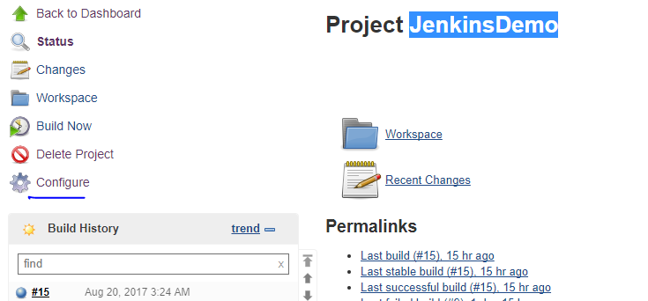

* We need to go to “Add build step”

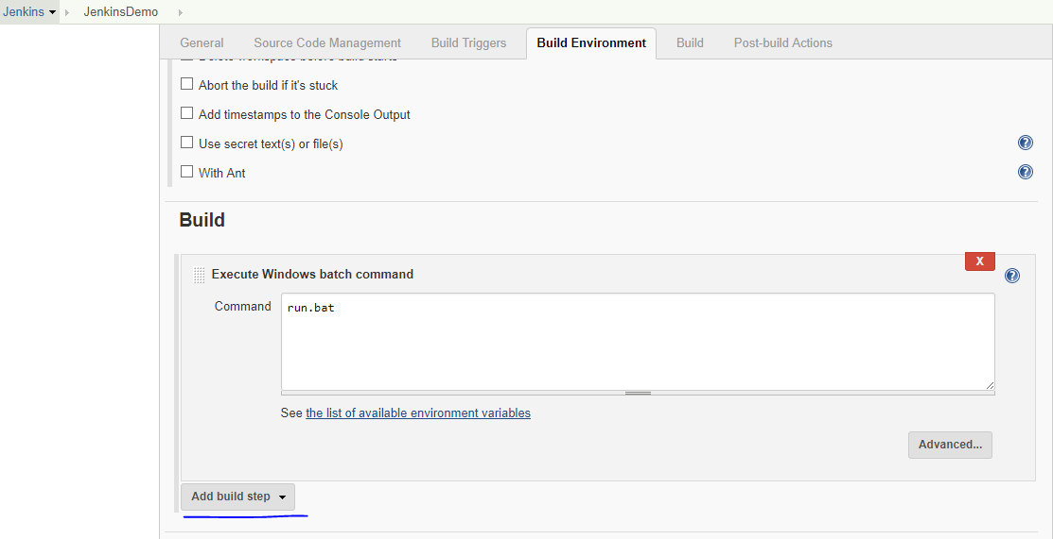

* Then need to choose “Trigger a remote parametrized job”

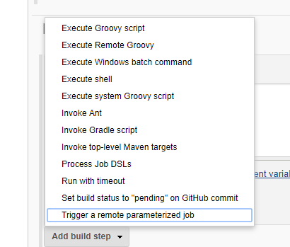

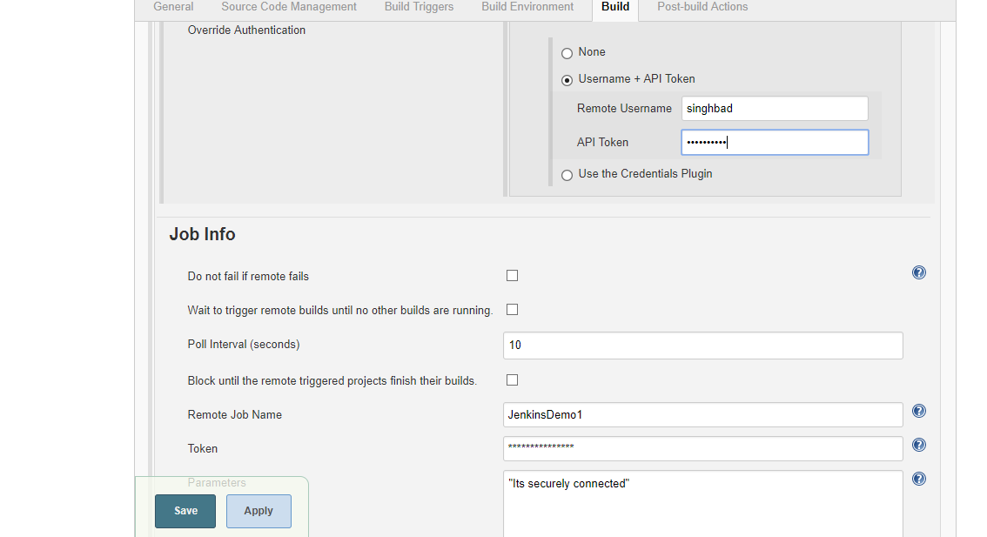

* Click Apply and Save.
* This is how I have managed to establish two or many different Jenkins jobs(Hosted on different servers) to pass the parameters / upstream-downstream jobs. (without using master slave connection in a secured way.