Name: Aakriti Pandey

UN ID: 17425089

Git ‘live’ URL:

Assignment 1: Web Development

Submission Date: 8th April 2017

Content Page no.

1. Introduction ……………………………………………………………………………..3

2. Designs……………………………………………………………………………………..3

2.1 Sketch……………………………………………………………………..……..4

2.1.1 Sketch for my home page…………………………..……….4

2.1.2 Sketch for my bio page……………….……………………...4

2.1.3 Sketch for my CV page…………………………………..…...5

2.1.4 Sketch for my contact page….……………………….…….6

2.2 Wireframe………………………………………………………………………7

2.2.1 Wireframe for my home page……………………..……..7

2.2.2 Wireframe for my bio page……………………..…………..8

2.2.3 Wireframe for my CV page…………………………………..9

2.2.4 Wireframe for my contact page……………………………..9

3. Images created………………………………………………………………………….10

4. Progression of my work…………………………………………………………….10

5. Evidence of good practice………………………………………………………..13

5.1 Visual Appeal……………………………………….………………………..13

5.2 Navigation………………………………………………………..……….…..13

6. Test through Validator …………………………………………………………….14

7. Conclusion…………………………………………………………………………………15

Introduction

Before getting started with the work of creating my personal website, I had zero idea about what to make and how to design. First, I viewed some of others personal websites and took inspirations for them however I created the new designs on my own. Below, here are some the websites that I looked for some ideas:

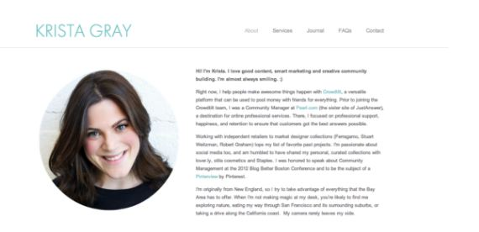

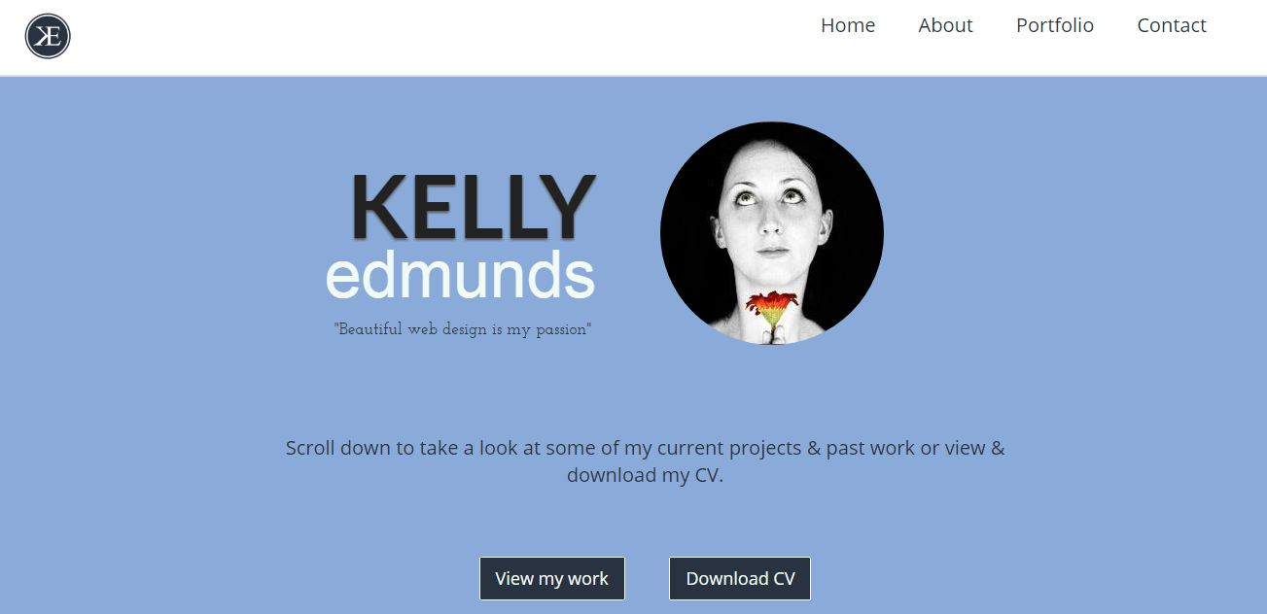

Designs

No matter how much content we put in our assignment, if it doesn’t have an appealing design the reader will not be interested. So it is very important when we design our website. At first, I draw the rough sketches in which I figured out what to put in each web page.

Sketches

Sketch for my home page

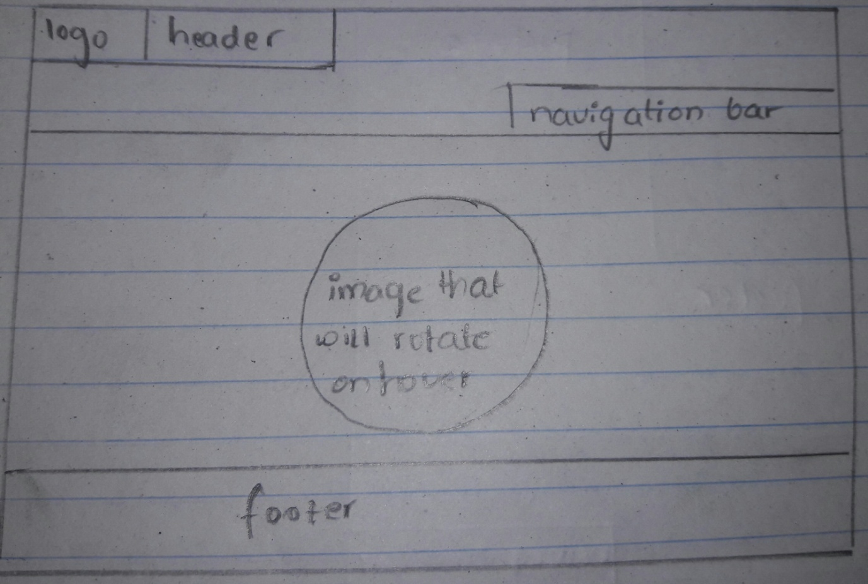

Sketch for my bio page

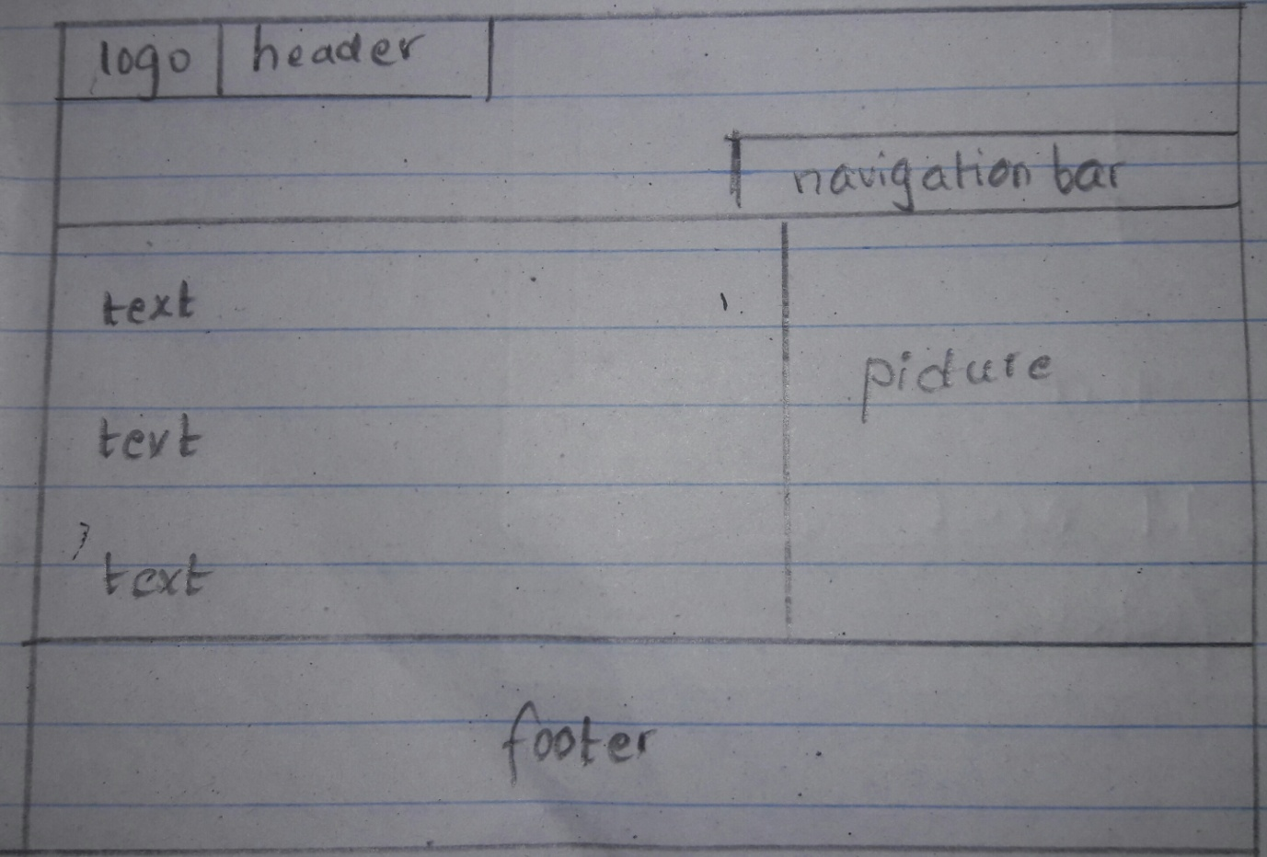

Sketch for my CV page

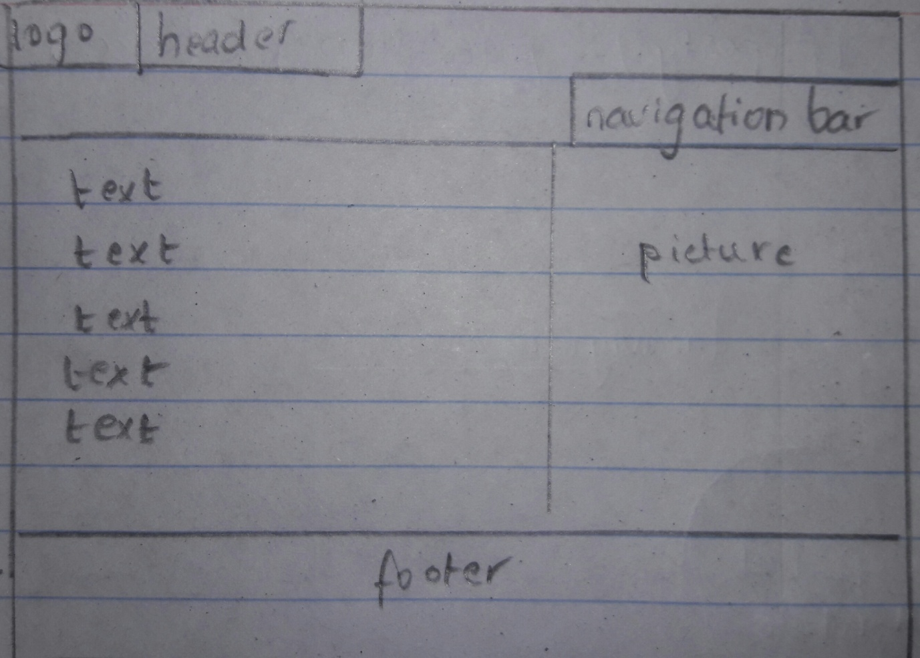

Sketch for my contact page

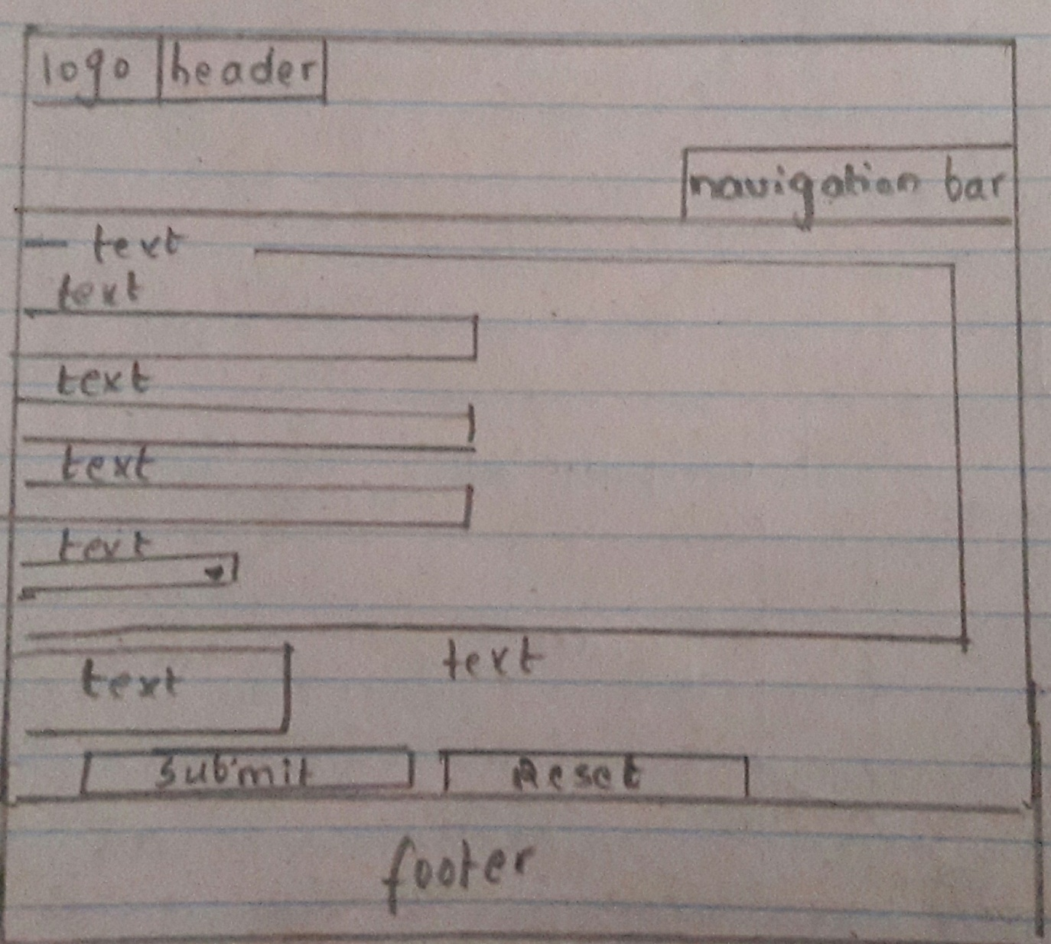

Wireframes

Wireframe for my home page

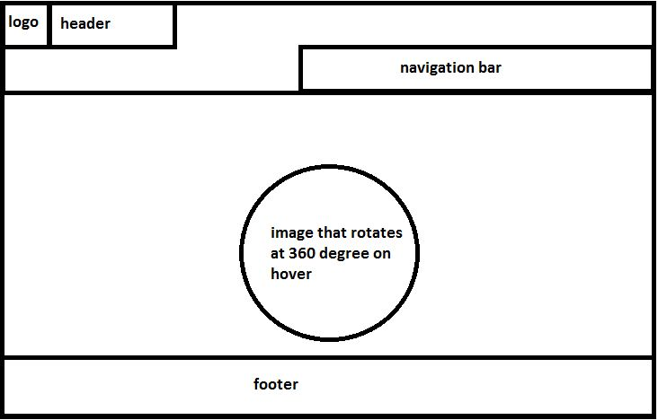

Wireframe for my bio page

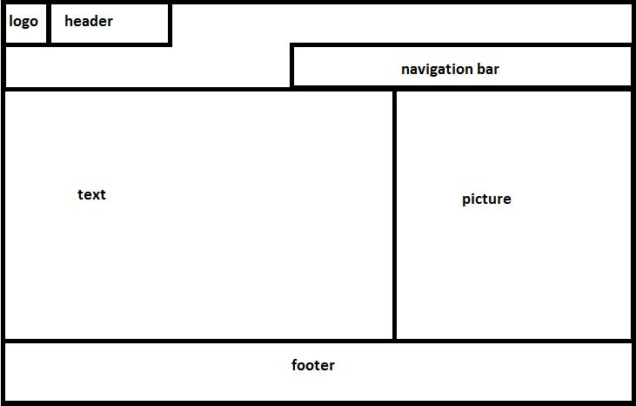

Wireframe for my CV page



Wireframe for my contact page

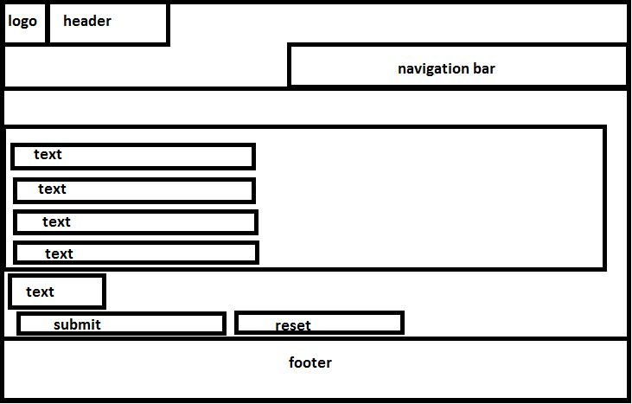

Image created

There are some pictures I have created using Microsoft paint.

 This picture is the logo as well as the favicon for my website.

This is the logo for facebook that is kept in the footer section.

This is the logo for instragarm that is also included in the footer section.

Progression of my work

I wanted to make my website look as simple as possible. So I started with the code. Then at the design portion I didn’t prefer vibrant colors, rather I used dark colors for header and footer and light color for the body.

My home page; For my home page I decided not to make it over crowded. So I used a sentence and a picture coveing the whole page. I also kept the rotating effect on the picture when hovered. I kept the logo of my website at the top left corner and the navigation section at the right side. Here is a look of my home page.

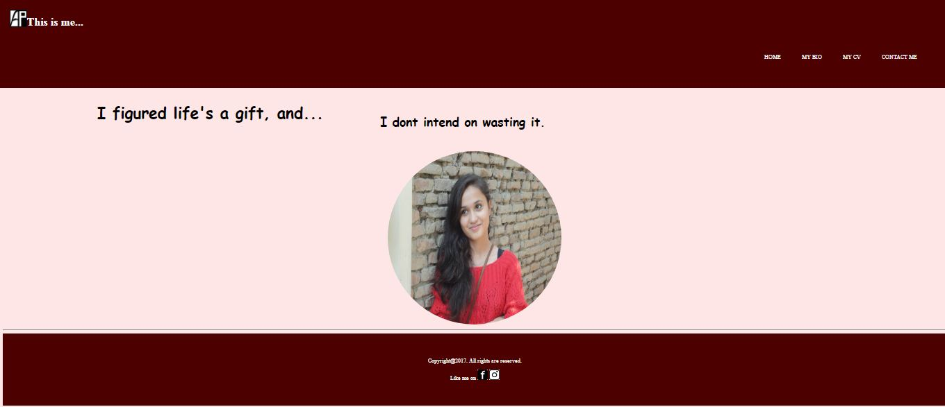

My bio page; For my bio page the header and footer stands in the same position creating a theme for the website. The change is made in the body part where I have added some description about myself.

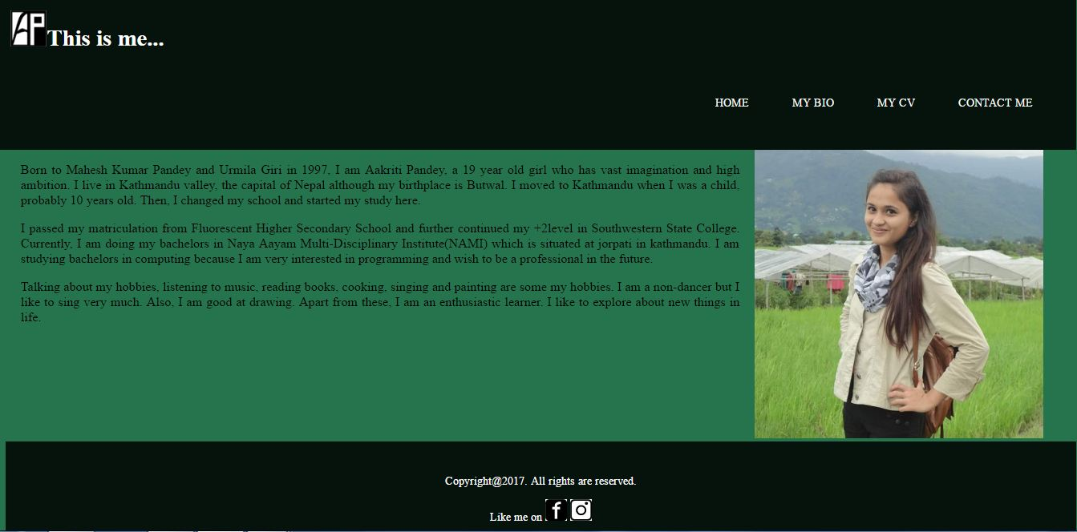

My CV page; In the CV page I have used different div to store the data. This page contains official data about me. Here is a look at my CV page.

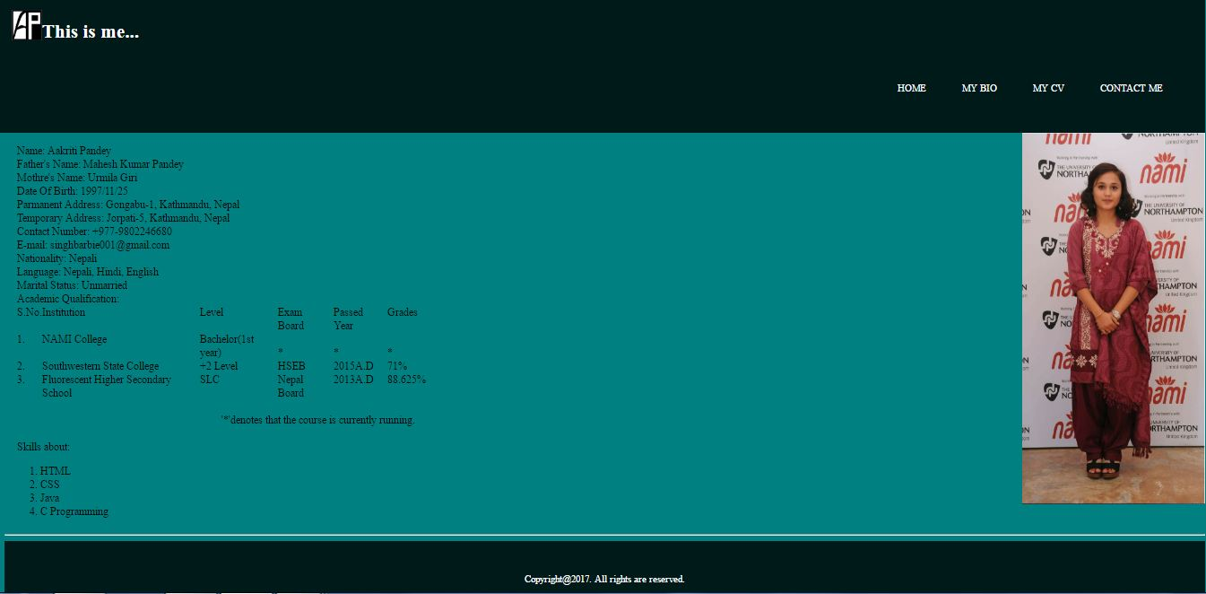

My contact page; Contact page is the page which allows the reader /user to communicate with the author/ creator. In this contact page I have tried to include every possible details of the visitor who visit my website so that I can interact with him/her in a better way. Here, I have used the html element form for creating this webpage along with many css elements.

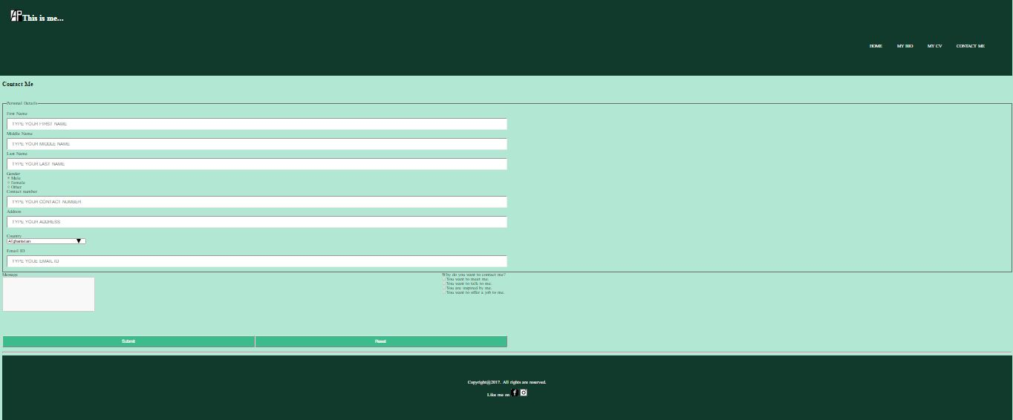

Evidence of how I used models of good practice

Visual Appeal:

I surfed through many online websites before making mine and I took the idea that simplicity is always more appealing than unwanted decoration. That is why I have tried my best to keep my website as simple as possible. I also think that the design and the color patterns are visually appealing to the visitors.

Navigation:

After appearance come the navigation of the website. If the webpage is too complicated to handle the users/visitors might lose interest from the web page. So it is very important to take care of the navigation. In my website I have tried to create a simple navigation by which the users will not feel bored or ambiguous.

Test through validator

After the completion of the assignment I had to validate my HTML and CSS code from the HTML and CSS validator. All HTML and CSS files were approved by the validator and no errors were found.

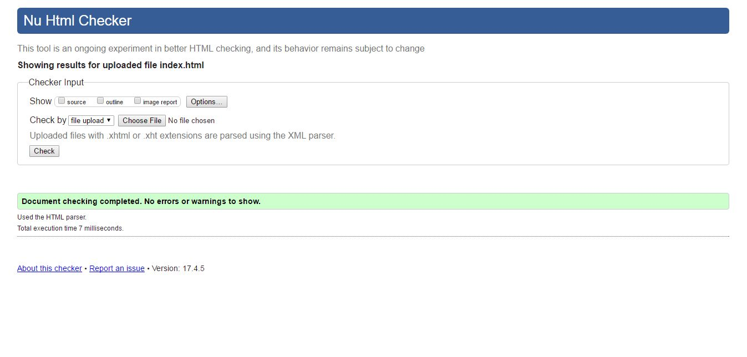

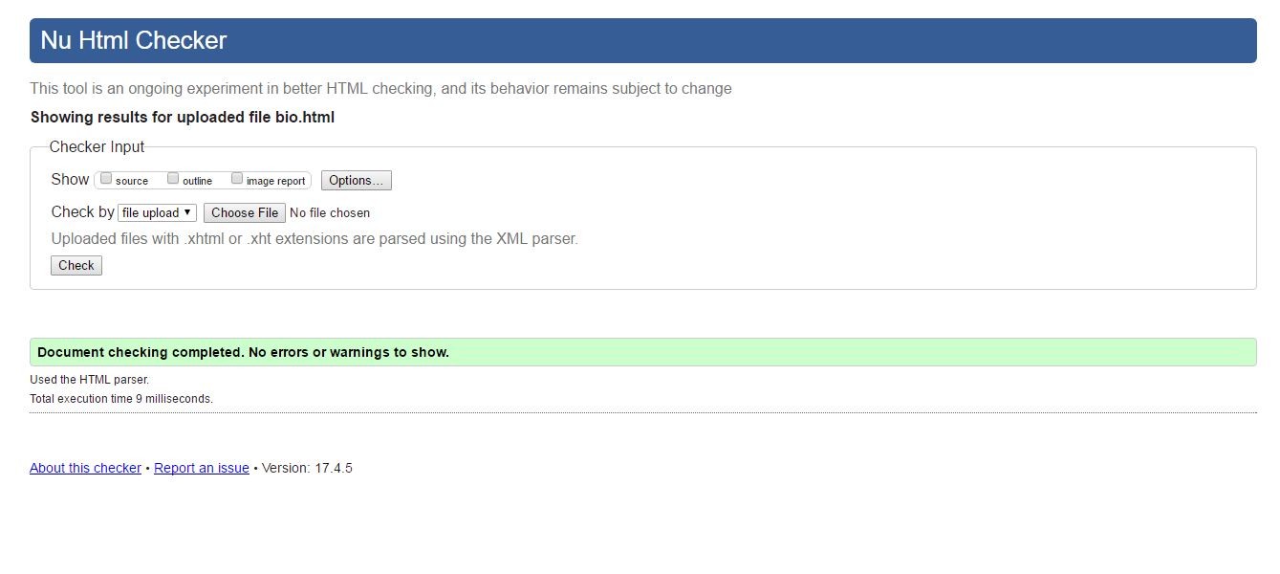

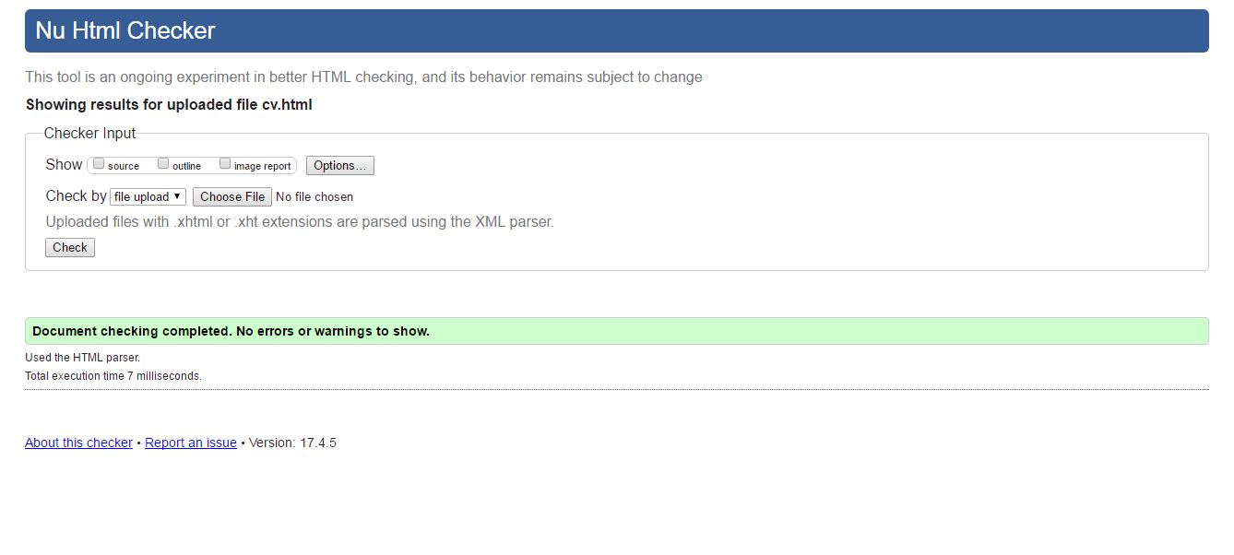

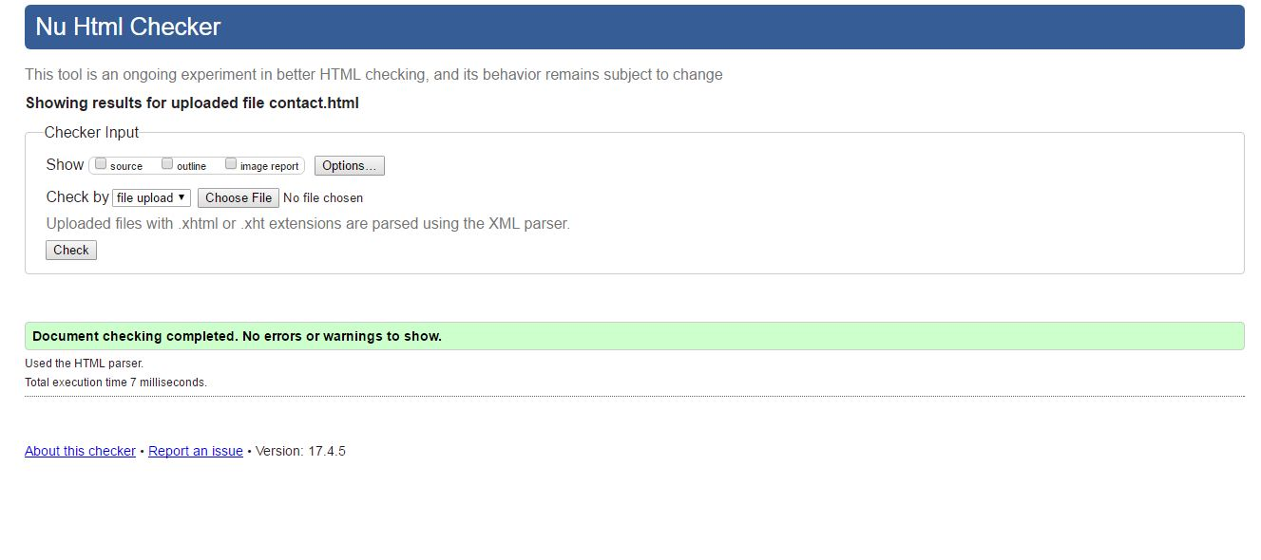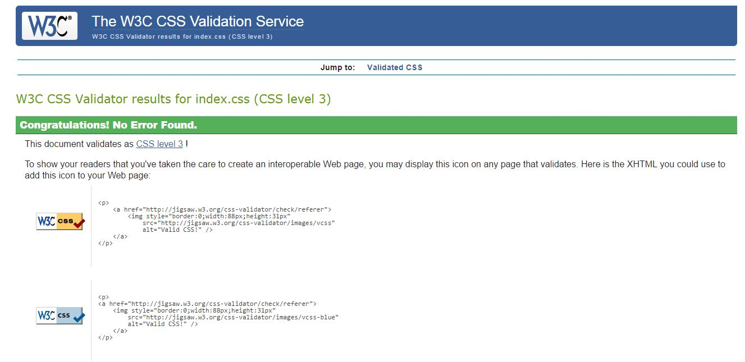

Conclusion:

Completing this assignment was a great fun and exciting. I learned many things from this assignment on how to create an actual and official website. If I had more time for the website then I would have added more transition and animation effects on my assignment which seems to be lacking currently.