UI/UX & SYSTEM DESIGN

3.1 Purpose
The purpose of this phase is to design the complete structure of the Digital Product Passport web application.
The system will be:
A responsive web application where electronic products receive a unique QR code, and authorized users can access and update their lifecycle information.

3.2 Overall System Architecture
We will use a simple 3-layer architecture:
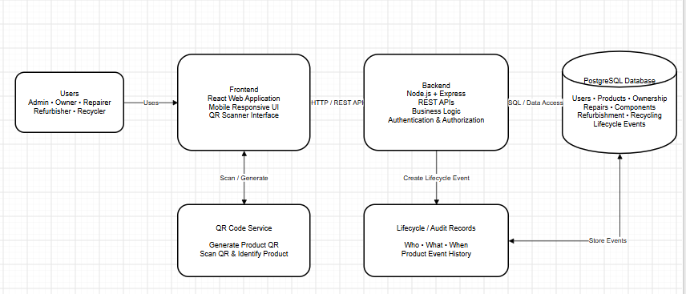

What does this mean?
Frontend = What the user sees.
Backend = The logic that processes requests.
Database = Where all product/user/history information is stored.

3.3 Main User Flow
The basic user journey is:
Login
↓
Dashboard
↓
Select Product
↓
Digital Product Passport
↓
View Lifecycle History
↓
Perform Authorized Action
↓
Save Event
↓
Updated Product History
For a person using the QR code:
Open Mobile Camera / QR Scanner
↓
Scan QR
↓
Product Passport
↓
View Product Info
↓
View Lifecycle History

3.4 Website Pages
We will design the following pages.
USE CASE DIAGRAM
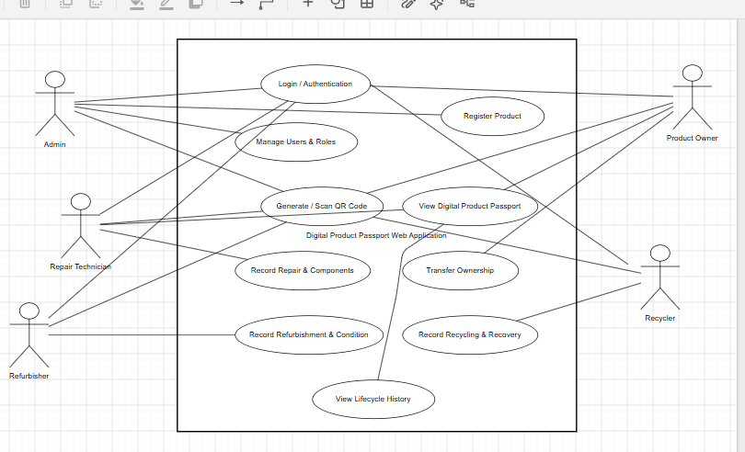

1. Login Page
Fields:
- Email
- Password
- Login button
Optional:
- Forgot password
- Register

2. Dashboard
The dashboard changes depending on the user's role.
For Admin:
----------------------------------
ADMIN DASHBOARD
----------------------------------

Total Products 250
Total Repairs 120
Refurbished 75
Recycled 40

[Products] [Users] [Reports]
----------------------------------

3. Product List
Shows registered products.
Example:
Product ID | Product | Brand | Condition | Owner
PROD001 | Laptop | Dell | Good | User A
PROD002 | Phone | Samsung | Refurbished | User B

3.5 Add Product Page
Admin enters:
Product Name
Product Type
Brand
Model
Serial Number
Manufacturing Date
Purchase Date
Warranty
Condition
Owner
Then:
[Register Product]
After registration:
✅ Product successfully registered
Then the system generates a QR code.

3.6 QR Code Page
After registering a product:
┌─────────────┐
│ │
│ QR CODE │
│ │
└─────────────┘

Product ID: PROD001

[Download QR]
The QR code should contain a unique product identifier or a secure passport URL.

3.7 Digital Product Passport Page
This is the most important screen.
It could look like:
---------------------------------------
DIGITAL PRODUCT PASSPORT
---------------------------------------

Product: Dell Laptop
Model: XYZ
Product ID: PROD001

Condition: Good
Owner: User A
Warranty: Active

---------------------------------------
LIFECYCLE HISTORY
---------------------------------------

2026
│
├── Product Registered
│
├── Purchased
│
├── Ownership Transferred
│
├── Screen Repaired
│
├── Battery Replaced
│
├── Refurbished
│
└── Reused
---------------------------------------
This page gives the user a complete picture of the product.

3.8 Repair Page
Repair technician sees:
Product ID: PROD001

Problem:
[_____________________]

Diagnosis:
[_____________________]

Repair Performed:
[_____________________]

Component Replaced:
[_____________________]

Repair Date:
[__________]

Condition After Repair:
[ Good ▼ ]

[Save Repair]

ER Diagram
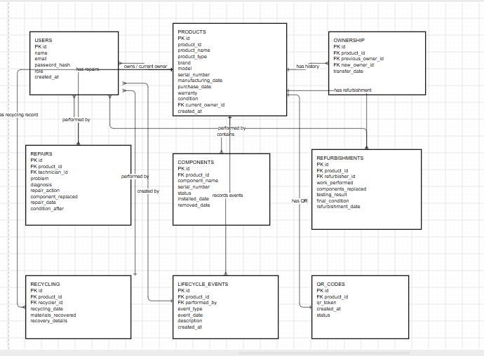

3.9 Ownership Transfer Page
Example:
CURRENT OWNER
User A

NEW OWNER
User B

TRANSFER DATE
10/09/2026

[Confirm Transfer]
The system should preserve the previous ownership record.

3.10 Refurbishment Page
Refurbisher can enter:
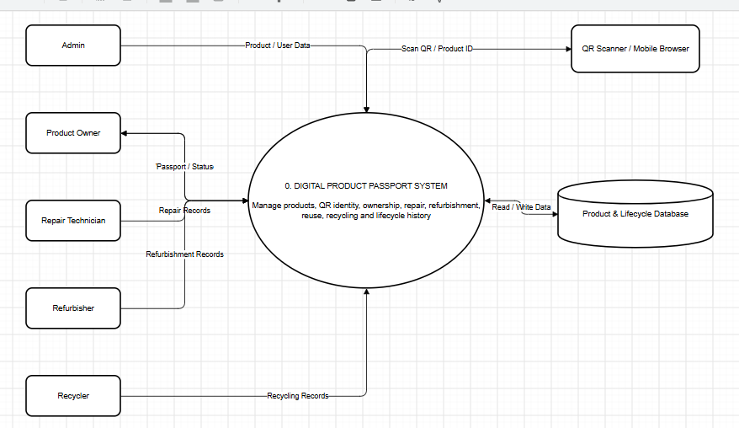

3.11 Recycling Page
Recycler enters:
Product ID

Recycling Date:
[________]

Materials Recovered:
☐ Metal
☐ Plastic
☐ Glass
☐ Battery
☐ Other

Recovery Details:
[________________]

[Submit Recycling Record]

3.12 Database Design
We need tables to store the information.

Main tables
Users
Products
Ownership
Repairs
Components
Refurbishments
Recycling
LifecycleEvents

Users Table
Users
-------------------
id
name
email
password
role
created_at
Possible roles:
ADMIN
OWNER
REPAIRER
REFURBISHER
RECYCLER

Products Table
Products
-------------------
id
product_id
product_name
product_type
brand
model
serial_number
manufacturing_date
purchase_date
warranty
condition
current_owner_id
created_at

Ownership Table
Ownership
-------------------
id
product_id
previous_owner_id
new_owner_id
transfer_date
This allows us to see the ownership history.

Repairs Table
Repairs
-------------------
id
product_id
technician_id
problem
diagnosis
repair_action
component_replaced
repair_date
condition_after

Refurbishment Table
Refurbishments
-------------------
id
product_id
refurbisher_id
work_performed
components_replaced
testing_result
final_condition
refurbishment_date

Recycling Table
Recycling
-------------------
id
product_id
recycler_id
recycling_date
materials_recovered
recovery_details

Lifecycle Events Table
This table is very useful.
LifecycleEvents
-------------------
id
product_id
event_type
performed_by
event_date
description
created_at
Example:
PROD001 | REPAIR | User25 | 10/09/26
PROD001 | TRANSFER | User10 | 15/09/26
PROD001 | REFURBISH | User31 | 20/09/26
PROD001 | RECYCLE | User42 | 30/12/26
This gives us a chronological product history.

3.13 Database Relationship
The basic relationship is:
USERS
│
│
↓
PRODUCTS
/ | \
/ | \
↓ ↓ ↓
OWNERSHIP REPAIRS REFURBISHMENT
\ /
\ /
↓ ↓
LIFECYCLE
EVENTS
│
↓
RECYCLING
One product can have:
- Many ownership records
- Many repairs
- Many refurbishment records
- Many lifecycle events
- One or more recycling records depending on the design

3.14 QR Scanning Design
The QR workflow should be:
QR CODE
↓
Mobile Camera
↓
QR Scanner
↓
Product Identifier
↓
Backend API
↓
Find Product
↓
Digital Passport

Important security point
The QR code should not contain sensitive information directly.
It should identify the product/passport, while the server controls what information the user can access.

3.15 Role-Based Access
The backend should check the user's role before allowing an action.
For example:
Repair Request
↓
Is user logged in?
↓
YES
↓
Is user a REPAIRER?
↙ ↘
YES NO
↓ ↓
Allow Reject
This prevents unauthorized people from adding or changing lifecycle information.

3.16 UI Design Principles
The application should be:

Simple
Users should not need technical knowledge.

Mobile-first
QR scanning will mainly happen on phones.

Clear
Important information such as:
Condition, Owner, Repair History, and Recycling Status
should be easy to find.

Consistent
Buttons, forms, menus, and layouts should look consistent throughout the application.

3.17 Proposed Navigation

Admin
Dashboard
│
├── Products
│ ├── Add Product
│ ├── Product List
│ └── Product Passport
│
├── Users
│
└── Reports

Owner
Dashboard
│
├── My Products
│
├── Scan QR
│
└── Product Passport

Repairer
Dashboard
│
├── Scan QR
│
├── Product
│
└── Add Repair

Refurbisher
Dashboard
│
├── Scan QR
│
├── Product
│
└── Add Refurbishment

Recycler
Dashboard
│
├── Scan QR
│
├── Product
│
└── Add Recycling

3.18 API Planning
The frontend and backend will communicate through APIs.
Some planned endpoints:
POST /api/auth/login

GET /api/products
POST /api/products
GET /api/products/:id

GET /api/products/:id/passport

POST /api/products/:id/repairs
GET /api/products/:id/repairs

POST /api/products/:id/ownership

POST /api/products/:id/refurbishment

POST /api/products/:id/recycling

GET /api/products/:id/lifecycle
We will implement these later during development.

3.19 Phase 3 Security Design
Security should be considered from the beginning.
We will use:
- Login authentication
- Password hashing
- Role-based authorization
- Input validation
- Secure API endpoints
- Database constraints
- Audit/lifecycle records
- Duplicate product detection
For example:
A recycler should not be able to edit a repair record.
They can view appropriate information, but their role only allows them to add recycling information.

