Path Coverage Testing
Path coverage testing is a structural testing technique used in software engineering to ensure that all possible execution paths through a program are tested at least once. The goal is to evaluate the correctness and robustness of the software by examining various paths through its source code.
Cyclomatic Complexity: Cyclomatic complexity is a software metric used to measure the complexity of a program. It quantifies the number of linearly independent paths through a program's source code.
V(G) = E-V+2

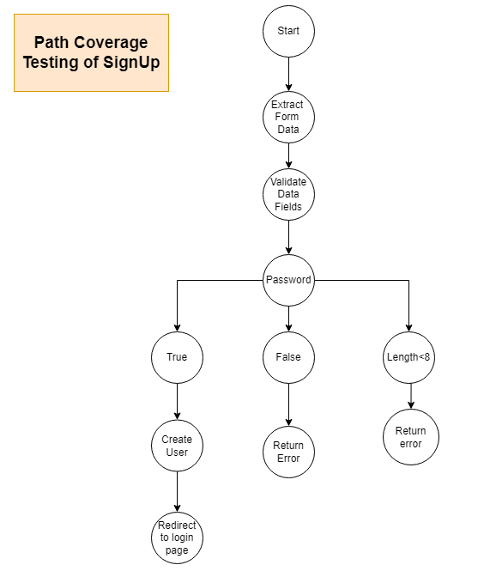

V(G) = 10-11+2 = 1

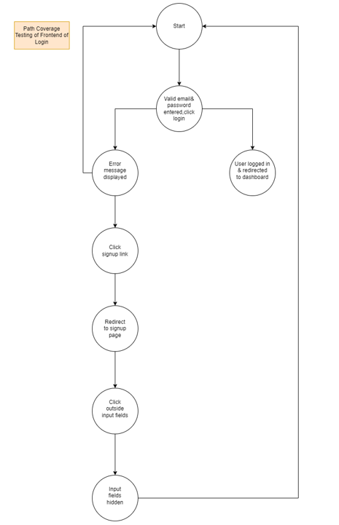

V(G) = 9-8+2 = 3

Path Coverage Testing of Backend of Login

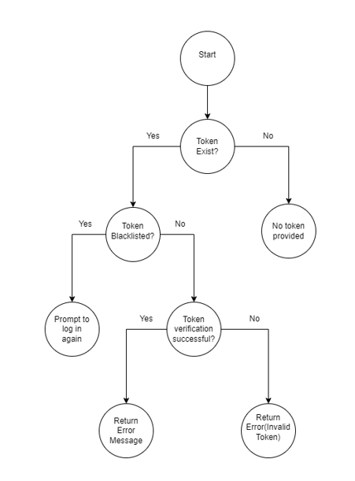

V(G) = 7-8+2 = 1

Path Coverage Testing of Frontend of AddUser
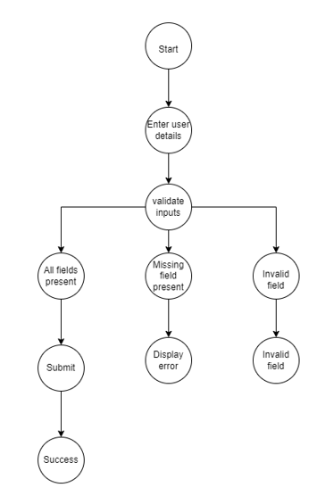
V(G) = 9-10+2 = 1

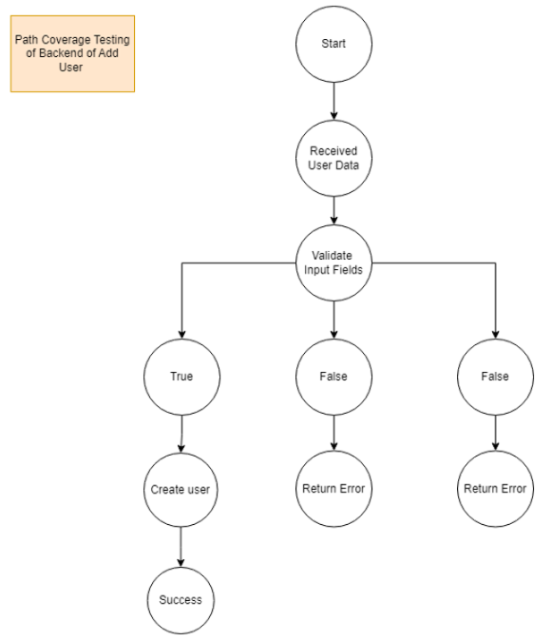

V(G) = 9-10+2 = 1

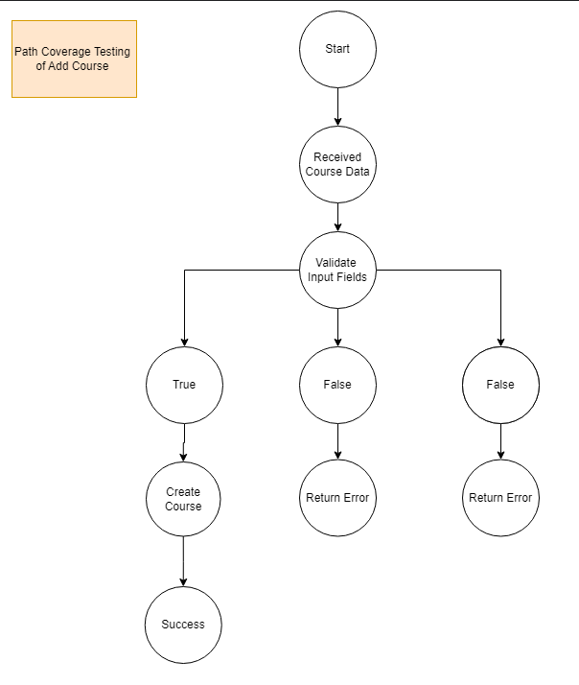

V(G) = 9-10+2 = 1

