DataBel: Case Study Analysing on Customer Churn Rate

Problem Statement
To analyze why customers are churning, or in other words, leaving Databel. ● What is Churn Rate?
The churn rate, also known as the rate of attrition or customer churn, is the rate at which customers stop doing business with an entity ● Churn Rate formula
The simplified formula for churn is to divide customers lost by the total number of customers. If we have a total of 100 customers in a certain period, and 10 end up leaving, we have a churn rate of 10%. There are multiple methods to calculate churn, and depending on the industry, it might make sense for a company to slightly alter the formula. A traditional e-commerce platform might consider a certain customer a churner if he or she hasn't made a purchase in the last 12 months. Data.
The Data
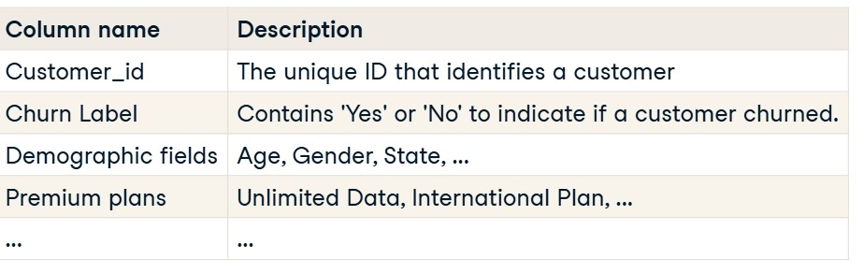

Full

Data

Link:

Metadata Databel.pd
f
Approach
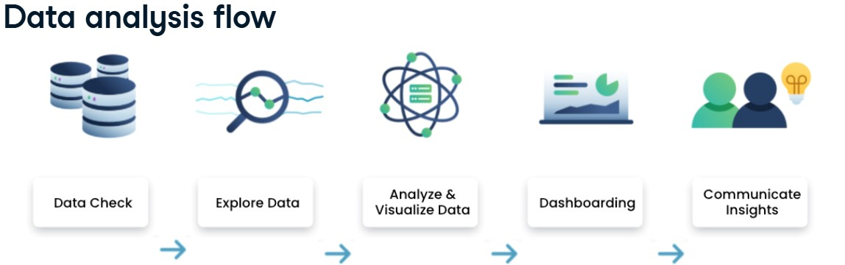
Questions Explored [Questions | Page Name]
1. Churn Rate and Churn Reasons || Churn Demographics.

Solution
Analysis shows that the main drivers of churn are better offers and devices from competitors, along with negative customer support experiences. To remain competitive, we recommend investing in R&D for improved, cost-effective services and introducing a loyalty program to retain long-term customers. For customer support, stricter guidelines, training, and a feedback system should be implemented, with a three-strike policy for repeated poor behavior. These measures will enhance satisfaction and reduce churn.

2. Avg Monthly Charges & Churn Rate by No. of Customers in a Group || Groups and Categories.

Solution
The analysis of monthly contracts reveals a significant churn rate of 46.29%, with the primary reasons being competitors offering better alternatives, dissatisfaction with the services provided, and impolite or unprofessional behavior from customer support staff. To address this, it is crucial to strengthen customer service operations by improving training and development programs, implementing stricter performance monitoring, and, where necessary, replacing consistently underperforming employees. A disciplined approach to service quality will help improve customer satisfaction and reduce churn.
Across both yearly and monthly contracts, a common observation is that churn is consistently higher among customers who are not part of a group compared to those who are, with the exception of monthly contracts for groups of five. This highlights the importance of strengthening team-based plans, as 75% of churn across these contracts can be attributed to competitors, staff attitude, and dissatisfaction with solutions provided. For monthly groups of five, the churn rate stands at 20.41% of the total monthly contract churn. While the top reasons remain consistent with other contracts, pricing emerges as a notable additional factor. This suggests that, alongside resolving core service and support issues, careful attention should also be given to pricing strategies for group contracts.

- Churn Rate by Contract Category and Gender || Groups and Categories.
- Churn Rate by Data Consumption and Data Dataplans || Unlimited Plan.
- Churn Rate by Intl Active (Yes, No International Calls) and Intl Plan by state || International Calls (Reference: Metadata Link Metadata Databel.pdf ).

Solution
Inactive customers on Premium plans exhibit the highest churn rate at 71.19%. We recommend encouraging this segment to downgrade to a more cost-effective plan, aligning better with their usage and improving retention. Conversely, active customers who frequently make international calls but are not on the Premium plan should be advised to upgrade. Additionally, offering coupons to loyal and frequent users—such as bonus data or a limited number of free international calls—can further incentivize engagement, enhance satisfaction, and strengthen retention. This combined approach can effectively reduce overall churn. Challenge: This strategy includes high implementation cost.

6. Churn Rate by Account Length (In months), Payment Methods || Contract Type.

Solution
The analysis indicates that the highest churn rates are observed in month-on-month contracts, with particularly concerning figures among customers with account lengths of 69 months (66.67%), 1 month (64.10%), and 49 months (63.16%). These levels are critically high and highlight an urgent need for intervention. To address this, the previously discussed strategies should be implemented to resolve ongoing service-related issues. Additionally, it is recommended to proactively reach out to long-term customers who have churned, offering them improved deals and emphasizing enhanced service quality. By demonstrating tangible improvements and rebuilding trust, the company can create opportunities to win back valuable customers and reduce overall churn.

Challenge
Re-engaging churned long-term customers can be resource-intensive, as it requires personalized outreach, special offers, and dedicated support. There is also a risk that customers may perceive the improved deals as reactive rather than proactive, which could reduce trust or loyalty. Additionally, competitors may continue to offer aggressive pricing or device incentives, making it harder to win customers back even with improved service. Managing costs will also be a concern, as offering discounts or enhanced benefits to attract churned customers could impact profitability if not carefully targeted. Finally, ensuring that the promised improvements in service quality are consistently delivered is critical—without this, customers may churn again despite the incentives
7. Churn Rate by Customer Age Bins || Age Groups

Observation
The analysis shows that the highest churn rates are observed among customers aged 60 and above. This trend may suggest that older customers are either less interested in continuing with the service or fall outside the target demographic, and therefore this segment may not warrant strategic focus. For other age groups, churn rates generally remain below 20% for customers with account lengths of 12 months or more, indicating stronger retention within this segment. However, an exception is observed in the 55 and 35 age groups, where churn rates exceed 30% specifically among customers with account lengths between 12 and 24 months and who are not part of a group. This highlights the need for targeted strategies to address the unique challenges and expectations of these customer segments.
8. Avg Service Calls, Corr of. Avg Account Length & Churn Rate by Payment Methods and Contract Types || Payment and Contract.

Conclusion
The analysis further indicates that churn rates decline as the average account length increases, emphasizing the value of fostering long-term customer relationships.
9. Avg Extra Data and Avg Extra International Charges || Extra Charges

Conclusion
Customers without an unlimited data plan pay an average of 10.29, while the overall average spend on international calls remains 33.64 regardless of plan type. This suggests that customers are willing to pay a higher price when satisfied with the service, presenting a profitable opportunity for the company
10. Avg Service Calls by Churn Label & State, Churn Rate by State and Service Calls ||
Insights

Solution
The map visualization displays churn rates by state, with bubble sizes representing the volume of customer service calls per state (refer to the metadata document). States shaded in red indicate the highest number of service calls, while those in green represent the lowest. Based on this insight, it is recommended to form a dedicated team to proactively reach out to customers, starting with states in red and progressing toward those in green. This approach ensures that internal issues are addressed first in the most affected regions, thereby improving customer satisfaction and gradually reducing churn.

