Compiler Design Lab 5

Dipesh Singh – 190905520

Question 1 :

S -> a | > | ( T )
T -> T , S | S

Eliminating Left Recursion :

S -> a | > | ( T )
T -> S T`
T` -> , S T` | ϵ

Source Code :

#include <stdio.h>
#include <stdlib.h>
#include <ctype.h>
#include <string.h>

char buffer[100];
int current = 0;

void success();
void failure();
void S();
void T();
void T_Prime();

int main(){
printf("Enter the string : \n");
char c = 0;
gets(buffer);
strcat(buffer, "$");
S();
if(buffer[current] == '$'){
success();
}
else{
failure();
}
}

void failure(){
printf("String NOT accepted!\n");
exit(1);
}

void success(){
printf("String accepted!\n");
exit(0);
}

void S(){
if(buffer[current] == 'a'){
current++;
}
else if(buffer[current] == '>'){
current++;
}
else if(buffer[current] == '('){
current++;
T();
if(buffer[current] == ')'){
current++;
}
else{
failure();
}
}
else{
failure();
}
}

void T_Prime(){
if(buffer[current] == ','){
current++;
S();
T_Prime;
}
}

void T(){
S();
T_Prime();
}

Output :

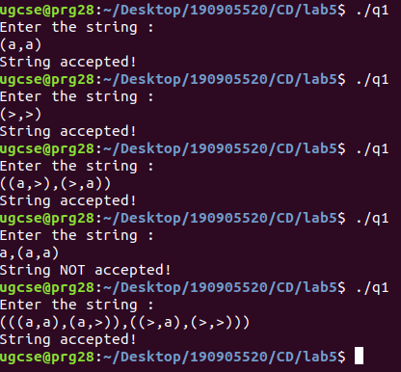

Question 2 :

S -> U V W
U ->( S ) | a S b | d
V -> a V | ϵ
W -> c W | ϵ

There us no left recursion to be eliminated or left factoring to be done.

Source Code :

#include <stdio.h>
#include <stdlib.h>
#include <ctype.h>
#include <string.h>

char buffer[100];
int current = 0;

void success();
void failure();
void S();
void U();
void V();
void W();

int main(){
printf("Enter the string : \n");
char c = 0;
gets(buffer);
strcat(buffer, "$");
S();
if(buffer[current] == '$'){
success();
}
else{
failure();
}
}

void failure(){
printf("String NOT accepted!\n");
exit(1);
}

void success(){
printf("String accepted!\n");
exit(0);
}

void S(){
U();
V();
W();
}

void U(){
if(buffer[current] == '('){
current++;
S();
if(buffer[current] == ')'){
current++;
}
else{
failure();
}
}
else if(buffer[current] == 'a'){
current++;
S();
if(buffer[current] = 'b'){
current++;
}
else{
failure();
}
}
else if(buffer[current] == 'd'){
current++;
}
else{
failure();
}
}

void V(){
if(buffer[current] == 'a'){
current++;
V();
}
}

void W(){
if(buffer[current] == 'c'){
current++;
W();
}
}

Output :

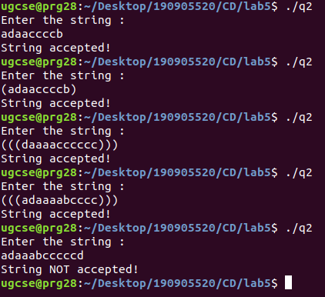
Question 3 :

S -> a A c B e
A -> A b | b
B -> d

Eliminating left recursion

S -> a A c B e
A -> b A`
A` -> b A` | ϵ
B -> d

Source Code :

#include <stdio.h>
#include <stdlib.h>
#include <ctype.h>
#include <string.h>

char buffer[100];
int current = 0;

void success();
void failure();
void S();
void A();
void A_Prime();
void B();

int main(){
printf("Enter the string : \n");
char c = 0;
gets(buffer);
strcat(buffer, "$");
S();
if(buffer[current] == '$'){
success();
}
else{
failure();
}
}

void failure(){
printf("String NOT accepted!\n");
exit(1);
}

void success(){
printf("String accepted!\n");
exit(0);
}

void S(){
if(buffer[current] == 'a'){
current++;
A();
if(buffer[current] == 'c'){
current++;
B();
if(buffer[current] == 'e'){
current++;
}
else{
failure();
}
}
else{
failure();
}
}
else{
failure();
}
}

void A(){
if(buffer[current] == 'b'){
current++;
A_Prime();
}
else{
failure();
}
}

void A_Prime(){
if(buffer[current] == 'b'){
current++;
A_Prime();
}
}

void B(){
if(buffer[current] == 'd'){
current++;
}
else{
failure();
}
}

Output :

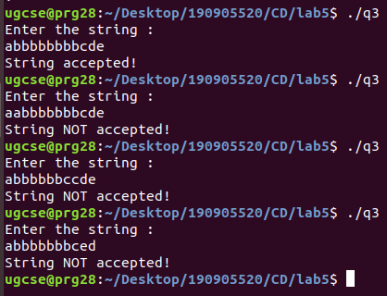

Question 4 :

S -> ( L ) | a
L -> L , S | S

Eliminating left recursion

S -> ( L ) | a
L -> S L`
L` -> , S L` | ϵ

Source Code :

#include <stdio.h>
#include <stdlib.h>
#include <ctype.h>
#include <string.h>

char buffer[100];
int current = 0;

void success();
void failure();
void S();
void L();
void L_Prime();

int main(){
printf("Enter the string : \n");
char c = 0;
gets(buffer);
strcat(buffer, "$");
S();
if(buffer[current] == '$'){
success();
}
else{
failure();
}
}

void failure(){
printf("String NOT accepted!\n");
exit(1);
}

void success(){
printf("String accepted!\n");
exit(0);
}

void S(){
if(buffer[current] == '('){
current++;
L();
if(buffer[current] == ')'){
current++;
}
else{
failure();
}
}
else if(buffer[current] == 'a'){
current++;
}
else{
failure();
}
}

void L(){
S();
L_Prime();
}

void L_Prime(){
if(buffer[current] == ','){
current++;
S();
L_Prime();
}
}
Output :

