Compiler Design Lab 1 – Dipesh Singh - 190905520

Question 1 : To count the number of lines and characters in a file.

Source Code :

#include<stdio.h>
#include<stdlib.h>
#include<string.h>

int main(){
FILE *finp;
finp = fopen("input.txt", "r");
if(finp == NULL) {
printf("Cannot find the file, exiting ...");
return 0;
}
int lines = 0, characters = 0;
char c = 0;
while(c!=EOF){
c = fgetc(finp);
if(c == '\n'){
lines++;
}
else
characters++;
}
printf("The number of lines are : %d, and the number of characters are : %d\n", lines, characters);
fclose(finp);
return 0;
}

input.txt :

This is
a sample
input
file
with 5 lines

Output :

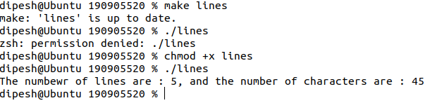

Question 2 : To reverse the file contents and store in another file.Also display the size of file using file handling function.

Source Code :

#include <stdio.h>
#include <stdlib.h>
#include <string.h>

int main(){
FILE *finp , *fout;
finp = fopen("input.txt", "r");
if(finp == NULL){
printf("Cannot find the file, exiting ...");
return 0;
}
fseek(finp, 0L, SEEK_END);
long sz = ftell(finp);
fseek(finp, 0L, SEEK_SET);
char * buffer = (char *)calloc(sz, sizeof(char));
int bufferIndex = sz-1;
fout = fopen("output.txt", "w+");
if(fout==NULL){
printf("Cannot find the file");
return 0;
}
char c = 0;
while(c!=EOF){
c = fgetc(finp);
buffer[bufferIndex--] = c;
}
for(long i = 1; i<sz; i++){
fputc(buffer[i], fout);
}
printf("The size of the file is : %ld\n bytes", sz);
fclose(finp);
fclose(fout);
return 0;
}

input.txt :
This is
a sample
input
file
with 5 lines

Output :

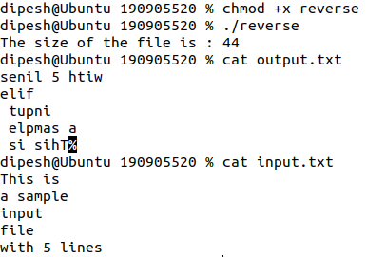

Question 3 : That merges lines alternatively from 2 files and stores it in a resultant file.

Source Code :

#include <stdio.h>
#include <stdlib.h>
#include <string.h>

int main(){
FILE *file1, *file2, *fout;
file1 = fopen("file1.txt", "r");
if(file1 == NULL){
printf("Cannot find file, exiting ...");
return 0;
}
file2 = fopen("file2.txt", "r");
if(file2 == NULL){
printf("Cannot find file, exiting ...");
return 0;
}
fout = fopen("output.txt", "w+");
if(fout == NULL){
printf("Cannot find file, exiting ...");
return 0;
}
char f1 = 0, f2 = 0;
while(f1!=EOF || f2!=EOF){

while(f1!='\n' && f1!=EOF){
f1 = fgetc(file1);

if(f1!=EOF){
fputc(f1, fout);
}
}
if(f1!=EOF){
f1 = 0;
}

while(f2!='\n' && f2!=EOF){
f2 = fgetc(file2);
if(f2!=EOF){
fputc(f2, fout);
}
}
if(f2!=EOF){
f2 = 0;
}
}
fclose(file1);
fclose(file2);
fclose(fout);
return 0;
}

file1.txt :

this is the first file
1 one
1 two
1 three
1 four
1 five

file2.txt :

this is the second file
2 one
2 two
2 three
2 four
2 five

output.txt :

this is the first file
this is the second file
1 one
2 one
1 two
2 two
1 three
2 three
1 four
2 four
1 five
2 five

