**Case Study 3**

Query 1:

select W_location_D.Location_id,W_location_D.location_name,W_Sales_Class_D.Sales_Class_ID,W_Sales_Class_D.Sales_class_desc,W_Sales_Class_D.base_price,w_time_d.time_year,w_time_d.time_month,SUM(w_job_f.quantity_ordered) Sumqtyordered, SUM(W_job_f.quantity_ordered * w_job_f.unit_price) totaljobamounts

from w_job_f, w_location_d, w_time_d, w_sales_class_d

where w_job_f.sales_class_id = w_sales_class_d.sales_class_id

and w_job_f.location_id = w_location_d.location_id

and w_job_f.contract_date = w_time_d.time_id

group by W_location_D.Location_id,W_location_D.location_name,W_Sales_Class_D.Sales_Class_ID,W_Sales_Class_D.Sales_class_desc,W_Sales_Class_D.base_price,w_time_d.time_year,w_time_d.time_month;

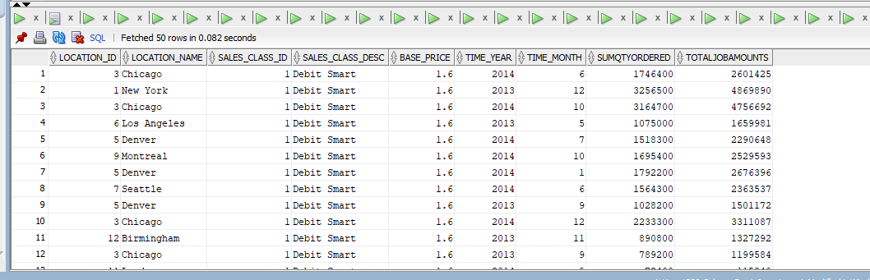

Query 2:

create view basequery2 as

select w_job_f.job_id, w_location_d.location_id, w_location_d.location_name, w_job_f.unit_price, w_job_f.quantity_ordered, w_time_d.time_year, w_time_d.time_month, SUM(w_invoiceline_f.invoice_amount) totalinvoiceamount, SUM(w_invoiceline_f.invoice_quantity) totalinvoicequantity

from w_location_d, w_invoiceline_f, w_time_d, w_job_f, w_sub_job_f, w_job_shipment_f

where w_job_f.location_id = w_location_d.location_id

and w_invoiceline_f.location_id = w_location_d.location_id

and w_sub_job_f.job_id = w_job_f.job_id

and w_job_shipment_f.invoice_id = w_invoiceline_f.invoice_id

and w_job_f.contract_date = w_time_d.time_id

group by w_job_f.job_id, w_location_d.location_id, w_location_d.location_name, w_job_f.unit_price, w_job_f.quantity_ordered, w_time_d.time_year, w_time_d.time_month;

select * from basequery2;

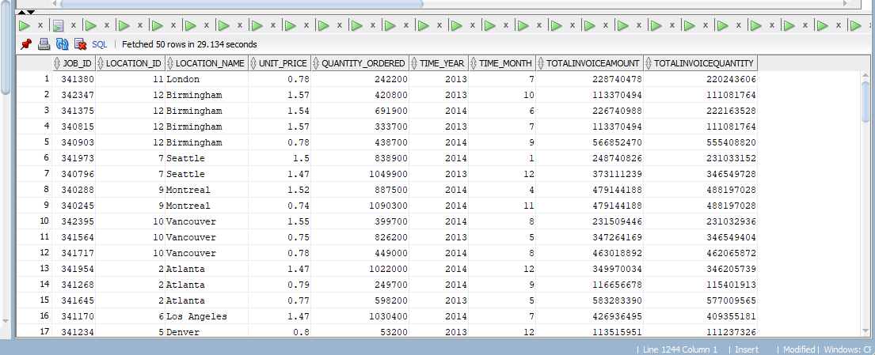

Query 3:

create view basequer3 as

select w_job_f.job_id, w_location_d.location_id, w_location_d.location_name, w_time_d.time_year, w_time_d.time_month,SUM(w_sub_job_f.cost_labor) laborcost, SUM(w_sub_job_f.cost_material) materia1cost, SUM(w_sub_job_f.cost_overhead) as ohcost, SUM(w_sub_job_f.machine_hours * w_machine_type_d.rate_per_hour) machinecost, SUM(w_sub_job_f.cost_labor + w_sub_job_f.cost_material + w_sub_job_f.cost_overhead) as totalcost, SUM(w_sub_job_f.quantity_produced) as totalquantity, SUM(w_sub_job_f.cost_labor + w_sub_job_f.cost_material + w_sub_job_f.cost_overhead) / SUM(w_sub_job_f.quantity_produced) unitcost

from w_job_f, w_location_d, w_time_d, w_sub_job_f, w_machine_type_d

where w_job_f.location_id = w_location_d.location_id

and w_sub_job_f.job_id = w_job_f.job_id

and w_job_f.contract_date = w_time_d.time_id

and w_machine_type_d.machine_type_id = w_sub_job_f.machine_type_id

group by w_job_f.job_id, w_location_d.location_id, w_location_d.location_name, w_time_d.time_year, w_time_d.time_month;

select * from basequer3;

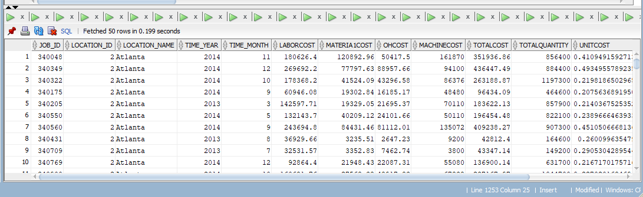

Query 4:

create view basequery4 as

select w_location_d.location_id, w_location_d.location_name, w_sales_class_d.sales_class_id, w_sales_class_d.sales_class_desc, w_time_d.time_year, w_time_d.time_month, SUM(w_invoiceline_f.quantity_shipped - w_invoiceline_f.invoice_quantity) returnquantity, SUM((w_invoiceline_f.invoice_amount/w_invoiceline_f.invoice_quantity)*(w_invoiceline_f.quantity_shipped - w_invoiceline_f.invoice_quantity)) amonutreturned

from w_location_d, w_sales_class_d, w_time_d, w_invoiceline_f

where w_invoiceline_f.invoice_sent_date = w_time_d.time_id

and w_invoiceline_f.quantity_shipped > w_invoiceline_f.invoice_quantity

and w_invoiceline_f.location_id = w_location_d.location_id

and w_invoiceline_f.sales_class_id = w_sales_class_d.sales_class_id

group by w_location_d.location_id, w_location_d.location_name, w_sales_class_d.sales_class_id, w_sales_class_d.sales_class_desc, w_time_d.time_year, w_time_d.time_month;

select * from basequery4;

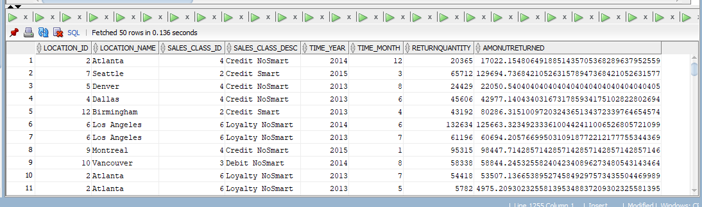

Query 5:

create view basequery5 as

select w_job_f.job_id, w_location_d.location_id, w_location_d.location_name,

w_sales_class_d.sales_class_id, w_sales_class_d.sales_class_desc,

w_job_f.date_promised, x1.last_shipment_date, x1.sumdelayshipqty, w_job_f.quantity_ordered, GetBusDaysDiff(W_JOB_F.date_promised, X1.Last_Shipment_Date) AS BusDaysDiff

from w_job_f, w_location_d, w_sales_class_d,

( select w_sub_job_f.job_id,

max(actual_ship_date) as last_shipment_date,

sum ( actual_quantity ) as sumdelayshipqty

from w_job_shipment_f, w_sub_job_f, w_job_f

where w_sub_job_f.sub_job_id = w_job_shipment_f.sub_job_id

and w_job_f.job_id = w_sub_job_f.job_id

and actual_ship_date > date_promised

group by w_sub_job_f.job_id

) x1

where w_job_f.location_id = w_location_d.location_id

and w_job_f.sales_class_id = w_sales_class_d.sales_class_id

and x1.job_id = w_job_f.job_id;

select * from basequery5;

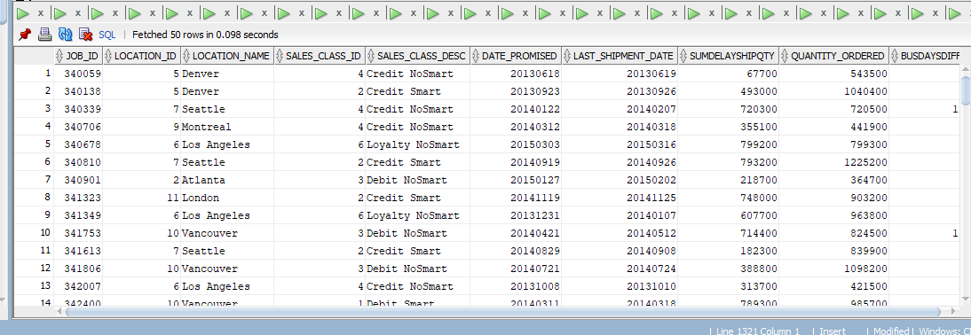

Query 6:

create view basequery6 as

select w_job_f.job_id, w_location_d.location_id, w_location_d.location_name, w_sales_class_d.sales_class_id, w_sales_class_d.sales_class_desc, w_job_f.date_ship_by, x1.firstshipdate firstshipdate, getbusdaysdiff( x1.firstshipdate, w_job_f.date_ship_by) datedifference

from

( select w_sub_job_f.job_id, min(actual_ship_date) as firstshipdate

from w_job_shipment_f, w_sub_job_f

where w_sub_job_f.sub_job_id = w_job_shipment_f.sub_job_id

group by w_sub_job_f.job_id

) x1,

w_job_f, w_location_d, w_sales_class_d

where

w_job_f.location_id = w_location_d.location_id

and w_job_f.sales_class_id = w_sales_class_d.sales_class_id

and x1.firstshipdate > w_job_f.date_ship_by

and x1.job_id = w_job_f.job_id;

select * from basequery6;

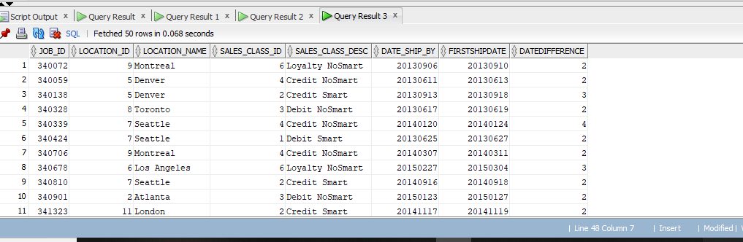

Query A1:

select w_location_d.location_name, w_time_d.time_year, w_time_d.time_month, SUM(SUM(w_job_f.quantity_ordered)) over (partition by w_location_d.location_name, w_time_d.time_year order by w_time_d.time_month rows unbounded preceding) cummulativeorders, SUM(w_job_f.quantity_ordered * w_job_f.unit_price) totaljobamounts

from w_location_d, w_time_d, w_job_f

where w_job_f.location_id = w_location_d.location_id

and w_job_f.contract_date = w_time_d.time_id

group by w_location_d.location_name, w_time_d.time_year, w_time_d.time_month;

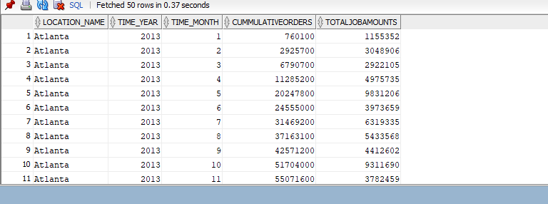

Query A2:

select w_location_d.location_name, w_time_d.time_year, w_time_d.time_month, AVG(AVG(w_job_f.quantity_ordered)) over (partition by w_location_d.location_name order by w_time_d.time_year, w_time_d.time_month rows between 11 preceding and 0 following) moving_avg_orders, AVG(w_job_f.quantity_ordered * w_job_f.unit_price) avg_job_amounts

from w_location_d, w_time_d, w_job_f

where w_job_f.location_id = w_location_d.location_id

and w_job_f.contract_date = w_time_d.time_id

group by w_location_d.location_name, w_time_d.time_year, w_time_d.time_month;

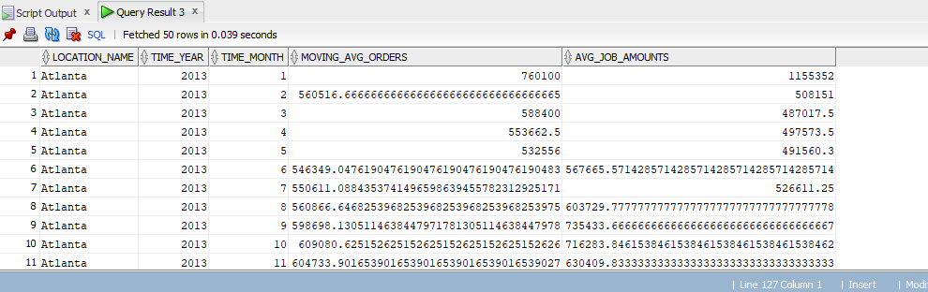

Query A3:

select basequery2.location_name, basequery2.time_year, SUM(basequery2.totalinvoiceamount - basequer3.totalcost) sumofprofit, rank() over (partition by basequery2.time_year order by (SUM(basequery2.totalinvoiceamount - basequer3.totalcost)) desc) annualprofit

from basequery2, basequer3

where basequery2.job_id = basequer3.job_id

group by basequery2.location_name, basequery2.time_year;

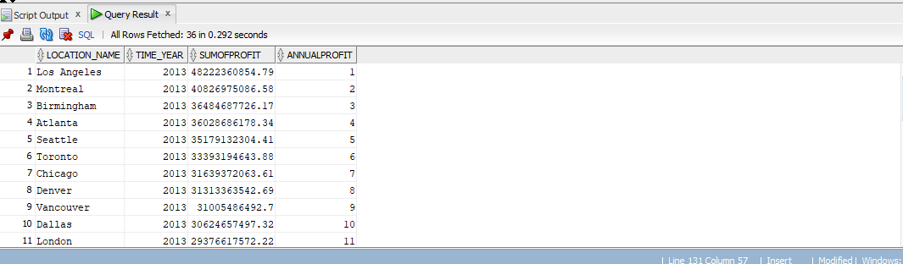

Query A4:

select basequery2.location_name, basequery2.time_year, SUM(basequery2.totalinvoiceamount - basequer3.totalcost) / SUM(basequery2.totalinvoiceamount) profit_margin, rank() over (partition by basequery2.time_year order by (SUM(basequery2.totalinvoiceamount - basequer3.totalcost) / SUM(basequery2.totalinvoiceamount)) desc) rank

from basequery2, basequer3

where basequery2.job_id = basequer3.job_id

group by basequery2.location_name, basequery2.time_year;

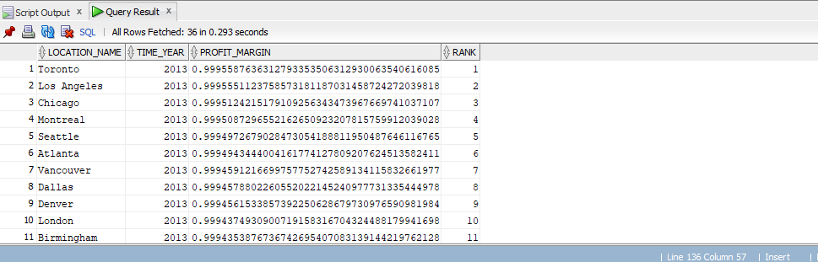

Query A5:

select basequery2.job_id, basequery2.location_name, basequery2.time_year, basequery2.time_month, SUM(basequery2.totalinvoiceamount - basequer3.totalcost) / SUM(basequery2.totalinvoiceamount) profit_margin,

percent_rank() over (order by (SUM(basequery2.totalinvoiceamount - basequer3.totalcost) / SUM(basequery2.totalinvoiceamount) )desc) percentrank

from basequery2, basequer3

where basequery2.job_id = basequer3.job_id

group by basequery2.job_id, basequery2.location_name, basequery2.time_year, basequery2.time_month;

Query A6:

select basequery2.job_id, basequery2.location_name, basequery2.time_year, basequery2.time_month, SUM(basequery2.totalinvoiceamount - basequer3.totalcost) / SUM(basequery2.totalinvoiceamount) profit_margin, percent_rank() over (order by (SUM(basequery2.totalinvoiceamount - basequer3.totalcost) / SUM(basequery2.totalinvoiceamount)) desc) percent_rank

from basequery2, basequer3,

(select basequery2.job_id, basequery2.location_name, basequery2.time_year, basequery2.time_month, SUM(basequery2.totalinvoiceamount - basequer3.totalcost) / SUM(basequery2.totalinvoiceamount) profit_margin,

percent_rank() over (order by (SUM(basequery2.totalinvoiceamount - basequer3.totalcost) / SUM(basequery2.totalinvoiceamount)) desc) percent_rank

from basequery2, basequer3

where basequery2.job_id = basequer3.job_id

group by basequery2.job_id, basequery2.location_name, basequery2.time_year, basequery2.time_month

)

where percent_rank < 0.05

group by basequery2.job_id, basequery2.location_name, basequery2.time_year, basequery2.time_month;

Query A7:

select basequery4.sales_class_desc, basequery4.time_year, SUM(returnquantity), rank() over(partition by basequery4.time_year order by SUM(returnquantity) desc) rank_sales

from basequery4,w_invoiceline_f

where w_invoiceline_f.quantity_shipped > w_invoiceline_f.invoice_quantity

group by basequery4.sales_class_desc, basequery4.time_year;

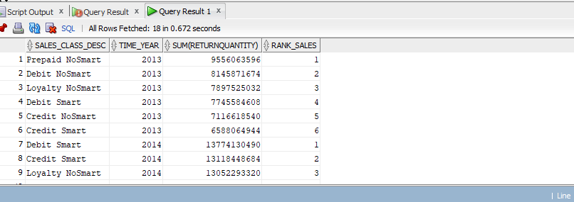

Query A8:

select basequery4.sales_class_desc, basequery4.time_year, SUM(returnquantity), ratio_to_report(SUM(returnquantity)) over (partition by basequery4.time_year) ratio

from basequery4,w_invoiceline_f

where w_invoiceline_f.quantity_shipped > w_invoiceline_f.invoice_quantity

group by basequery4.sales_class_desc, basequery4.time_year;

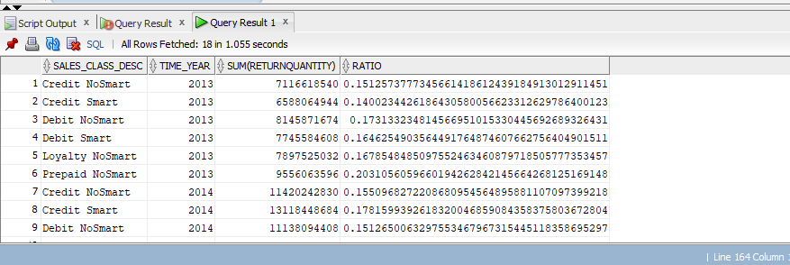

Query A9:

select basequery6.location_name, w_time_d.time_year, SUM(basequery6.datedifference), rank() over(partition by w_time_d.time_year order by SUM(basequery6.datedifference)desc) rank, percent_rank() over(partition by w_time_d.time_year order by SUM(basequery6.datedifference) desc) percent_rank

from basequery6, w_time_d

where basequery6.date_ship_by = w_time_d.time_id

group by basequery6.location_name, w_time_d.time_year;

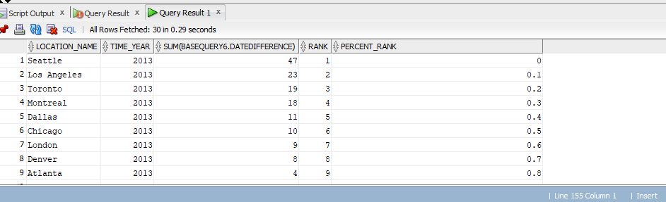

Query A10:

select basequery5.location_name, w_time_d.time_year, count(*) totaljobs, SUM(quantity_ordered - sumdelayshipqty)/SUM(quantity_ordered),

rank() over ( partition by w_time_d.time_year order by SUM(quantity_ordered - sumdelayshipqty)/SUM(quantity_ordered)desc) rankdelay

from basequery5, w_time_d

where w_time_d.time_id = basequery5.date_promised

group by basequery5.location_name, w_time_d.time_year;

