# Related image

[**IT Project Management**](https://ucdenver.instructure.com/courses/395447)

**Assignment**

**ISMG 6450**

**Submitted By:**

**Garima Singh**

**Name of Project:** **Autonomous Vehicles**

**Sponsor & Co-Sponsors:** Waymo, BMW, Tesla, CrowdFlower, Gestoos, IPG Automotive, Quantum

<https://autonomousvehicles.iqpc.com/sponsors>

**Executive Summary:**

Unmanned technology is sophisticated and it will continue to develop and become more commercially available. Autonomous vehicles are vehicles which can drive themselves without human intervention; these are either controlled remotely, or perhaps operate autonomously. The continuous evolution of this technology will expand its application across a large range of activities. Adoption of this technology will rely on many factors and have issues of safety and security. The major challenge is to incorporate unmanned vehicles into the existing environment. Additionally, there is significant public concern over safety and responsible use. Autonomous cars incorporate sophisticated safety features, but human input will continue to be a significant risk factor.

My project is about autonomous cars and its innovations, though it has many risks associated with it. Autonomous and unmanned vehicles involve a transfer of control from direct human input to automated or remote control. This has implications for the determination of liability in the event of an incident, and will be a key factor in the pricing and structure of risk transfer.

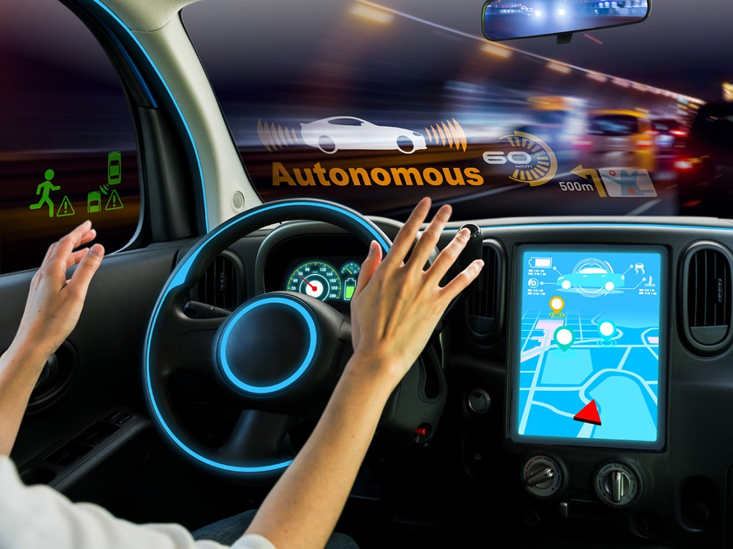

This concept is not new but is having an incremental advance over the years. Many big companies like google and tesla are having a keen interest in investing in these future cars.

**Project Scope Statement:**

The main scope of this project is to make cars which do not need any human intervention. It may have very high risk but with time and technology this can lead to a better & safe driving experience and less accidents.

There will be a time when people do not have to pay for the driver’s salary; your rides will be five to ten times cheaper. This will take time to implement but there will be a time where travel will become cheaper to use these shared cars.

**Five Milestones to accomplish the Project:**

- Self-parking.

- Full highway autonomy.

- Self-fueling.

- Highway lane keeping.

- Autonomous engine reviving at red lights.

- Legal and licensing considerations

### Budget: The technology which is being used to make autonomous car is definitely very high as we need expertise of each domain and technology we are using in that. We cannot afford to loosen up any part of this as it will be fully automatic and a small glitch can result in loss of life.

### While current estimates for the cost of a self-driving hardware and software package range from $70,000 to $150,000, “the cost of that autonomous driving stack by 2025 will come down to about $5,000 because of technology developments and (higher) volume.

### Staff Needs:

### Gestoos is an AI platform that enables cameras and sensors to see, understand, and respond to human movement and behavior in any environment or context. Autonomous vehicles will enable new ways of driving, with more freedom than ever before.

### IPG Automotive: Driving technology forward and providing efficient vehicle development solutions. With virtual test driving, we offer a solution to meet the increasing demands of the development process. Autonomous vehicle testing and development processes generate massive amounts of data.

### Quantum’s automotive storage solutions enable in-car storage capacity for complete test cycles; fast ingest rates for prompt access to test data; multi-tier storage to manage cost and performance; seamless scalability to simply add capacity and performance independently

### TomTom created the easy-to-use navigation device, one of the most influential inventions of all time. Since then, we have grown from a start-up, into a global technology company. Our software and navigation technologies power over hundreds of millions of applications across the globe.