import numpy as np

import pandas as pd

import matplotlib.pyplot as plt

def estimate_coef(x, y):

    # number of observations/points

    n = np.size(x)

    # mean of x and y vector

    m_x = np.mean(x)

    m_y = np.mean(y)

    # calculating cross-deviation and deviation about x

    SS_xy = np.sum(y*x) - n*m_y*m_x

    SS_xx = np.sum(x*x) - n*m_x*m_x

    # calculating regression coefficients

    b_1 = SS_xy / SS_xx

    b_0 = m_y - b_1*m_x

    return (b_0, b_1)

def plot_regression_line(x, y, b):

    # plotting the actual points as scatter plot

    plt.scatter(x, y, color = "m",

            marker = "o", s = 30)

    # predicted response vector

    y_pred = b[0] + b[1]*x

    # plotting the regression line

    plt.plot(x, y_pred, color = "g")

    # putting labels

    plt.xlabel('x')

    plt.ylabel('y')

    # function to show plot

    plt.show()

def main():

    # observations / data

    dataset = pd.read_csv("Salary_Data.csv")

    years = dataset.iloc[:,0:1].values

    x = years

    salary= data = dataset.iloc[:,1:2].values

    y = salary

    # estimating coefficients

    b = estimate_coef(x, y)

    print("Estimated coefficients:\nb_0 = {} \

        \nb_1 = {}".format(b[0], b[1]))

    # plotting regression line

    plot_regression_line(x, y, b)

if __name__ == "__main__":

    main()

Output

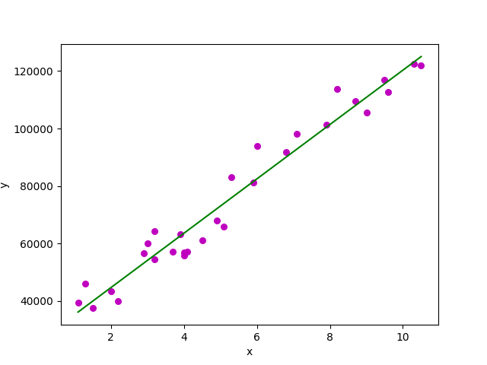

import matplotlib.pyplot as plt

import numpy as np

from sklearn import datasets, linear_model, metrics

# load the boston dataset

boston = datasets.load_boston(return_X_y=False)

# defining feature matrix(X) and response vector(y)

X = boston.data

y = boston.target

# splitting X and y into training and testing sets

from sklearn.model_selection import train_test_split

X_train, X_test, y_train, y_test = train_test_split(X, y, test_size=0.4,

                                                    random_state=1)

# create linear regression object

reg = linear_model.LinearRegression()

# train the model using the training sets

reg.fit(X_train, y_train)

# regression coefficients

print('Coefficients: ', reg.coef_)

# variance score: 1 means perfect prediction

print('Variance score: {}'.format(reg.score(X_test, y_test)))

# plot for residual error

## setting plot style

plt.style.use('fivethirtyeight')

## plotting residual errors in training data

plt.scatter(reg.predict(X_train), reg.predict(X_train) - y_train,

            color = "green", s = 10, label = 'Train data')

## plotting residual errors in test data

plt.scatter(reg.predict(X_test), reg.predict(X_test) - y_test,

            color = "blue", s = 10, label = 'Test data')

## plotting line for zero residual error

plt.hlines(y = 0, xmin = 0, xmax = 50, linewidth = 2)

## plotting legend

plt.legend(loc = 'upper right')

## plot title

plt.title("Residual errors")

## method call for showing the plot

plt.show()

output

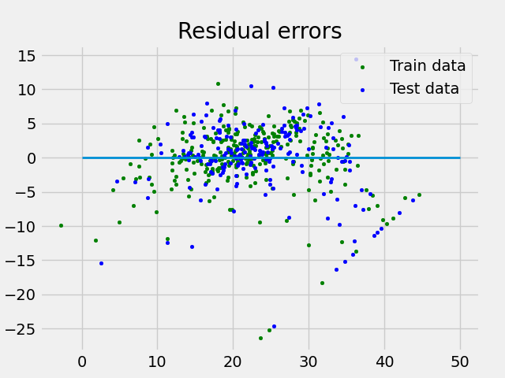

import pandas as pd

import numpy as np

import matplotlib.pyplot as plt

dataset = pd.read_csv("Social_Network_Ads")

# input

x = dataset.iloc[:, [2, 3]].values

# output

y = dataset.iloc[:, 4].values

from sklearn.model_selection import train_test_split

X_train, X_test, y_train, y_test = train_test_split(x, y, test_size = 0.25, random_state = 0)

from sklearn.preprocessing import StandardScaler

sc_x = StandardScaler()

xtrain = sc_x.fit_transform(xtrain)

xtest = sc_x.transform(xtest)

print (xtrain[0:10, :])

from sklearn.linear_model import LogisticRegression

classifier = LogisticRegression(random_state = 0)

classifier.fit(xtrain, ytrain)

y_pred = classifier.predict(xtest)

from sklearn.metrics import confusion_matrix

cm = confusion_matrix(ytest, y_pred)

print ("Confusion Matrix : \n", cm)

from sklearn.metrics import accuracy_score

print ("Accuracy : ", accuracy_score(ytest, y_pred))

from matplotlib.colors import ListedColormap

X_set, y_set = xtest, ytest

X1, X2 = np.meshgrid(np.arange(start = X_set[:, 0].min() - 1,

                            stop = X_set[:, 0].max() + 1, step = 0.01),

                    np.arange(start = X_set[:, 1].min() - 1,

                            stop = X_set[:, 1].max() + 1, step = 0.01))

plt.contourf(X1, X2, classifier.predict(

            np.array([X1.ravel(), X2.ravel()]).T).reshape(

            X1.shape), alpha = 0.75, cmap = ListedColormap(('red', 'green')))

plt.xlim(X1.min(), X1.max())

plt.ylim(X2.min(), X2.max())

for i, j in enumerate(np.unique(y_set)):

    plt.scatter(X_set[y_set == j, 0], X_set[y_set == j, 1],

                c = ListedColormap(('red', 'green'))(i), label = j)

plt.title('Classifier (Test set)')

plt.xlabel('Age')

plt.ylabel('Estimated Salary')

plt.legend()

plt.show()

