Vendor app updation:

1.Their must be other option in service list while registering the vendor on the vendor app.

As shown below:-

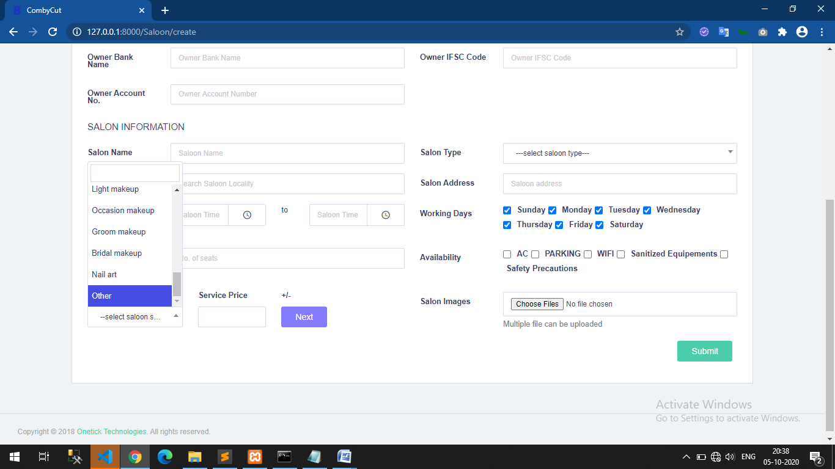

2. when vendor click on other option from the service list an input box for other service will appear were vendor can enter their other service which is not there in the service list.

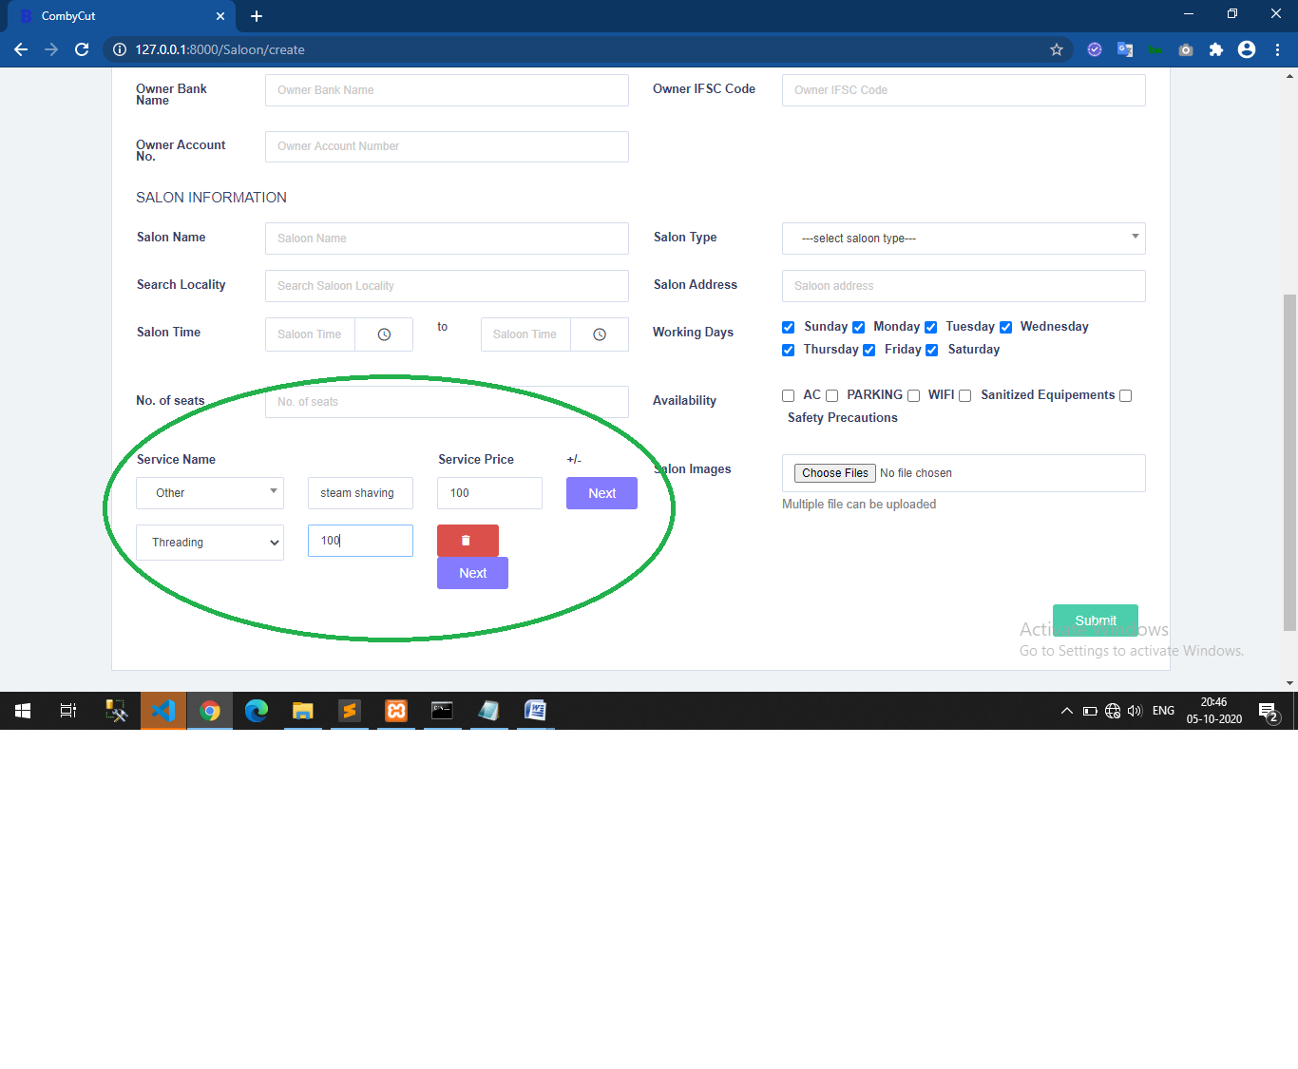

3. same will be done after the registration, if further after registration vendor wants to add his services in my services then this other service should be available there also with same procedure as explained above while registration.

In the below section of the app:-

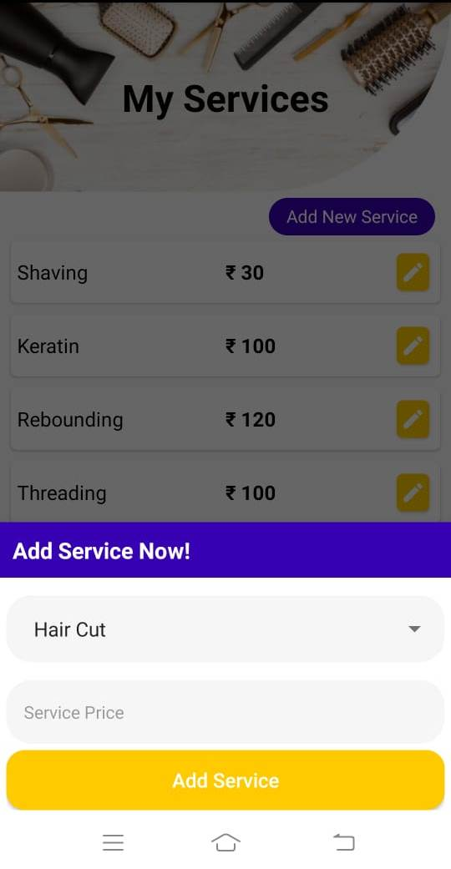

4.Gallery image must be full screen

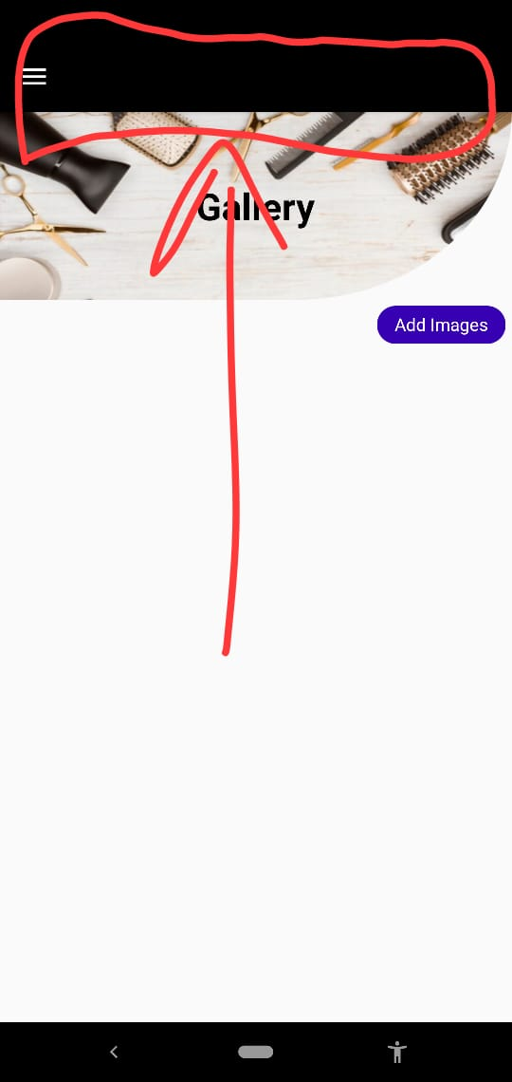

5.word should in one tab

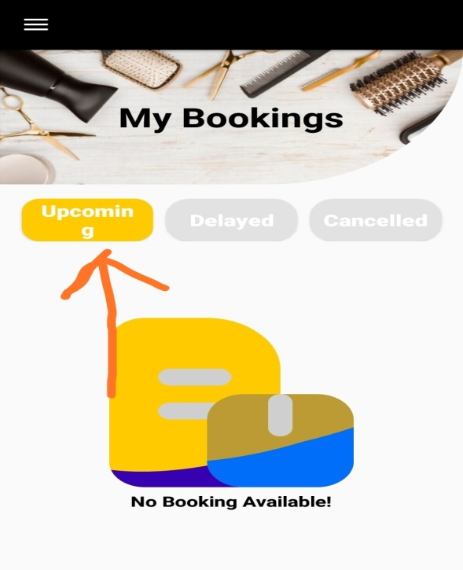

6.In earning tab month name should change according to current month automatically

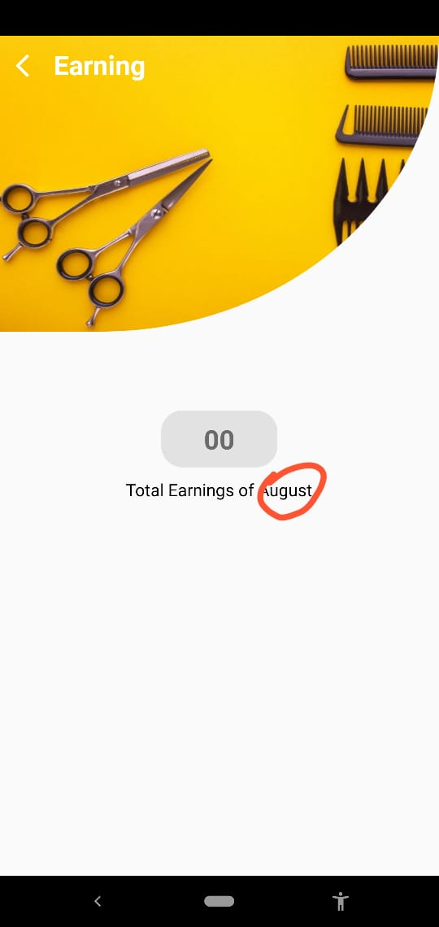

7.App crashes while updation of vendor details.

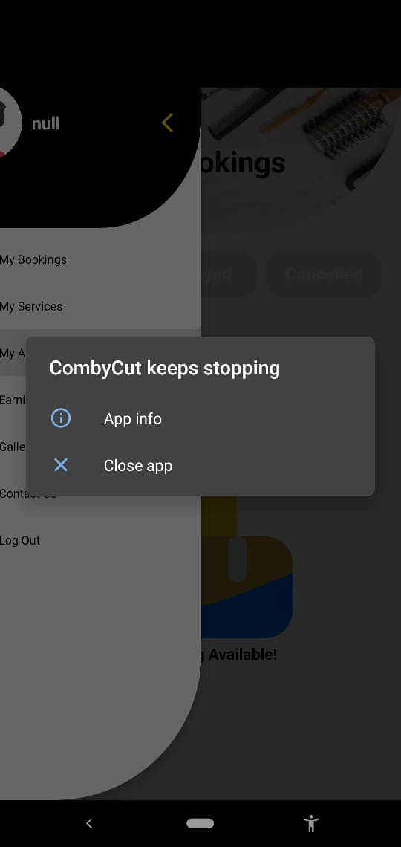

Note- when we register a vendor and with out filling its futher details (like owner details, saloon information) ,he/she got registered ,so after login app crashes on following condition :-

1. On updation vendor app crashes,
2. Vendor name is showing null , pls handle it on front end, because vendor has registered with mobile number no other details is their in database related to that vendor, so api is returning null details . (handle it on front end)

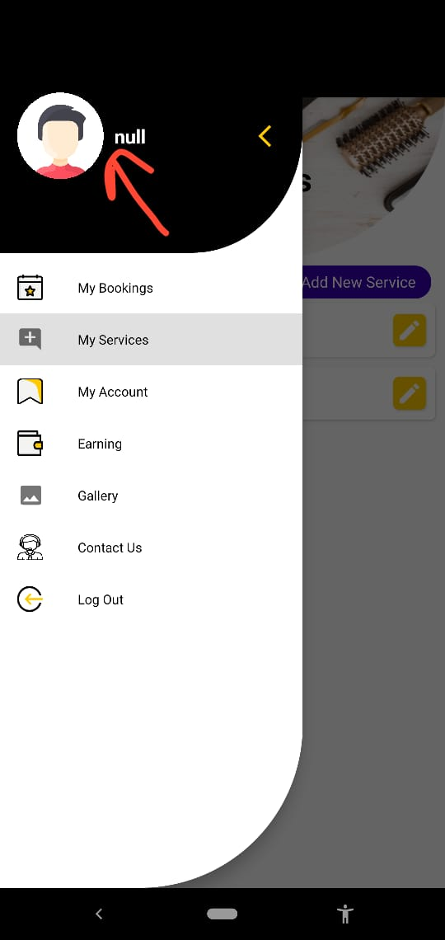

8.While vendor registration ,vendor address must be automatically filled field. Or may provide auto complete address.

