VENDOR APP BUGS

1. While selecting salon from time(field) by default must be pm.

2. App crashes while registration, when we fill details and goes back to change some details.

3. Address is not filling up automatically while registration.

4. App crashes when we are registration is done only with mobile no. , then after login if we tries to update account app crashes.

5. When we are registering only with mobile no. , then after login vendor name is showing null.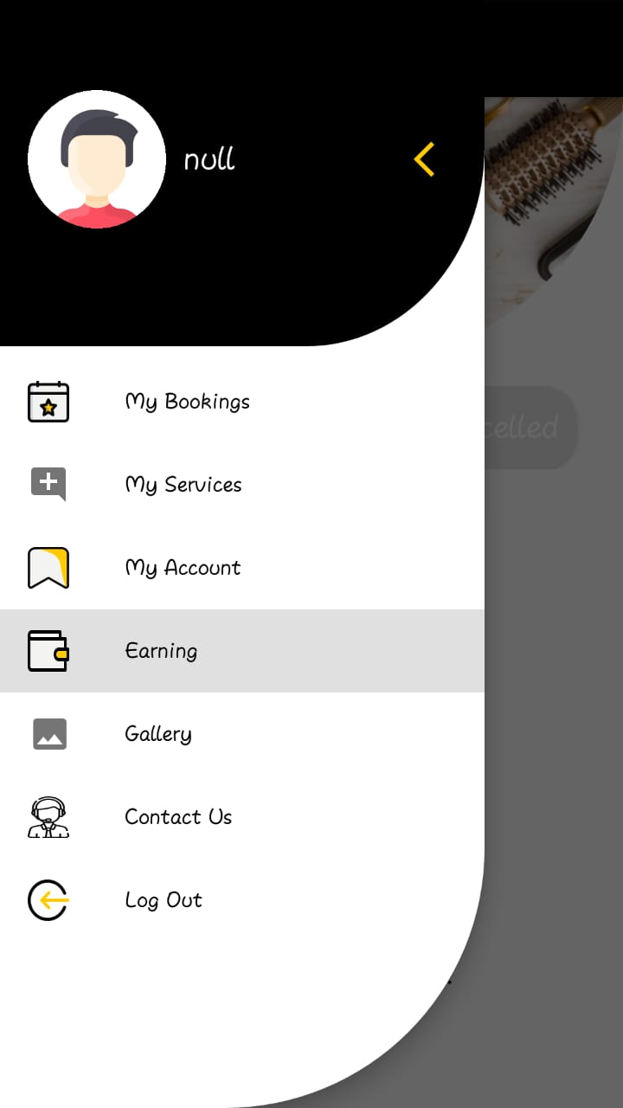

6. While adding other service (new service field) remain filled with previous service name.

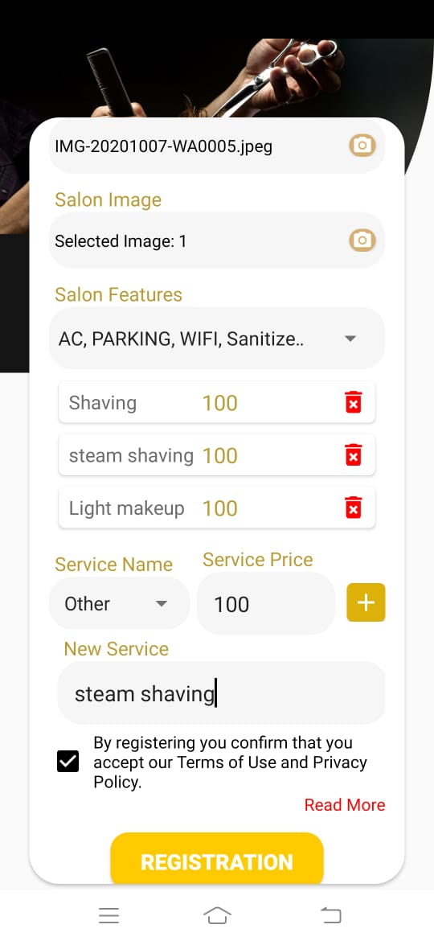

7. Other service is not visible in service list of vendor.