**Associate Software Development Engineer Intern**

**Himansu**

**EXPEDIA GROUP | gURUGRAM**

INTERNSHIP REPORT

ACKNOWLEDGEMENT

First and foremost I would like to express the deepest appreciation to Mr. Ram Sharma , Manager Information Technology for guiding me on my internship procedure at Expedia Group. I will always be grateful to him for helping me throughout the processes.

**Table of Content**

List of Figures……….

List of Tables……..

List of Abbreviations…….

**Chapter 1: INTRODUCTION**

1.1 Overview…….

1.2 Origin of the Report……

1.3 Methodology………..

1.4 Conclusion……………………..

**Chapter 2: ORGANIZATION OVERVIEW**

2.1 Overview about the Company ……………

2.2 History of Expedia………………………..

2.3 Products/Brands of Expedia Group………………..

2.4 Mission and Purpose of Expedia Group………….

2.5 Departments/Divisions at Expedia Group……………..

2.6 eCP (eCommerce Platform)………..

2.7 PFS (Platform Foundation & Strategy)……….

2.8 Hybrid Infrastructure Team………….

**Chapter 3: INTERSHIP PROJECT**

3.1 Objective of Project……….

3.2 Purpose of Project………….

3.3 Knowledge and skills Acquired for Project…………

**CHAPTER 1: INTRODUCTION**

**1.1 OVERVIEW**

Internship is a program that enhances the capability of the graduates and a scope to do practical works in an organization related to the student’s major to gain the work experience. According to Oxford Dictionary, A student or trainee who works, sometimes without pay, in order to gain work experience or satisfy requirements for a qualification. As the outside world is very competitive for anyone after graduation, internship gives the student great opportunity to have a head start.

As a student of NSUT(Netaji Subhas University of Technology, formerly Netaji Subhas Institute of Technology) we undergraduate students requires that we complete an internship period with a reputable company where I will be trained practically with working environment practices and get familiar with the industry.

In this report, I have discussed my internship period at Expedia Group, an overview of the company and its activities, my experiences working for a reputed firm, what I have learned and how it is helped me to develop and grow.

**1.2 ORIGIN OF THE REPORT**

This report reflects upon the two-month long internship period at Expedia Group. It focuses on overview of Expedia Group , my contribution to the organization and how it has developed my skills and how I have applied my skills in development project.

**1.3 METHODOLOGY**

All information used in the report is collected from both internal and external sources. The primary sources of data for this report are Through personal experience and observation and Through conversation with other employees. The Secondary sources of data for this report are Company website , Related office Documents and Internet.

**1.4 CONCLUSION**

The internship period helps in developing skills and knowledge, but it also gets us in touch with industry experts and the big names. In this report I have given an overview of my company, my experiences working there, my involvement and contributions and finally I have made a self-assessment on my performance during the internship period.

**CHAPTER 2: ORGANIZATION OVERVIEW**

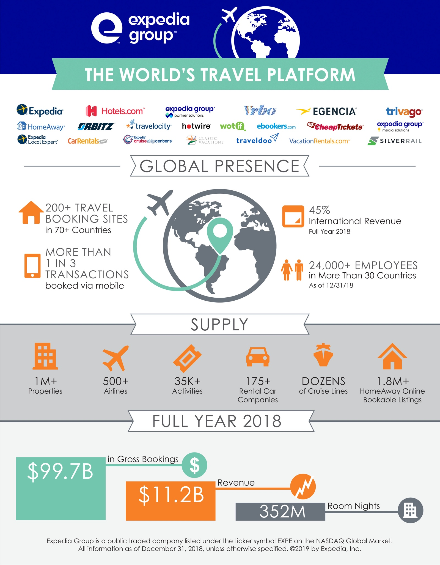

**2.1 ABOUT THE COMPANY**

**Expedia Group** is an American global travel technology company. Its websites, which are primarily travel fare aggregators and travel metasearch engines, include CarRentals.com, CheapTickets,Expedia.com, HomeAway,  Hotels.com, Hotwire.com, Orbitz, Travelocity, trivago, and Venere.com.

According to Rich Barton, the company's first CEO, the word "Expedia" is derived from a combination of exploration and speed.

**2.1 HISTORY**

Founded as a division of Microsoft in October 1996, Expedia was spun off into a public company in 1999.

In 2001, IAC/InterActiveCorp (known at the time as USA Networks Inc) bought a controlling interest in the company for an estimated $1.5 billion.

In 2003, it was fully purchased by IAC/InterActiveCorp.

In August 2005, IAC spun off Expedia Inc., which owned its travel group of businesses, including Expedia, Expedia Corporate Travel (now Egencia), TripAdvisor, Classic Vacations, Hotels.com, and Hotwire.com.

On December 21, 2012, Expedia bought a majority stake in travel metasearch engine Trivago in a combined cash and stock deal worth €477 million (approximately $630 million).

In 2012, Expedia's Egencia unit acquired Via Travel, the largest travel company in Norway.

In 2014, Expedia acquired Wotif.com for $658 million.

In January 2015, Expedia acquired Travelocity from Sabre Corp for $280 million.

In 2015, Expedia acquired Orbitz for $1.2 billion in cash.

In 2015, Expedia bought HomeAway for $3.9 billion.

In August 2017, Mark Okerstrom became the President and CEO of Expedia, Inc.

In March 2018, Expedia, Inc. announced that it had changed its name to Expedia Group, Inc.

**2.3 PRODUCTS OF EXPEDIA**

BedandBreakfast.com  
CarRentals.com  
CheapTickets  
Classic Vacations  
Ebookers  
Egencia  
Expedia.com  
Expedia Affiliate Network  
Expedia Local Expert  
Expedia CruiseShipCenters  
Expedia Global Partner Solutions  
HomeAway  
Hotels.com  
Hotwire Group  
Orbitz  
Travelocity  
trivago  
wotif  
ALICE



**2.3 MISSION AND PURPOSE OF EXPEDIA**

Expedia Group Mission is to Revolutionize Travel Through the Power of Technology.

Expedia Group is to bring the world within reach.

**Expedia Group’s Guiding Principles**

Put Yourself in the Shoes of our Customers and Partners

One Team, Group First

Have a Bias to Action

Relentlessly Strive for Better

Think Big and Small

Be Data Driven and Business Judgment Led

Simplify

Be Open and Honest

Be Humble

Be Positive. Assume Positive Intent

**2.4 DEPARTMENTS/DIVISIONS**

1. BEX Group
2. Commercial Strategy and Services(CSS)
3. Corporate Account Payable
4. Data Services & Platforms
5. eCommerce Platform (eCP)
6. Expedia Partner Solutions (EPS)
7. Financial & Core Transaction Services (FCTS)
8. Global Finance
9. Global Real Estate
10. Legal
11. Network Operations Center (NOC)
12. Procurement
13. Regulatory Reporting
14. Strategic Growth Initiatives
15. Trovers
16. Workplace Facilities

**2.5 MY DIVISION (eCP- eCOMMERCE PLATFORM)**

​I worked under the Division eCP(eCommerce Platform).

The eCommerce Platform (or eCP for short), an organization of over 4,000 employees — not including many customer support agents — that runs the technology engine under the hood of the world's largest travel platform. Its mission is to be the most expansive​​​ and versat​ile transaction platform in travel​.​

eCP is the foundation for Expedia Group's daily operations - from IT support to data centre management, system access to traveller assistance, payment services to big data. The teams are front and center in the lives of EG employees, providing laptops, office space, network access, and data security, among many other things; and They are working steadily behind Expedia Group's front-end brand websites, converting customer "clicks" into incredible travel experiences.​​

**2.6 MY SUBDIVISION (PFS PLATFORM FOUNDATION & STRATEGY)**

**2.7 MY TEAM (HYBRID INFRASTRUCTURE)**

**CHAPTER 3: INTERNSHIP PROJECT**

**3.1 OBJECTIVE**

**Network Device Configuration Management**

“The objective of the Project is to take the Backup of Network Devices weekly And save it to Github – Using the Backup at the time of Incident”

**Actions/Steps Required to complete the project**

1. Work on Python Script to SSH the Network Devices.
2. Work on username and Process to trigger script through Stackstorm.
3. Push the Configuration of Network Devices on Github.

**3.2 PURPOSE**

**3.3 KNOWLEDGE AND SKILL ACQUIRED**

* **Overview of OSI Model**
* **Types and Classes of IP Address**
* **HTTP Vs HTTPS**
* **API (Response)**
* **Python Language**
* **Paramiko Module in Python**
* **SSH Protocol**
* **GIT**