Step for installing Apache tomcat on Server1, Server 2, and Jenskin

Step 1: launch ec2 server 1 / go to folder opt..

ssh -i "amkey.pem" [ec2-user@ec2-18-220-102-60.us-east-](mailto:ec2-user@ec2-18-220-102-60.us-east-)

2.compute.amazonaws.com

Cd opt

Step 2: update the server – sudo yum update

Step 3: download the tomcat from web

wget su <https://apache.claz.org/tomcat/tomcat-9/v9.0.34/bin/apache-tomcat-9.0.34.tar>

step 4: list the files and unzip apache tomcat folder

ls-l

tar -xvzf apache-tomcat-9.0.34.tar.gz

Step 5: open the folder and go to bin folder

ll

cd apache-tomcat-9.0.34/

cd bin

Step 6: install java open jdk

yum install java-1.8.0-openjdk

Step 7: open the folder and start the Tomcat

ll

./startup.sh

Screenshot for installing Tomcat

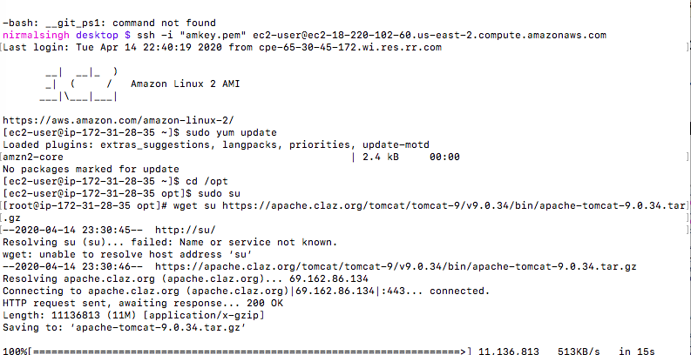

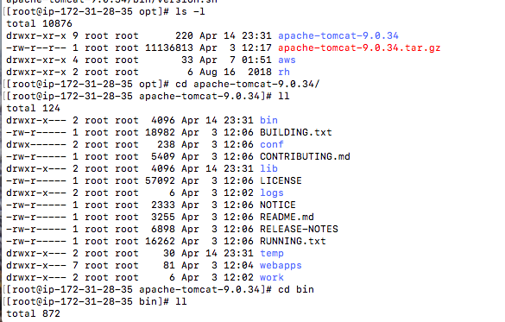

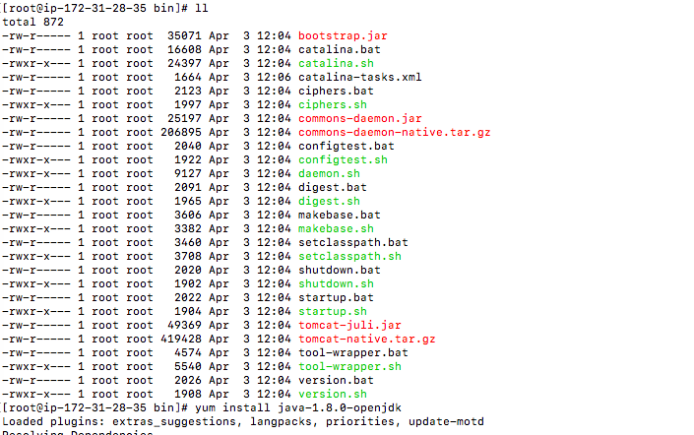

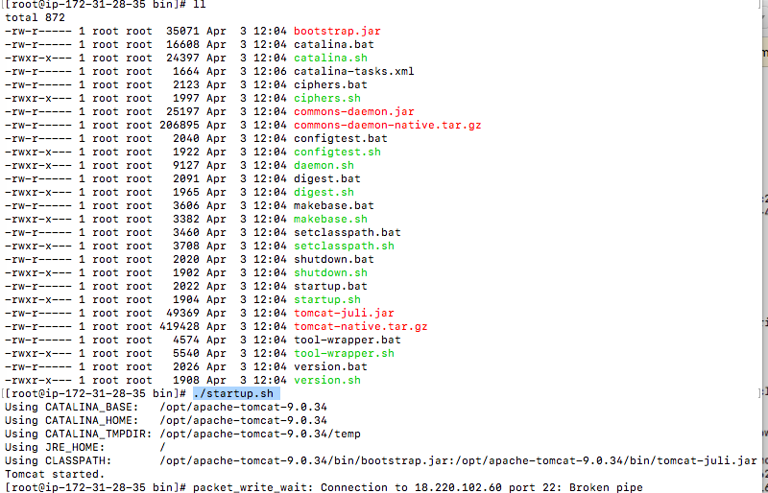

Install Jenkin on Jenkin Server

Step 1: go ec2 user folder

cd home/ec2-user/

Step 2: open you.repos.d folder

cd /etc/yum.repos.d

Step3: installed Jenkins

sudo rpm --import https://jenkins-ci.org/redhat/jenkins-ci.org.key

yum install Jenkins

Step 4: start jenkin server

service jenkins start

Screenshot for Jenkins

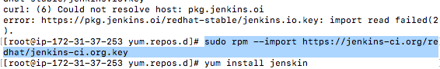

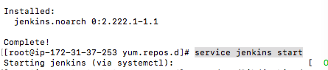

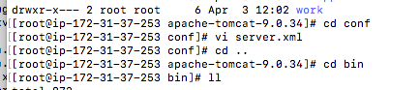

Creating Pipeline :

Step 1: Creating Git Downloading

-Create folder

- go to configure

- Go to source code management

-select git

- - type Repository URL

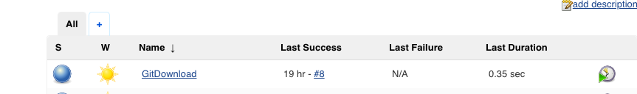

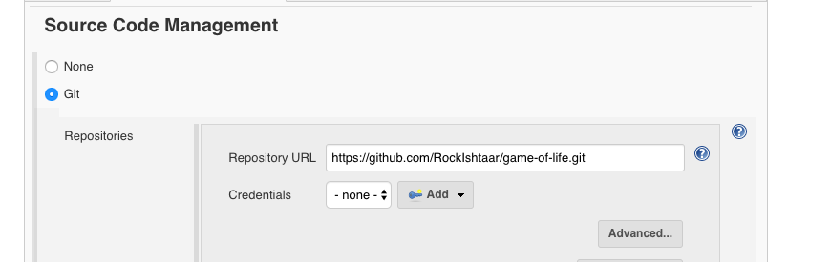

Step 2 Create project for maven

* go to configure
* Go under build
* Execute shell
* cd /var/lib/jenkins/workspace/GitDownload
* ls -lrt
* mvn clean install

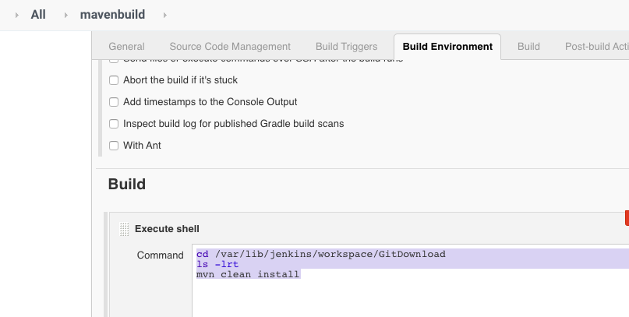

Step 3: Transfer file to Server 1 and Server 2

-create project

- go to configure

- copy the war file to Jenkins

cp /var/lib/jenkins/workspace/GitDownload/gameoflife-web/target/gameoflife.war .

-Source file

Gameoflife.war

-send file to server1 and server2 in Exec command

sudo /opt/apache-tomcat-9.0.34/bin/shutdown.sh

sudo /opt/apache-tomcat-9.0.34/bin/startup.sh

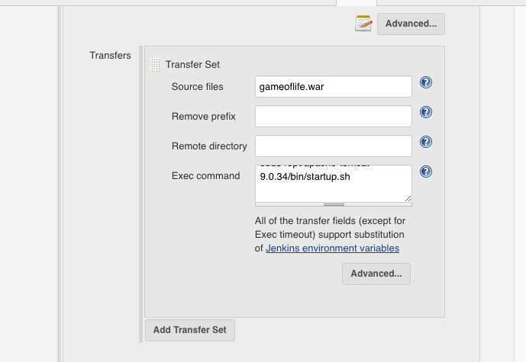

Create pipeline project : last step

-Select pipeline project

- select pipeline script

- run the script

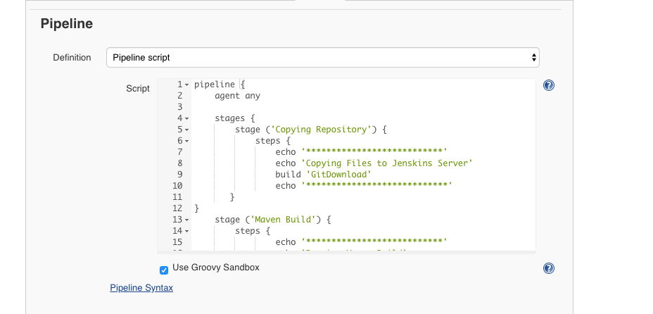

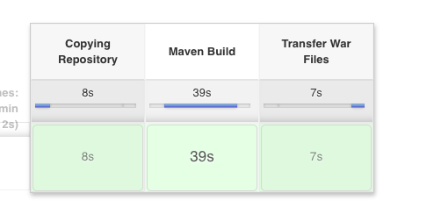

pipeline {

agent any

stages {

stage ('Copying Repository') {

steps {

echo '\*\*\*\*\*\*\*\*\*\*\*\*\*\*\*\*\*\*\*\*\*\*\*\*\*\*\*'

echo 'Copying Files to Jenskins Server'

build 'GitDownload'

echo '\*\*\*\*\*\*\*\*\*\*\*\*\*\*\*\*\*\*\*\*\*\*\*\*\*\*\*\*'

}

}

stage ('Maven Build') {

steps {

echo '\*\*\*\*\*\*\*\*\*\*\*\*\*\*\*\*\*\*\*\*\*\*\*\*\*\*\*'

echo 'Running Maven Build'

build 'mavenbuild'

echo '\*\*\*\*\*\*\*\*\*\*\*\*\*\*\*\*\*\*\*\*\*\*\*\*\*\*\*\*'

}

}

stage ('Transfer War Files') {

steps {

echo '\*\*\*\*\*\*\*\*\*\*\*\*\*\*\*\*\*\*\*\*\*\*\*\*\*\*\*'

echo 'Transferring War Files to AppServer'

build 'TransferWarFiles'

echo '\*\*\*\*\*\*\*\*\*\*\*\*\*\*\*\*\*\*\*\*\*\*\*\*\*\*\*\*'

}

}

}

}