Jagjot Singh-100374227

USE CASE DESCRIPTION

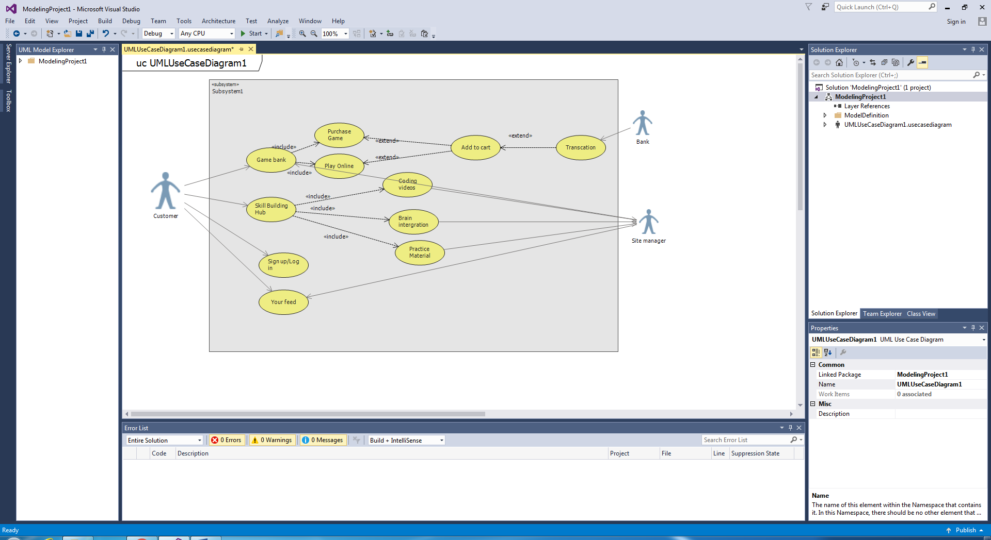

USE CASE Game Bank

Primary Actor Customer

Level Homepage Level

Stakeholder Customer, Bank, Site holder

Precondition User logged in

Minimal Guarantee Transactions are made easily

Success Guarantee Games customer is searching will be on the top

Trigger User redirected to homepage

USE CASE Skill Building Hub

Primary Actor Customer

Level Homepage level

Stakeholder Customer, Site manager

Precondition Logged in

Minimal Guarantee Failure of tutorial

Success Guarantee Customer will get deeper knowledge of developing games

Trigger User redirected to Skill Building Hub

USE CASE Sign up/Log in

Primary Actor Customer

Level Homepage level

Stakeholder Customer, Site manager

Precondition Customer Access to website

Minimal Guarantee Customer will get all task easily available

Success Guarantee Customer will be logged in

Trigger Customer redirected to homepage

USE CASE Your Feed

Primary Actor Customer

Level Homepage Level

Stakeholder Customer, Site Manager

Precondition Customer should be logged in.

Minimal Guarantee Comment can be done easily.

Success Guarantee Comments will be kept secret

Trigger Customer redirected to homepage