Jagjot Singh

100374227

INFO1113 S11

Assignment 3

November 14, 2018

Instructor-Abhijit Sen

Team Members:

1. Jaskirat Singh Grewal(100365933):<https://github.com/jazzgrewal/gamerzhere_jaskirat>
2. Rishabh Garg(100371073):<https://github.com/rishabh4899/UseCaseDiagram>
3. Omar Abushbak (100368325):<https://github.com/omarabushbakxx/gamerzhere-omar>
4. Jagjot Singh(100374227):<https://github.com/singhjagjot0013/gamerzhere-jagjotsingh>

**Reviewing**

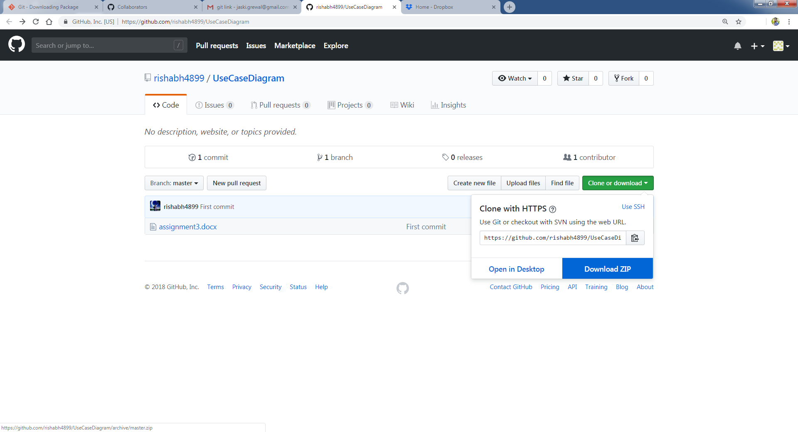

Step 1: Downloading Rishabh Garg’s Assignment 3 file which has UML diagram and the Use Case Description.

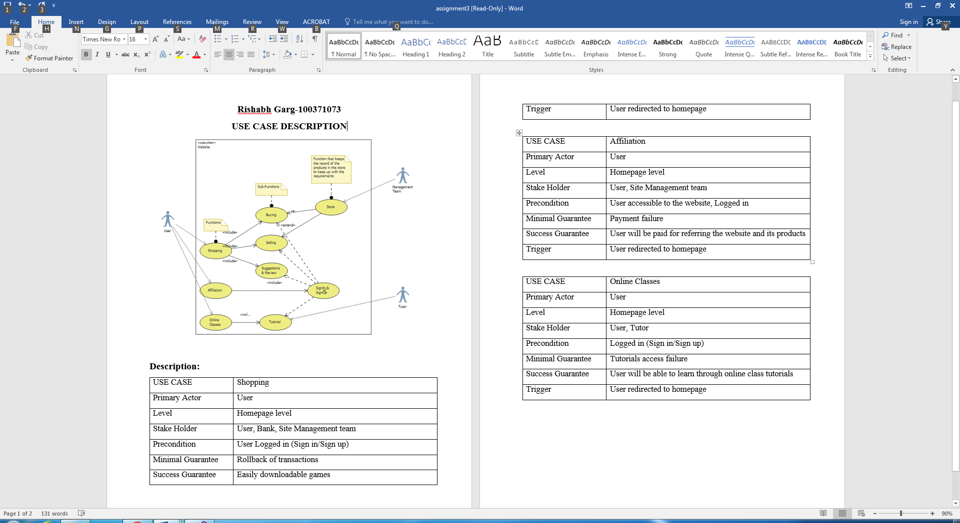

Step 2: Review Screenshot, his idea of gaming project was awesome but according to me it is too much complicated. When we will consider this as are final project then this require lot of attention. Moreover he has one use case that is affiliation, that will be tricky.

**Uploading The Final UML Diagram and Adding Collaborators**

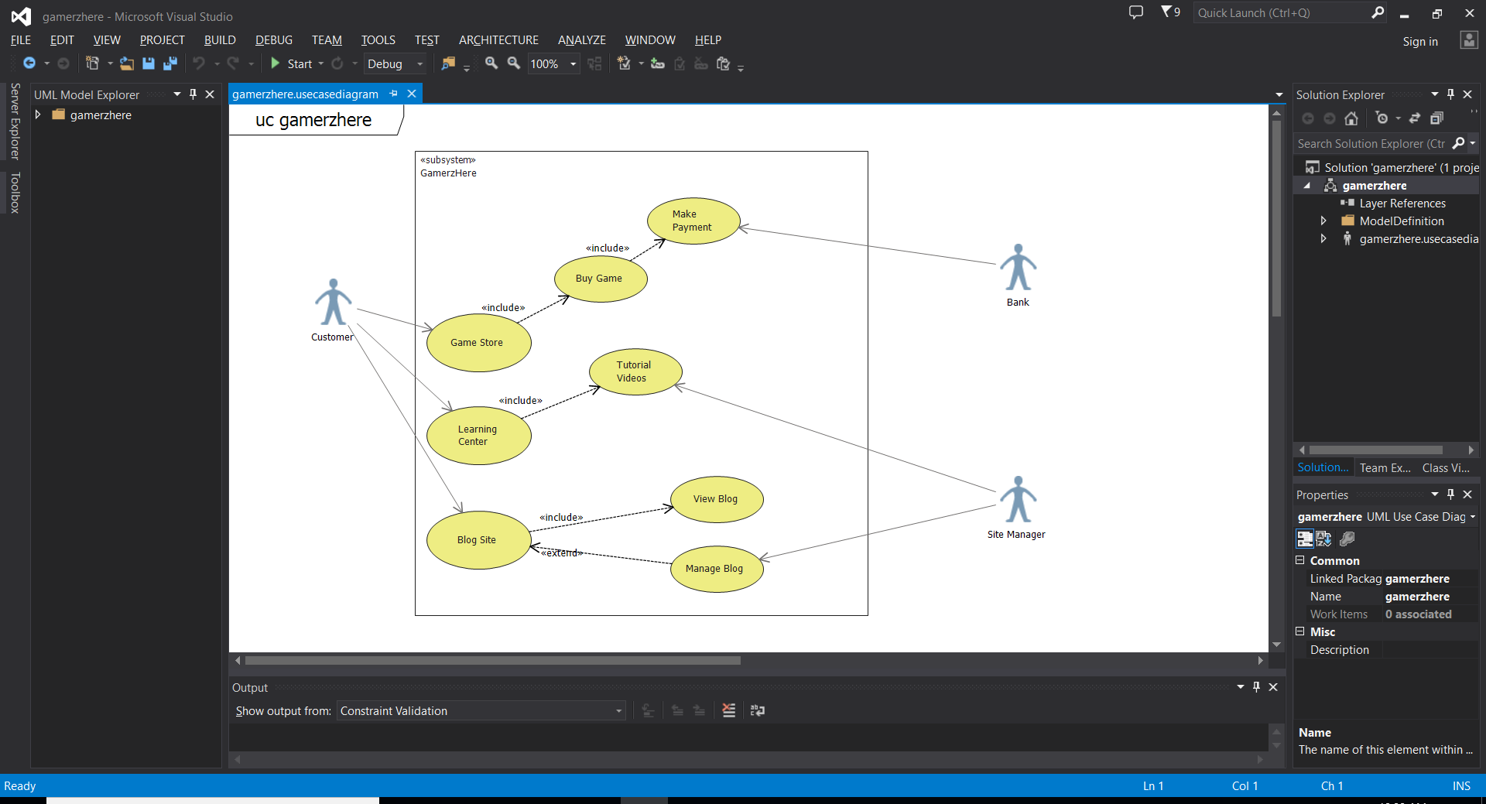

Step 1: Created a neat structured diagram using visual studio 2013.

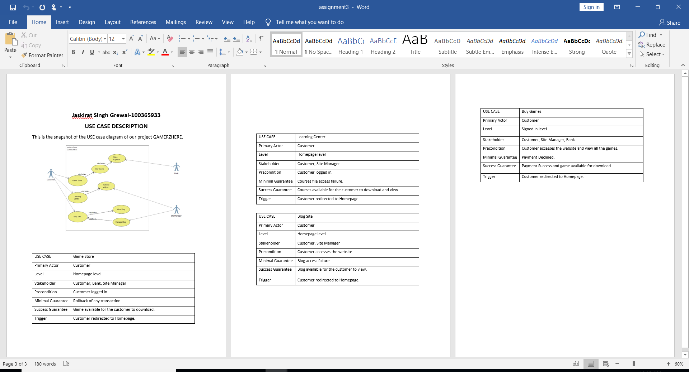

Step 2: Created a word document named gamerzhere_description.docx with a snapshot of the use case diagram and description of all the necessary use cases.

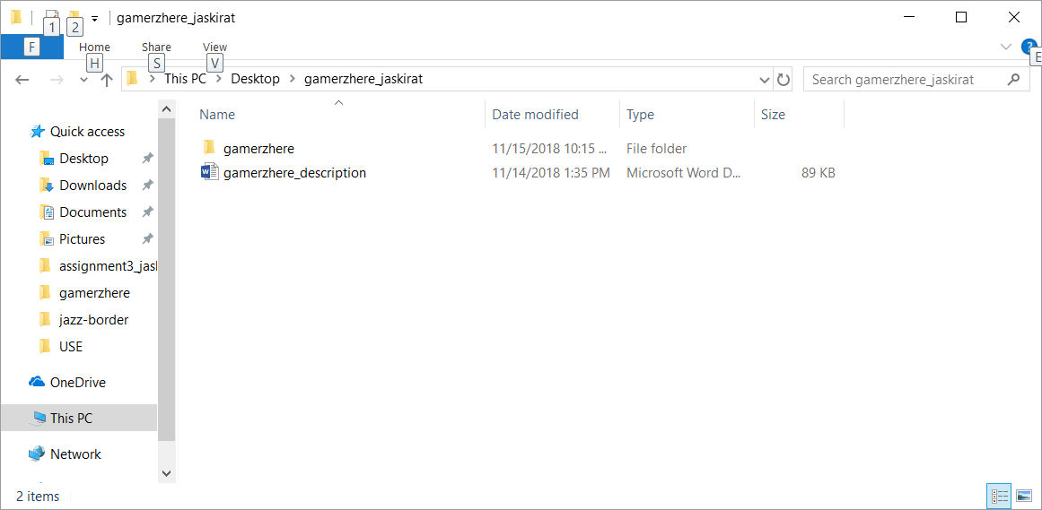

Step 3: Copied both the description and the diagram in a folder named gamerzhere_jaskirat, we will use git init in this folder later.

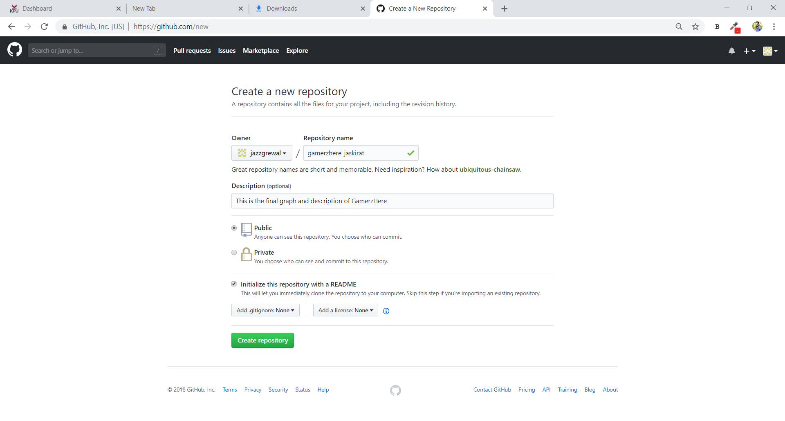

Step 4: Creating a new repository in git named gamerzhere_jaskirat with the description as “This is the final graph and description of GamerzHere”.

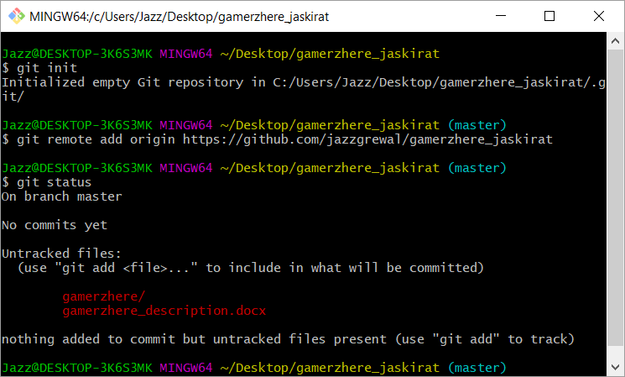

Step 5: Initialize the repository and set the URL.

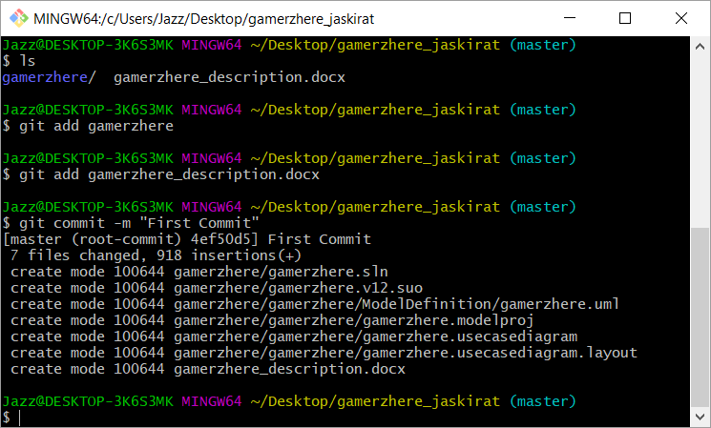

Step 6: Added both the files and named the commit as First Commit

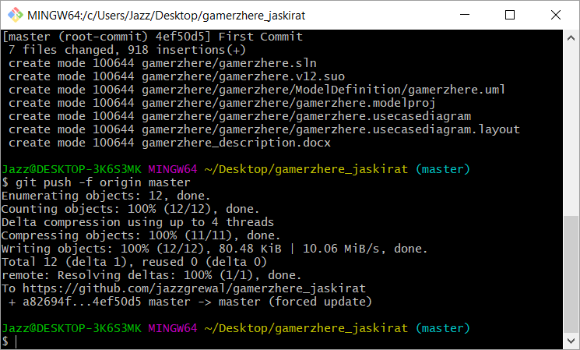

Step 7: Successfully pushed the files to the repository.

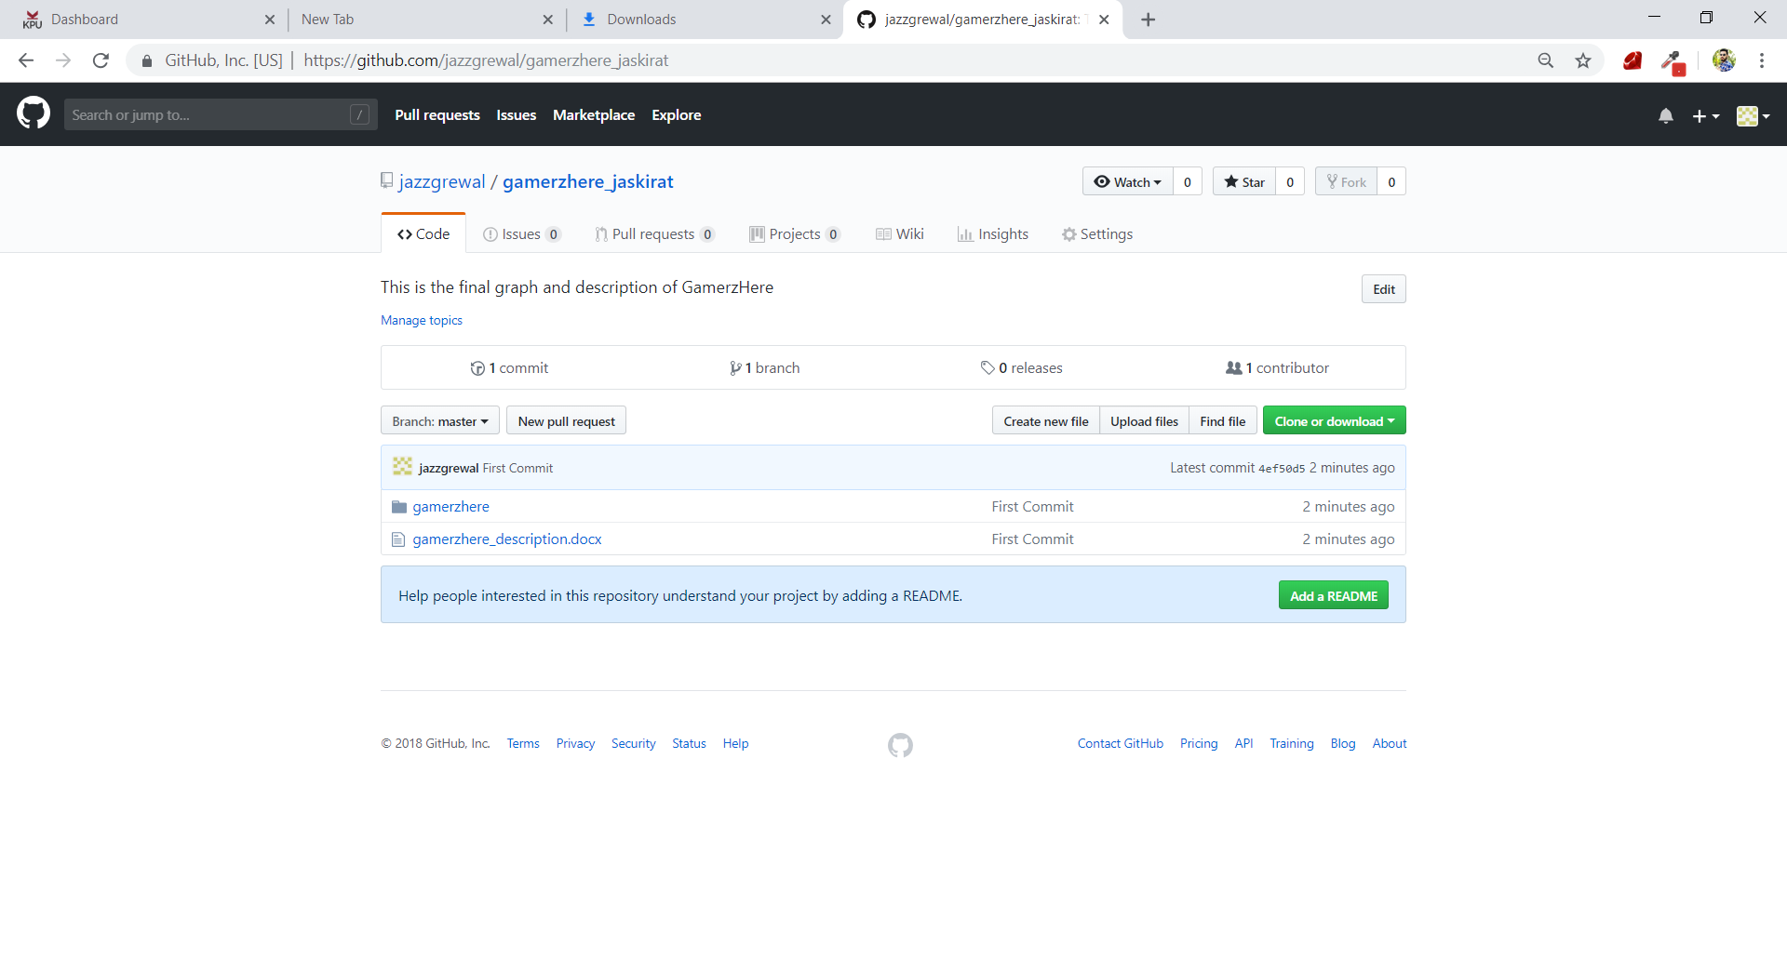

Step 8: We can see our files uploaded on the repository.

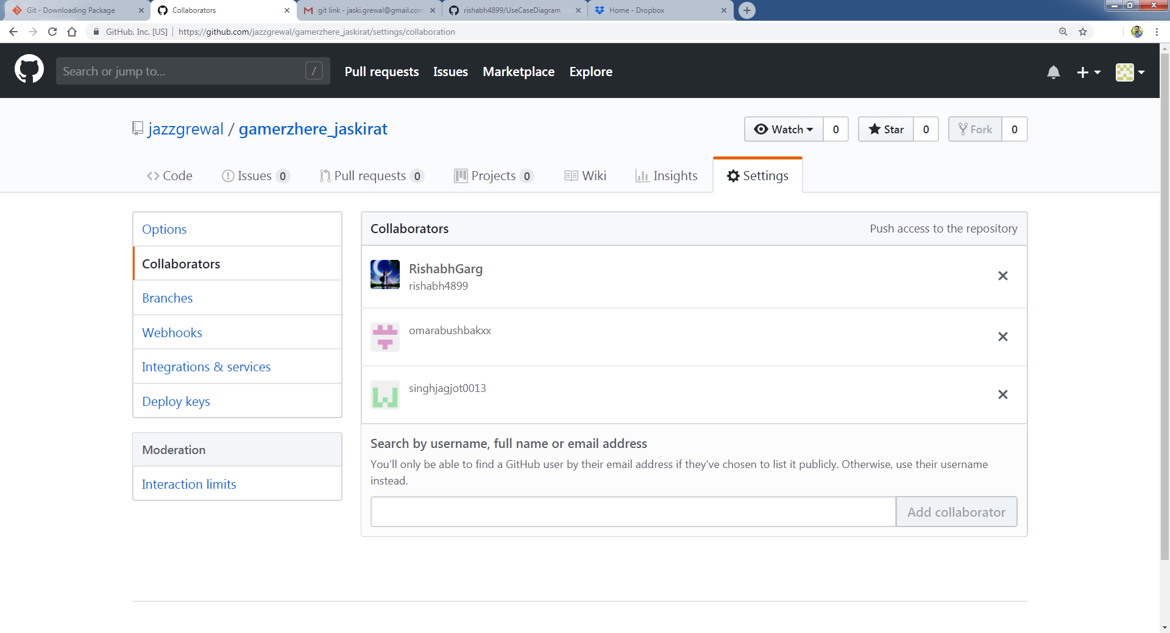

Step 9: Finally Added all the three group members as Collaborators, now they do have access to push anything in this repository in the future.

**References**

1. **Youtube:**

**Use case Diagram Tutorial:** [**https://www.youtube.com/watch?v=zid-MVo7M-E**](https://www.youtube.com/watch?v=zid-MVo7M-E)

**Use case Description Ideas:** [**https://www.youtube.com/watch?v=i3dg99MWLZU**](https://www.youtube.com/watch?v=i3dg99MWLZU)

**2)GitHub references uploaded by instructor on Moodle.**