**WEB INTELLIGENCE**

**AND BIG DATA**

**LAB**



**Name: Jaskirat Singh**

**Roll number: 05413202717**

**Section: CSE-1 (8th Semester)**

**EXPERIMENT-1**

**AIM:** Create the data frame in big data and implement the following:

#### CODE:

**import** **pandas** **as** **pd**

weather_data = {

'day': ['1/1/2017','1/2/2017','1/3/2017','1/4/2017','1/5/2017','1/6/2017'],

'temperature': [32,35,28,24,32,31],

'windspeed': [6,7,2,7,4,2],

'event': ['Rain', 'Sunny', 'Snow','Snow','Rain', 'Sunny']

}

df = pd.DataFrame(weather_data)

df = pd.read_csv("weather_data.csv")

df

#### OUTPUT:

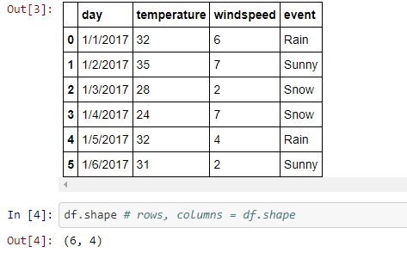

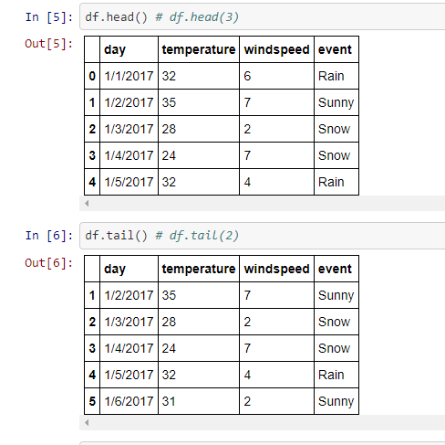

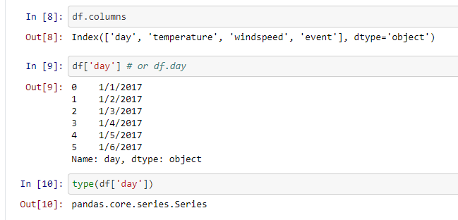

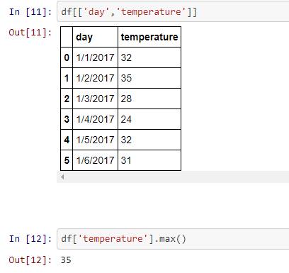

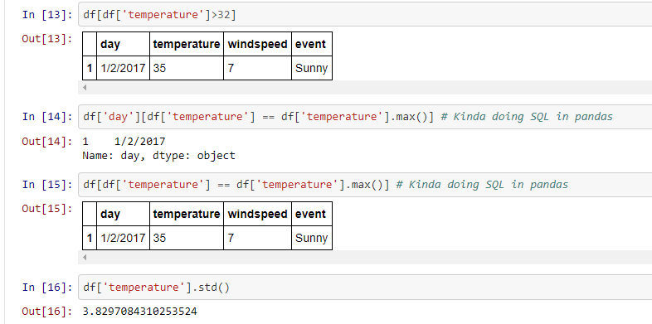

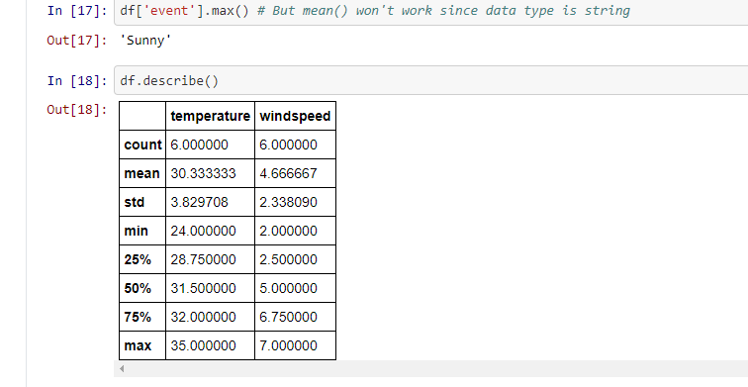

**EXPERIMENT-2**

**AIM:** Write different ways of creating pandas data frame at least 5.

**CODE**:

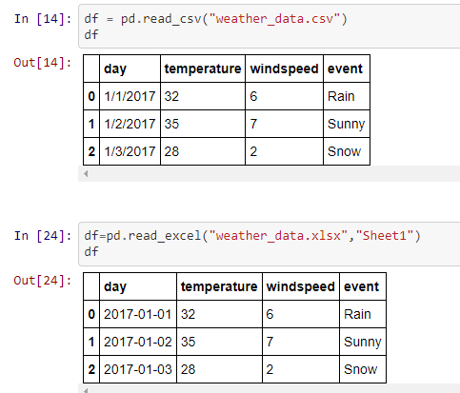

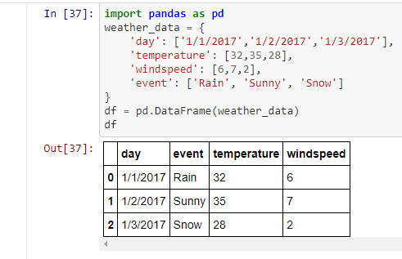

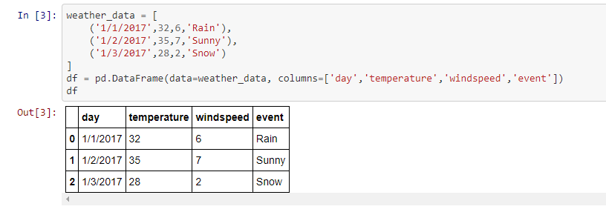

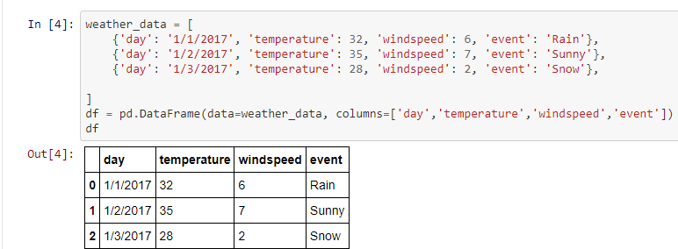

**EXPERIMENT-3**

**AIM:** How to handle missing data in pandas using fillna, interpolate and dropna methods.

#### CODE:

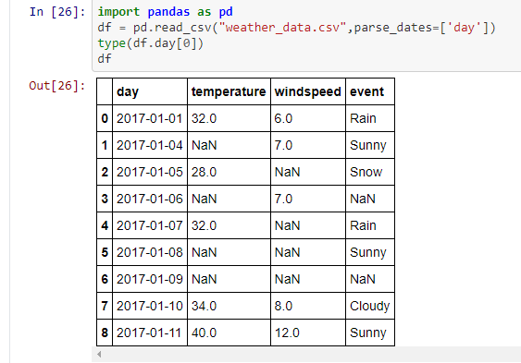

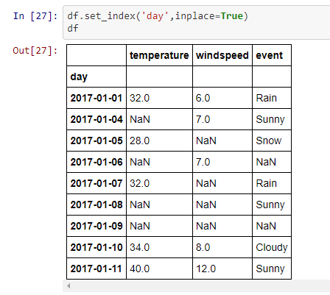

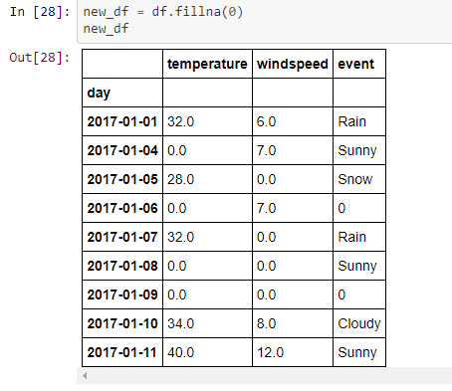

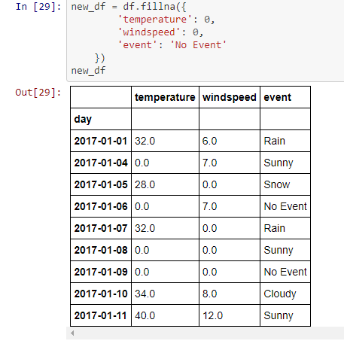

**EXPERIMENT-4**

**AIM:** How to handle the ffill ,bfill, interpolate().

#### CODE:

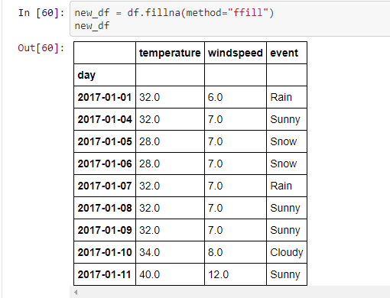

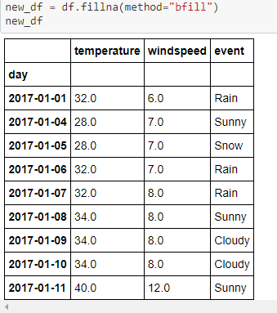

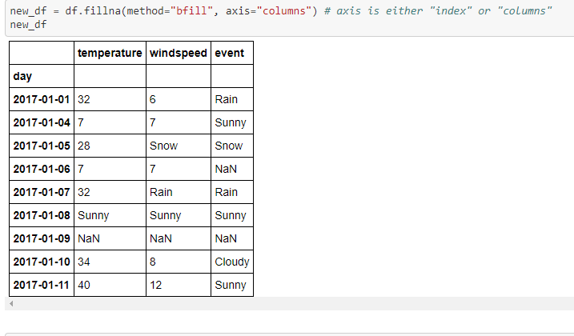

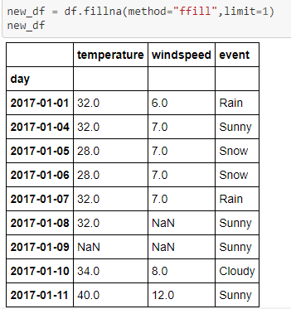

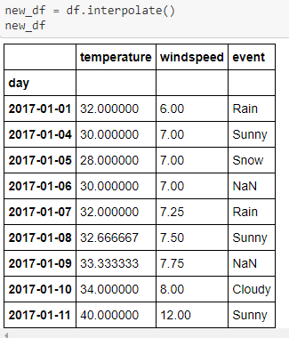

**EXPERIMENT-5**

**AIM:** How dataframe.replace method can be used to replace specific values with some other values.

#### CODE:

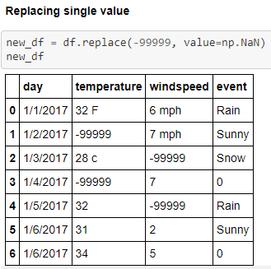

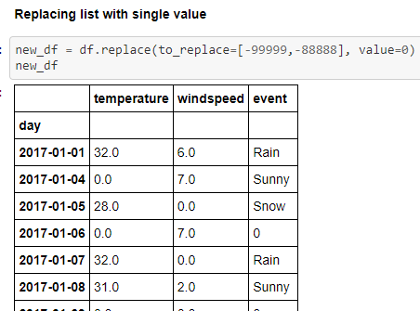

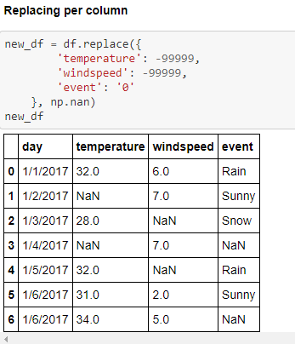

**EXPERIMENT-6**

**AIM:** How dataframe.replace method can be used In mapping replace specific values with some other values.

#### CODE:

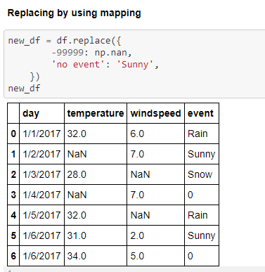

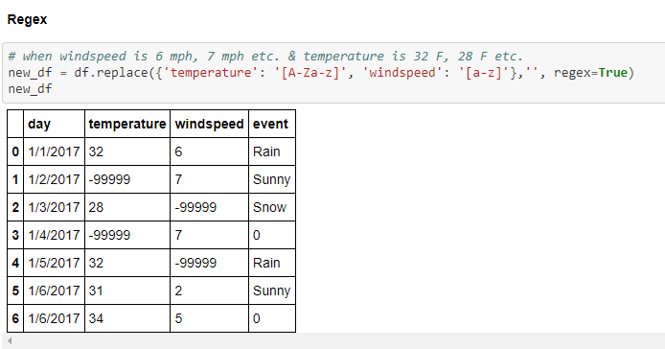

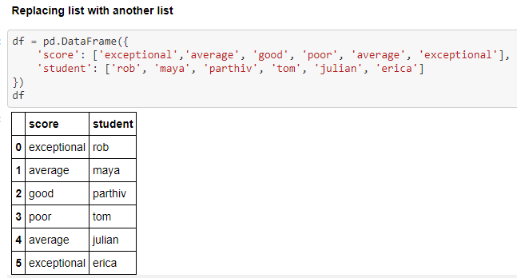

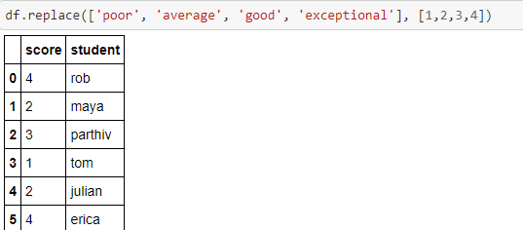

**EXPERIMENT-7**

**AIM:** How to use pandas concat function to join or append dataframes In big data analysis.

**CODE:**

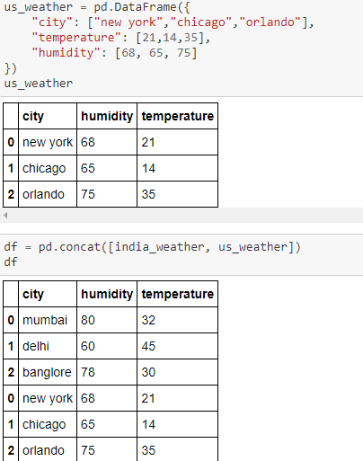

.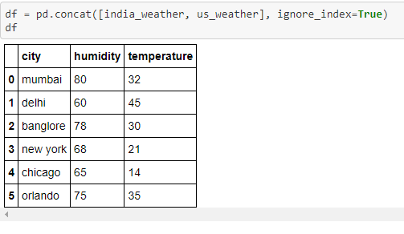

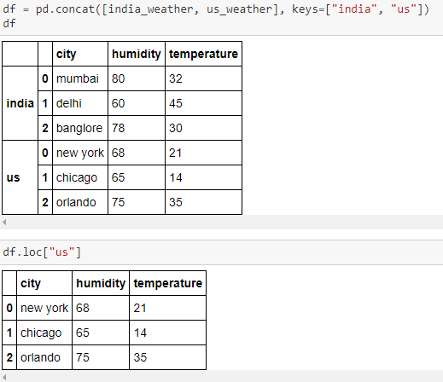

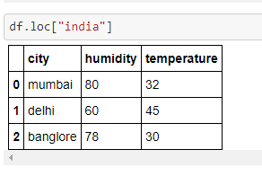

**EXPERIMENT-8**

**AIM:** Implement Merge Data frames in big data analysis.

**CODE:**

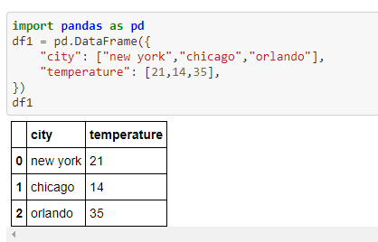

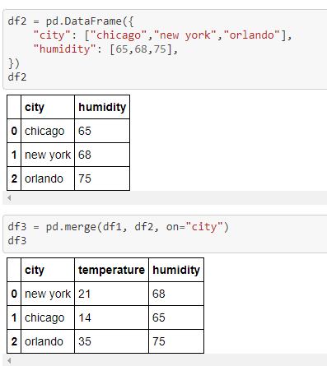

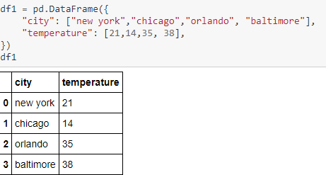

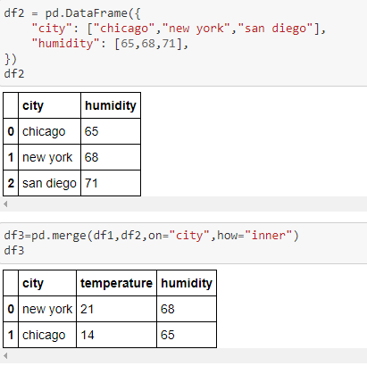

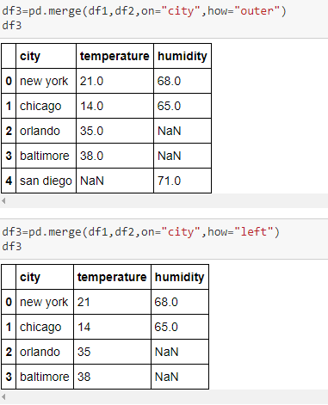

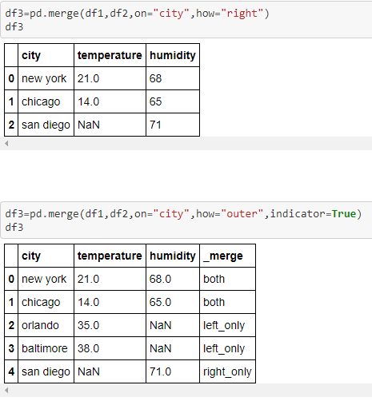

**EXPERIMENT-9**

**AIM:** What is pivot? Use pivot() function and its arguments , What is a pivot table? Use pivot_table() in dataframe.

**CODE:**

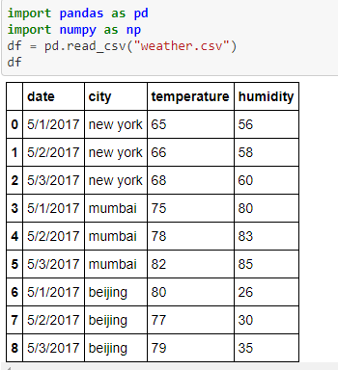

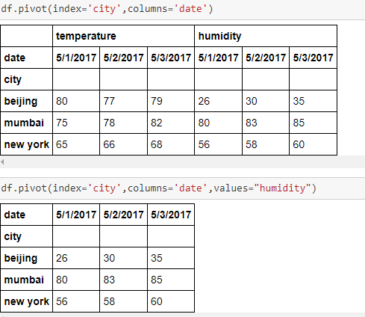

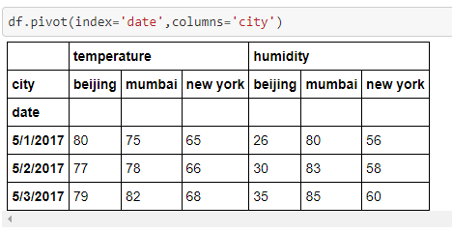

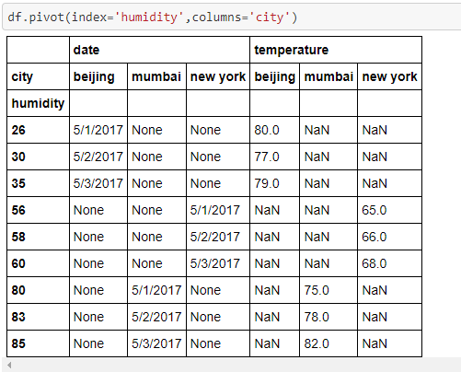

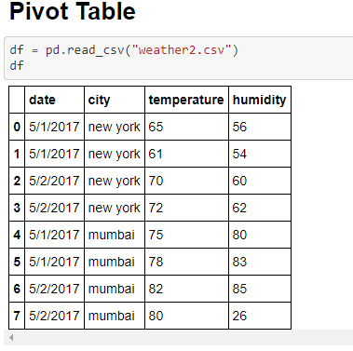

**EXPERIMENT-10**

**AIM:** Implement the Reshape function in big data analysis.

**CODE:**

