**NAME-** Kanishk Vardhan Singh

**SUPERSET ID-** 6365335

***Advanced SQL Exercises***

**Exercise 1: Ranking and Window Functions**

**Using the Below sample Data (from Exercise 2)**

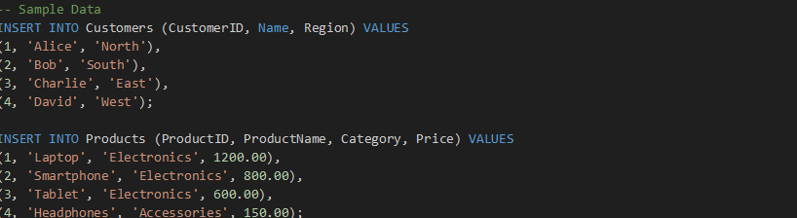

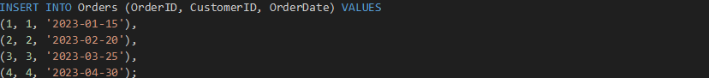

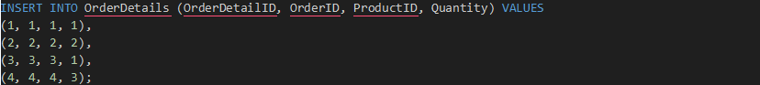

1. Using ROW_NUMBER() to assign unique rank per category

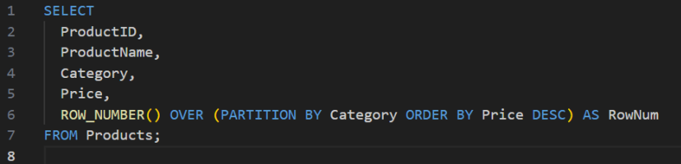

1. Using RANK() to handle ties (same price → same rank, skips numbers)

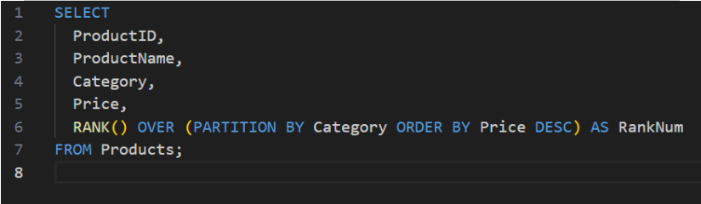

1. Using DENSE_RANK() to handle ties (same price → same rank, no skips)

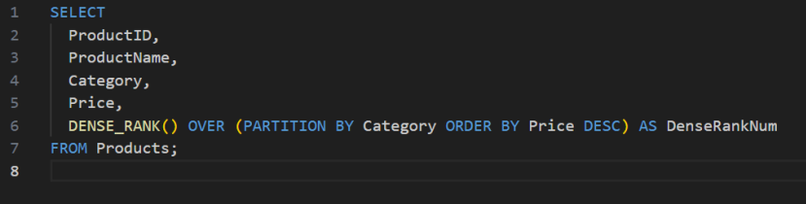

**Now, to filter Top 3 products in each category**

1. ROW_NUMBER() – Top 3 Products per Category

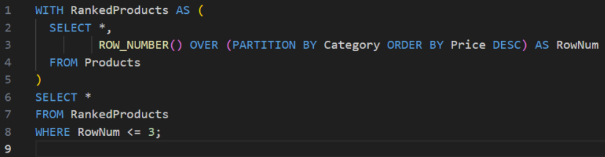

Output:

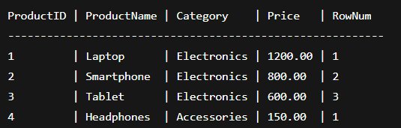

1. RANK() – Top 3 Products per Category (with gap on ties)

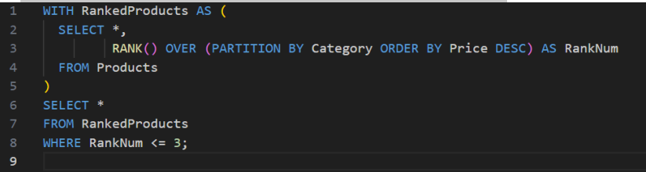

Output:

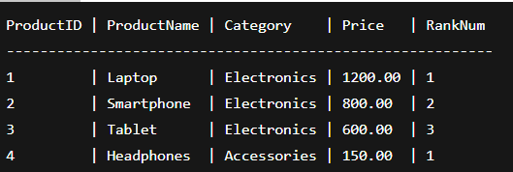

1. DENSE_RANK() – Top 3 Products per Category (no gap on ties)

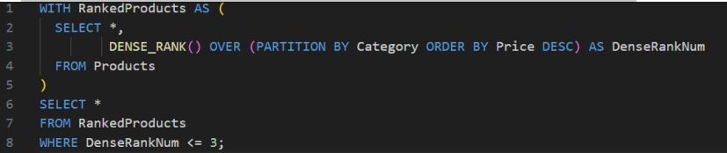

Output:

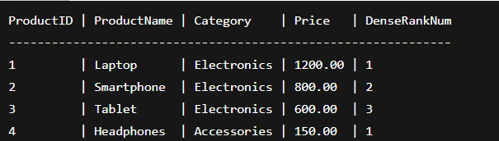

*SQL stored procedure*

**Exercise 1: Create a Stored Procedure**

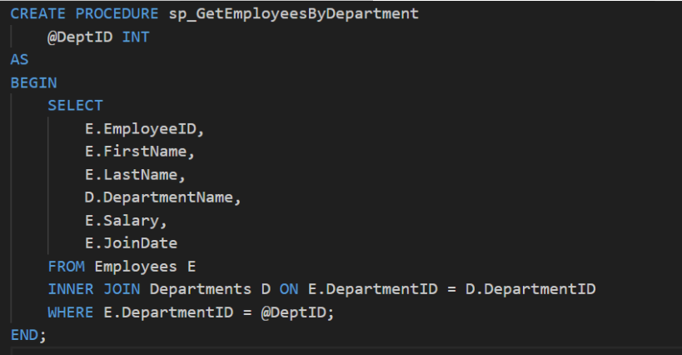

Input:

**Screenshot 2025-06-29 202657**

Output:

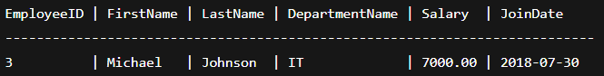

**Exercise 5: Return Data from a Stored Procedure**

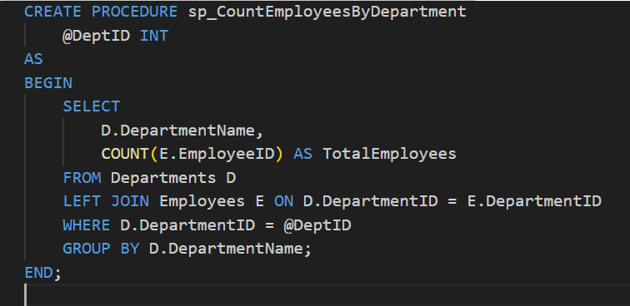

Input:

**Screenshot 2025-06-29 202931**

Output:

