**NAME** - Kanishk Vardhan Singh

**SUPERSET ID** - 6365335

***Web API Net Core***

1. **First Web Api using .Net core**

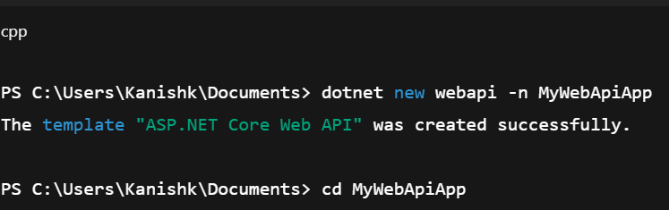

**Controllers/ValuesController.cs**

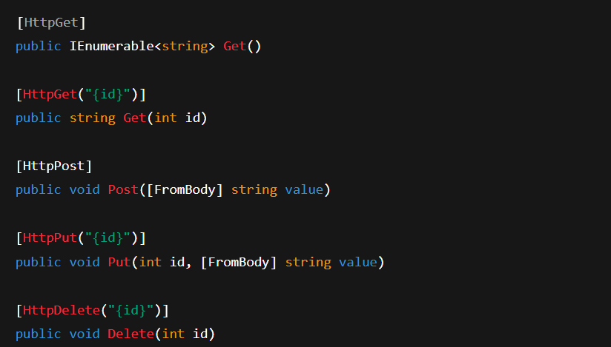

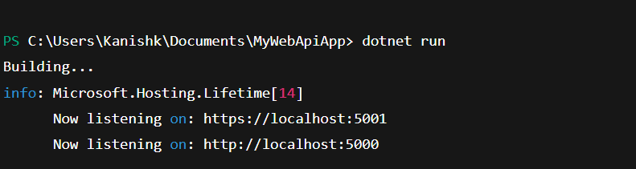

**Web Api using custom model class**

Department.cs

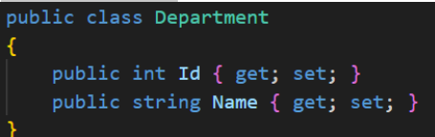

**Skill.cs**

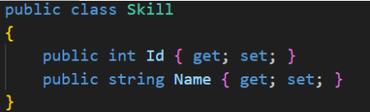

**Employee.cs**

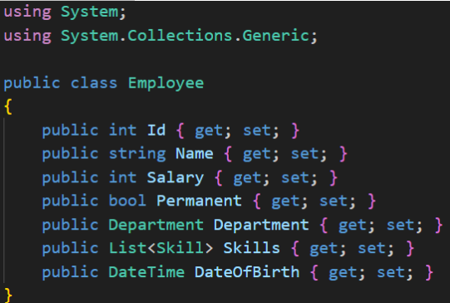

**Creating EmployeeController.cs**

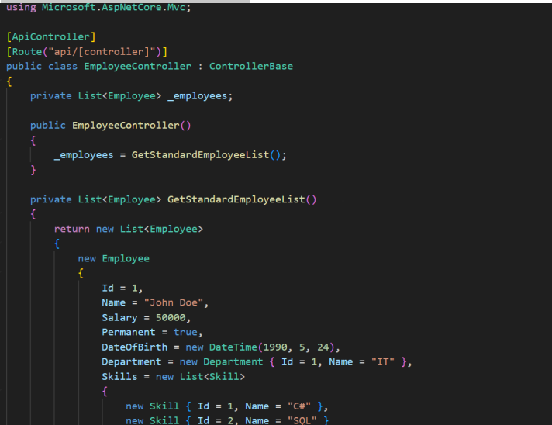

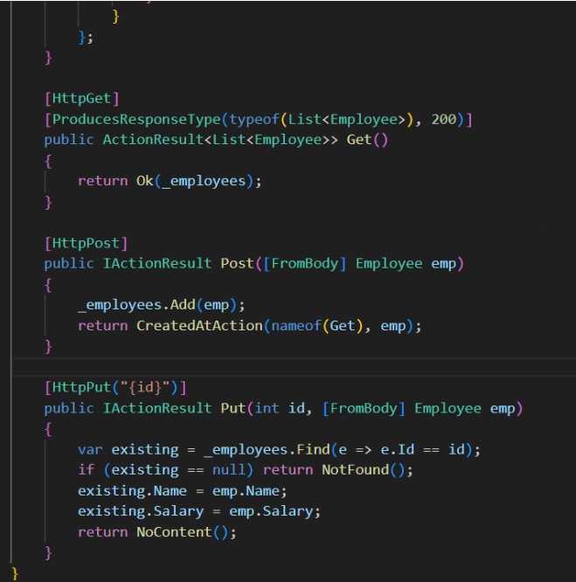

Creating CustomAuthFilter.cs

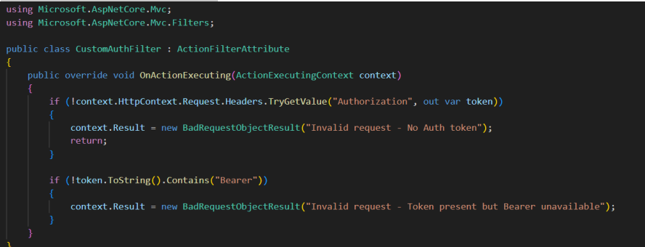

Screenshot 2025-07-14 193252

Installing Required NuGet

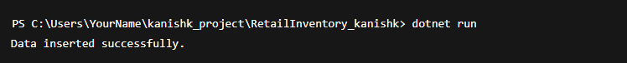

Creating CustomExceptionFilter.cs

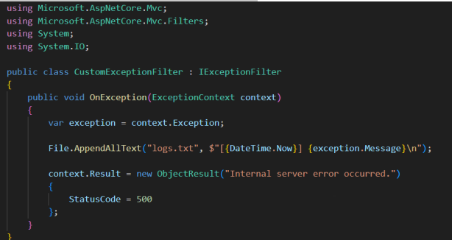

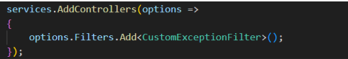

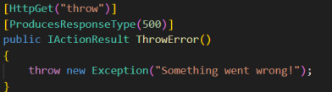

**4. Web Api CRUD operation**

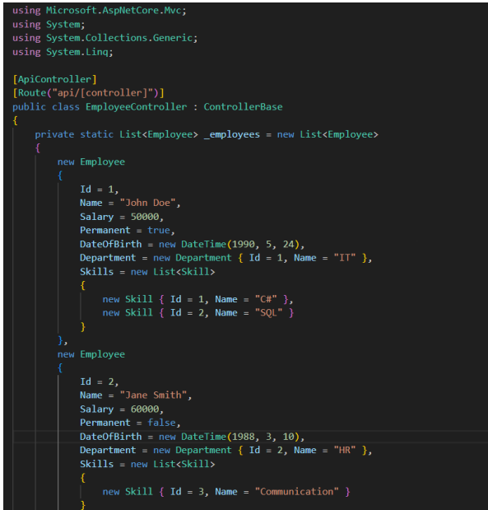

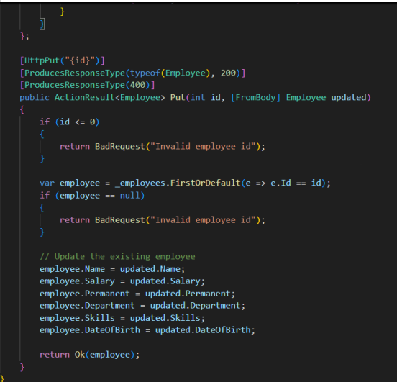

**Input:**

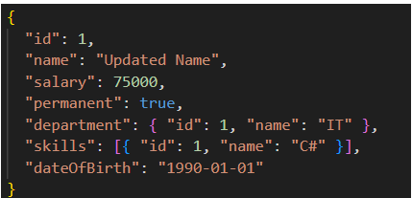

**OUTPUT:**

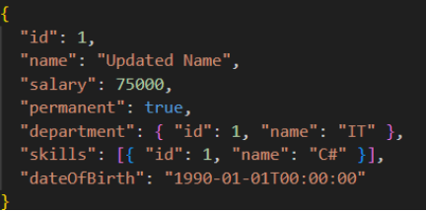

**5. Week 5 HandsOn**

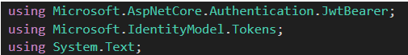

In ConfigureServices

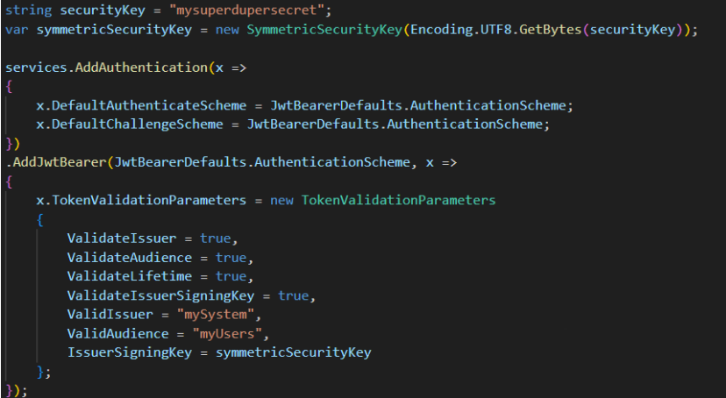

Controllers/AuthController.cs

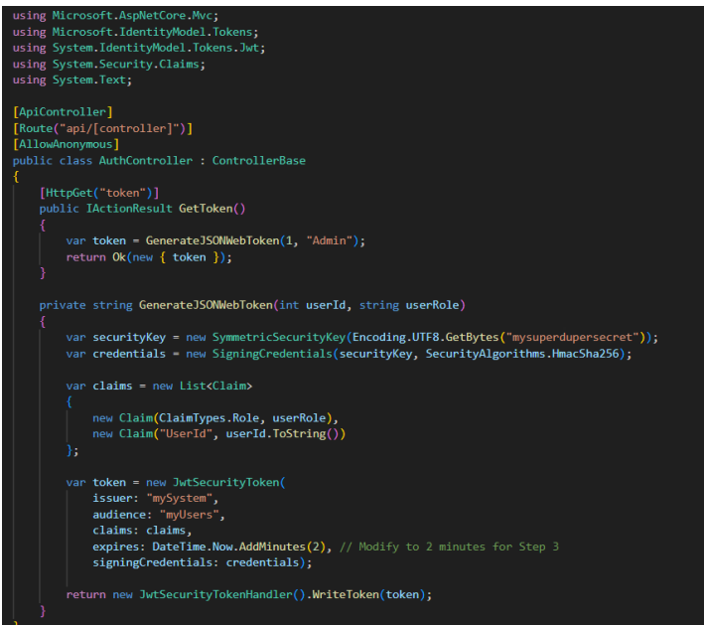

### Updated Controllers/EmployeeController.

