**Name:** Kanishk Vardhan Singh

**Superset ID:** 6365335

***Entity Framework Core 8.0***

**Lab 1: Understanding ORM with a Retail Inventory System**

1. ORM (Object Relational Mapping) helps map C# classes to database tables. It allows us to manage data using objects without manually writing SQL code. Benefits include higher productivity, easier maintenance, and abstraction from SQL queries.
2. EF Core is the lightweight, modern, cross-platform version of Entity Framework. It supports async queries, LINQ, and runs on .NET Core/.NET 6+. EF Framework (EF6) is older, Windows-only, and used with legacy .NET Framework apps.

3. EF Core 8.0 brings powerful features like:

- JSON column mapping

- Compiled models for faster startup

- Interceptors for better monitoring and logging

- Improved performance for bulk data operations

1. Create a .NET Console App

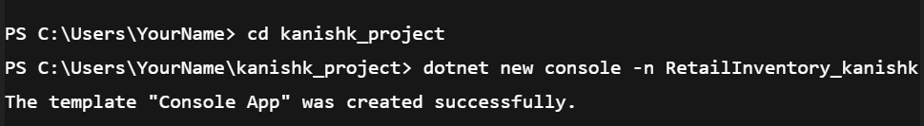

1. Install EF Core Packages:

Screenshot 2025-07-06 205916

Screenshot 2025-07-06 205956

**Lab 2: Setting Up the Database Context for a Retail Store**

Creating the **Models/Category.cs** File

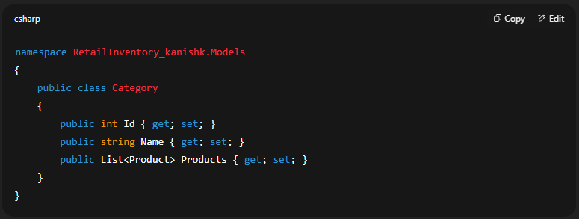

Creating the **Models/Product.cs** File

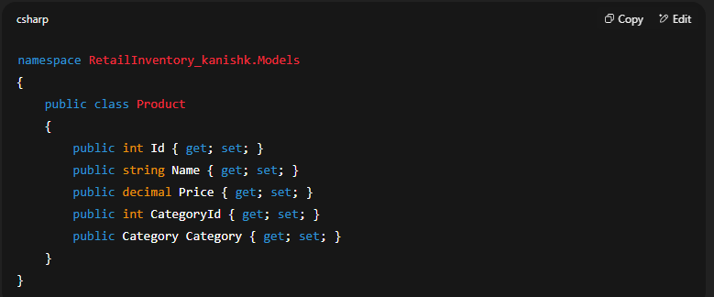

Creating the **AppDbContext.cs** File

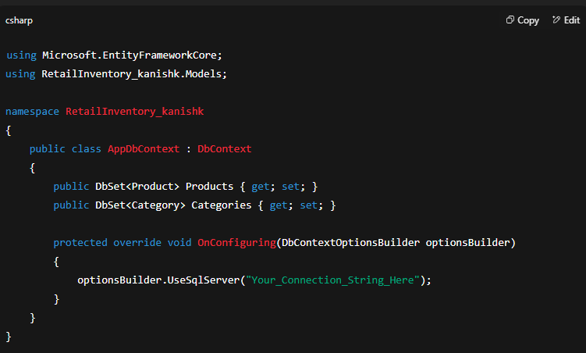

**Lab 3: Using EF Core CLI to Create and Apply Migrations**

1. Screenshot 2025-07-06 220423
2. Screenshot 2025-07-06 220438
3. Screenshot 2025-07-06 220451

**Lab 4: Inserting Initial Data into the Database**

Creating File Program.cs

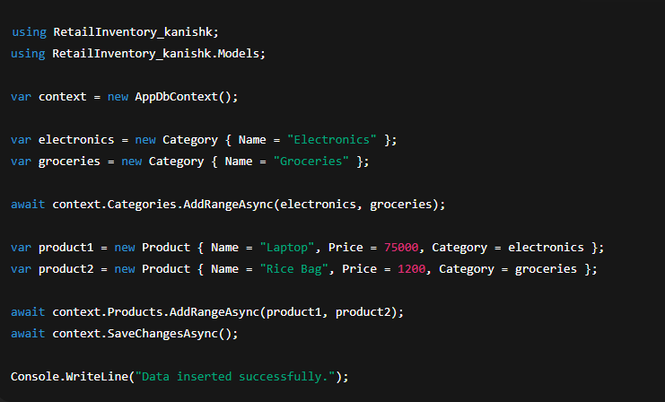

Output:

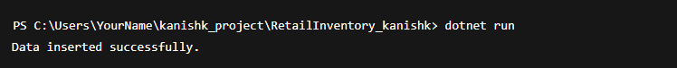

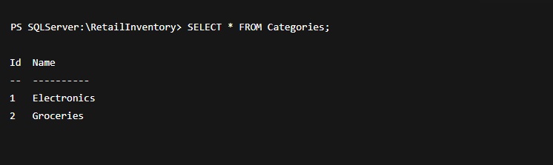

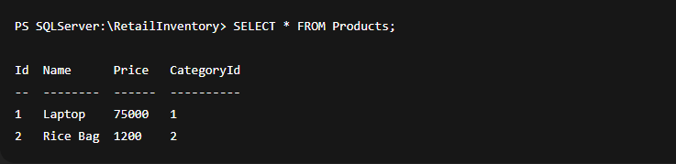

**Lab 5: Retrieving Data from the Database**

Updating Program.cs File

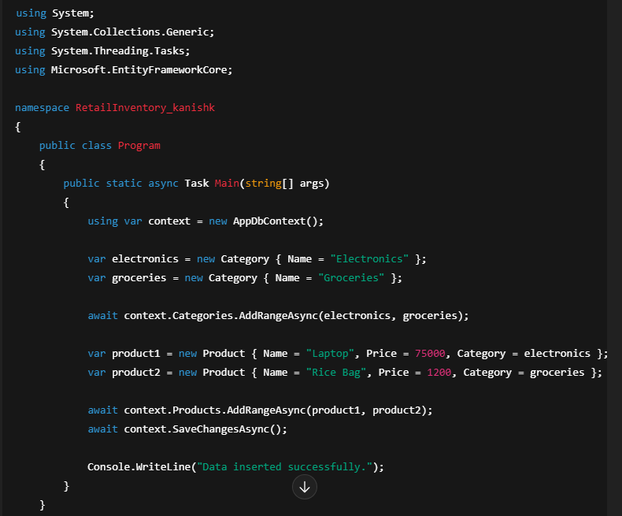

Output:

