

|  |  |  |
| --- | --- | --- |
| **INDEX** | | |
|  | | |
| **S. No** | **Title** | **Page No.** |
| 1. | Introduction | 3 |
| 2. | Purpose | 3 |
| 3. | Scope | 3 |
| 4. | Requirements | 3 |
| 5. | Functional Requirements | 3-4 |
| 6. | Non-functional requirements | 4 |
| 7. | Use- case Diagram | 4 |
| 8. | Class Diagram | 4 |
| 9. | Sequence Diagram | 5 |
| 10. | Entity Relationship Diagram | 5 |
| 11. | Prototype of the website | 6-20 |
| 12. | References | 21 |

**INTRODUCTION**

Online Shopping System (sometime also known for e-shop) is a form of e- commerce where the consumers can buy goods and services from dealers through the computer network (internet) using a web browser. Online shopping site has both high as well as low quality of products. Shoppers can directly buy any product by just visiting on their desired website where they can find enormous products with description (images of the product, along with the information about the product features and price). Purchasing of goods online, user can choose various products based on categories, prices, online payments and delivery services. This system is available for all the time for the customers. So, it’s very convenient for them to shop online

**PURPOSE**

The main purpose of this project to expand the quantity of sales with the help of the web page design using attractive pictures etc. This system also proposed to save time for both retailers and buyer. Through online shopping one can save his money also because here, the prices are very low as compared to the market price and we can receive bought things directly at home.

**SCOPE**

The scope of the project is to give the automated platform to the whole process of shopping and also to understand the customer’s priority towards online shopping.

**REQUIREMENTS**

The list of requirements for the online shopping system is as follows:

* **Software requirements**:

Operating system – Linux, Windows, Mac etc.

Development tool – HTML, CSS, JavaScript and Nodejs

Database – SQL

* **Hardware requirements**:

Processor: Pentium or higher

RAM: 128MB or higher

* **Performance requirement**: It describe the performance of the system that how much efficient the system would perform. As the whole process is online, so the sever should be working all the time at any system without the problem of page uploading.
* **Functional requirements:** Functional requirementdefines a system or its components. Following is a list of functional requirements:

Login page: The main page which should clearly describe the login for the older users and also have a sign-up button for new users.

User registration: This screen allows the new customers to entered their details i.e., name, email, password, address etc.

Product Screen: This screen gives the information about the product such as product name according to categories so that the user is able to select any product with the ease of categories.

Product categories screen: This screen is featured to shows the various categories of the products that are available for the customers.

Deals: The customer is also looking for new offers and deals, so to make the website more interesting, also add the deals option into it where customer can directly see the new deals for the day.

Add to cart screen: This screen should display all the selected items along with the amount of quantity and total price etc.

Payment: Payment screen should display all the information regarding payment like banking detail and checkout button so that the user can complete the order after reviewing the cart.

**Non-functional requirements:** Non**-** functional requirements are those requirements that describe the performance attributes for the system. The following are the non-functional requirements for this online system:

Availability: The system must be available at all the time whenever the user wants to access it with any kind of browser.

Security: The system should never give the access to the third-party users, only the authorised user can log into the website and the website can automatically be logged out in a case of inactivity.

Maintainability: In a case of system failure, the system should have re-initialization of the program so that the database must be preserved and used again.

Reliability: The system must be backed up so that the most recent changes can provide the reliability and system should be up to date.

Portability: An end-user will be able to opens the website on any operating system. The system must be run on all devices.

**Use case Diagram**



**Class Diagram**



**Sequence Diagram**



**Entity Relationship Diagram (ERD)**

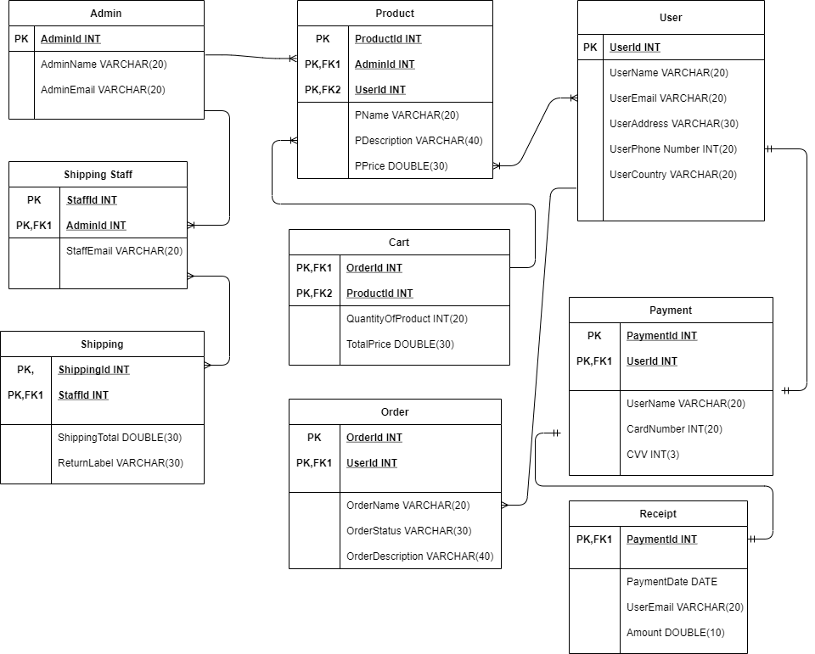



|  |
| --- |
| Prototype 1 |
| 2/22/21, 10:48 AM |
| **Author:** John Doe  **File name:** Prototype 1.vp  **Version** 1.0 |

02. Screens / Prototype 1 

Screen 1

|  |
| --- |
|  |

Interactions

|  |  |
| --- | --- |
| 1 | **on Click:** goes to 'LOGIN' 🡪 goes to 'LOGIN' 🡪 goes to 'Sign up' with effect: flip horizontal in 700ms 🡪 |
| 2 | **on Click:** goes to 'Home' 🡪 |

02. Screens / Prototype 1 

LOGIN

|  |
| --- |
|  |

Interactions

|  |  |
| --- | --- |
| 9 | **on Click:** goes to 'Sign up' 🡪 |

02. Screens / Prototype 1 

Sign up

|  |
| --- |
|  |

Interactions

|  |  |
| --- | --- |
| 10 | **on Click:** goes to 'Home' 🡪 |
| 11 | **on Click:** goes to 'LOGIN' 🡪 |
| 12 | **on Click:** goes to 'LOGIN' 🡪 |

02. Screens / Prototype 1 

Home

|  |
| --- |
|  |

Interactions

|  |  |
| --- | --- |
| 14 | **on Click:** goes to 'deals' 🡪 |
| 15 | **on Click:** goes to 'profile' 🡪 |
| 16 | **on Click:** goes to 'CONTACT' 🡪 |
| 17 | **on Click:** goes to 'ABOUT' 🡪 |

02. Screens / Prototype 1 

deals

|  |
| --- |
|  |

02. Screens / Prototype 1 

profile

|  |
| --- |
|  |

02. Screens / Prototype 1 

CONTACT

|  |
| --- |
|  |

02. Screens / Prototype 1 

ABOUT

|  |
| --- |
|  |

02. Screens / Prototype 1 

MEN

|  |
| --- |
|  |

Interactions

|  |  |
| --- | --- |
| 24 | **on Click:** goes to 'CART' 🡪 |

02. Screens / Prototype 1 

WOMEN

|  |
| --- |
|  |

Interactions

|  |  |
| --- | --- |
| 25 | **on Click:** goes to 'CART' 🡪 |

02. Screens / Prototype 1 

KIDS

|  |
| --- |
|  |

Interactions

|  |  |
| --- | --- |
| 26 | **on Click:** goes to 'CART' 🡪 |

02. Screens / Prototype 1 

PAYMENT

|  |
| --- |
|  |

02. Screens / Prototype 1 

CART

|  |
| --- |
|  |

Interactions

|  |  |
| --- | --- |
| 41 | **on Click:** goes to 'PAYMENT' 🡪 |

**References:**

<https://www.ukessays.com/essays/ecommerce/shopping-online-is-occupying-an-essential-part-of-shopping-ecommerce-essay.php>

<https://www.slideshare.net/Kkushum/online-shopping-system-69945887>