CodeAlpha Bioinformatics Internship
Task 1: DNA/Protein Sequence Analysis Using BLAST
Submitted by Kashaksingh | Student ID: CA/DF1/107728 | Domain: Bioinformatics

1. Objective
The objective of this task is to retrieve a protein sequence from a public biological database (NCBI) and perform a BLAST (Basic Local Alignment Search Tool) analysis to identify homologous sequences, examine sequence similarity and identity scores, and interpret the biological significance of the results.

2. Sequence Selected
Protein: Hemoglobin Subunit Beta (HBB)
- Organism: Homo sapiens (human)
- Database accession: UniProt / NCBI sp|P68871.2|HBB_HUMAN
- Sequence length: 147 amino acids
- Molecule type: Amino acid (protein)
Hemoglobin beta was selected because it is a well-characterised, evolutionarily conserved oxygen-transport protein with extensive homology data available across vertebrate species, making it well suited for demonstrating BLAST-based homology search and sequence identity analysis.

3. Methodology
- The HBB_HUMAN protein sequence was retrieved from the NCBI Protein database in FASTA format.
- A Protein BLAST (BLASTP) search was run at blast.ncbi.nlm.nih.gov against the ClusteredNR database.
- Default search parameters were used (no organism restriction applied initially).
- Results were examined under the Clusters, Graphic Summary, Alignments, and Taxonomy report tabs.

4. BLAST Search Summary
Parameter | Value
Program | BLASTP
Database | ClusteredNR
Query ID | sp|P68871.2|HBB_HUMAN
Query length | 147 amino acids
Request ID (RID) | 424T7H6C014
Total hits returned | ~110 significant alignments across 100 subject clusters

5. Top Homologous Sequences (Alignment Results)
Match | Length (aa) | Score | E-value | % Identity | % Positives
Hb Monza protein [Homo sapiens] | 170 | 288 (737 bits) | 1e-97 | 86.47% | 86.47%
Beta-globin [Homo sapiens] | 147 | 277 (708 bits) | 2e-93 | 93.20% | 93.20%
Hemoglobin subunit beta-like [Canis lupus familiaris] | 147 | 275 (702 bits) | 1e-92 | 90% | 93%
Hemoglobin subunit delta [Ailuropoda melanoleuca] | 147 | 273 (697 bits) | 6e-92 | 90% | 93%

The highest-scoring match was the human Hb Monza variant protein, which shares 86.47% identity with the query but is a longer 170-residue sequence (it appears to represent a duplicated/extended beta-globin gene variant). The second-best hit, canonical human beta-globin, showed a very high 93.20% identity over the full 147-residue length with zero gaps, confirming a near-exact match to a closely related beta-globin paralog/variant. Cross-species hits — dog (Canis lupus familiaris) hemoglobin subunit beta-like and giant panda (Ailuropoda melanoleuca) hemoglobin subunit delta — each retained 90% identity and 93% positive (similar residue) matches over the full 147-residue alignment with no gaps, demonstrating strong conservation of the globin fold across mammalian lineages separated by tens of millions of years of evolution.
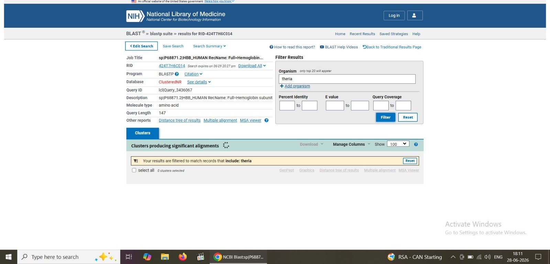
Figure 1: BLAST results overview — Job Title, Program (BLASTP), Database (ClusteredNR), and the organism filter panel.
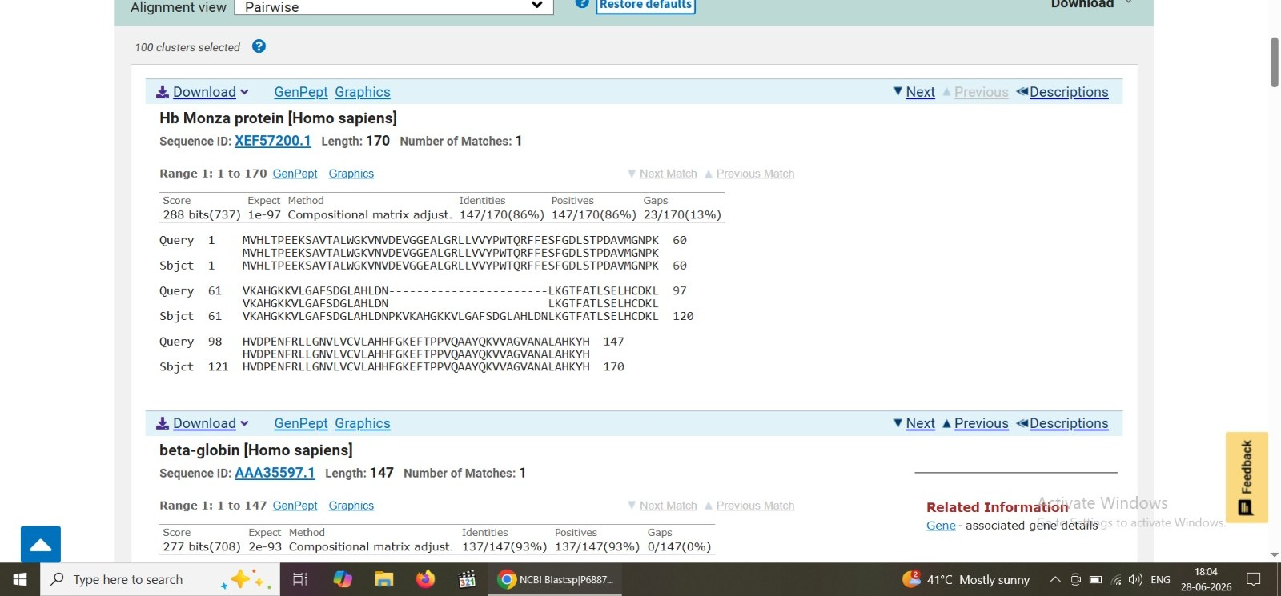
Figure 2: Pairwise alignment view — Hb Monza protein and beta-globin (Homo sapiens), showing Score, Expect (E-value), Identities, Positives, and Gaps.
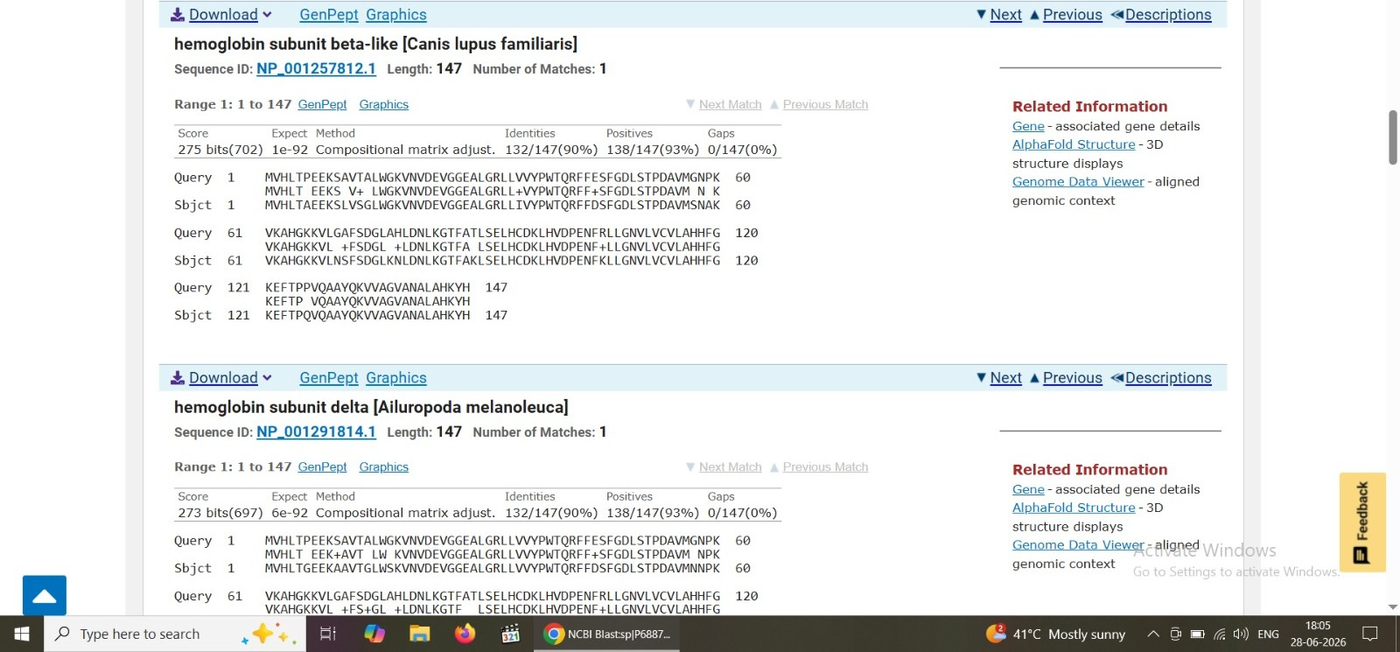
Figure 3: Pairwise alignment view — hemoglobin subunit beta-like (Canis lupus familiaris) and hemoglobin subunit delta (Ailuropoda melanoleuca).
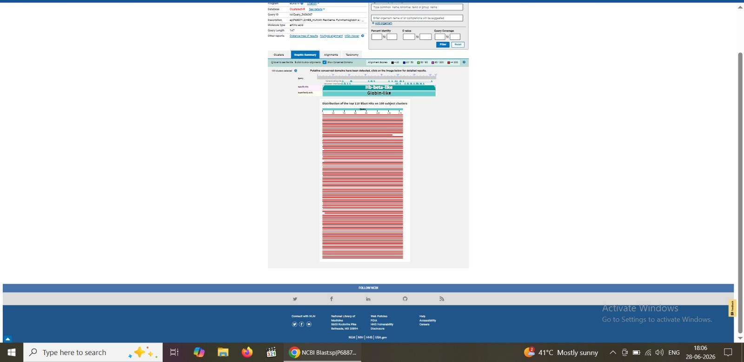
Figure 4: Graphic summary showing the conserved domain architecture (Hb-beta-like / Globin-like superfamily) and the distribution of the top 110 BLAST hits across 100 subject clusters, with full-length query coverage.

6. Interpretation of Results

6.1 Sequence Similarity and Identity
All top hits show high percent identity (86-93%) and very low E-values (1e-92 to 1e-97), indicating that the matches are statistically highly significant and not due to chance. An E-value this small means the probability of finding such a strong alignment by random chance is effectively zero.

6.2 Conserved Domains
The graphic summary identifies the query as belonging to the Hb-beta-like family within the broader Globin-like superfamily. Conserved functional sites are marked along the sequence, including heme-binding residues and tetramer interface residues — both essential for hemoglobin's biological role in oxygen transport and its assembly into the alpha2-beta2 tetramer.

6.3 Evolutionary Conservation
The presence of high-identity matches in distantly related mammals (dog, giant panda) alongside human paralogs/variants illustrates strong purifying selection on the beta-globin fold throughout mammalian evolution — consistent with hemoglobin's essential and highly conserved physiological function.

7. Conclusion
This BLAST analysis confirms that the human hemoglobin subunit beta (HBB) sequence shares strong homology with hemoglobin-family proteins both within humans (paralogs/variants such as Hb Monza) and across other mammalian species (dog, giant panda). The high percent identity, low E-values, and conserved domain architecture collectively demonstrate that BLAST is an effective tool for identifying evolutionarily related sequences and inferring shared structural and functional properties of proteins.

8. Tools Used
- NCBI Protein Database (sequence retrieval)
- NCBI BLASTP (blast.ncbi.nlm.nih.gov) — homology search
- ClusteredNR database

