CodeAlpha Bioinformatics Internship
Task 2: Multiple Sequence Alignment (MSA)
Submitted by Kashaksingh | Student ID: CA/DF1/107728 | Domain: Bioinformatics

1. Objective
The objective of this task is to perform a Multiple Sequence Alignment (MSA) on a set of related protein sequences using Clustal Omega, in order to identify conserved regions, examine sequence relationships, and interpret a guide tree / phylogenetic tree derived from the alignment.

2. Tool Used
- Clustal Omega (EMBL-EBI Job Dispatcher) — ebi.ac.uk/jdispatcher/msa/clustalo
- Job ID: clustalo-I20260628-135523-0114-39184612-p2m
- Alignment format: CLUSTAL O (1.2.4) multiple sequence alignment

3. Sequences Aligned
Five protein sequences were submitted to Clustal Omega for alignment, drawn from a combination of UniProtKB, the RCSB Protein Data Bank, and NCBI GenBank. The query sequence sp|P68871.2|HBB_HUMAN (human hemoglobin subunit beta) was carried over from Task 1 to anchor the alignment to a well-characterised reference.
Sequence ID | Source database | Notes
sp|P68871.2|HBB_HUMAN | UniProtKB/Swiss-Prot | Human hemoglobin subunit beta (reviewed entry; same query used in Task 1)
pdb|2QDN|B | RCSB Protein Data Bank | Chain B of PDB structure 2QDN, retrieved via the MSA tool's sequence search
pdb|6RWC|B | RCSB Protein Data Bank | Chain B of PDB structure 6RWC
GAB0092489.1 | NCBI GenBank | GenBank protein record identified during sequence search
KAJ1716055.1 | NCBI GenBank | GenBank protein record identified during sequence search

Note: this report describes the sequences strictly by the identifiers returned by the alignment tool. Full organism/protein annotations for the PDB and GenBank entries can be retrieved by following their accession links on NCBI or RCSB PDB if a fuller taxonomic description is required for grading.

4. Multiple Sequence Alignment Results
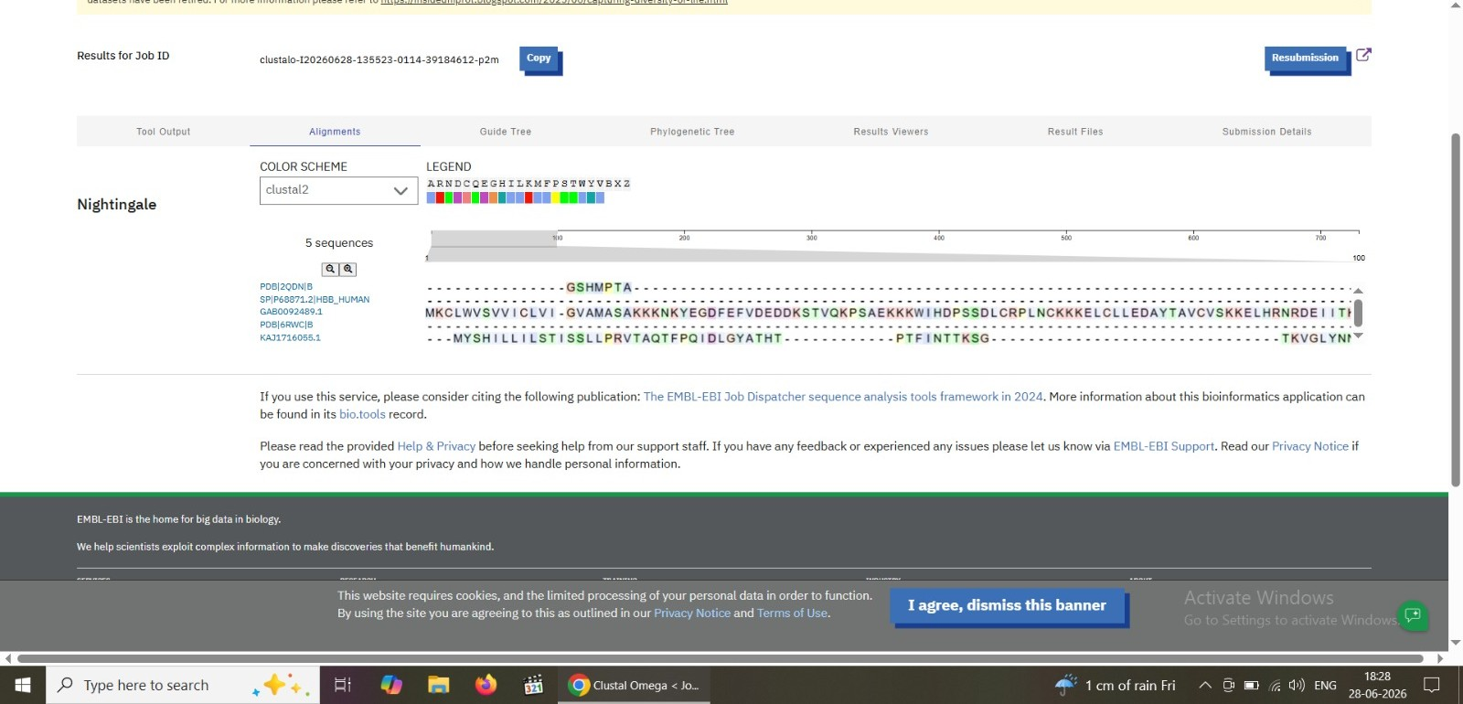
Figure 1: Clustal Omega alignment summary view, showing all 5 input sequences and the Clustal2 colour scheme legend.
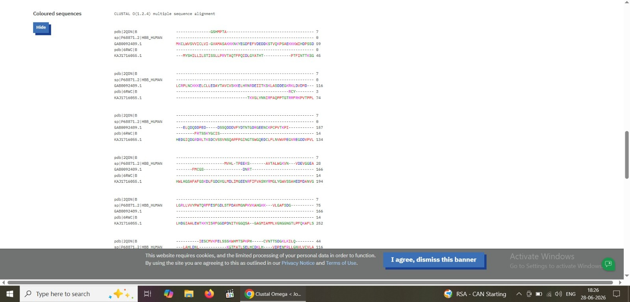
Figure 2: Detailed coloured-sequence alignment output (CLUSTAL O 1.2.4), showing aligned and gapped regions across all 5 sequences.

5. Guide Tree and Phylogenetic Tree
Clustal Omega builds a guide tree before computing the final alignment, and also outputs a phylogenetic tree (Newick format) summarising the pairwise distances between sequences. The branch lengths from the phylogenetic tree are summarised below:
Sequence | Branch length
pdb|2QDN|B | 0.43789
GAB0092489.1 | 0.38629
sp|P68871.2|HBB_HUMAN | 0.39604
pdb|6RWC|B | 0.43029
KAJ1716055.1 | 0.35132

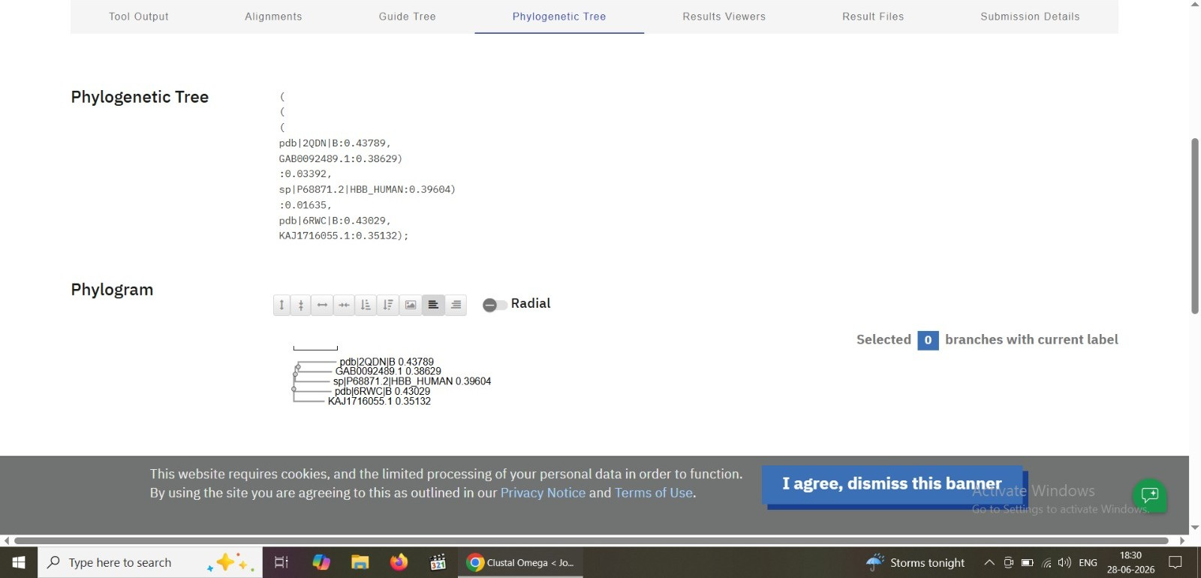
Figure 3: Phylogenetic tree (Newick notation) and corresponding phylogram, showing the branching relationships and branch lengths between the 5 aligned sequences.

6. Interpretation

6.1 Conserved and Gapped Regions
The coloured alignment output (Figure 2) shows long stretches of gap characters ("-") for several sequences in early alignment blocks, indicating that the 5 input sequences vary substantially in length and starting position. Where residues do align across all 5 sequences, colour-coded matching (under the Clustal2 scheme) highlights physicochemically similar amino acids, which is the basis for identifying conserved motifs in a family-wide alignment.

6.2 Branch Lengths and Relationships
In the phylogenetic tree, smaller branch lengths indicate sequences that are more similar to one another, while larger branch lengths indicate greater evolutionary or structural divergence. Based on the values obtained: KAJ1716055.1 (0.35132) and GAB0092489.1 (0.38629) show comparatively shorter branch lengths, while the two PDB chain sequences, pdb|2QDN|B (0.43789) and pdb|6RWC|B (0.43029), show the longest branch lengths in this tree, suggesting greater divergence from the rest of the set. The human reference sequence, sp|P68871.2|HBB_HUMAN, sits at an intermediate branch length of 0.39604.

6.3 Tree Topology
The Newick string — ((pdb|2QDN|B, GAB0092489.1), sp|P68871.2|HBB_HUMAN), (pdb|6RWC|B, KAJ1716055.1) — groups pdb|2QDN|B with GAB0092489.1 as a closer pair, and pdb|6RWC|B with KAJ1716055.1 as another closer pair, with the human beta-globin sequence branching separately from the first pair. This topology reflects the pairwise similarity scores computed internally by Clustal Omega during guide-tree construction.

7. Conclusion
This task demonstrates the use of Clustal Omega to perform a multiple sequence alignment across 5 protein sequences sourced from UniProtKB, PDB, and GenBank. The resulting alignment, guide tree, and phylogenetic tree together illustrate how MSA tools can be used to assess sequence similarity, identify conserved/variable regions, and infer relationships of relatedness between sequences, which is a foundational step in comparative and evolutionary bioinformatics analysis.

8. Tools Used
- Clustal Omega (EMBL-EBI Job Dispatcher)
- UniProtKB / RCSB PDB / NCBI GenBank (sequence sourcing)

