
4-in-1 Combo
Gift Set Catalogue

ROBUST GIFTING | Premium Corporate Gifting Solutions
47 Premium Designs | Prices exclusive of 18% GST
Diary Sets · Mug Sets · Bottle Sets · Combo Accessories

Item No. 01  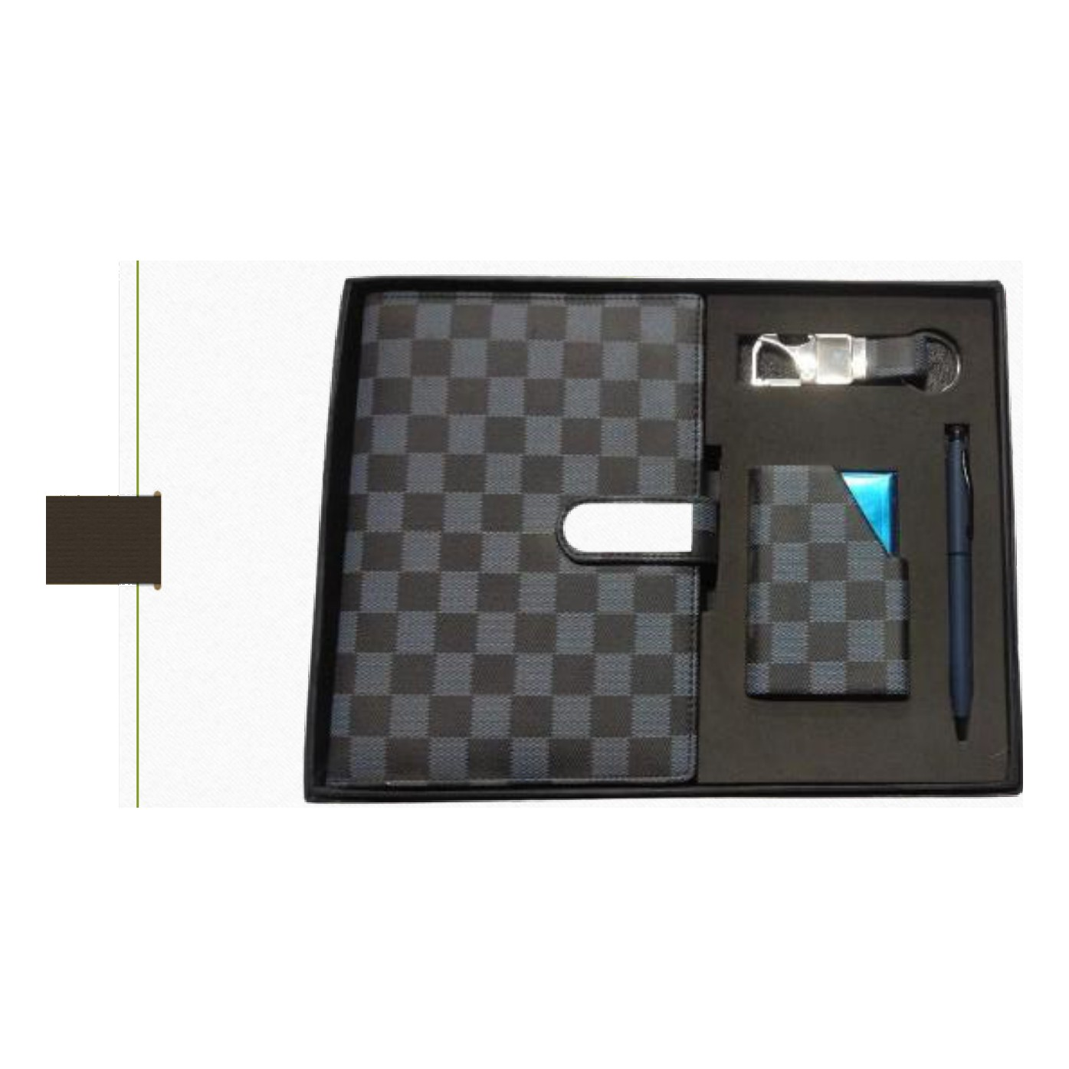  Diary · Pen · Keychain · Cardholder  Rs. 443/- (Base Rs.375 + 18% GST) |  | Item No. 02  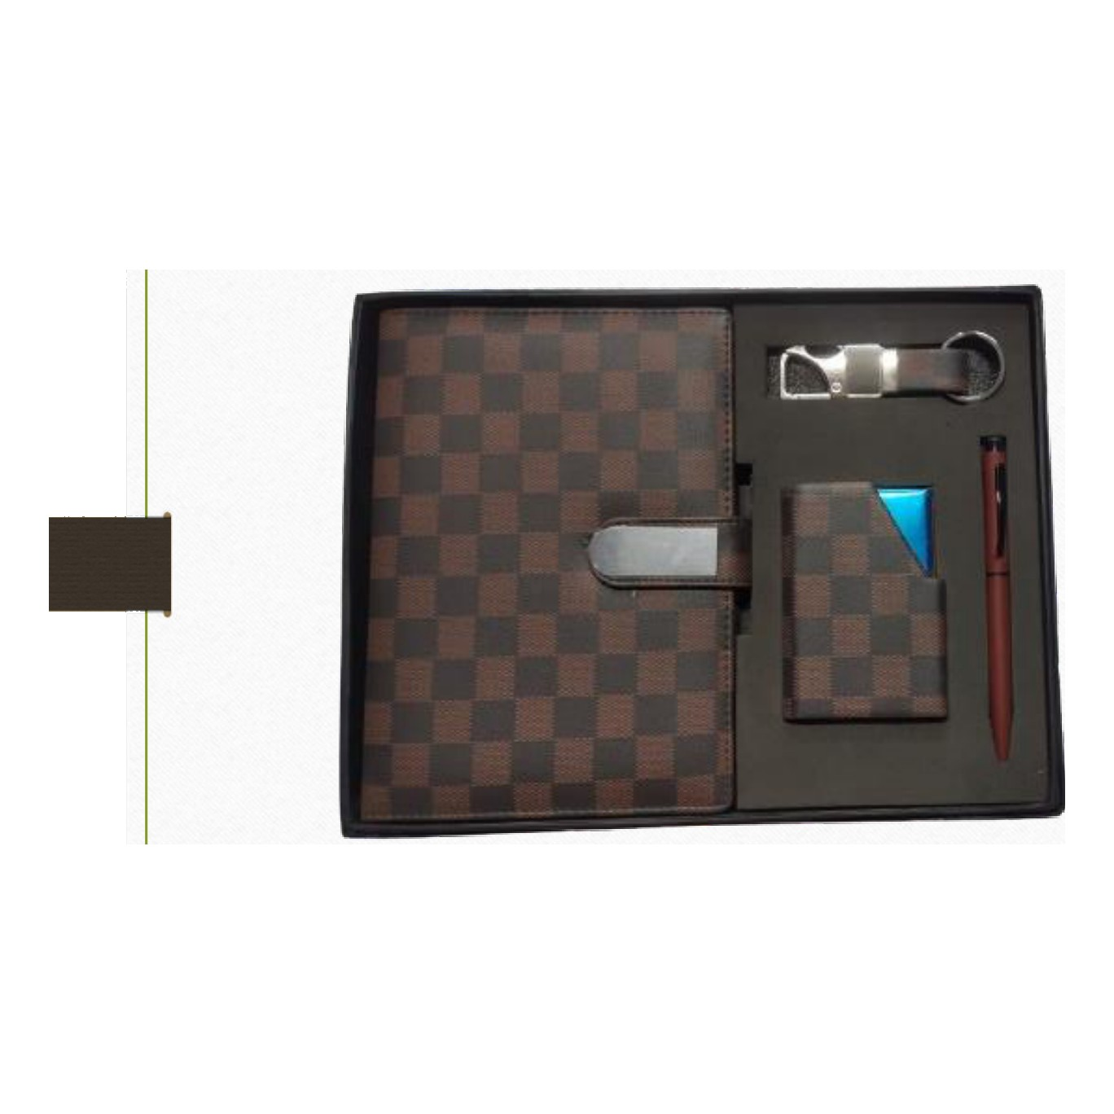  Diary · Pen · Keychain · Cardholder  Rs. 443/- (Base Rs.375 + 18% GST)
Item No. 03  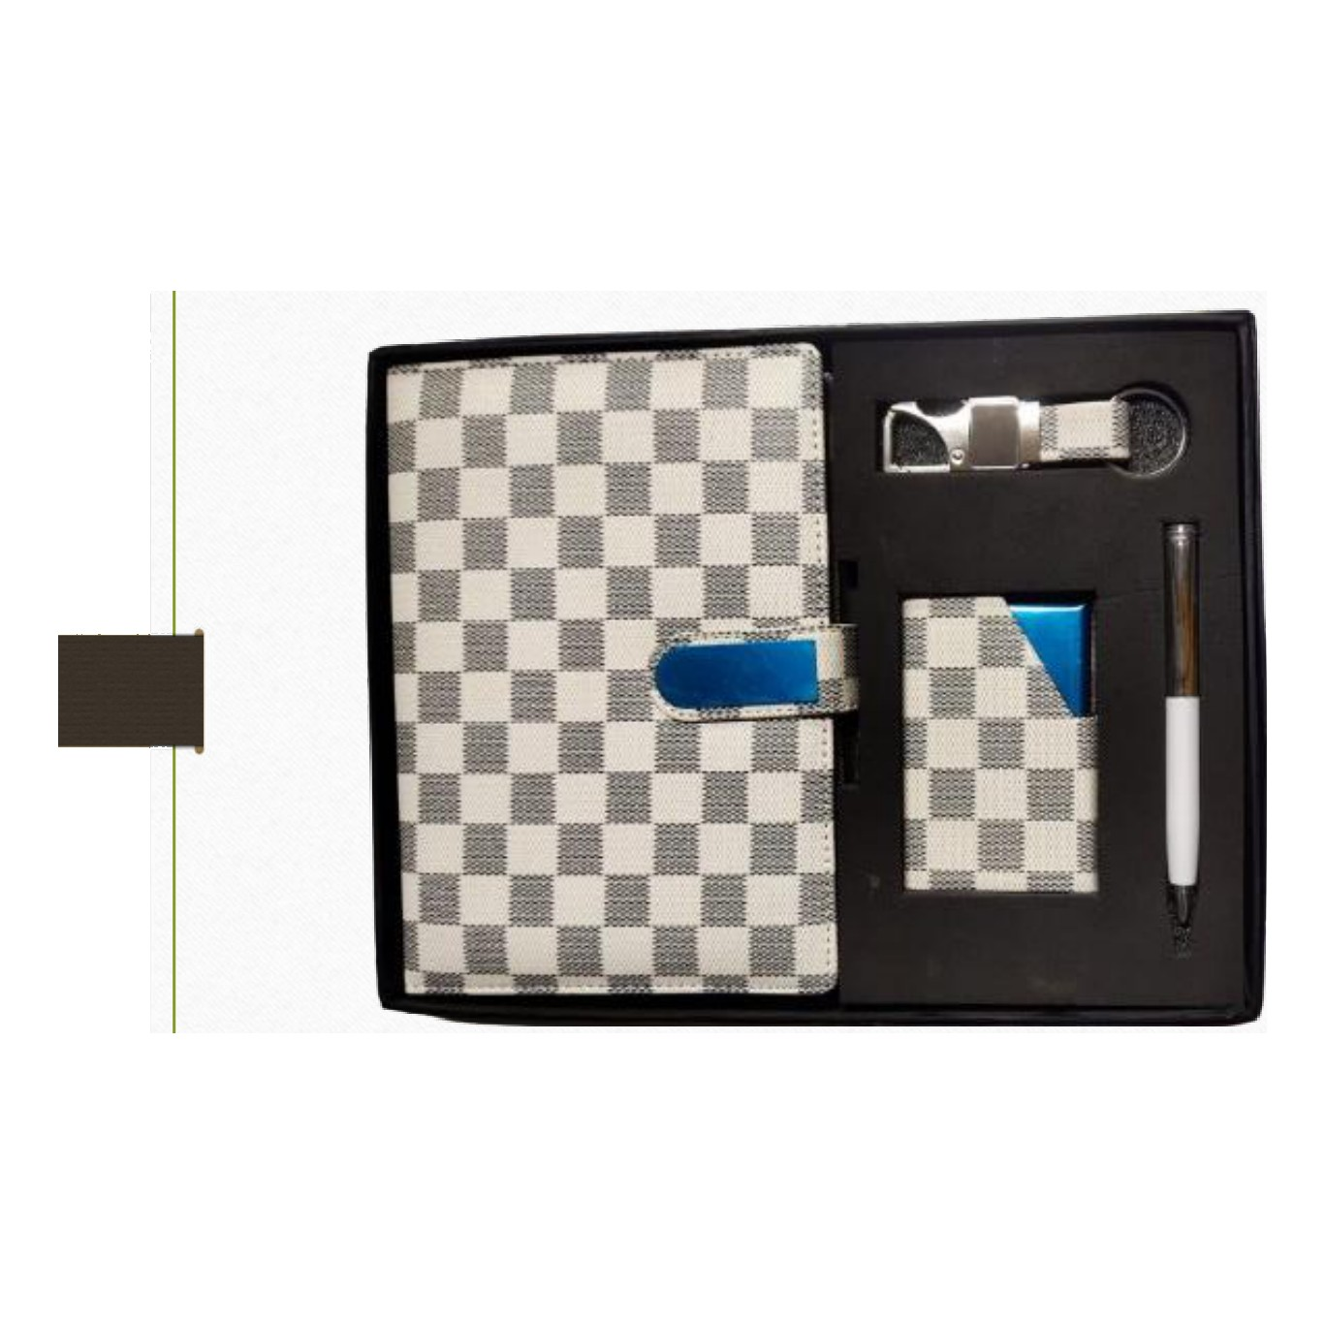  Diary · Pen · Keychain · Cardholder  Rs. 443/- (Base Rs.375 + 18% GST) |  | Item No. 04  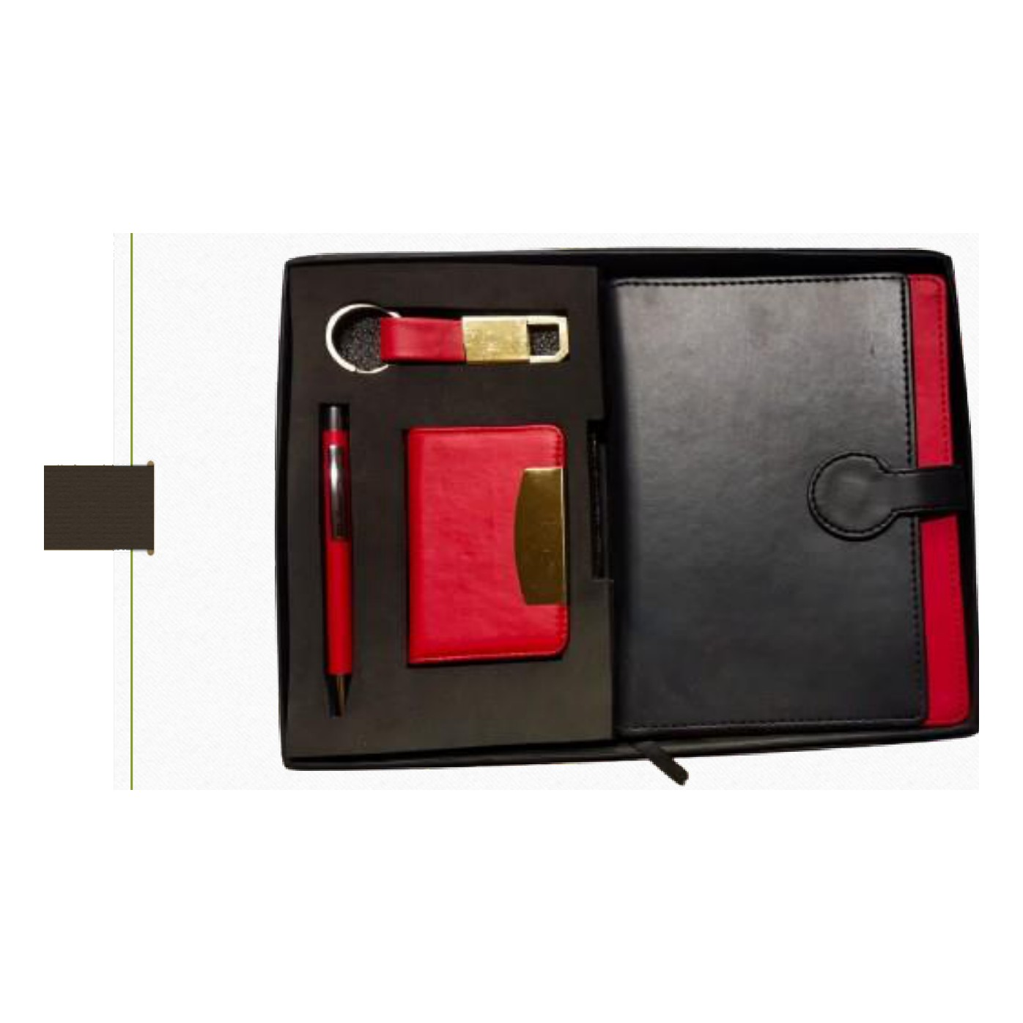  Diary · Pen · Keychain · Cardholder  Rs. 472/- (Base Rs.400 + 18% GST)
Item No. 05  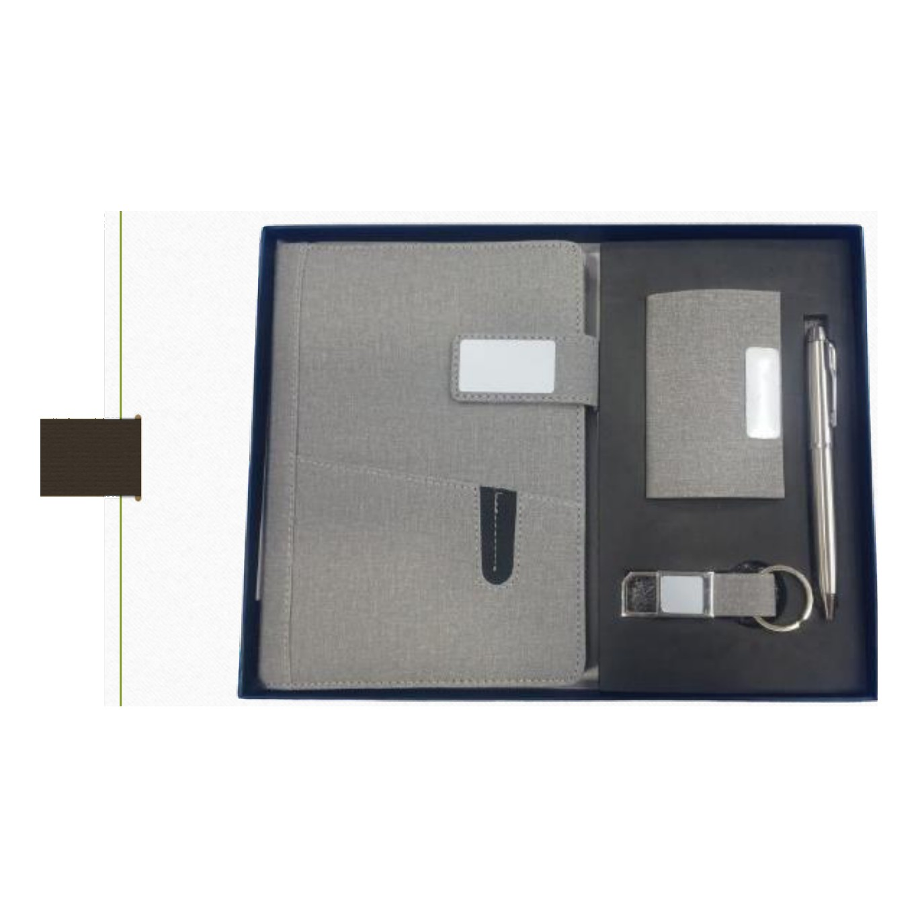  Diary · Pen · Keychain · Cardholder  Rs. 443/- (Base Rs.375 + 18% GST) |  | Item No. 06  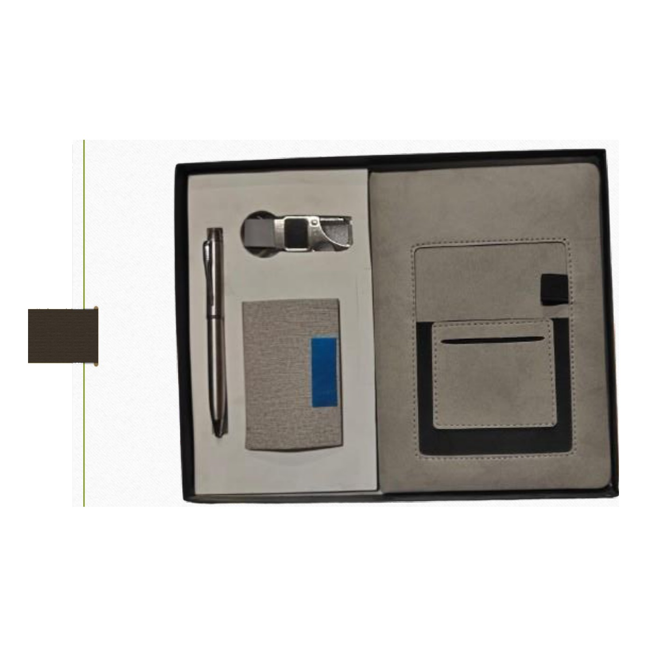  Diary · Pen · Keychain · Cardholder  Rs. 413/- (Base Rs.350 + 18% GST)
Item No. 07  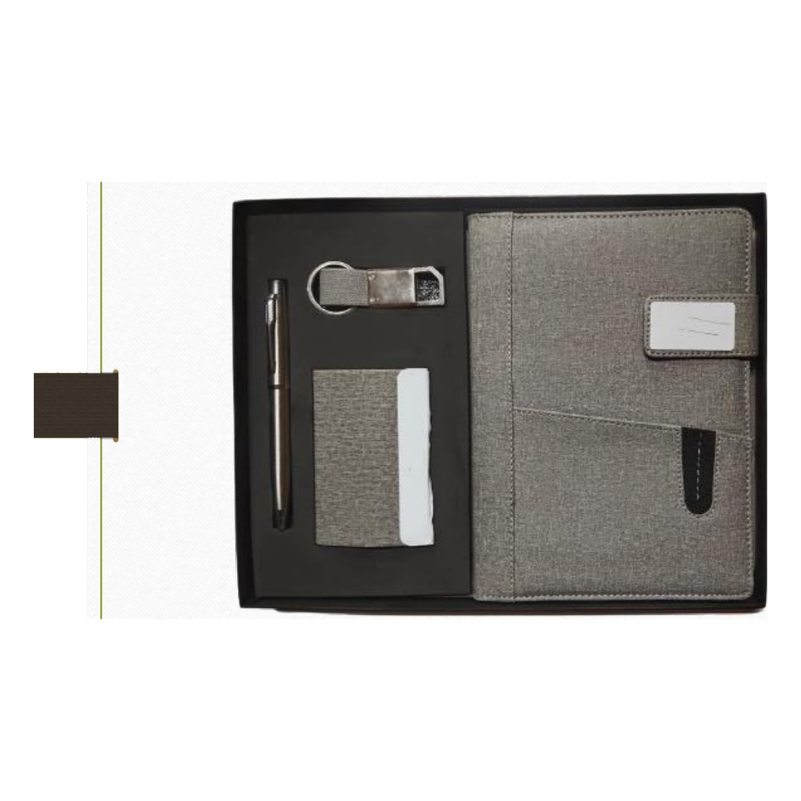  Diary · Pen · Keychain · Cardholder  Rs. 443/- (Base Rs.375 + 18% GST) |  | Item No. 08  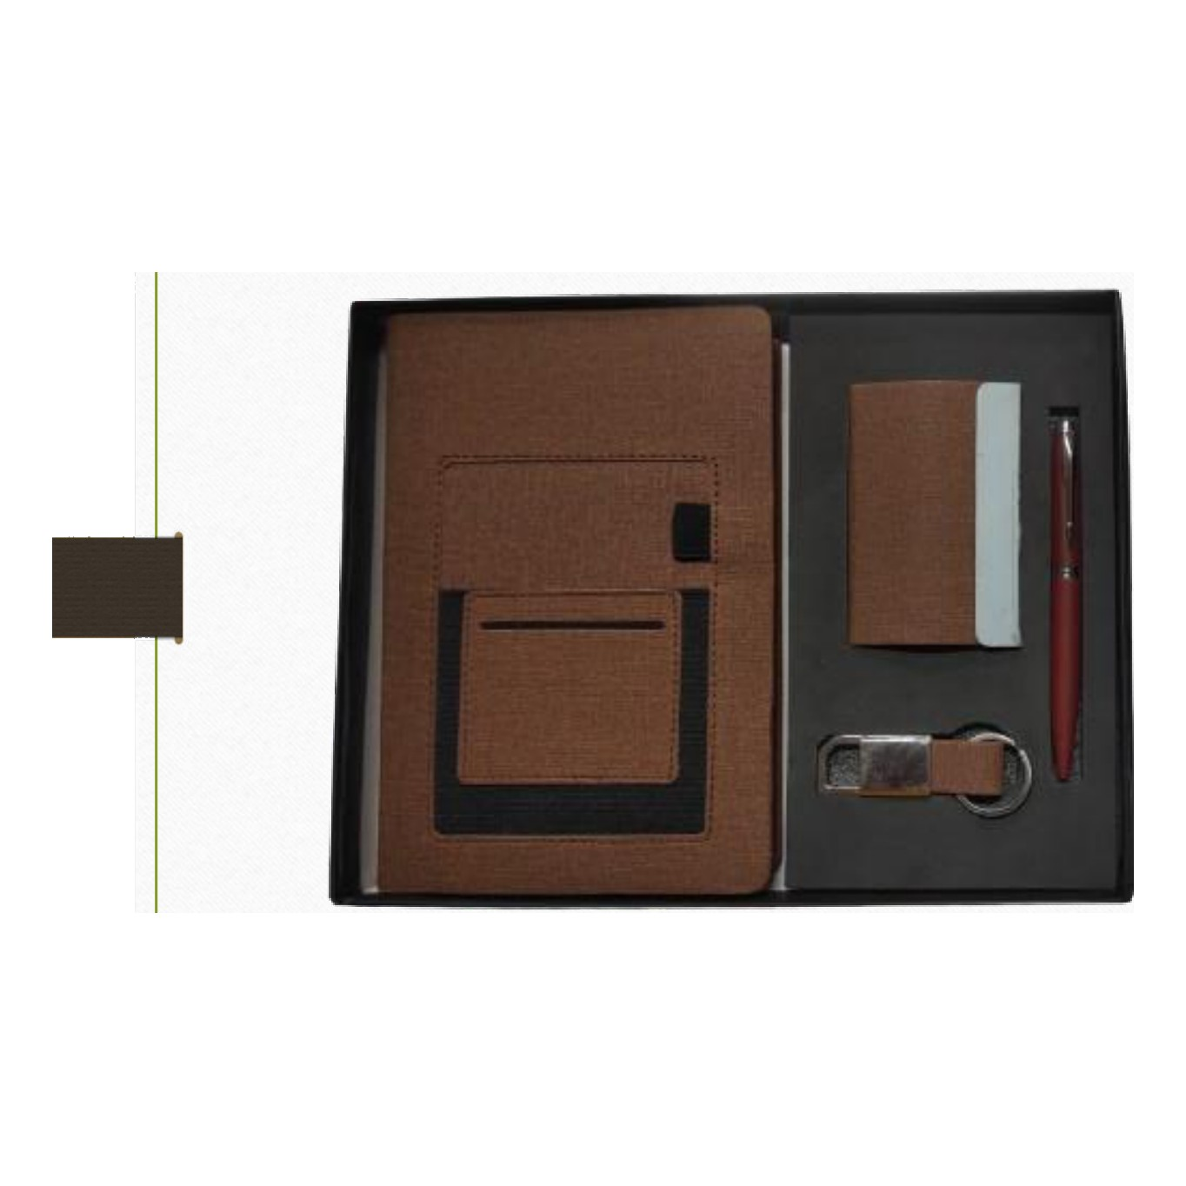  Diary · Pen · Keychain · Cardholder  Rs. 413/- (Base Rs.350 + 18% GST)
Item No. 09  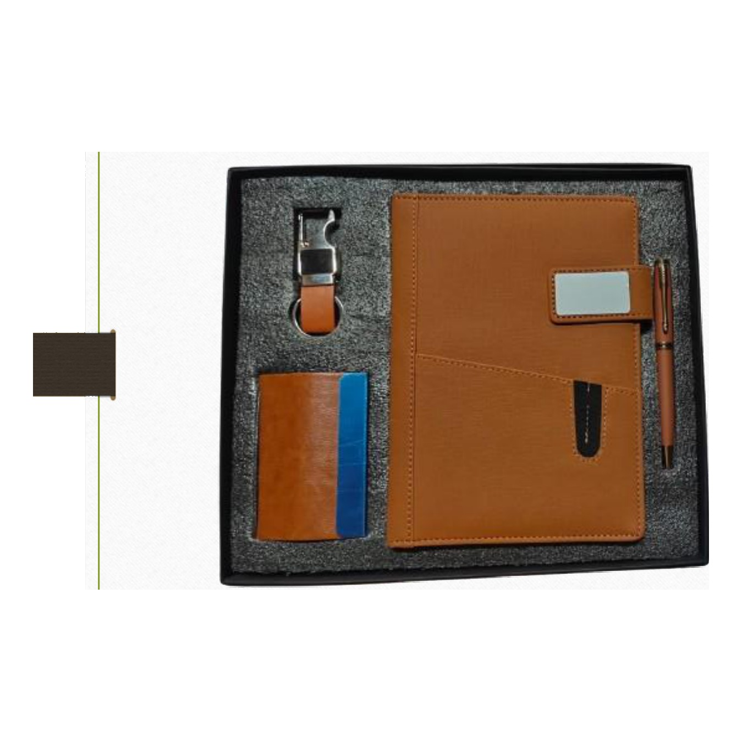  Diary · Pen · Keychain · Cardholder  Rs. 443/- (Base Rs.375 + 18% GST) |  | Item No. 10  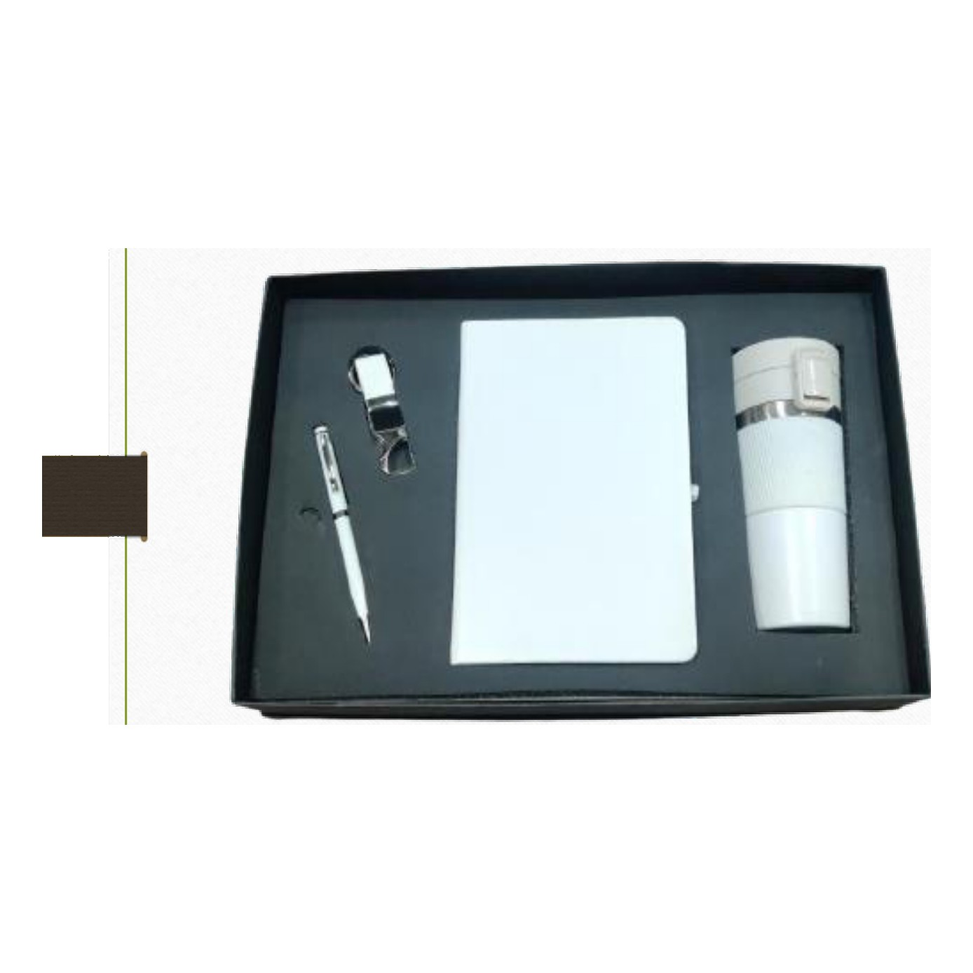  Diary · Pen · Keychain · Mug  Rs. 738/- (Base Rs.625 + 18% GST)
Item No. 11  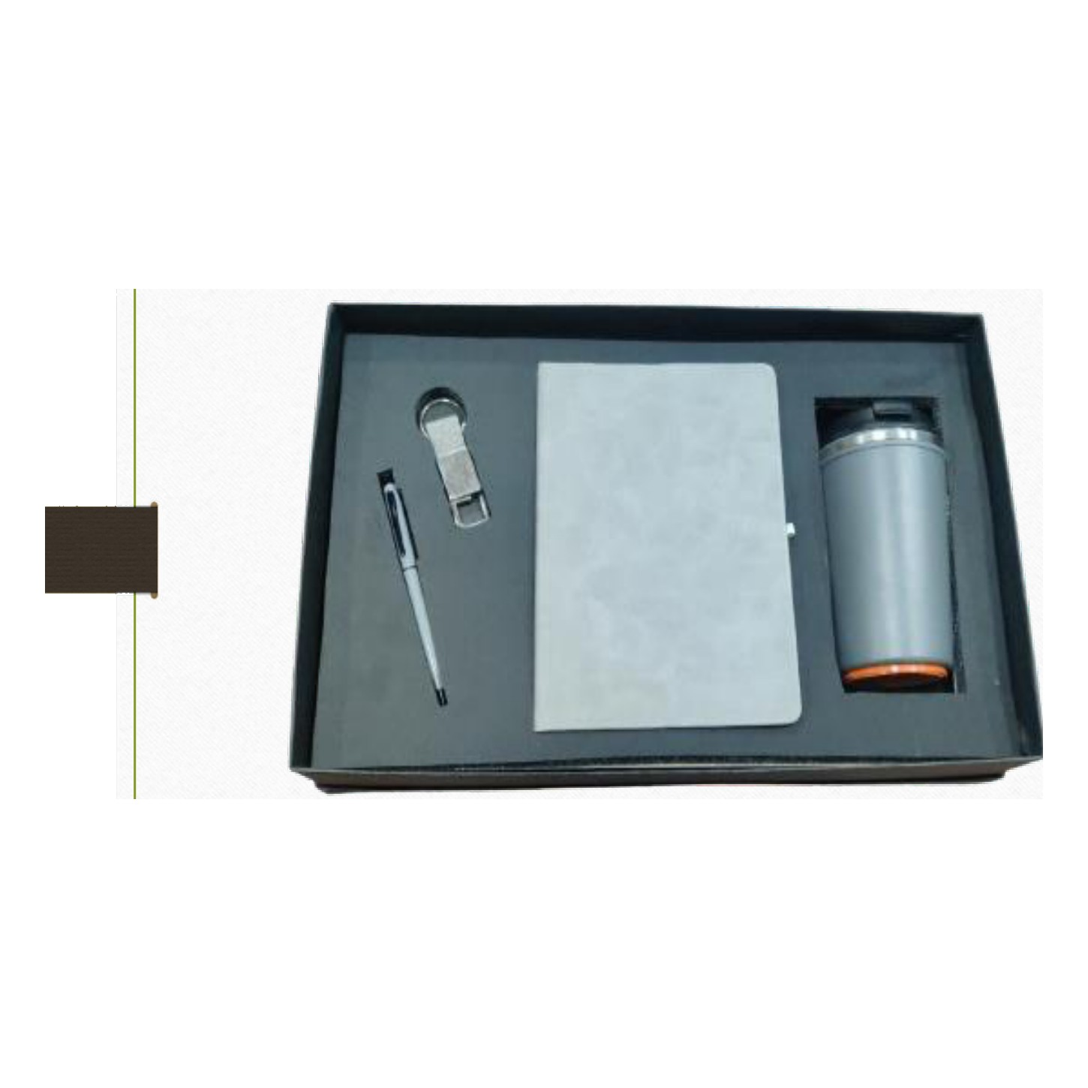  Diary · Pen · Keychain · LED Mug  Rs. 885/- (Base Rs.750 + 18% GST) |  | Item No. 12  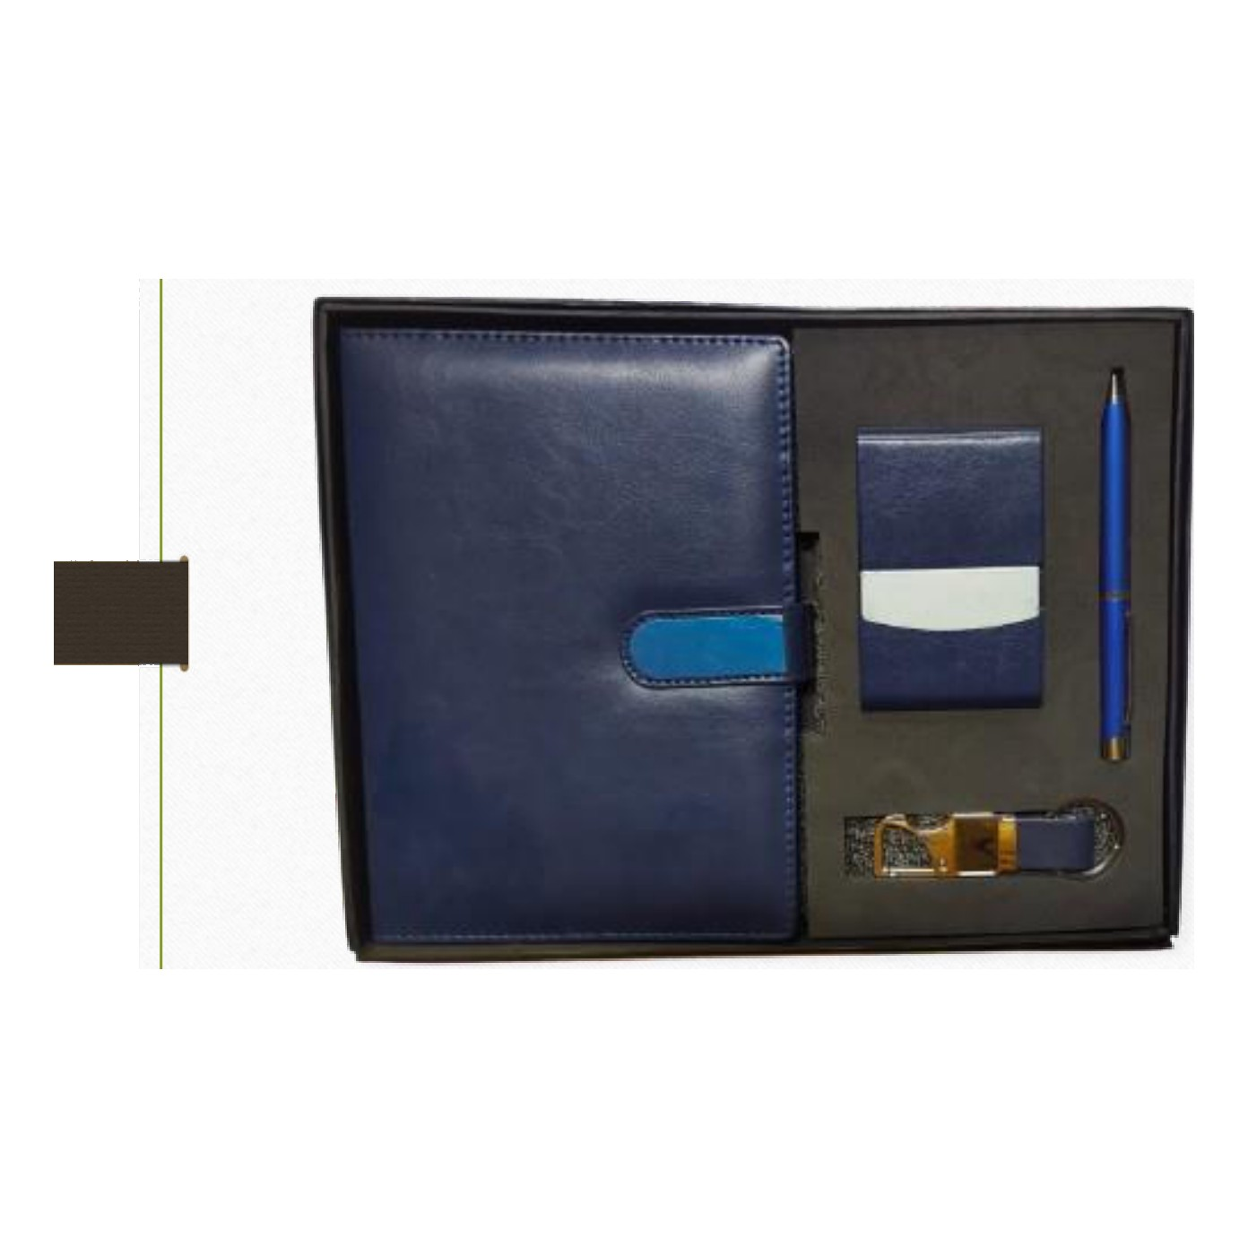  Diary · Pen · Keychain · Cardholder  Rs. 443/- (Base Rs.375 + 18% GST)
Item No. 13  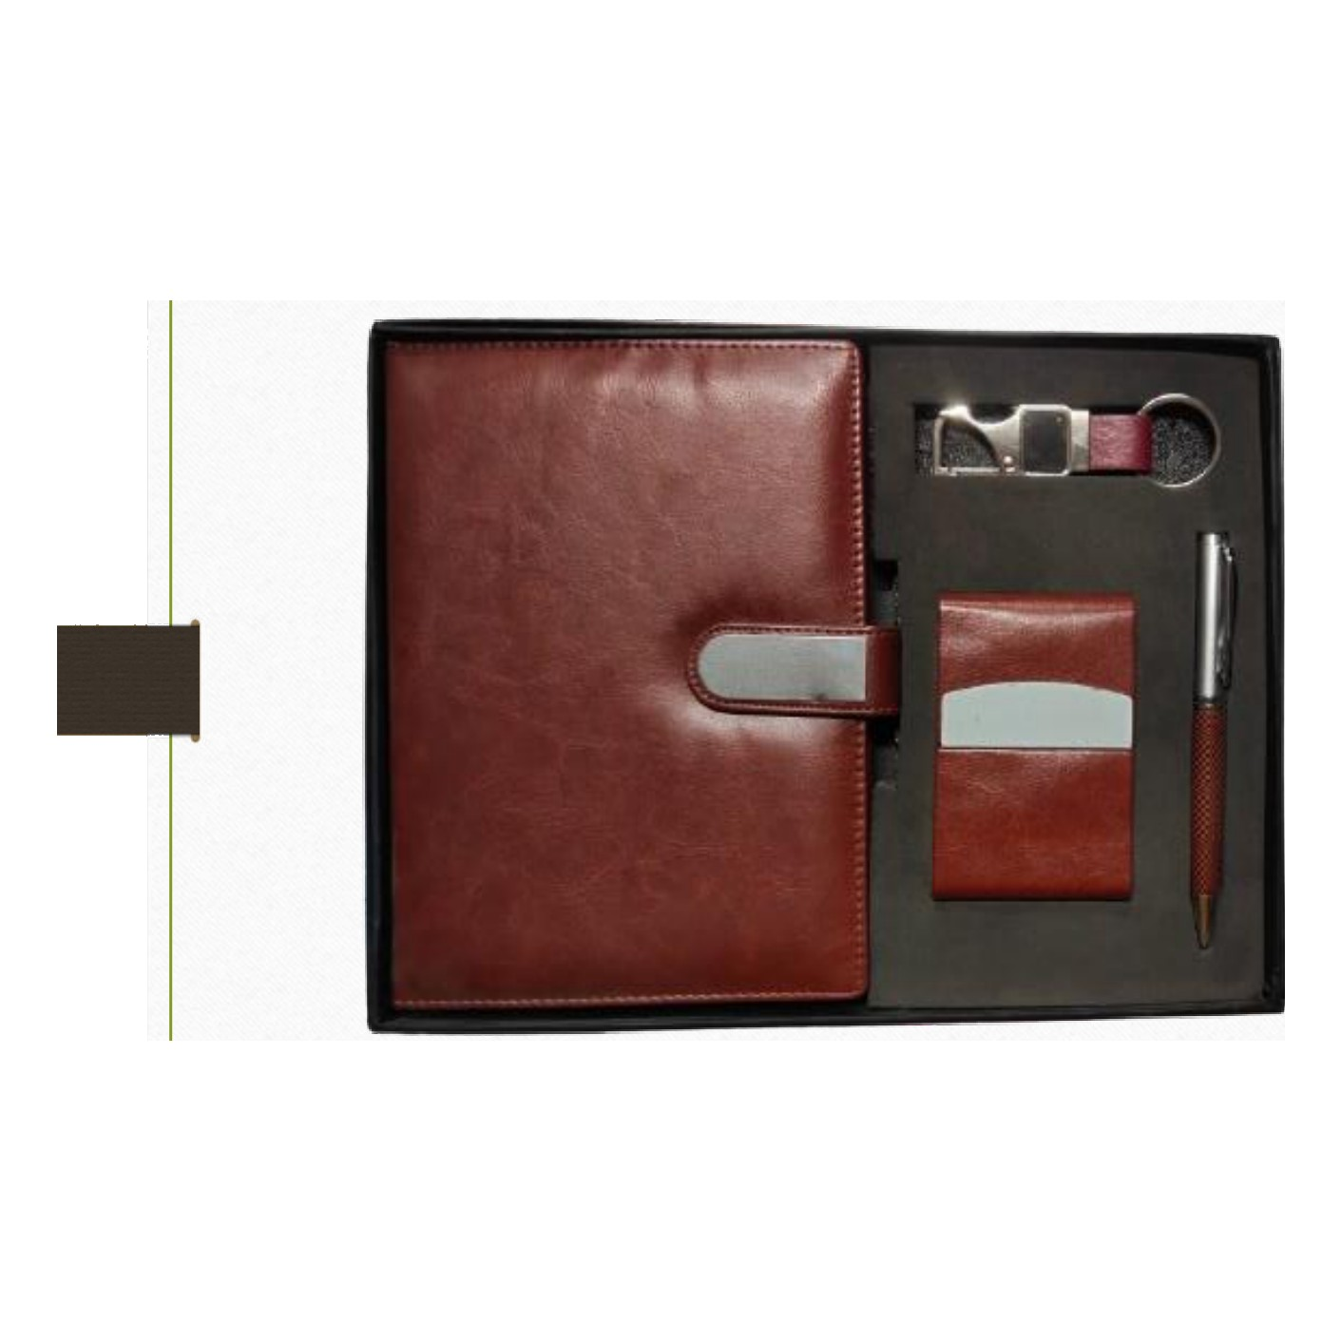  Diary · Pen · Keychain · Cardholder  Rs. 443/- (Base Rs.375 + 18% GST) |  | Item No. 14  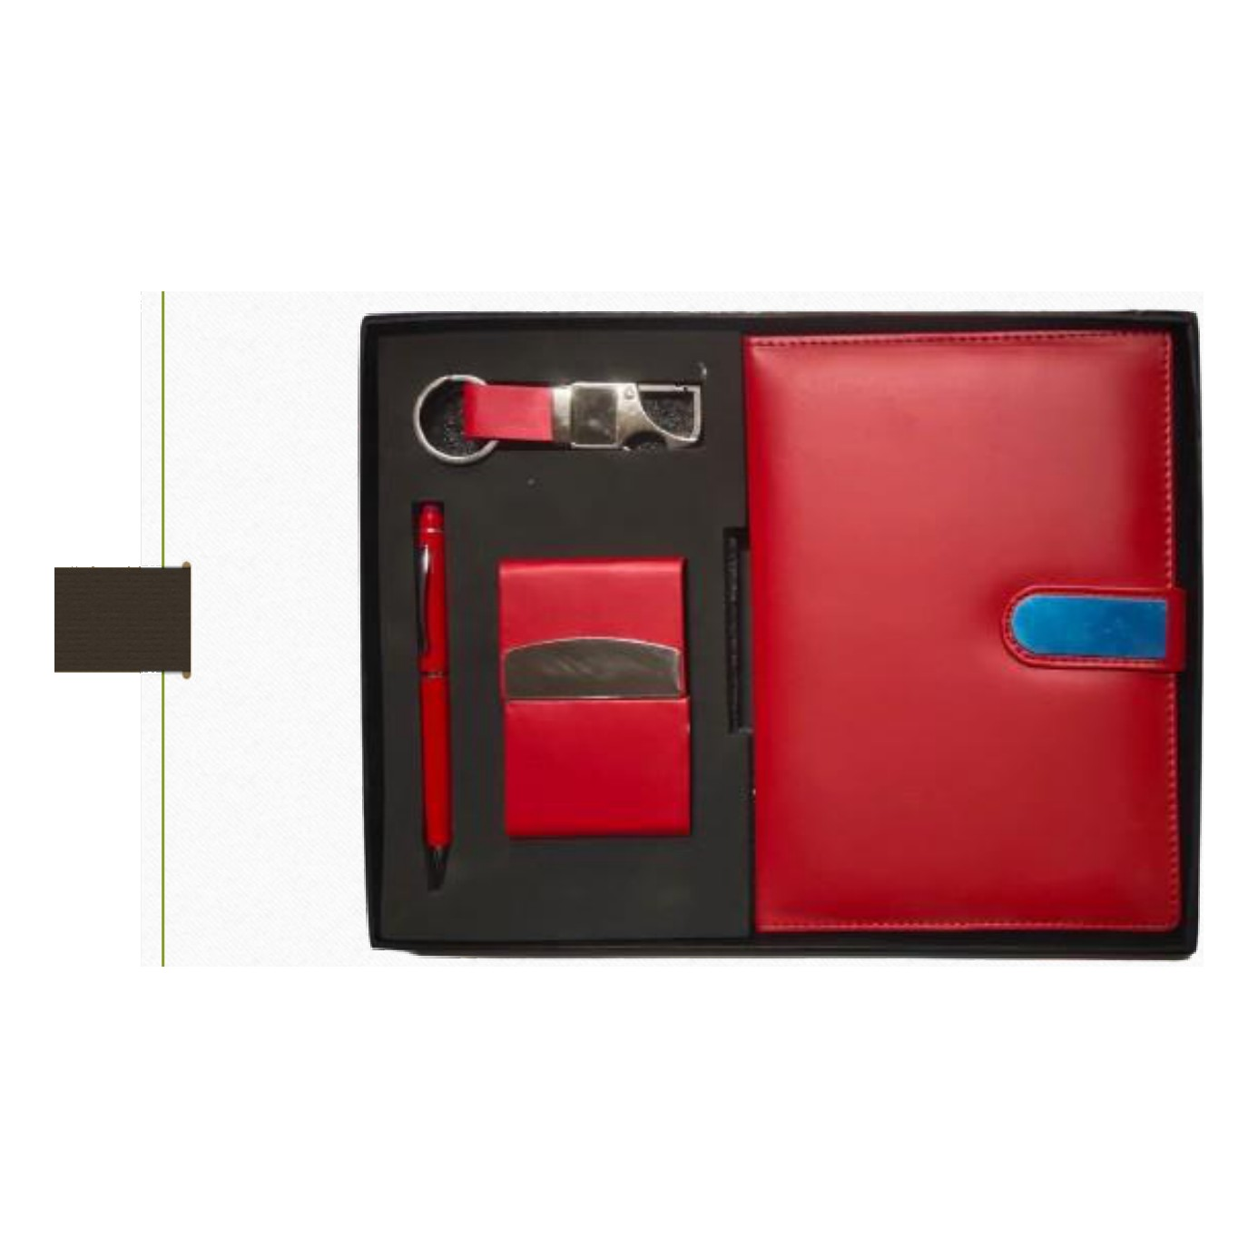  Diary · Pen · Keychain · Cardholder  Rs. 443/- (Base Rs.375 + 18% GST)
Item No. 15  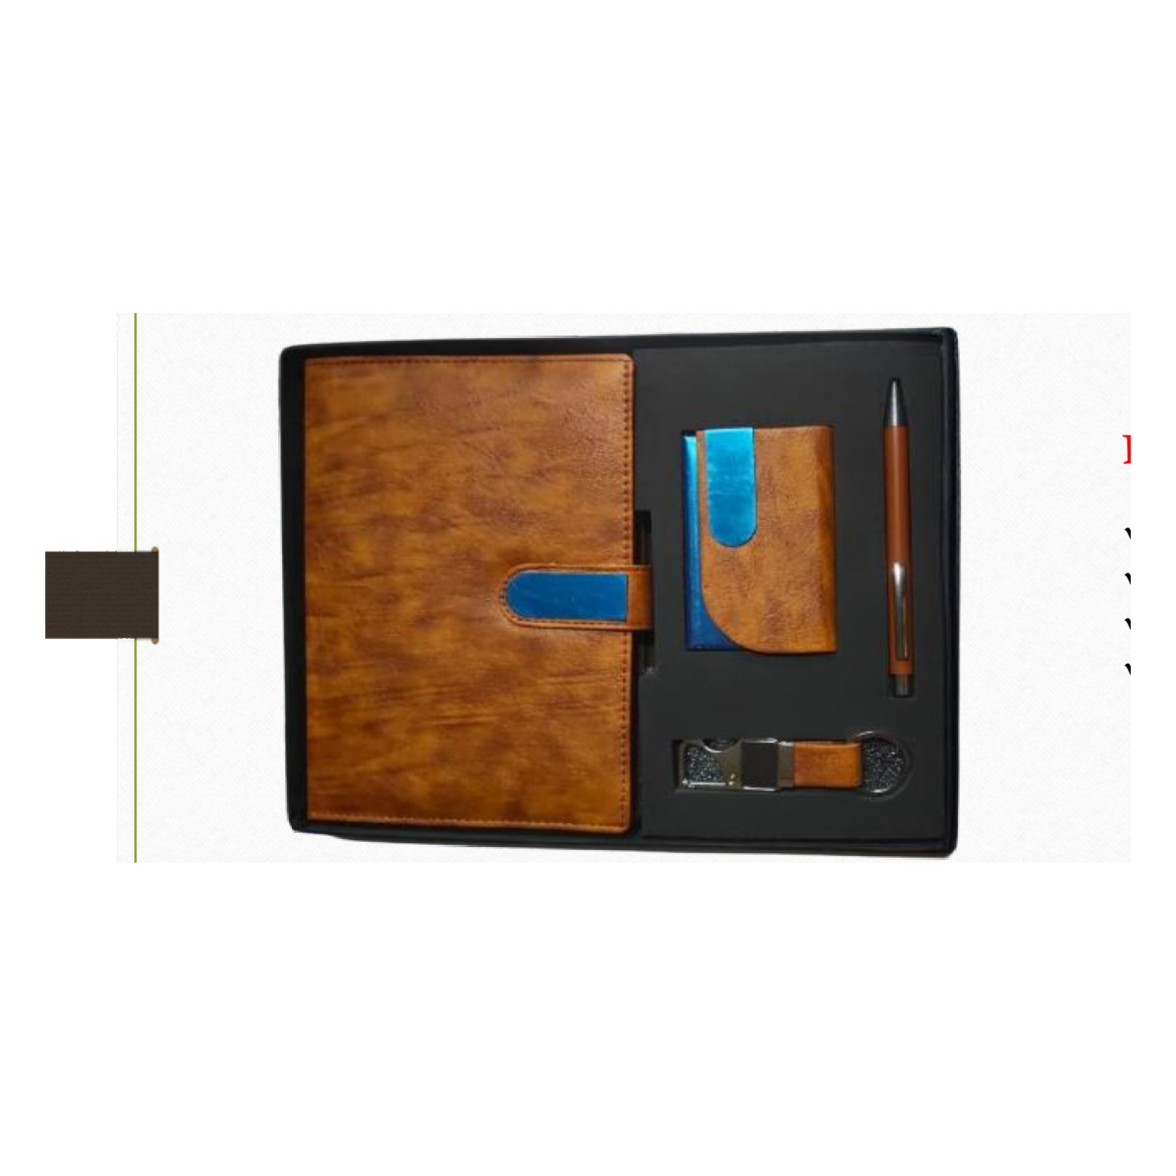  Diary · Pen · Keychain · Cardholder  Rs. 443/- (Base Rs.375 + 18% GST) |  | Item No. 16  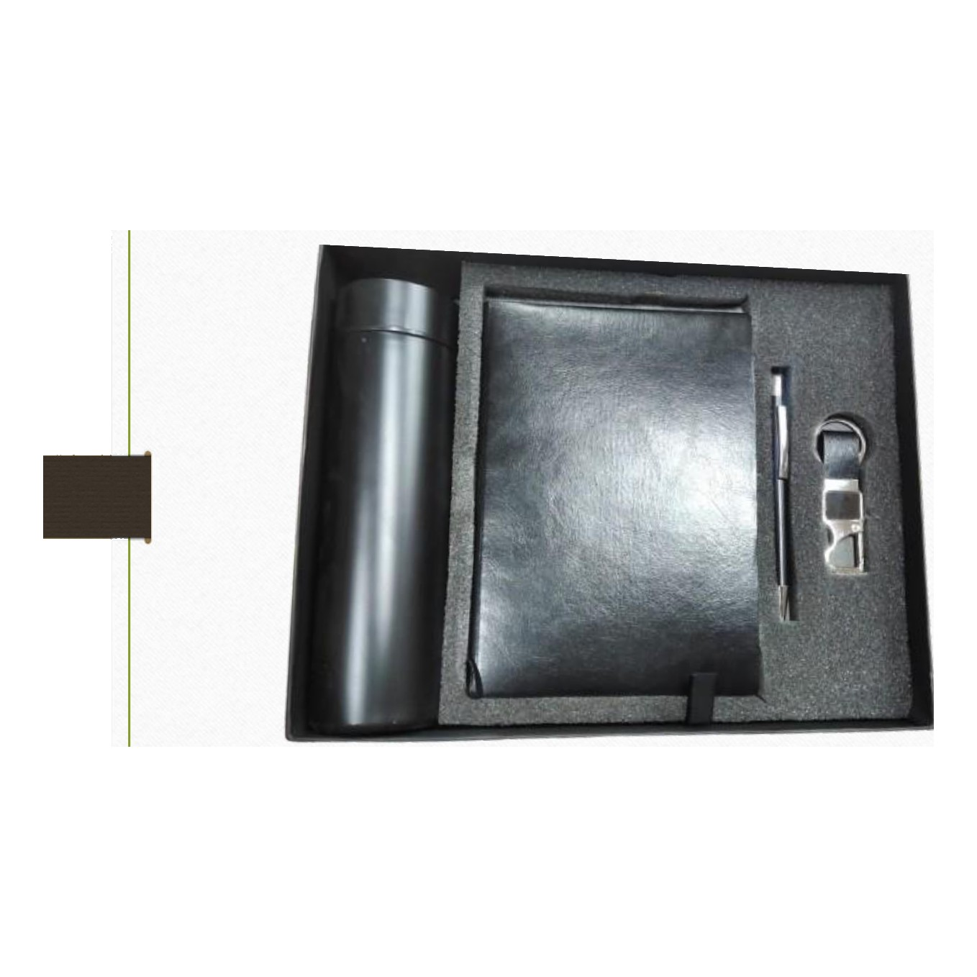  Soft Diary · Pen · Keychain · Bottle  Rs. 472/- (Base Rs.400 + 18% GST)
Item No. 17  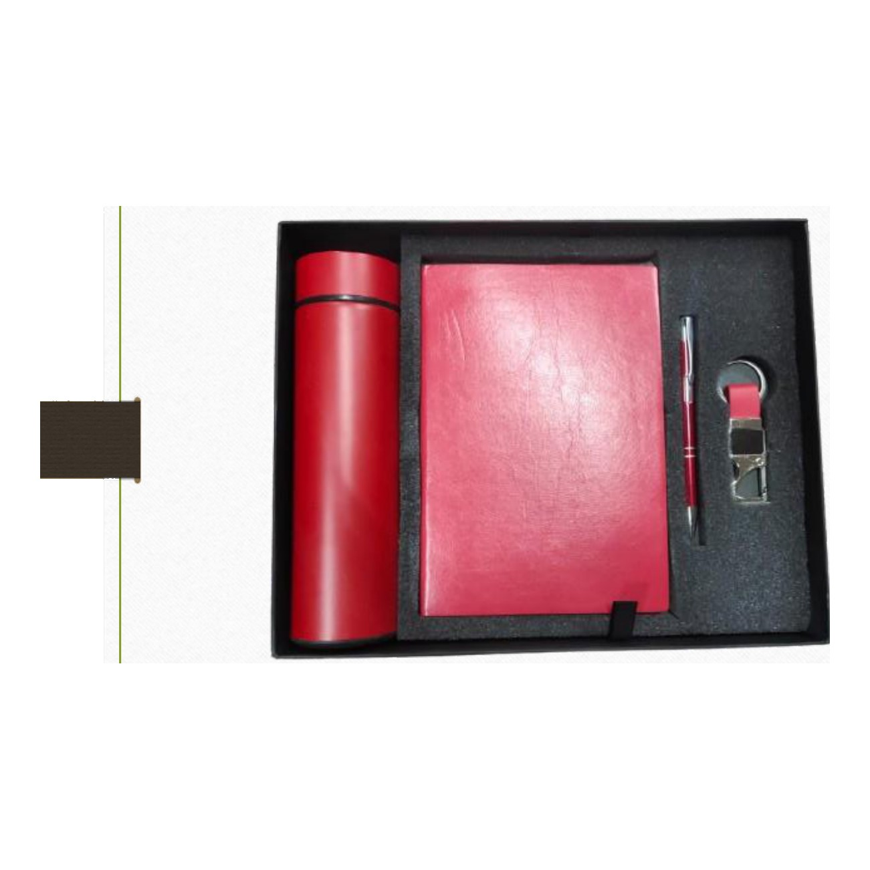  Soft Diary · Pen · Keychain · Bottle  Rs. 472/- (Base Rs.400 + 18% GST) |  | Item No. 18  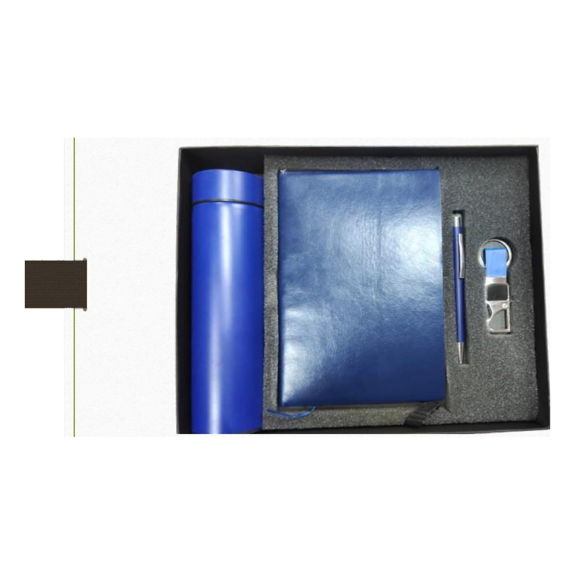  Soft Diary · Pen · Keychain · Bottle  Rs. 472/- (Base Rs.400 + 18% GST)
Item No. 19  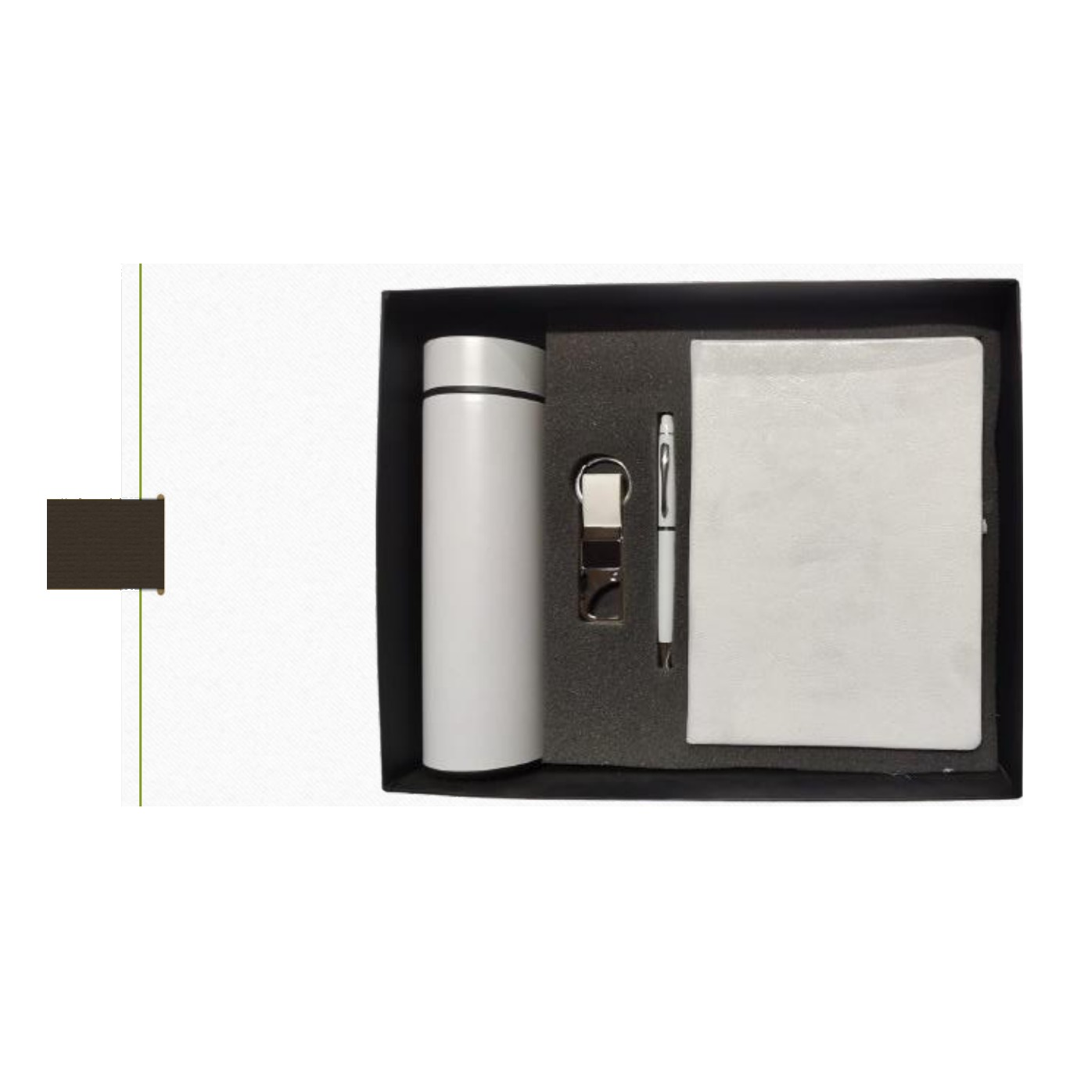  PU Leather Diary · Pen · Keychain · Bottle  Rs. 502/- (Base Rs.425 + 18% GST) |  | Item No. 20  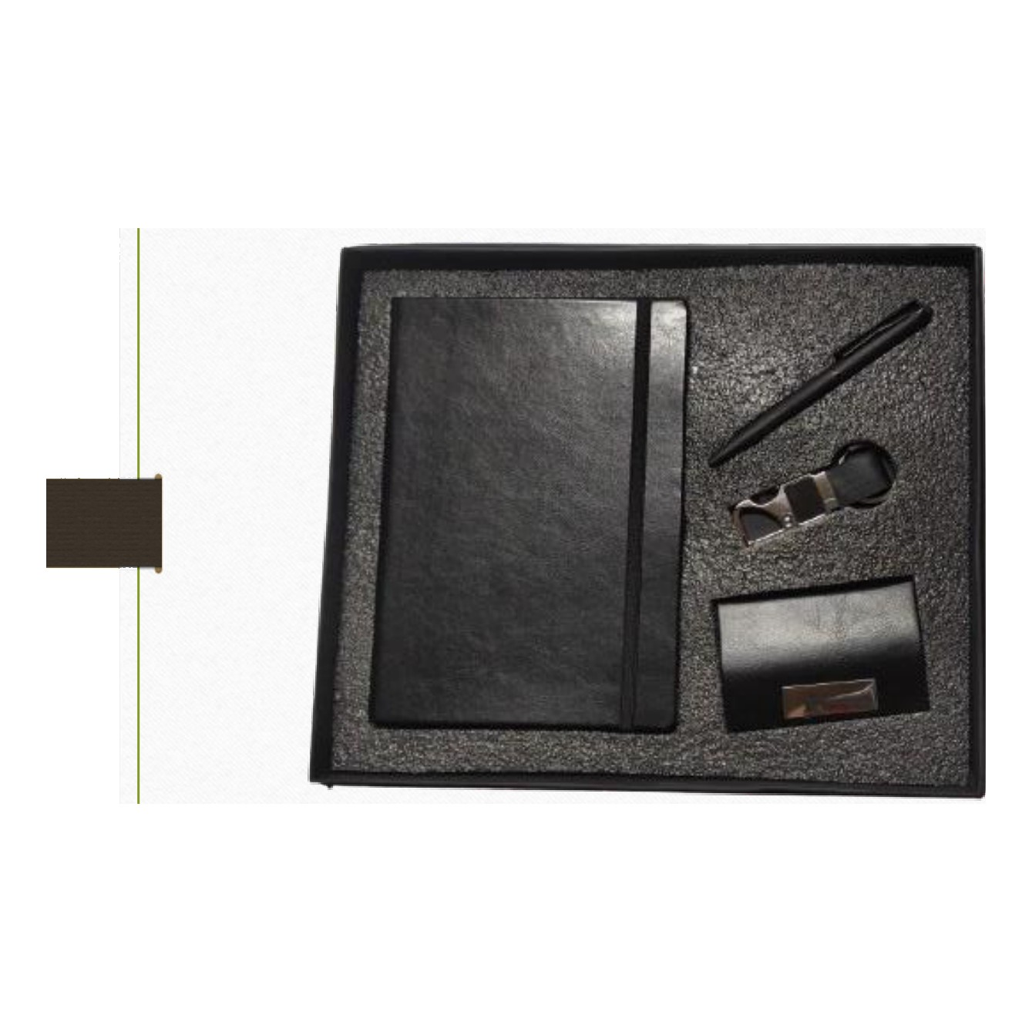  Diary · Pen · Keychain · Cardholder  Rs. 325/- (Base Rs.275 + 18% GST)
Item No. 21  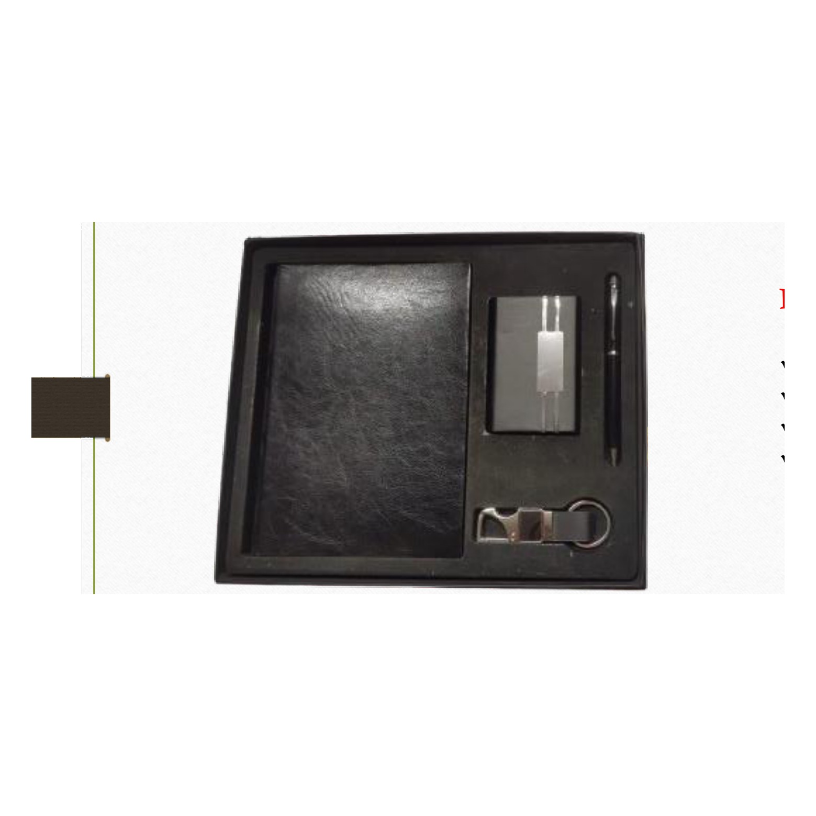  Diary · Pen · Keychain · Cardholder  Rs. 354/- (Base Rs.300 + 18% GST) |  | Item No. 22  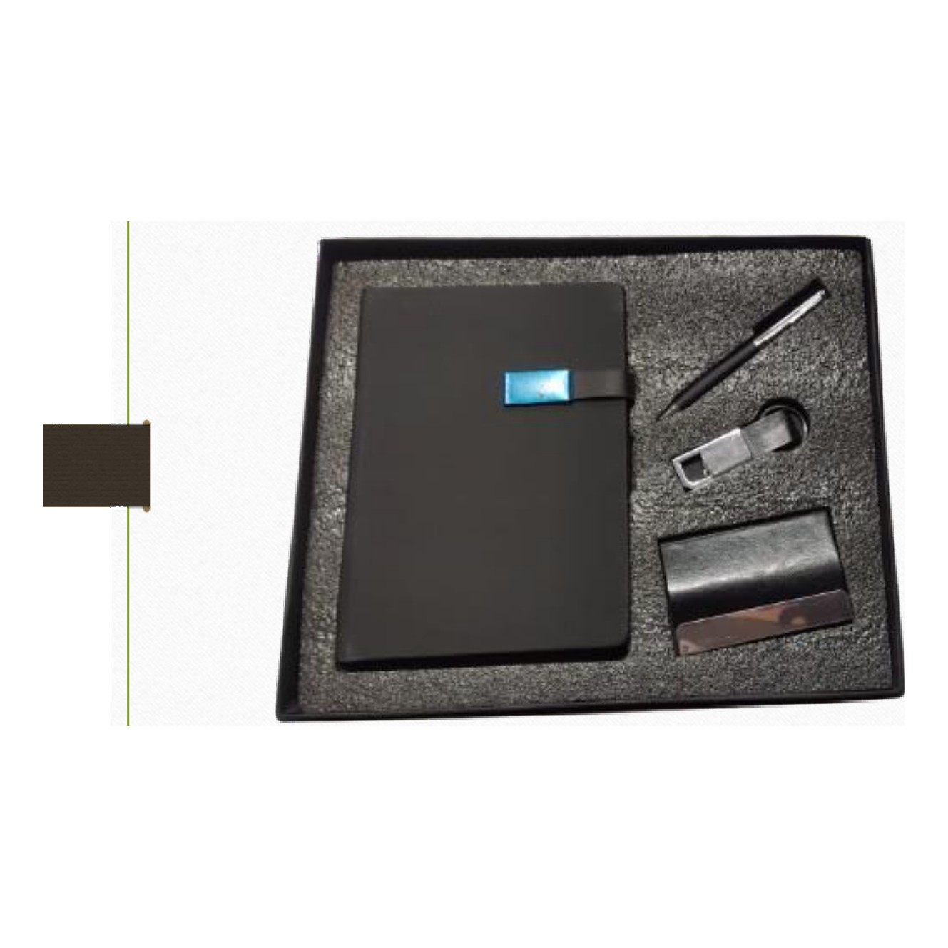  Diary · Pen · Keychain · Cardholder  Rs. 384/- (Base Rs.325 + 18% GST)
Item No. 23  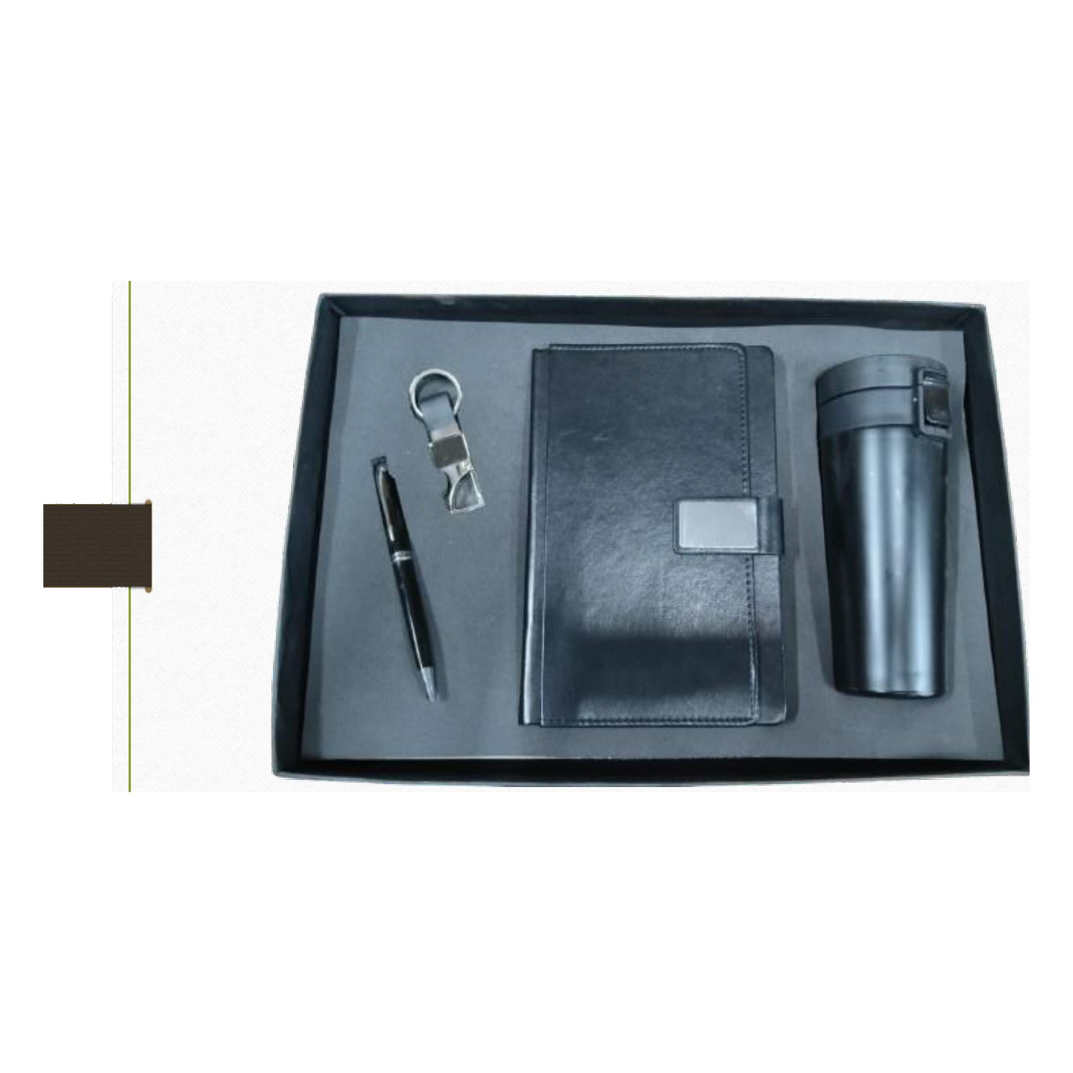  Diary · Pen · Keychain · Mug  Rs. 856/- (Base Rs.725 + 18% GST) |  | Item No. 24  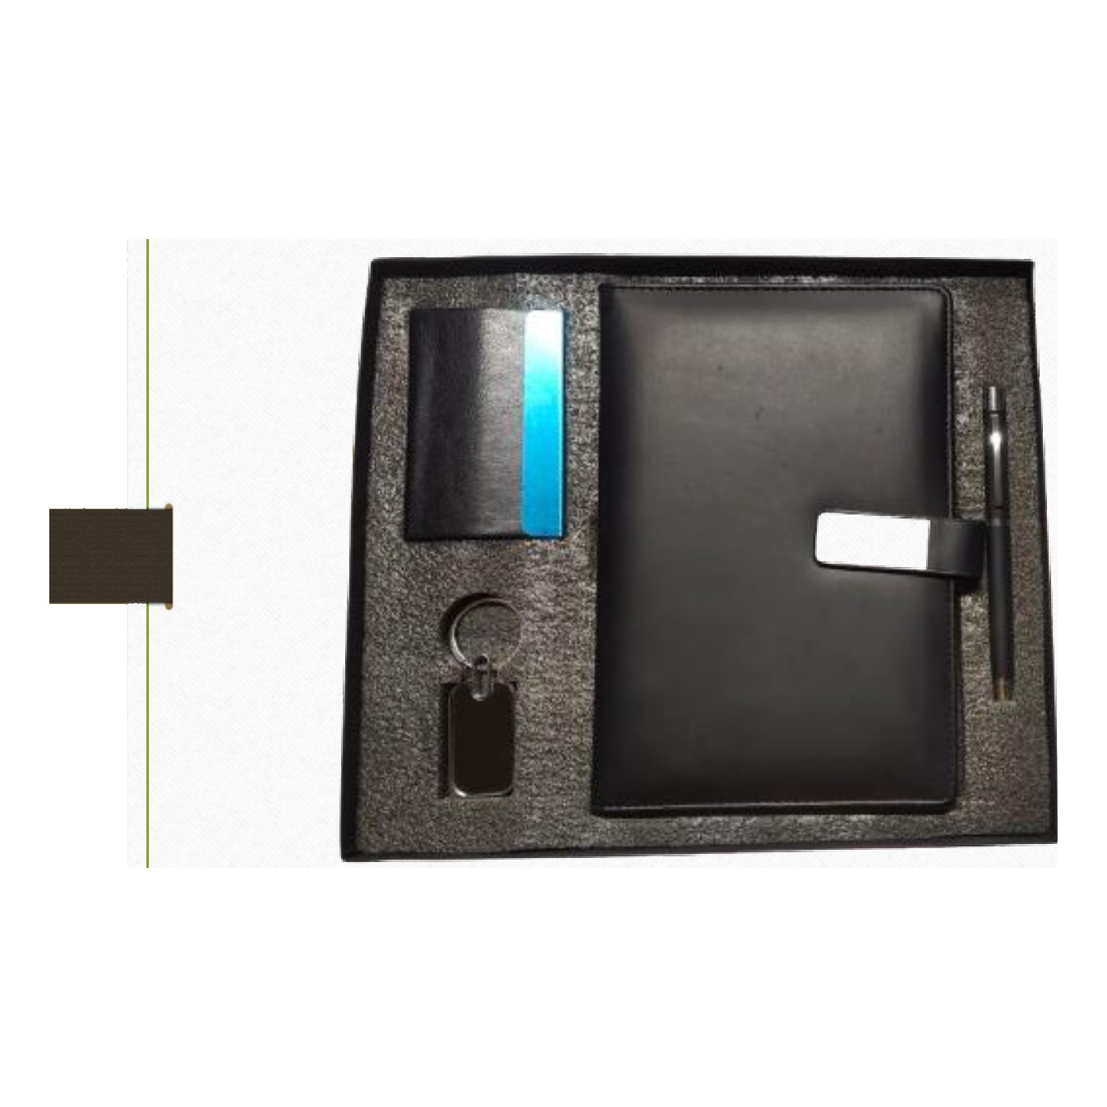  Diary · Pen · Keychain · Cardholder  Rs. 384/- (Base Rs.325 + 18% GST)
Item No. 25  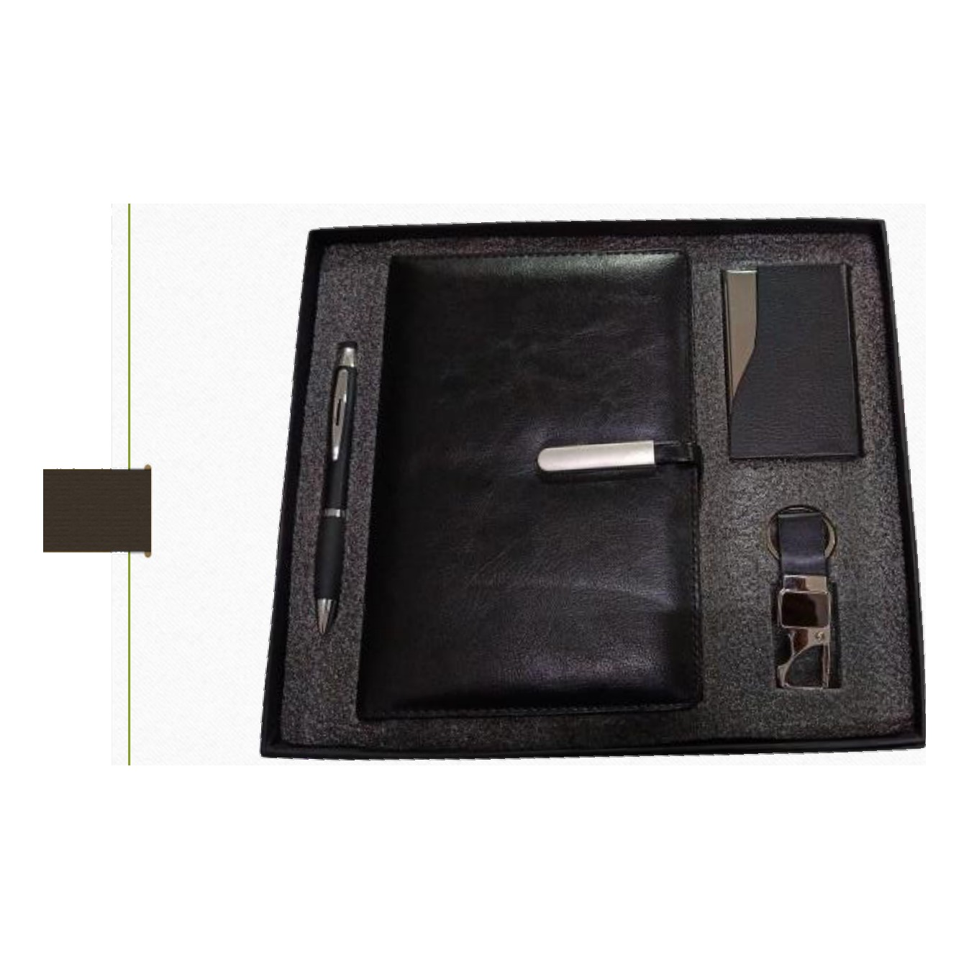  Diary · Pen · Keychain · Cardholder  Rs. 413/- (Base Rs.350 + 18% GST) |  | Item No. 26  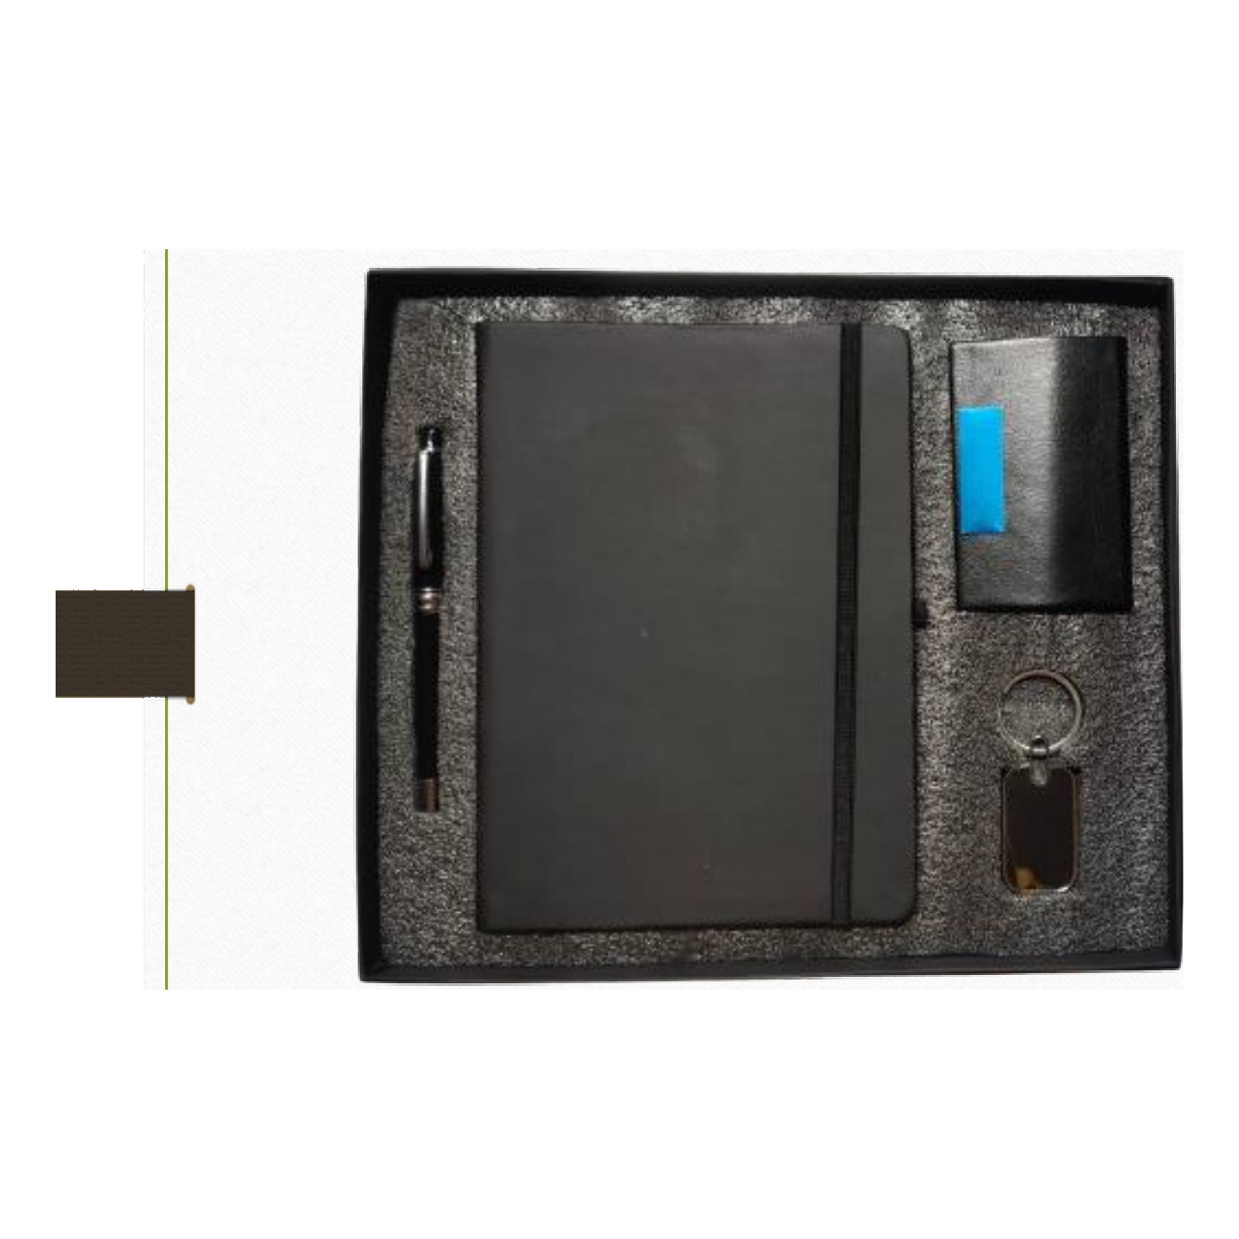  Diary · Pen · Keychain · Cardholder  Rs. 325/- (Base Rs.275 + 18% GST)
Item No. 27  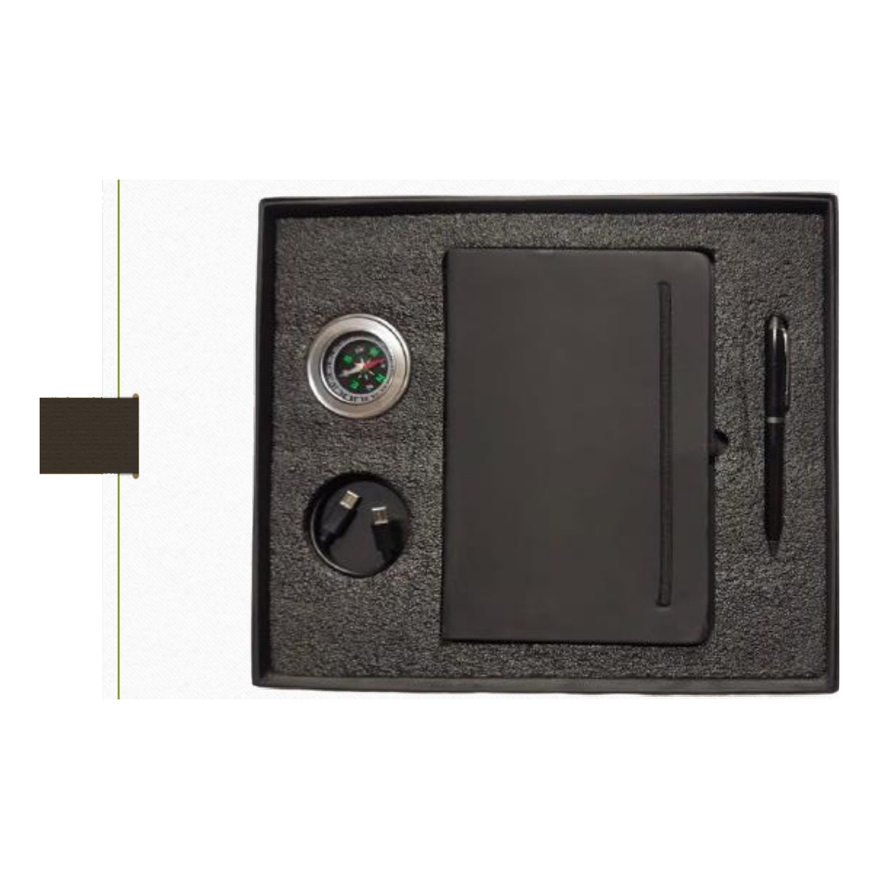  Diary · Pen · Compass · Cable  Rs. 472/- (Base Rs.400 + 18% GST) |  | Item No. 28  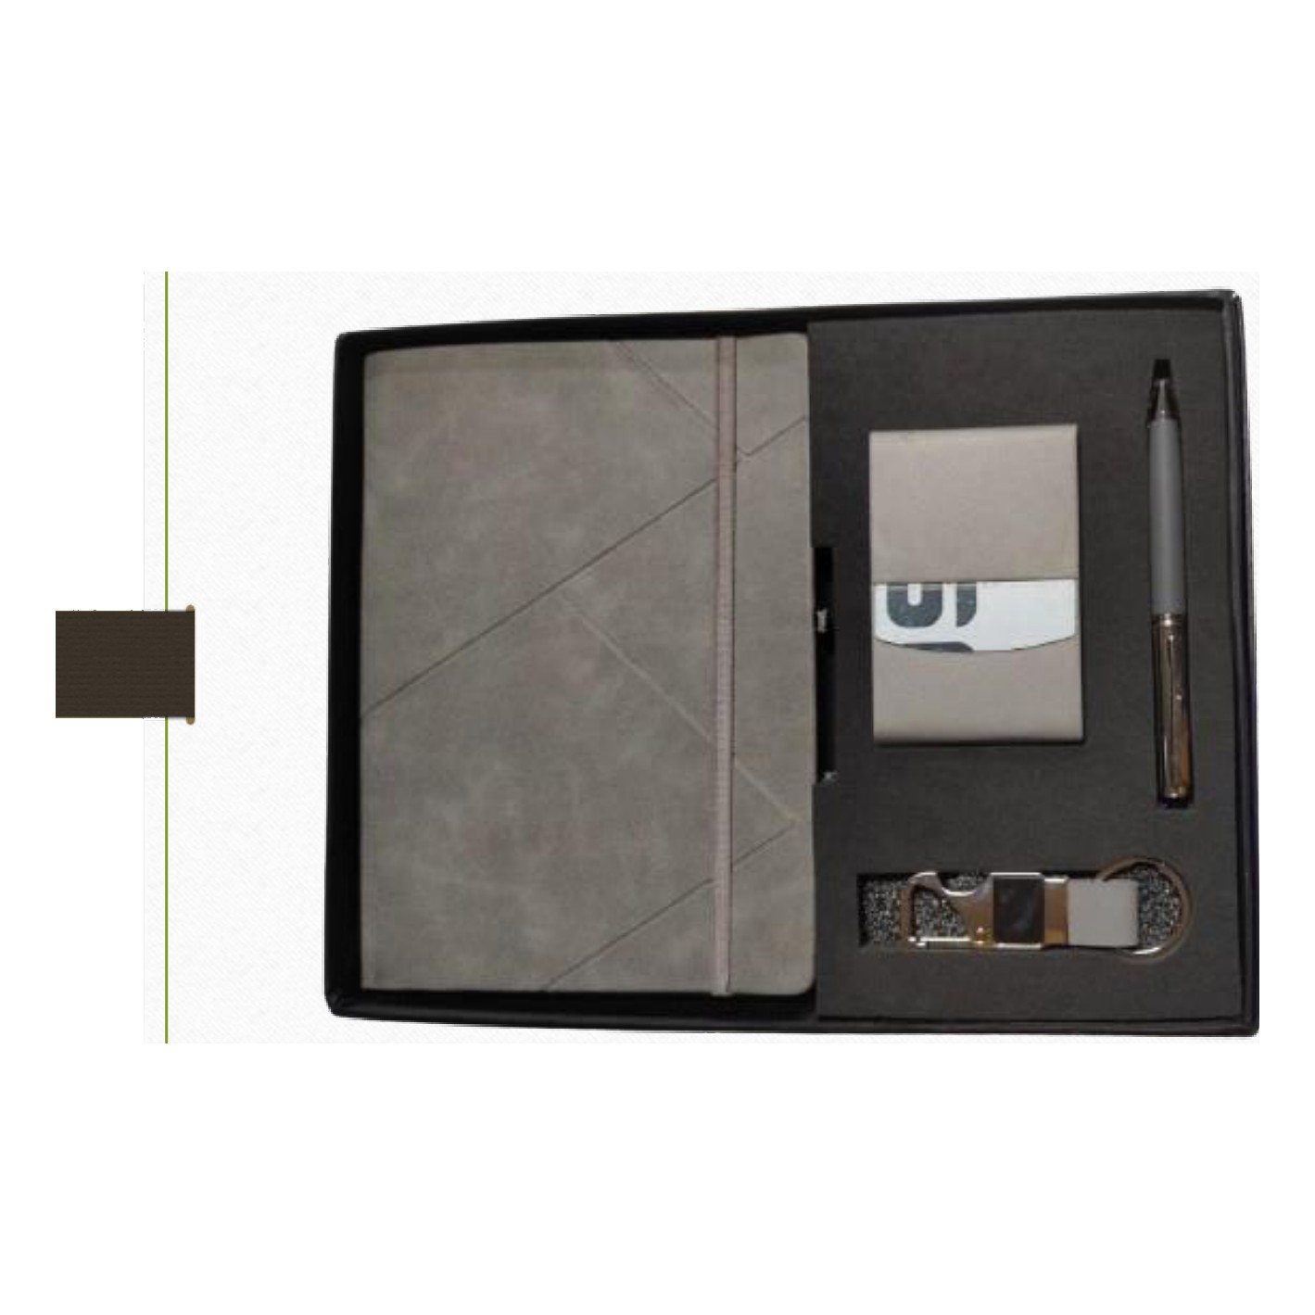  Diary · Pen · Keychain · Cardholder  Rs. 443/- (Base Rs.375 + 18% GST)
Item No. 29  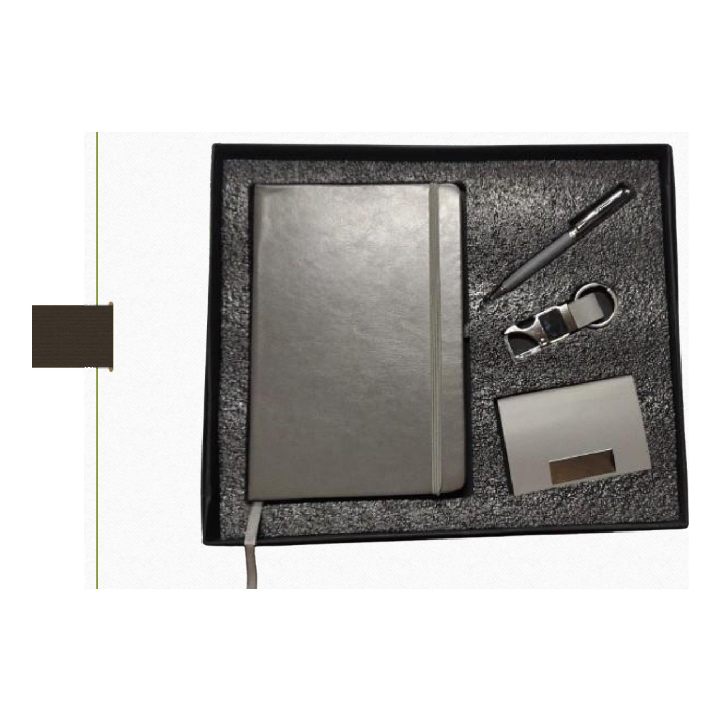  Diary · Pen · Keychain · Cardholder  Rs. 354/- (Base Rs.300 + 18% GST) |  | Item No. 30  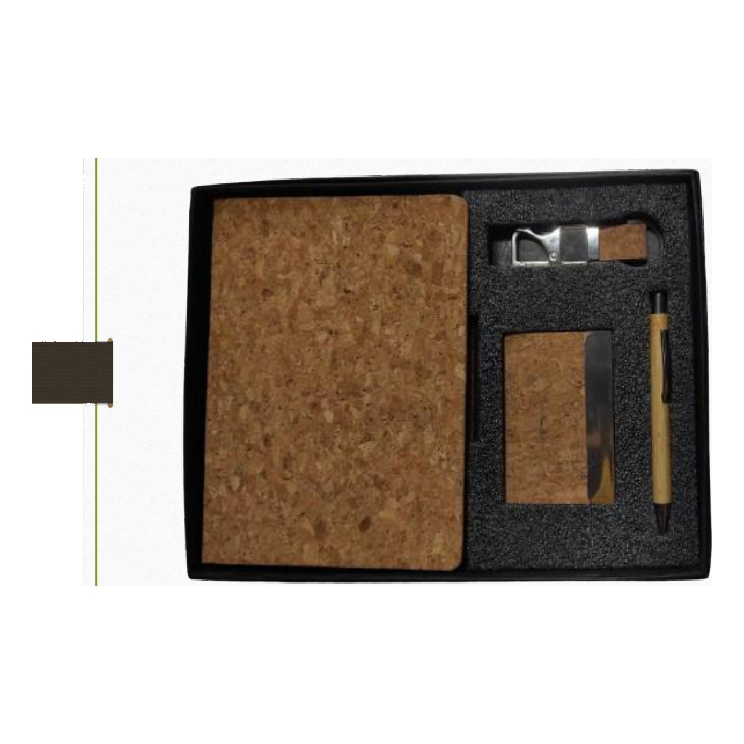  Diary · Pen · Keychain · Cardholder  Rs. 384/- (Base Rs.325 + 18% GST)
Item No. 31  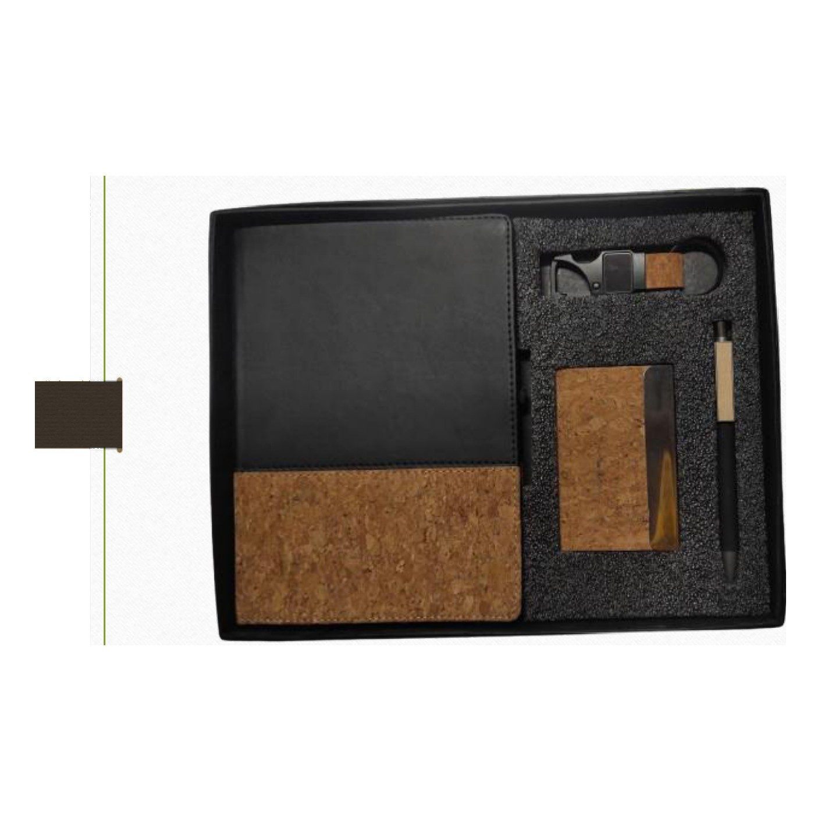  Diary · Pen · Keychain · Cardholder  Rs. 384/- (Base Rs.325 + 18% GST) |  | Item No. 32  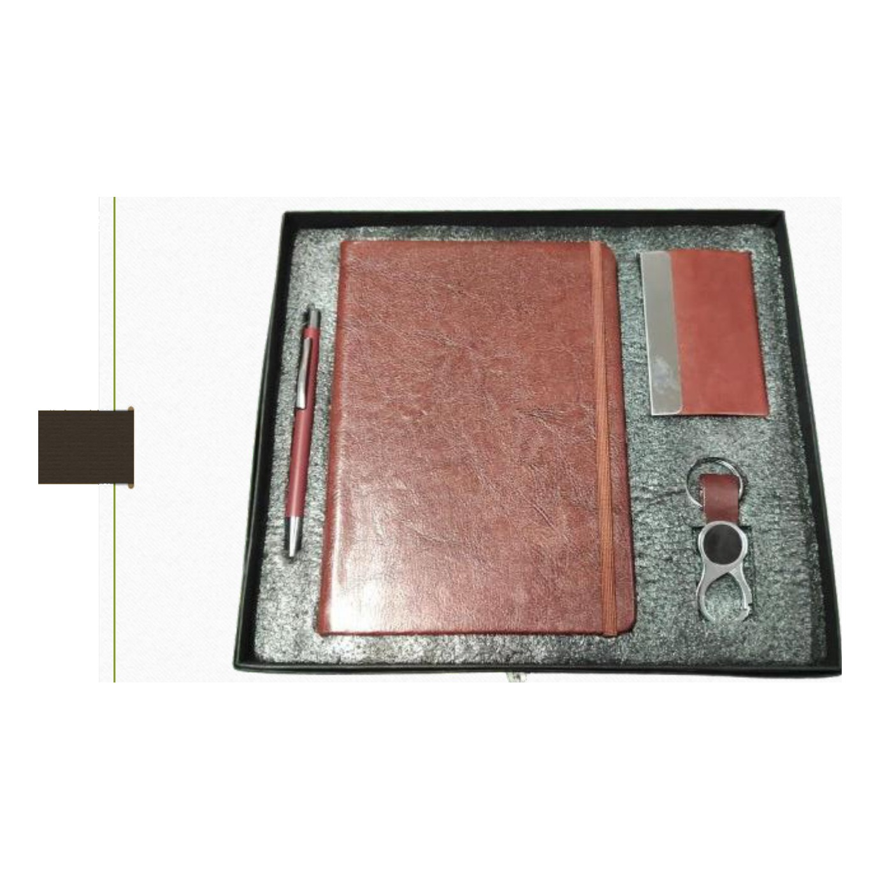  Diary · Pen · Keychain · Cardholder  Rs. 325/- (Base Rs.275 + 18% GST)
Item No. 33  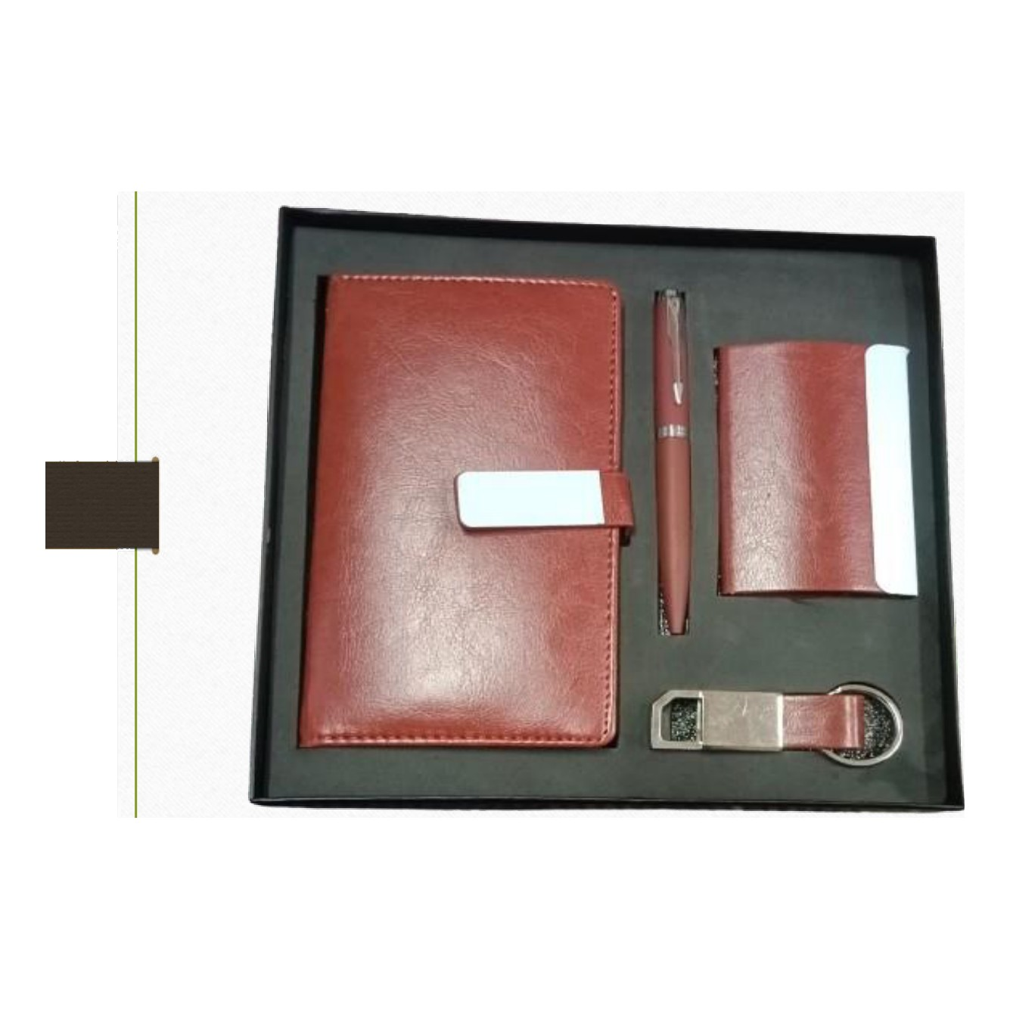  Diary · Pen · Keychain · Cardholder  Rs. 325/- (Base Rs.275 + 18% GST) |  | Item No. 34  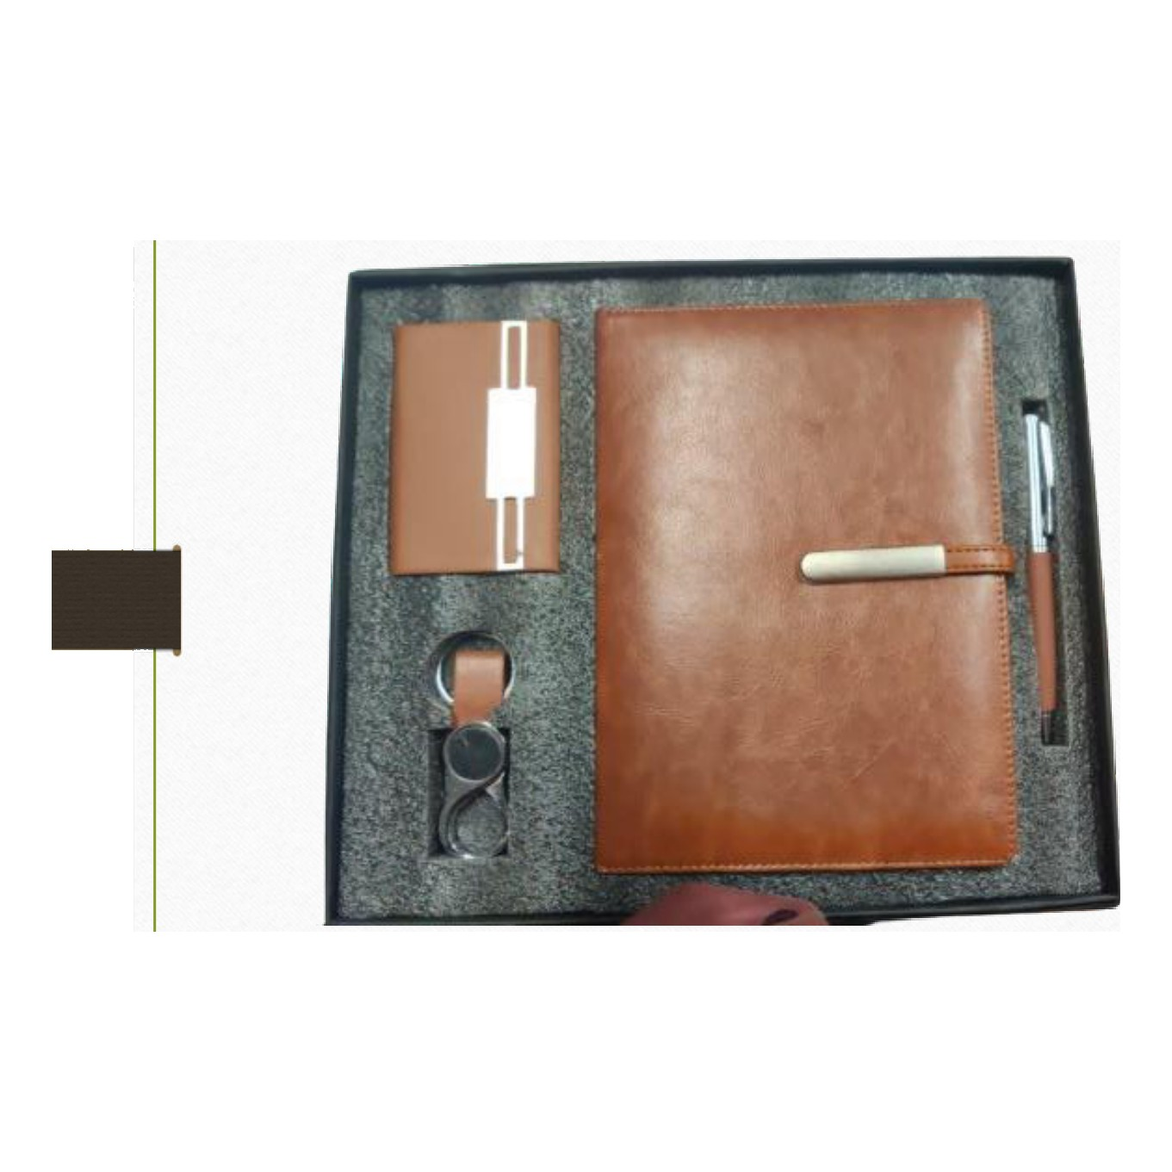  Diary · Pen · Keychain · Cardholder  Rs. 443/- (Base Rs.375 + 18% GST)
Item No. 35  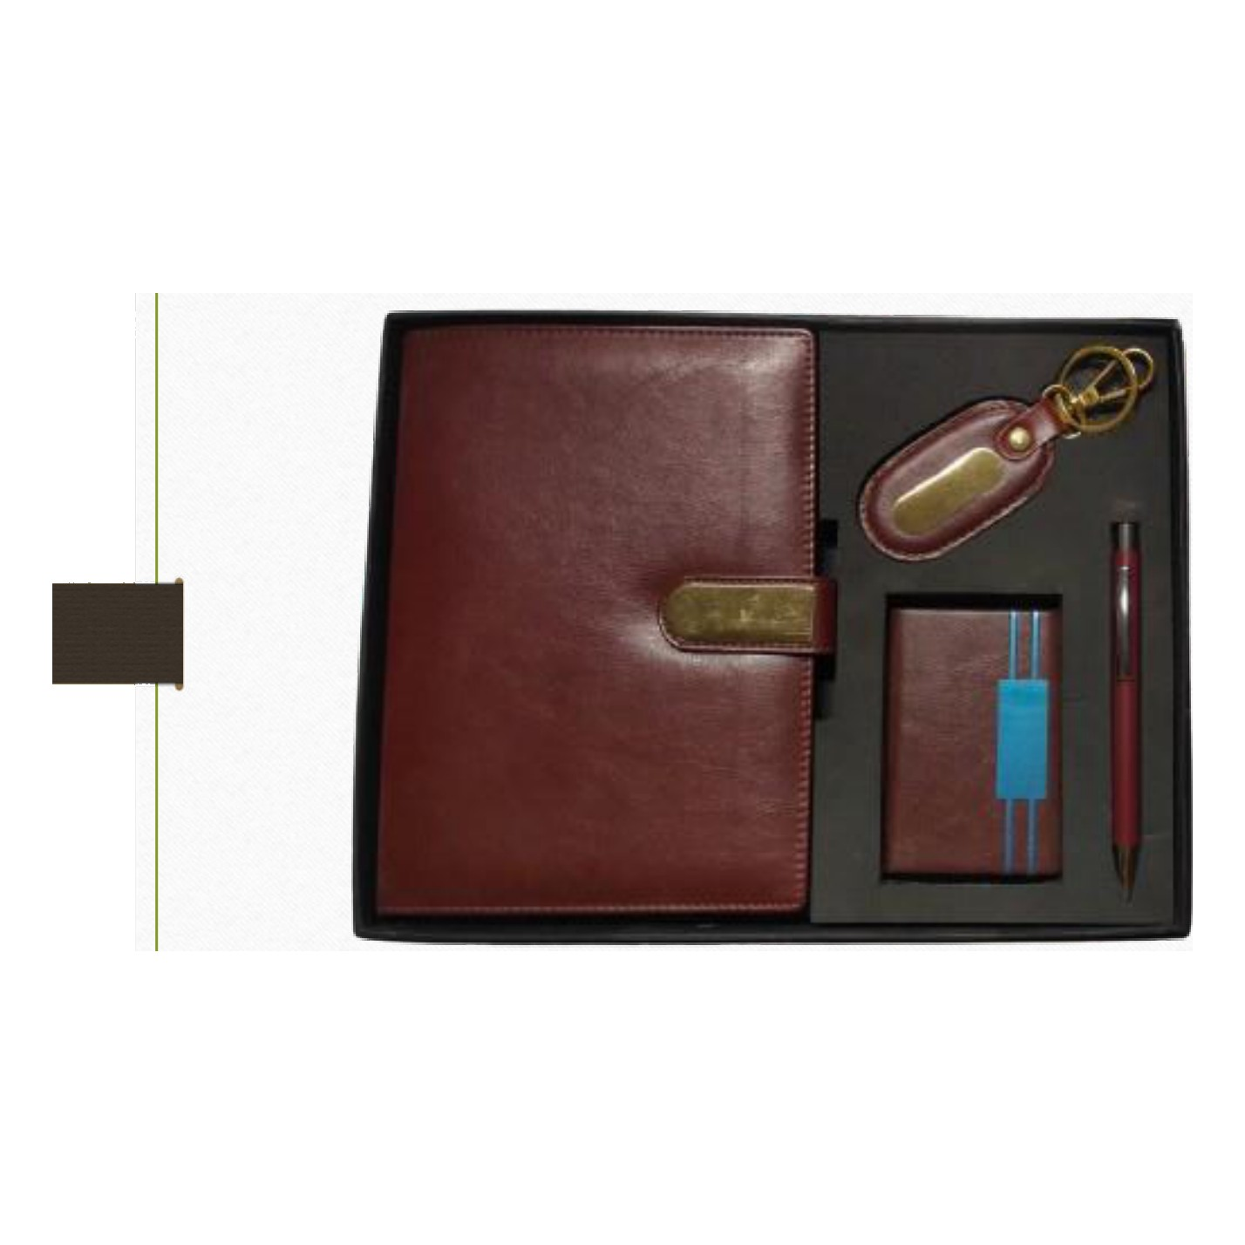  Diary · Pen · Keychain · Cardholder  Rs. 443/- (Base Rs.375 + 18% GST) |  | Item No. 36  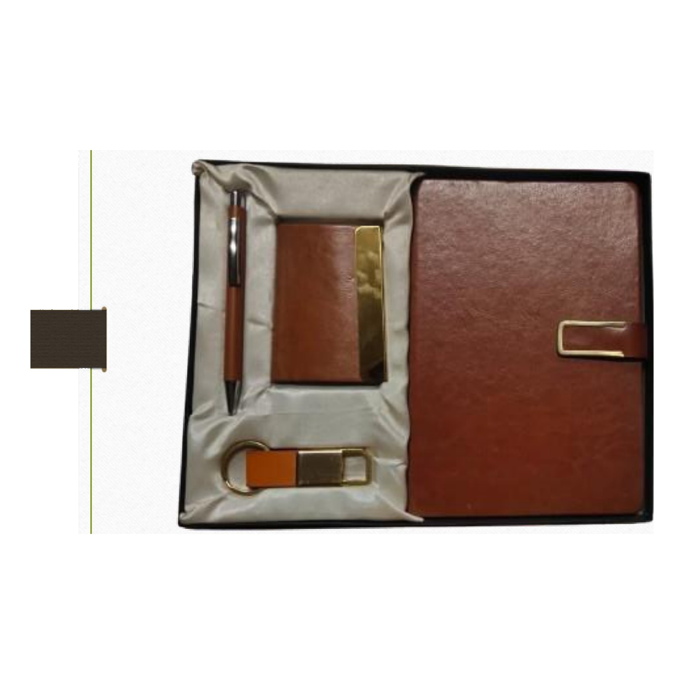  Diary · Pen · Keychain · Cardholder · Sortin Cloth  Rs. 502/- (Base Rs.425 + 18% GST)
Item No. 37  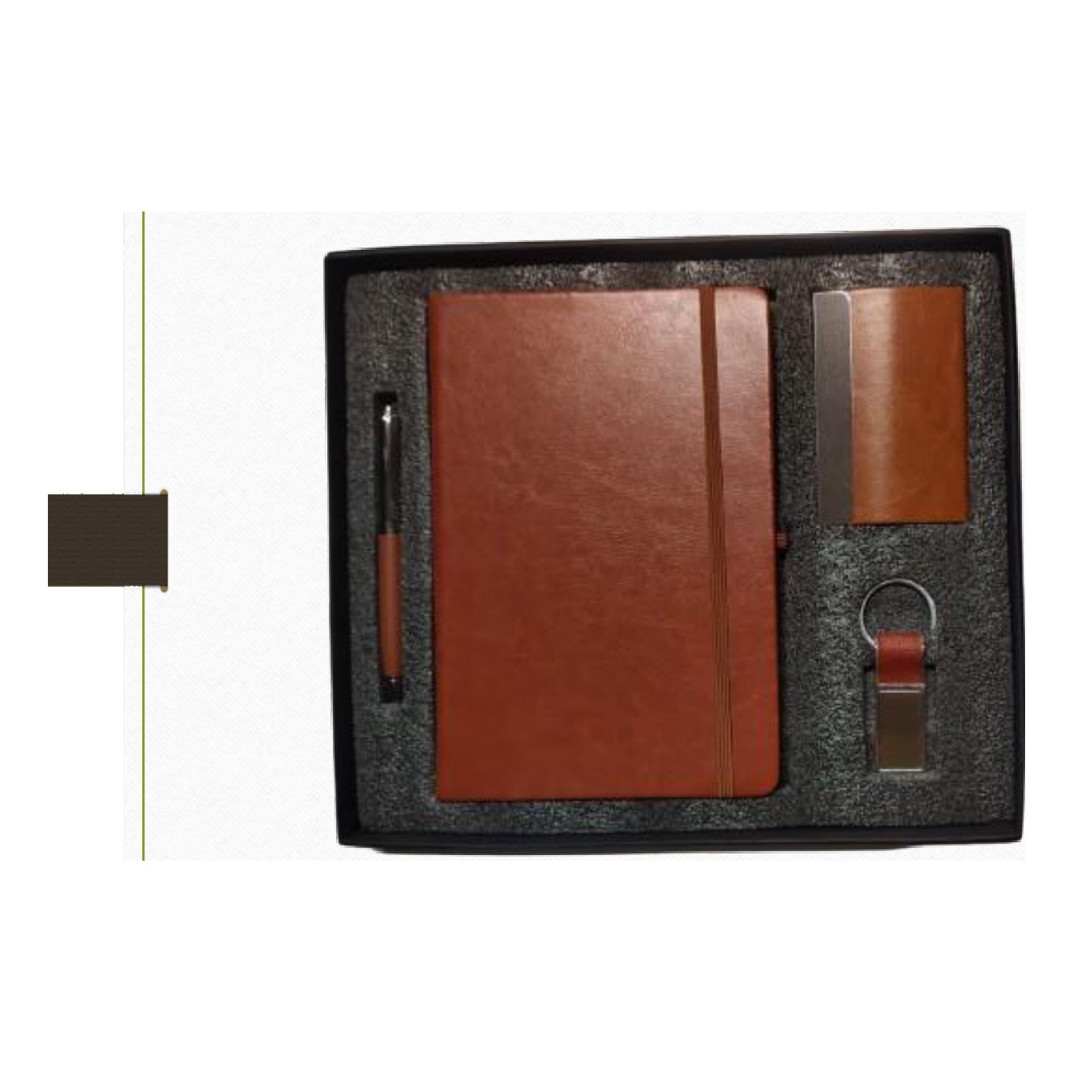  Diary · Pen · Keychain · Cardholder  Rs. 354/- (Base Rs.300 + 18% GST) |  | Item No. 38  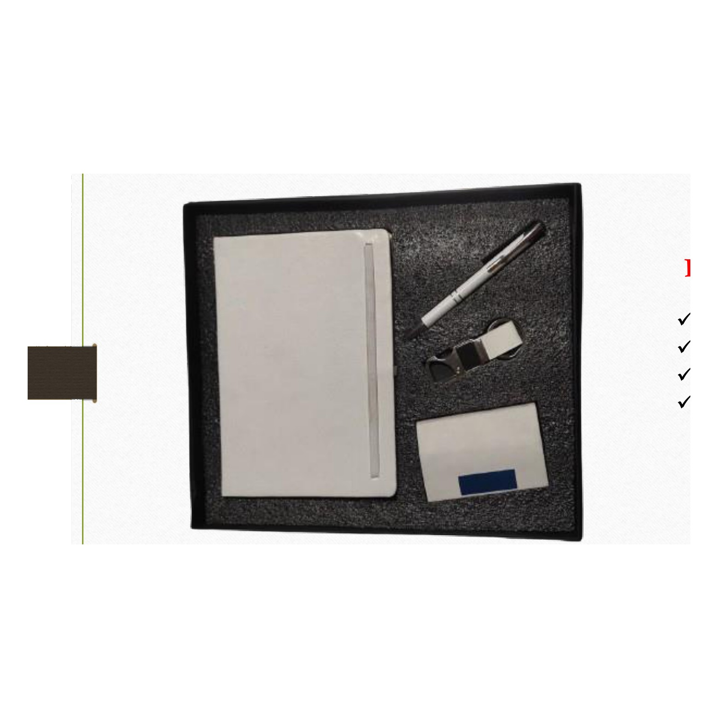  Diary · Pen · Keychain · Cardholder  Rs. 325/- (Base Rs.275 + 18% GST)
Item No. 39  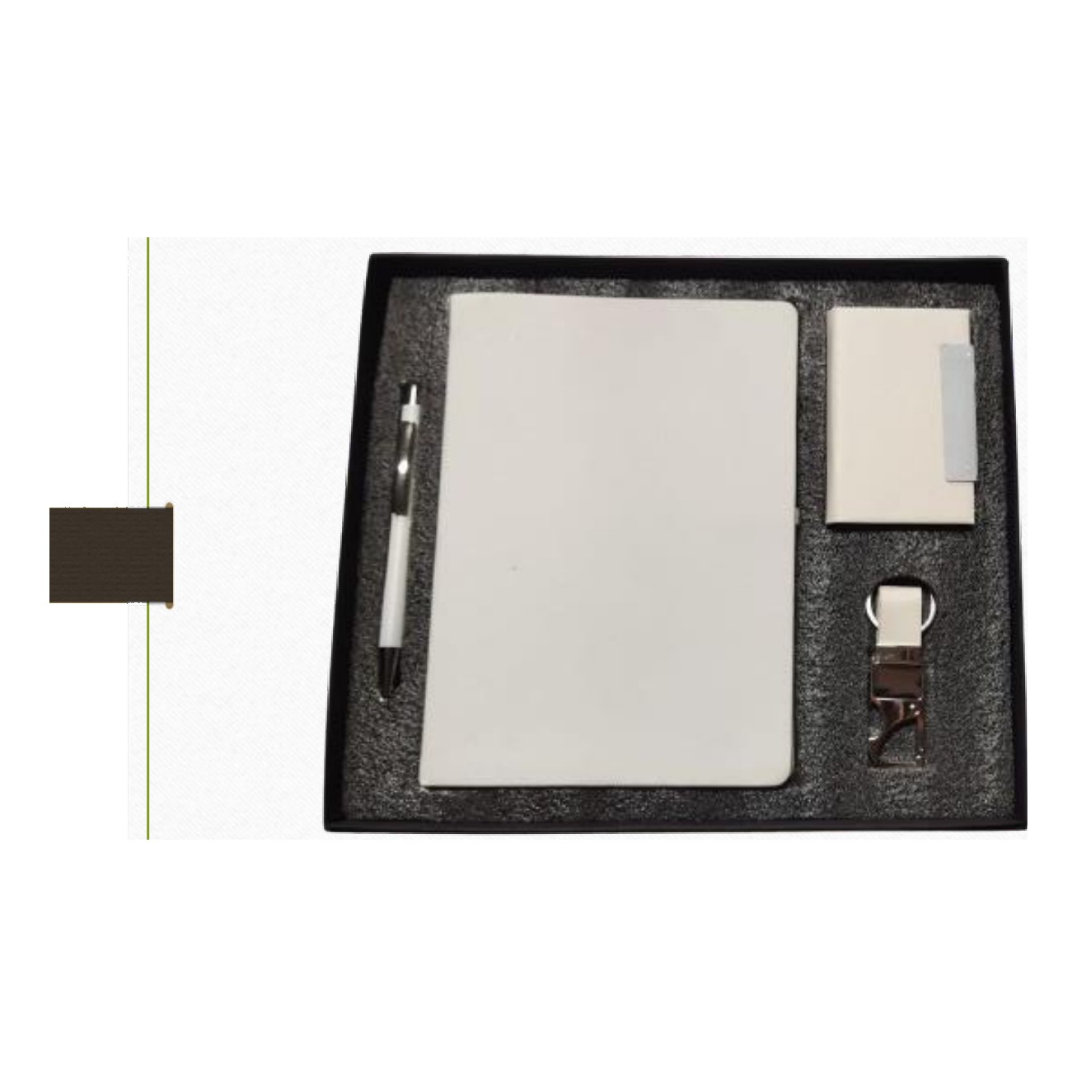  Diary · Pen · Keychain · Cardholder  Rs. 325/- (Base Rs.275 + 18% GST) |  | Item No. 40  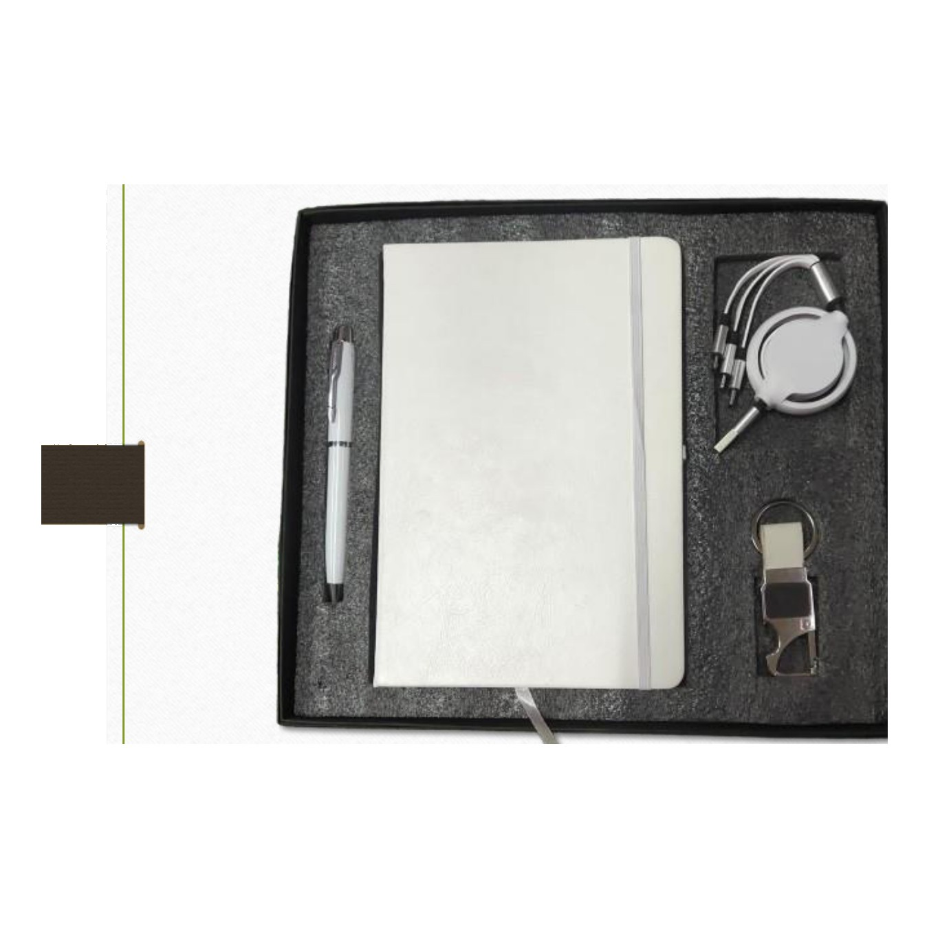  Diary · Pen · Keychain · Charging Cable  Rs. 472/- (Base Rs.400 + 18% GST)
Item No. 41  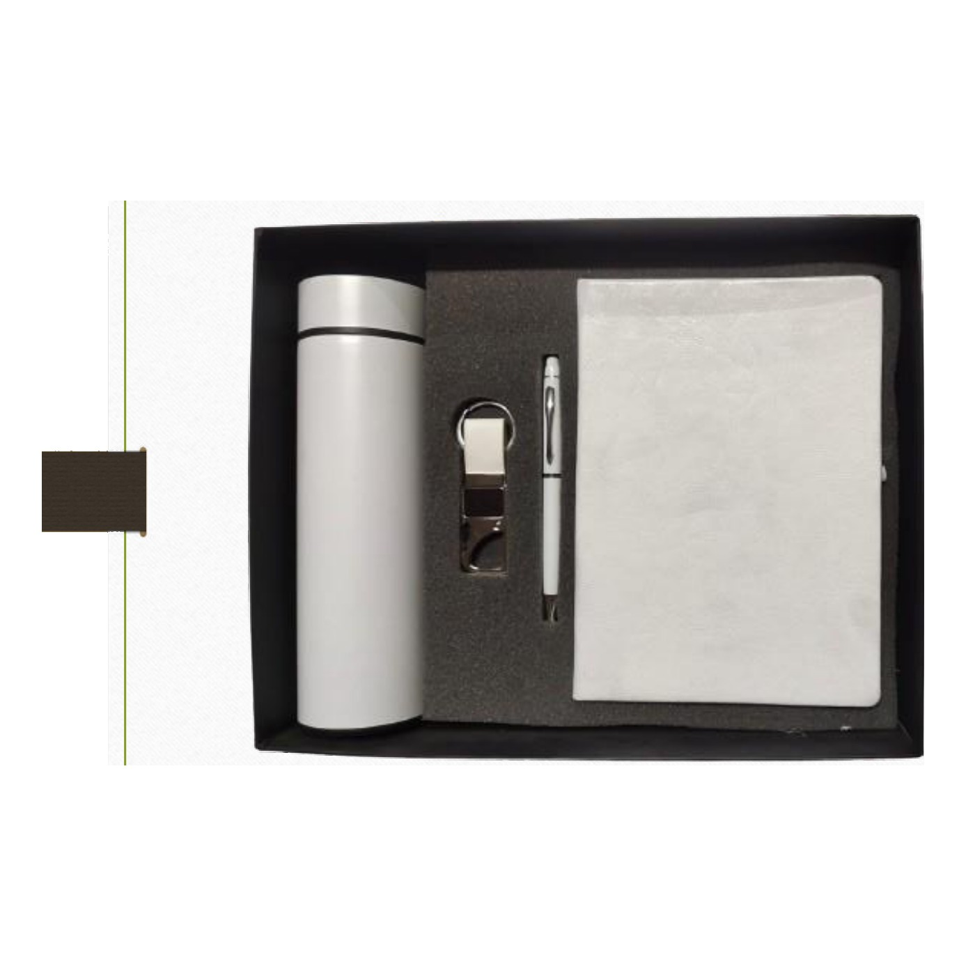  Diary · Pen · Keychain · Bottle  Rs. 502/- (Base Rs.425 + 18% GST) |  | Item No. 42  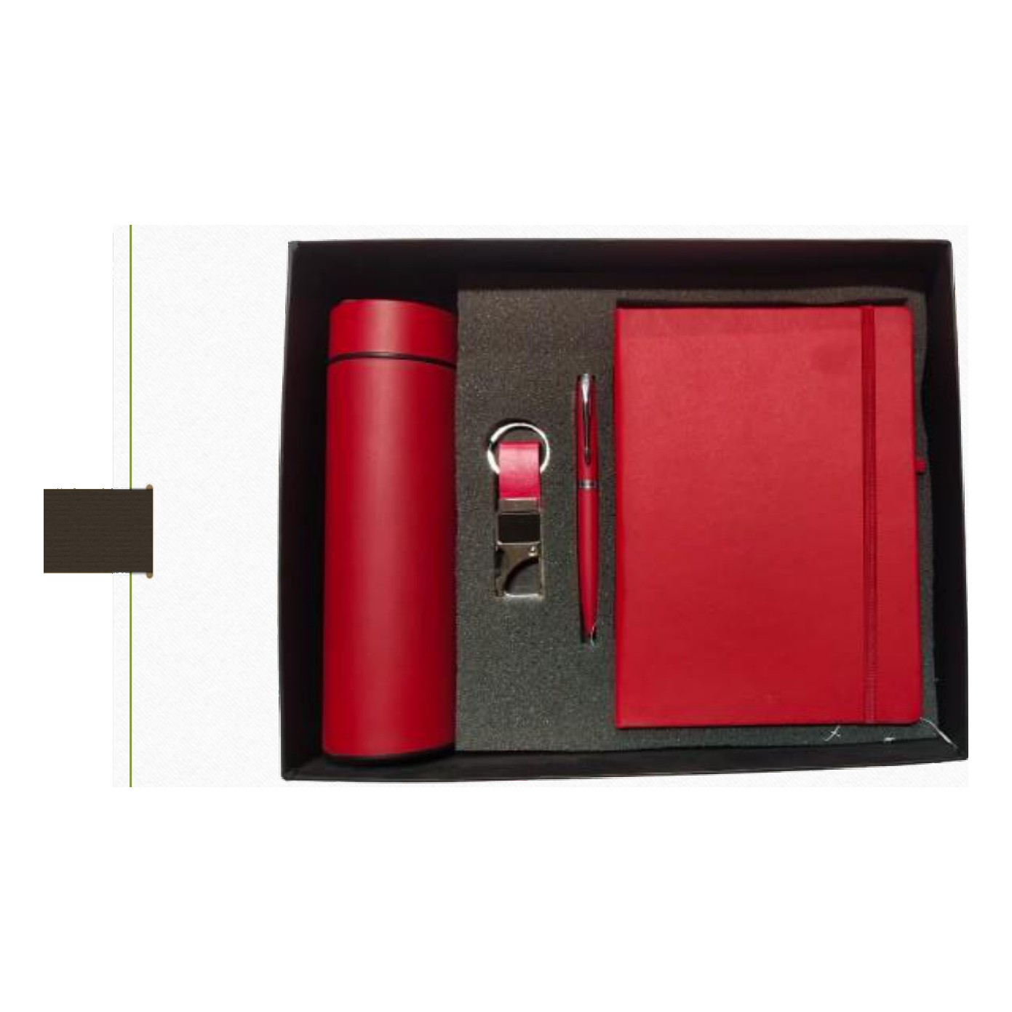  Diary · Pen · Keychain · Bottle  Rs. 502/- (Base Rs.425 + 18% GST)
Item No. 43  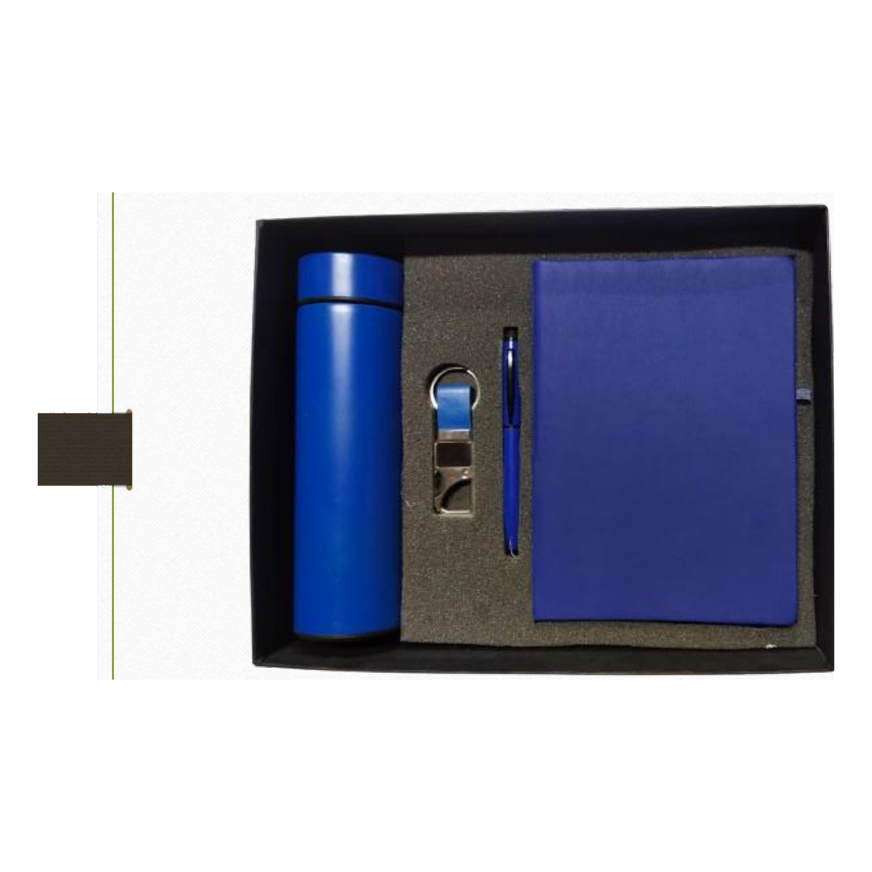  Diary · Pen · Keychain · Bottle  Rs. 502/- (Base Rs.425 + 18% GST) |  | Item No. 44  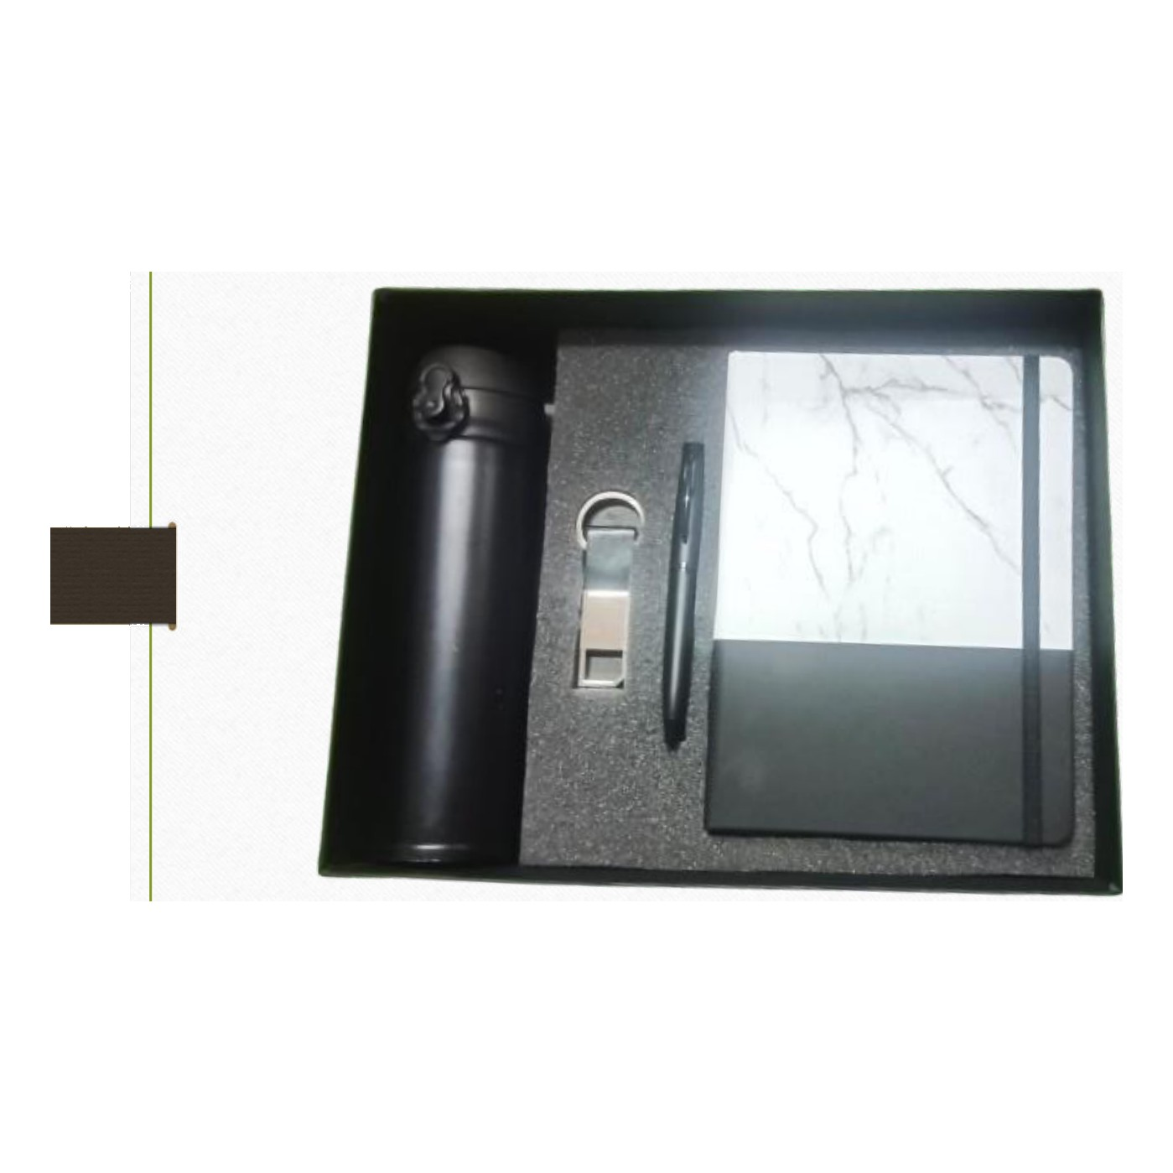  Diary · Pen · Keychain · Bottle  Rs. 531/- (Base Rs.450 + 18% GST)
Item No. 45  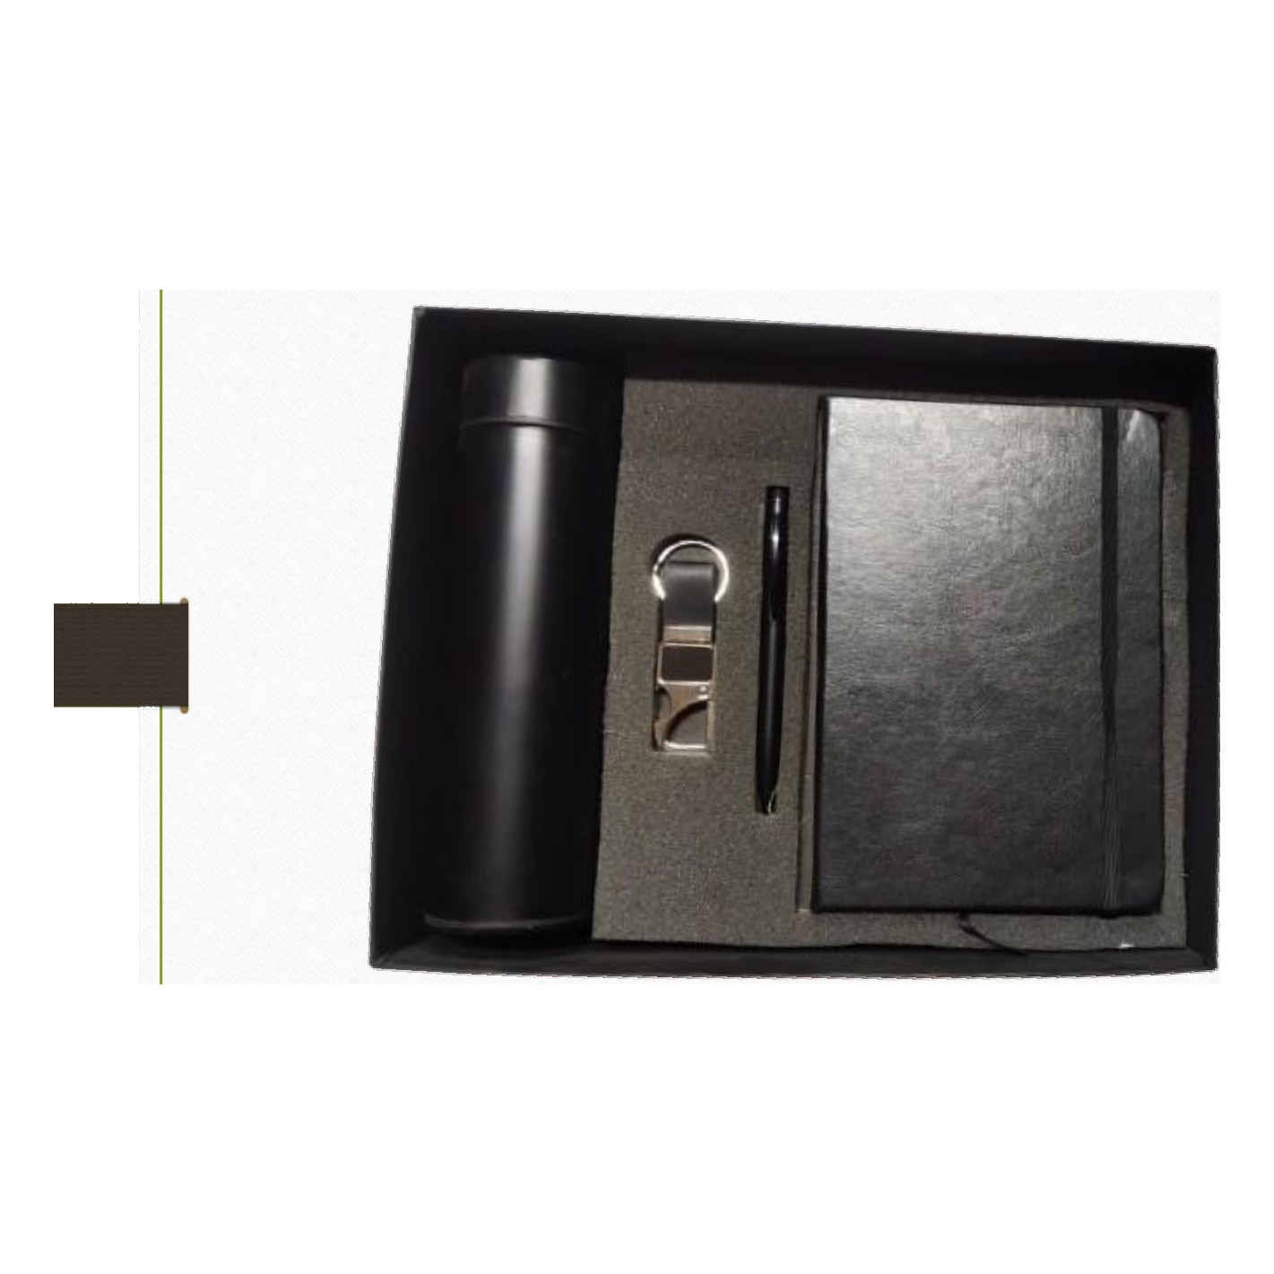  Diary · Pen · Keychain · Bottle  Rs. 502/- (Base Rs.425 + 18% GST) |  | Item No. 46  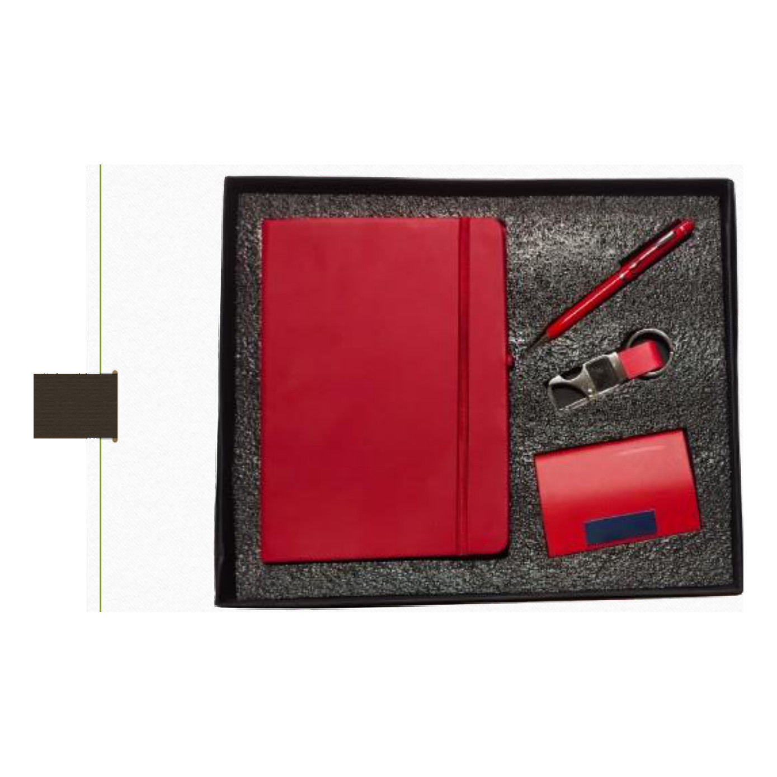  Diary · Pen · Keychain · Cardholder  Rs. 325/- (Base Rs.275 + 18% GST)
Item No. 47
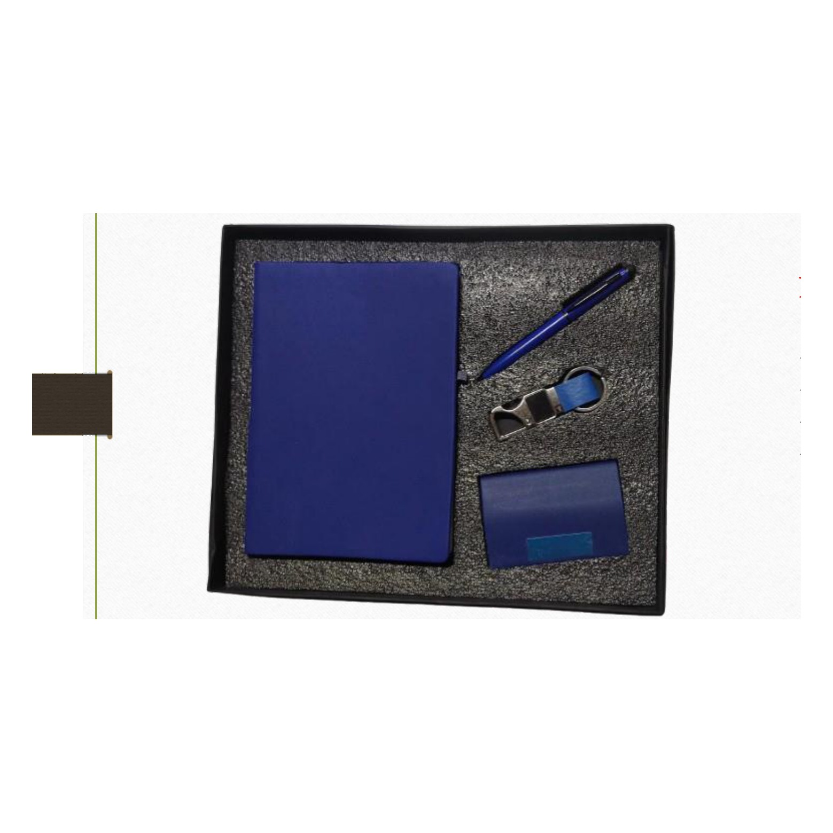
Diary · Pen · Keychain · Cardholder
Rs. 325/- (Base Rs.275 + 18% GST)

