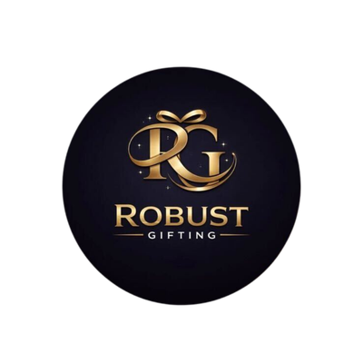
ROBUST GIFTING

5-in-1 Corporate
Gift Combo Catalogue
Premium 5-in-1 Corporate Gift Sets
Thoughtful gifting. Built to impress.
CURATED COLLECTION • VOLUME 01 • 2026

The 5-in-1 Collection
Twenty-eight ready-to-gift executive combos.
Every Robust Gifting 5-in-1 combo pairs a premium diary with a pen, keychain, bottle and a mug or cardholder — arranged in a tailored presentation tray that’s ready to hand over. Use this catalogue to choose the combination that best fits your brand and budget. Prices shown are exclusive of 18% GST.
All items available in bulk. Custom branding and packaging on request.
ITEM NO. 01  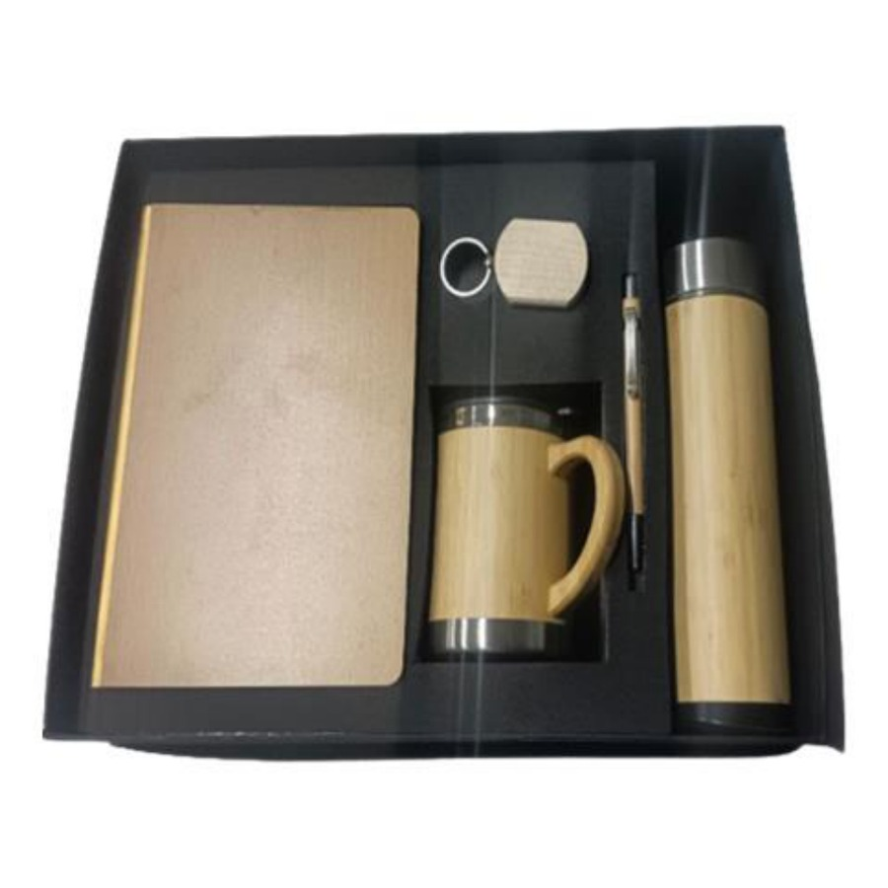  Diary, Pen, Keychain, Mug & Bottle Set  Bamboo thermos bottle, bamboo mug, diary, metal pen and keychain in a premium dark tray.  ₹ 850 + 18% GST |  | ITEM NO. 02  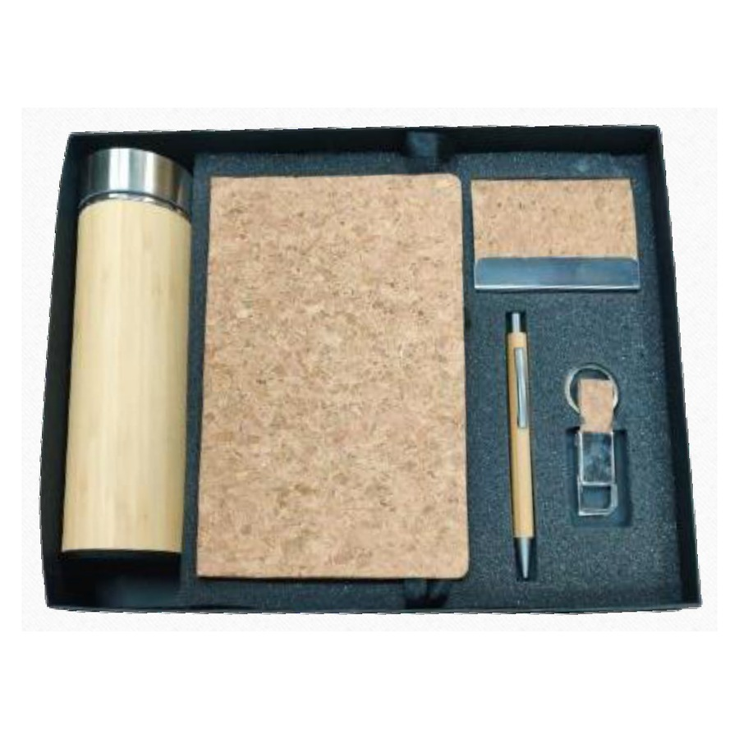  Diary, Pen, Bottle, Keychain & Cardholder Set  Executive 5-in-1 set with diary, pen, bottle, keychain and metal cardholder in a presentation tray.  ₹ 650 + 18% GST
ITEM NO. 03  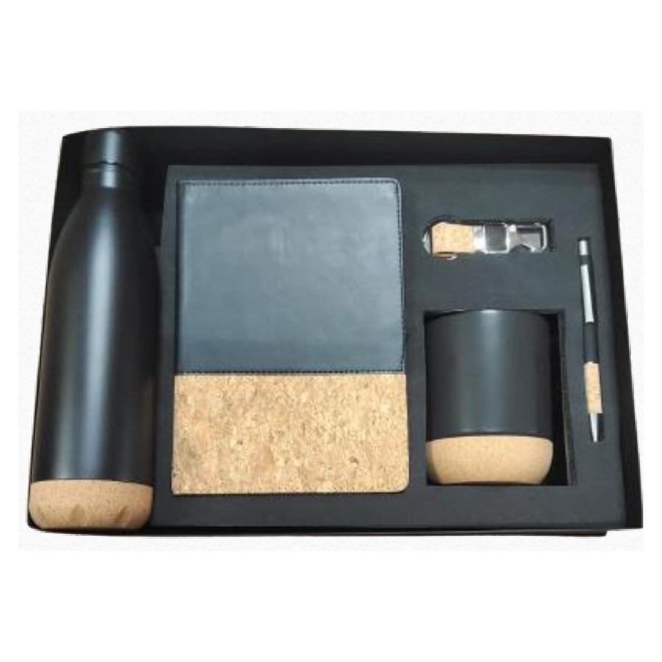  Diary, Pen, Keychain, Bottle & Mug Set  Classic corporate 5-in-1 gift set with diary, pen, keychain, bottle and mug.  ₹ 825 + 18% GST |  | ITEM NO. 04  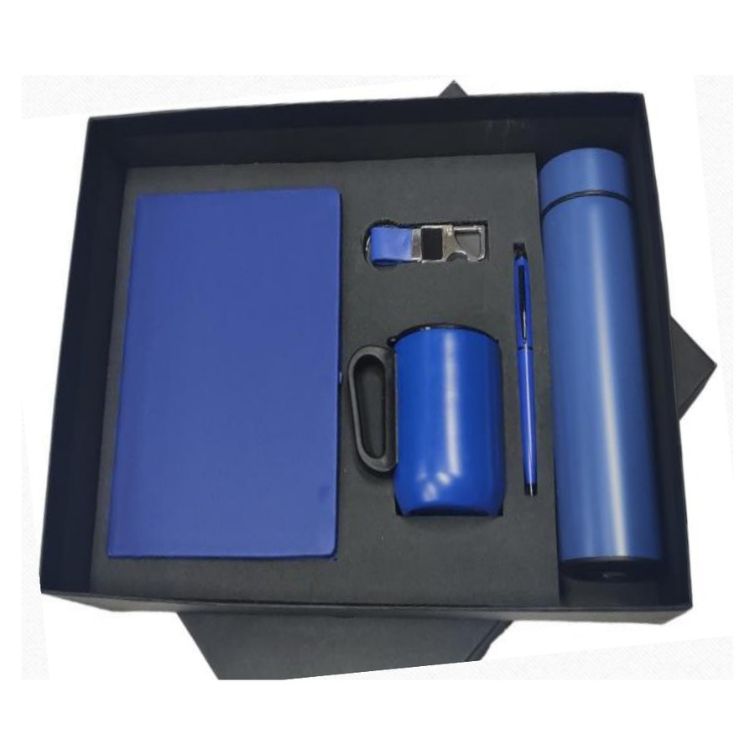  Diary, Pen, Keychain, Bottle & Mug Set  Sleek 5-in-1 gift box featuring A5 diary, branded pen, keychain, bottle and ceramic-style mug.  ₹ 625 + 18% GST  Available colours: Black, Red, Blue, White
ITEM NO. 05  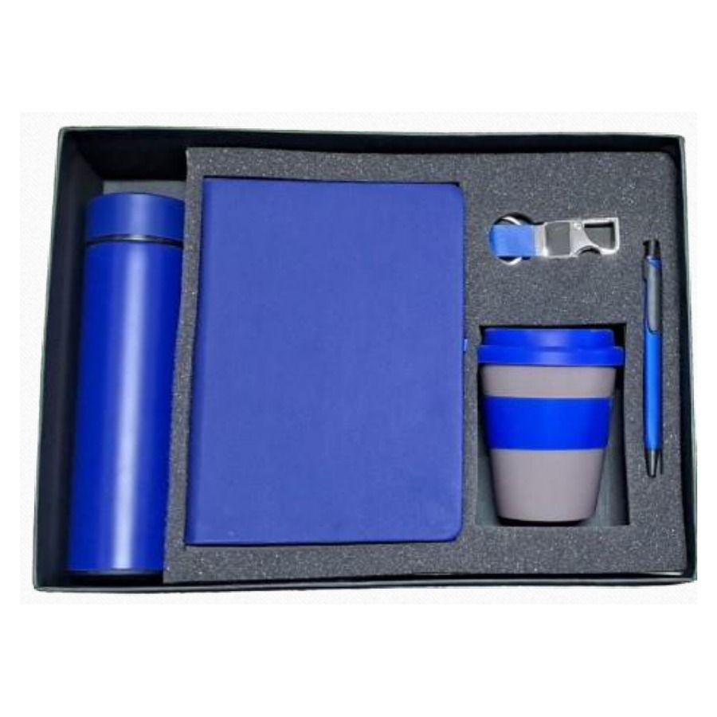  Diary, Pen, Keychain, Bottle & Mug Set  Coloured PU-leather diary paired with pen, keychain, bottle and mug in a fitted tray.  ₹ 575 + 18% GST  Available colours: Black, Red, Blue, White |  | ITEM NO. 06  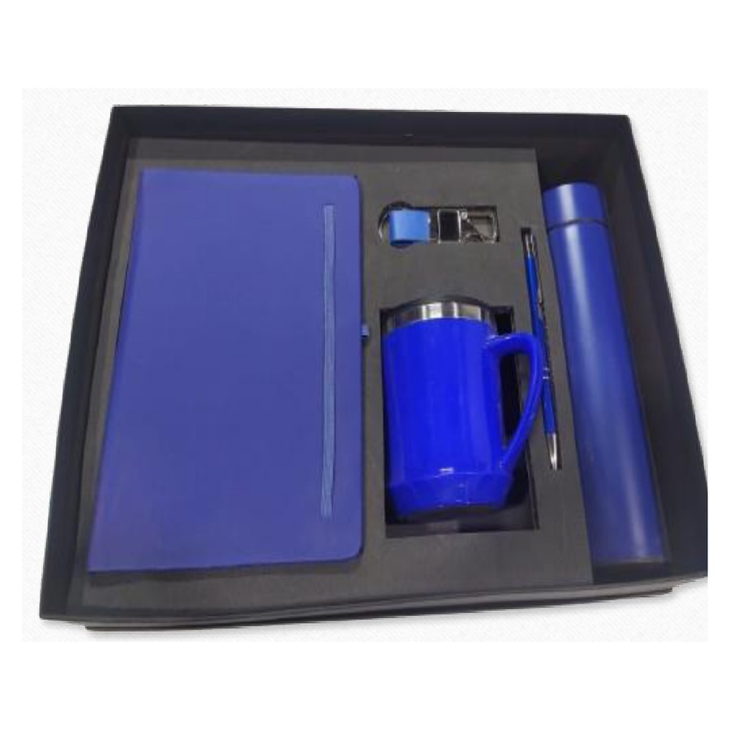  Diary, Pen, Keychain, Bottle & Mug Set  Matte black 5-in-1 corporate gift — diary, pen, keychain, bottle and mug.  ₹ 625 + 18% GST
ITEM NO. 07  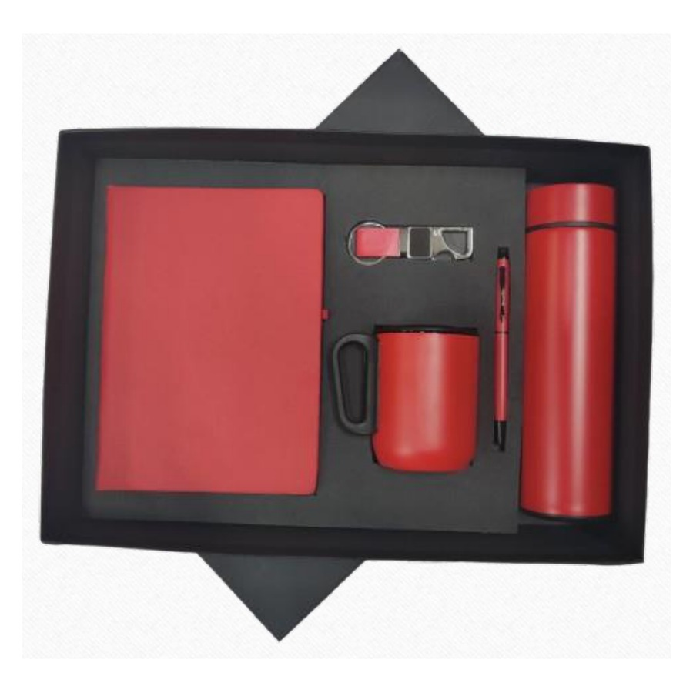  Diary, Pen, Keychain, Bottle & Mug Set  Coloured diary edition of the 5-in-1 with matching pen, keychain, bottle and mug.  ₹ 625 + 18% GST  Available colours: Black, Red, Blue, White |  | ITEM NO. 08  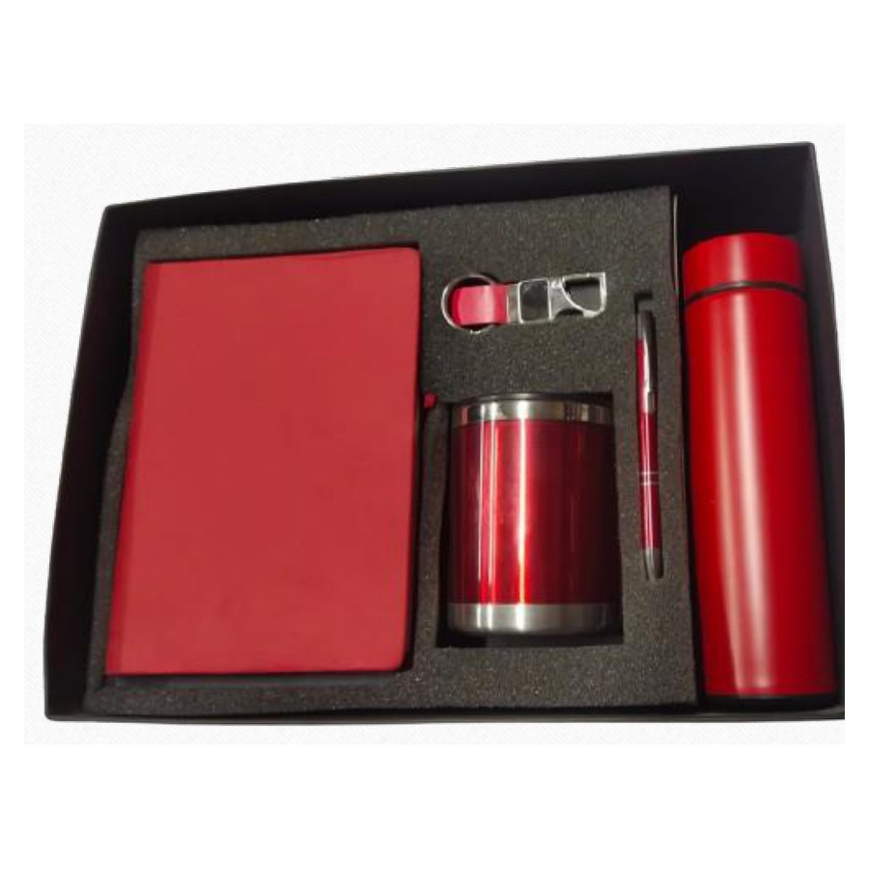  Diary, Pen, Bottle, Keychain & Mug Set  Premium 5-in-1 combo — diary, pen, bottle, keychain and mug in a contoured tray.  ₹ 675 + 18% GST
ITEM NO. 09  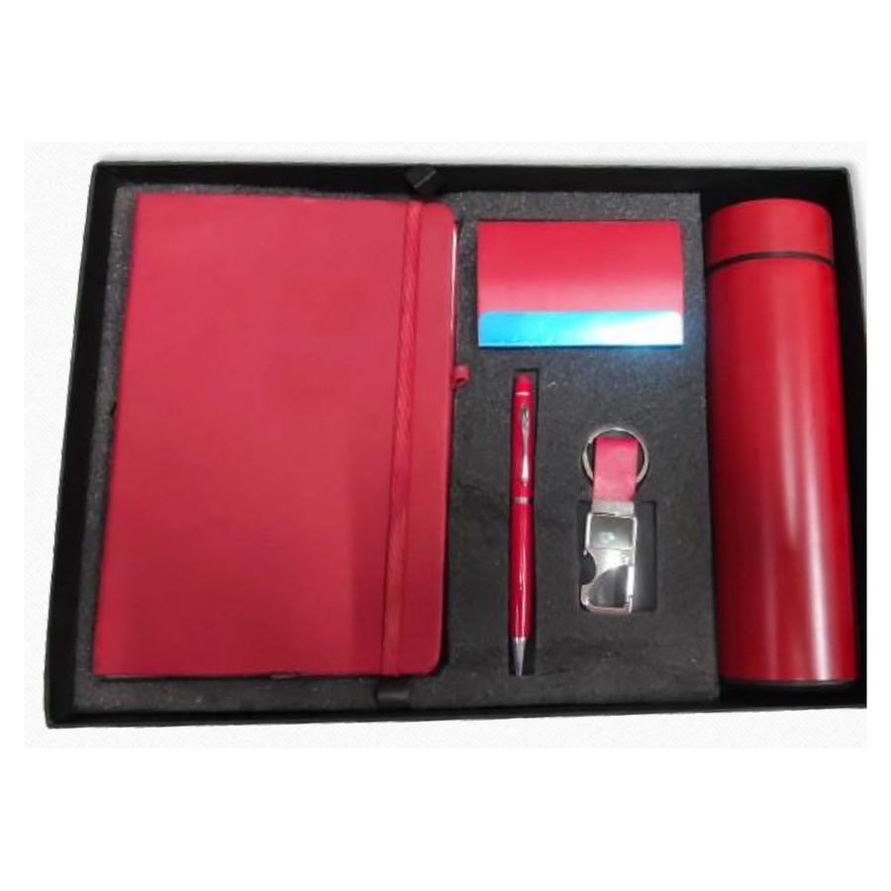  Diary, Pen, Bottle, Keychain & Cardholder Set  Compact executive combo with diary, pen, bottle, keychain and metal cardholder.  ₹ 500 + 18% GST  Available colours: Black, Red, Blue, White |  | ITEM NO. 10  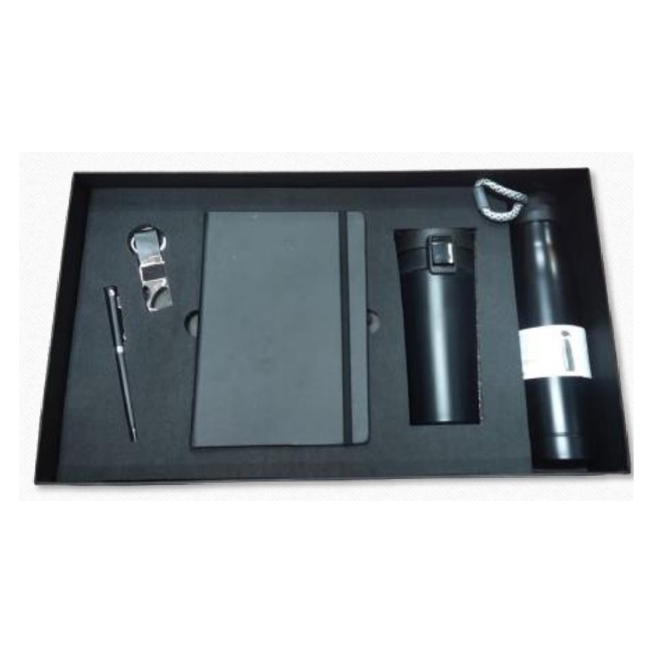  Diary, Pen, Keychain, Bottle & Mug Set  Stealth black 5-in-1 combo — matte diary, pen, keychain, bottle and mug.  ₹ 700 + 18% GST  Available colours: Black, White
ITEM NO. 11  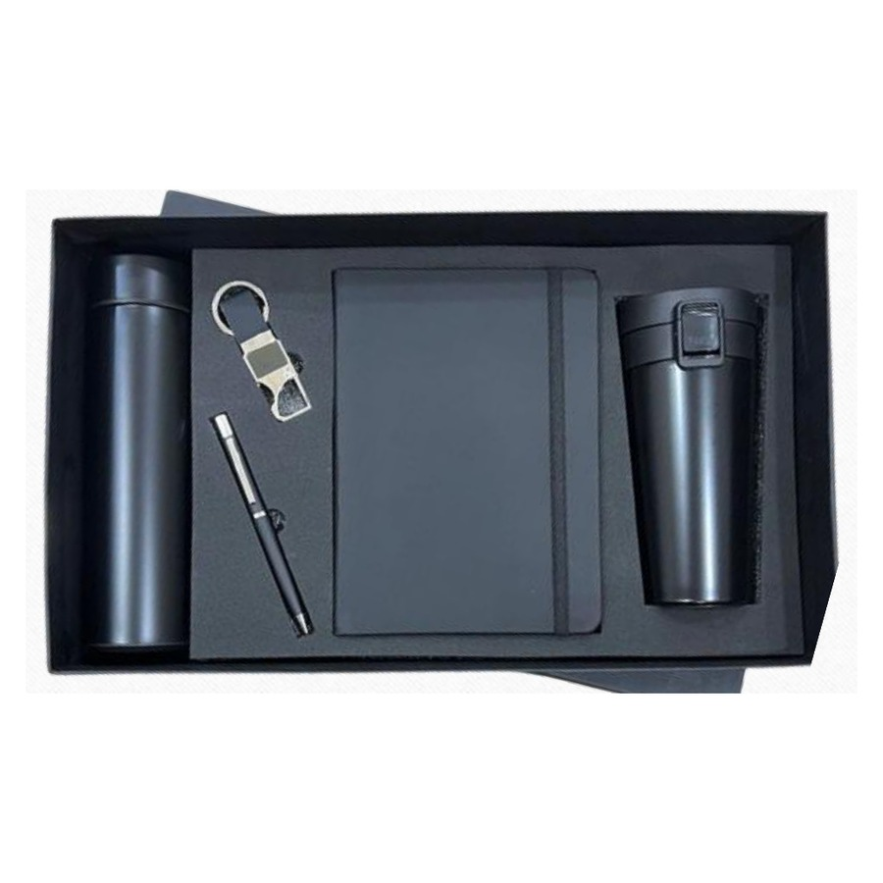  Diary, Pen, Keychain, Bottle & Mug Set  Premium 5-in-1 gift — A5 diary, pen, keychain, bottle and mug in a fitted tray.  ₹ 625 + 18% GST  Available colours: Black, White |  | ITEM NO. 12  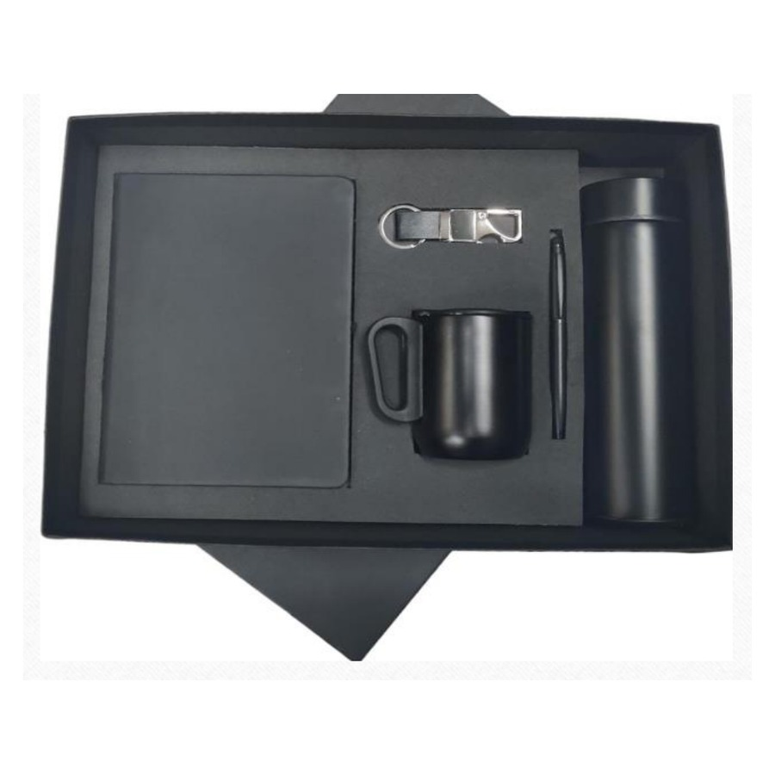  Diary, Pen, Keychain, Bottle & Mug Set  Coloured-strap diary with pen, keychain, bottle and mug in a presentation tray.  ₹ 625 + 18% GST  Available colours: Black, Red, Blue, White
ITEM NO. 13  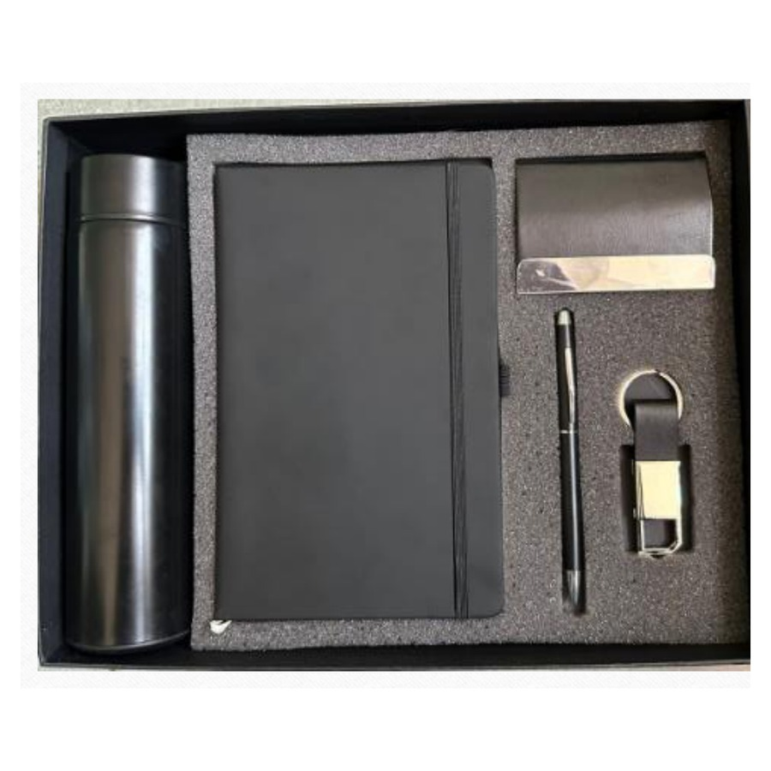  Diary, Pen, Bottle, Keychain & Cardholder Set  Smart-office 5-in-1 with diary, pen, bottle, keychain and metal cardholder.  ₹ 500 + 18% GST  Available colours: Black, White |  | ITEM NO. 14  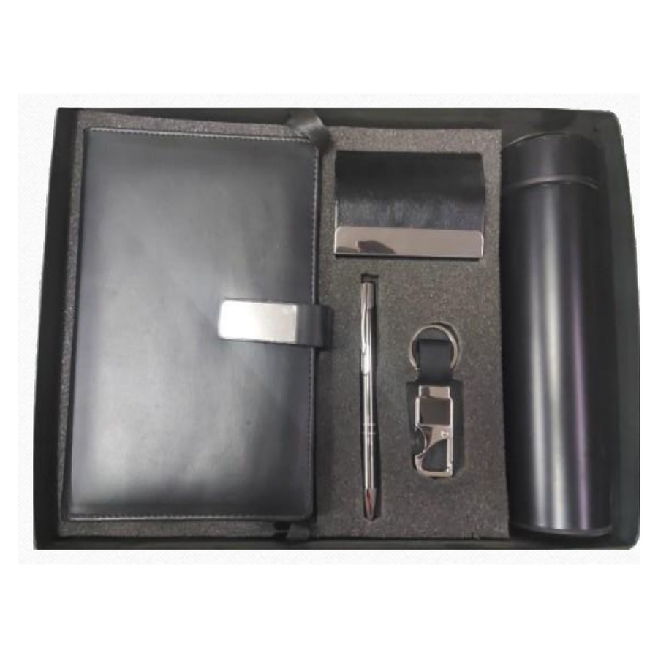  Diary, Pen, Bottle, Keychain & Cardholder Set  Elegant 5-in-1 executive combo with diary, pen, bottle, keychain and cardholder.  ₹ 550 + 18% GST  Available colours: Black, Red, Blue, White
ITEM NO. 15  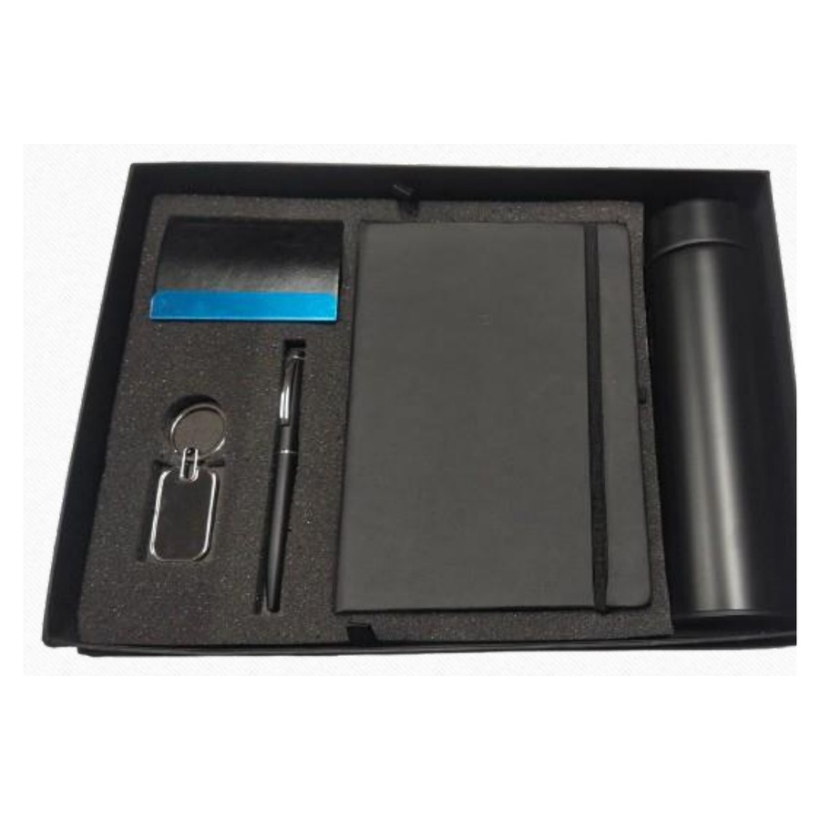  Diary, Pen, Bottle, Keychain & Cardholder Set  Colour-accent diary edition of the cardholder combo — diary, pen, bottle, keychain, cardholder.  ₹ 500 + 18% GST  Available colours: Black, Red, Blue, White |  | ITEM NO. 16  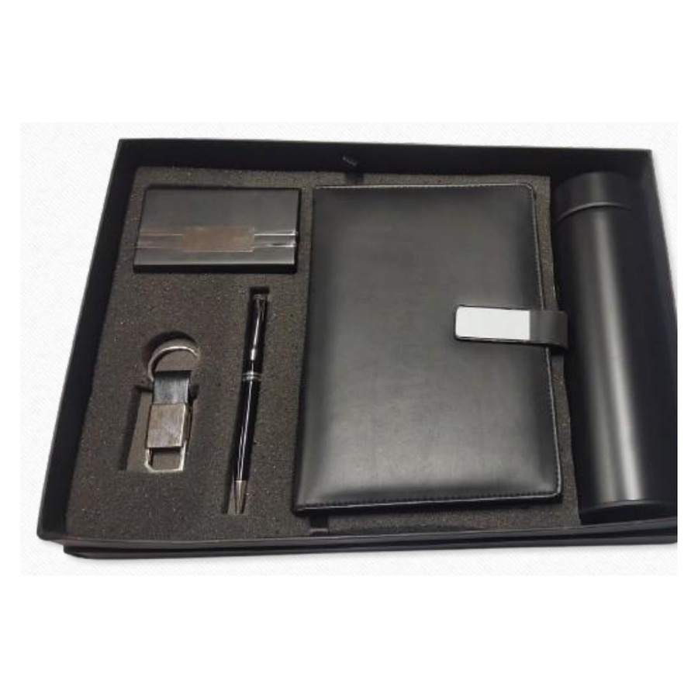  Diary, Pen, Bottle, Keychain & Cardholder Set  Premium 5-in-1 combo — coloured diary, pen, bottle, keychain and cardholder.  ₹ 550 + 18% GST  Available colours: Black, Red, Blue, White
ITEM NO. 17  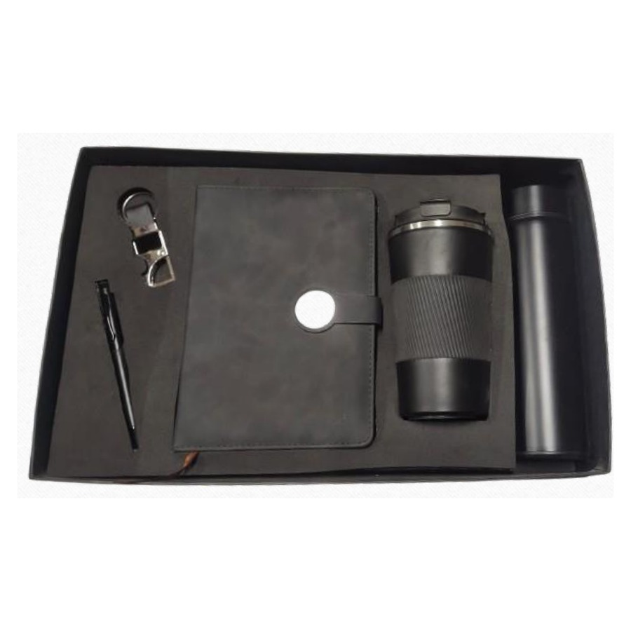  Diary, Pen, Bottle, Keychain & LED Mug Set  Deluxe 5-in-1 with LED logo mug, diary, pen, bottle and keychain.  ₹ 800 + 18% GST  Available colours: Black, White |  | ITEM NO. 18  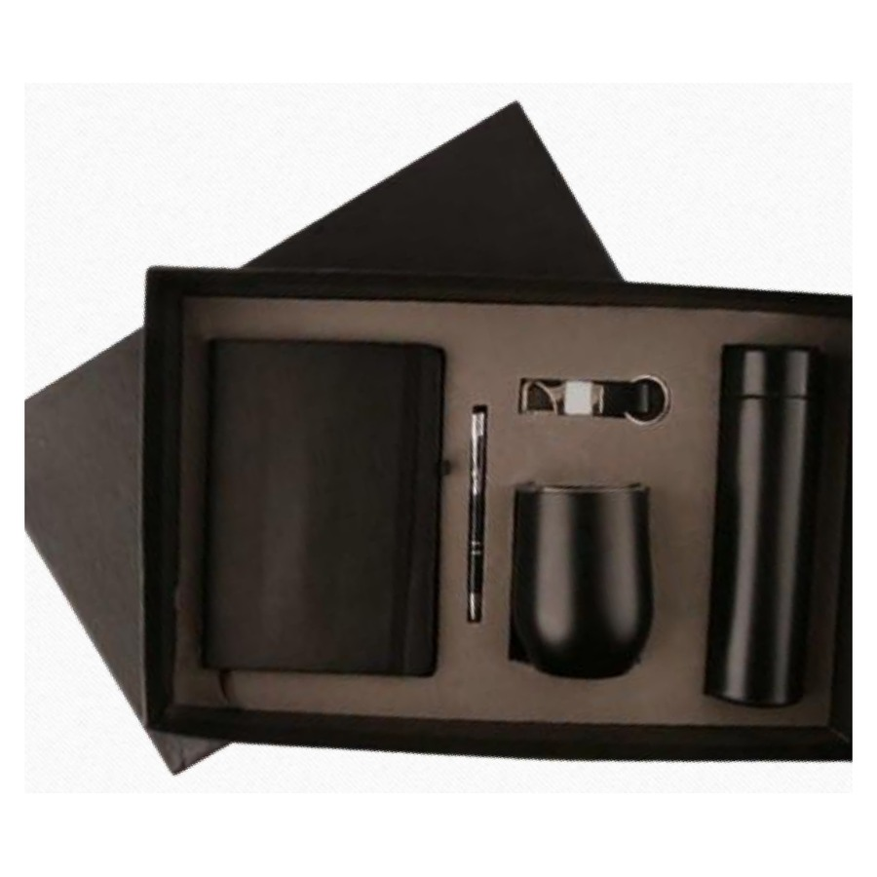  Diary, Pen, Keychain, Bottle & Mug Set  Refined 5-in-1 with embossed diary, pen, keychain, bottle and mug.  ₹ 625 + 18% GST
ITEM NO. 19  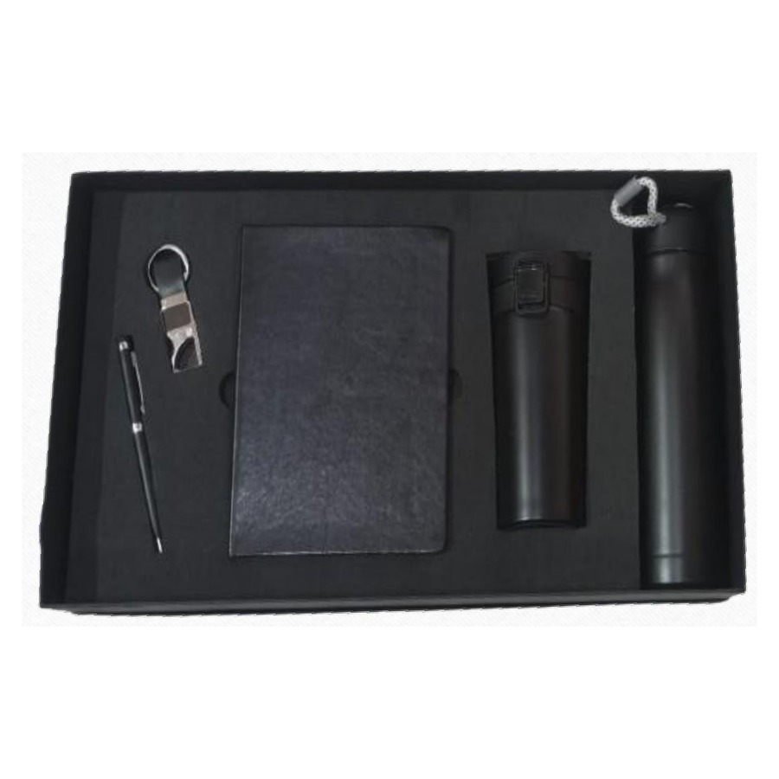  Diary, Pen, Keychain, Bottle & Mug Set  Premium matte 5-in-1 — diary, pen, keychain, bottle and mug.  ₹ 700 + 18% GST |  | ITEM NO. 20  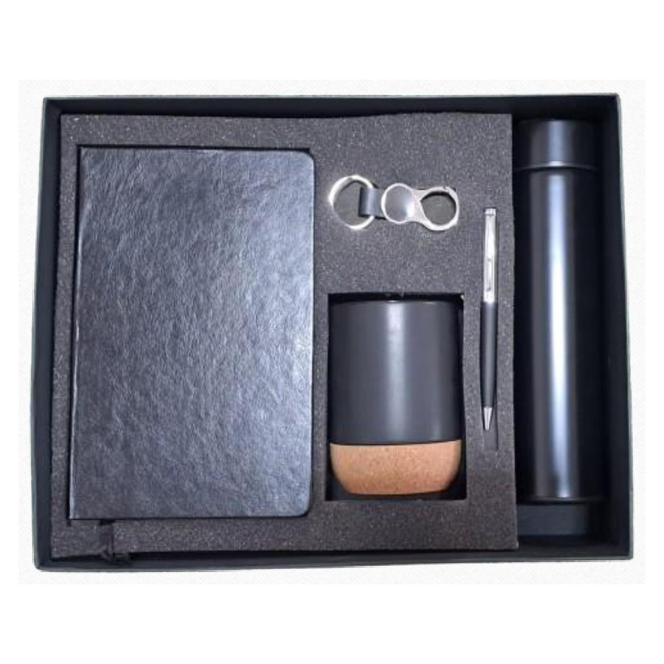  Diary, Pen, Keychain, Bottle & Mug Set  Clean-line 5-in-1 combo with diary, pen, keychain, bottle and mug.  ₹ 650 + 18% GST  Available colours: Black, White
ITEM NO. 21  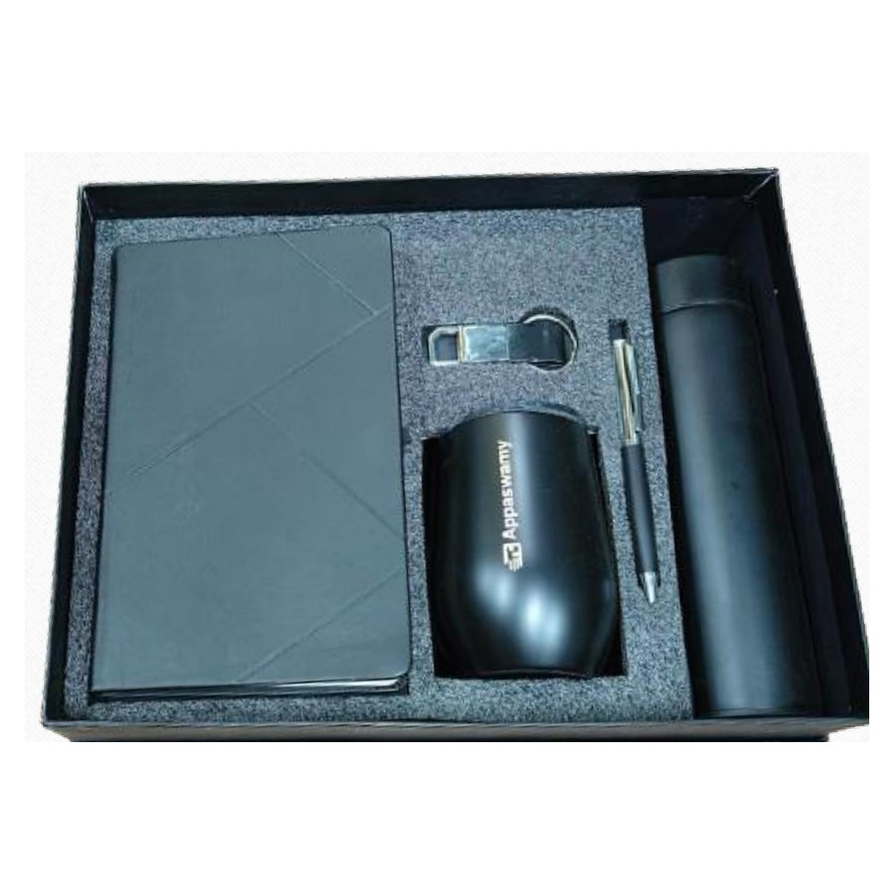  Diary, Pen, Keychain, Bottle & Mug Set  Essential 5-in-1 corporate gift — diary, pen, keychain, bottle and mug.  ₹ 650 + 18% GST  Available colours: Black, White |  | ITEM NO. 22  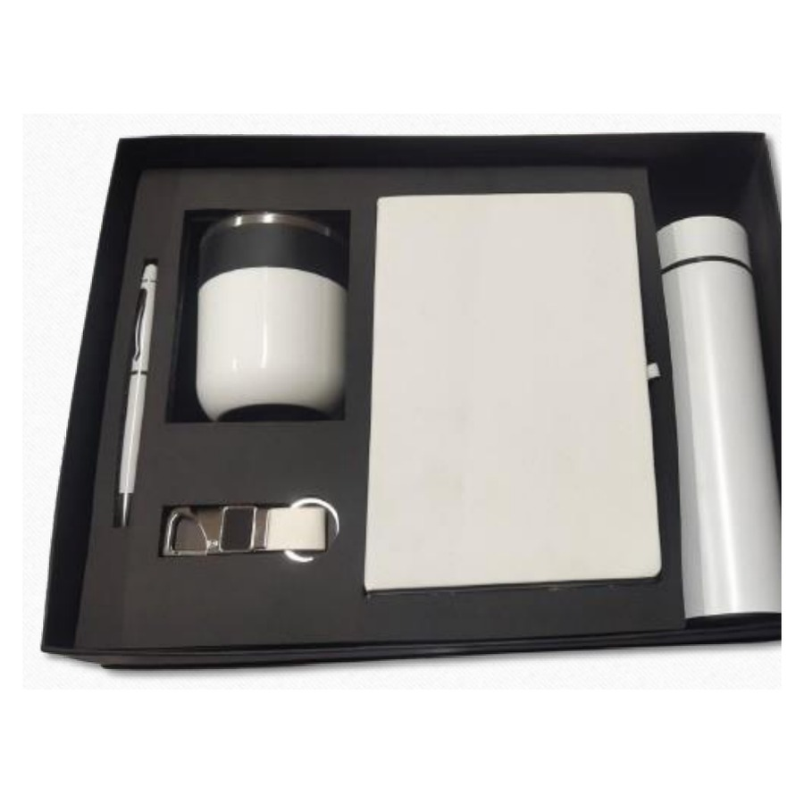  Diary, Pen, Bottle, Keychain & Mug Set  Classic 5-in-1 combo — diary, pen, bottle, keychain and mug in a presentation tray.  ₹ 625 + 18% GST
ITEM NO. 23  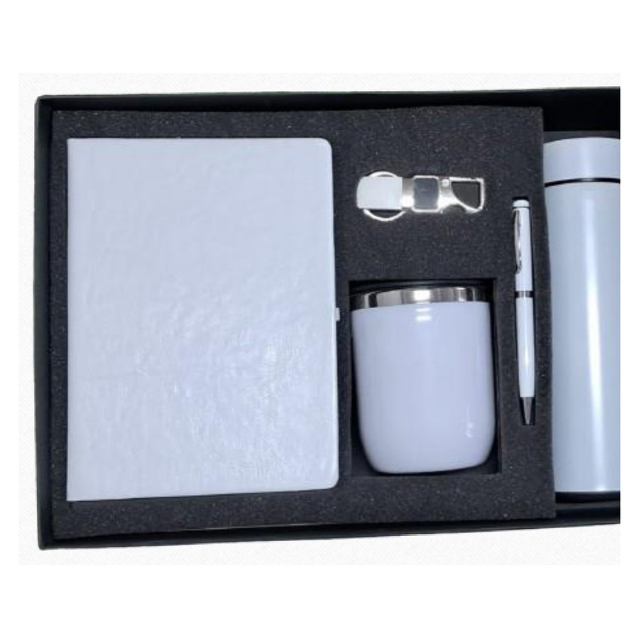  Diary, Pen, Keychain, Bottle & Mug Set  Professional 5-in-1 set with diary, pen, keychain, bottle and mug.  ₹ 625 + 18% GST |  | ITEM NO. 24  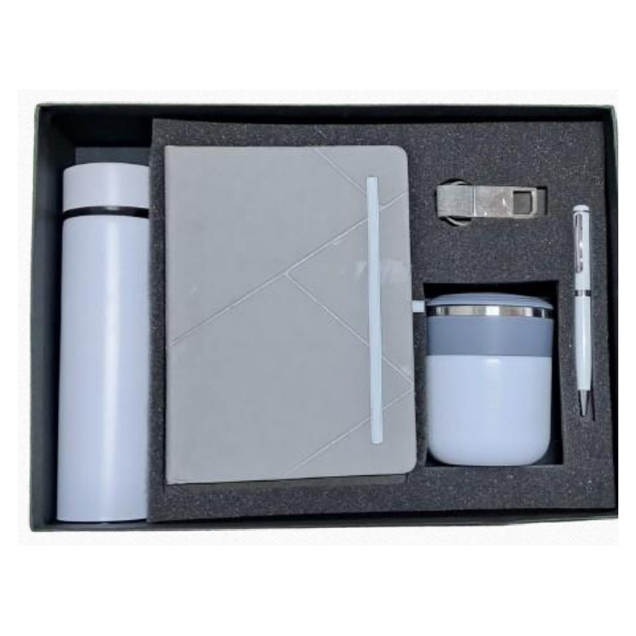  Diary, Pen, Keychain, Bottle & Mug Set  Branded 5-in-1 gift — diary, pen, keychain, bottle and mug.  ₹ 650 + 18% GST
ITEM NO. 25  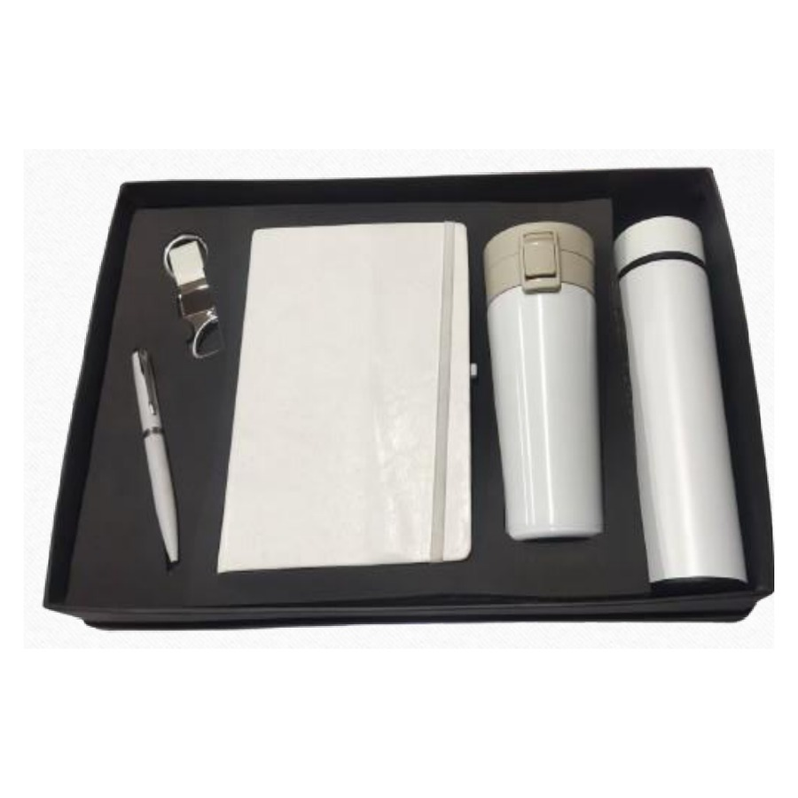  Diary, Pen, Keychain, Bottle & Mug Set  Modern 5-in-1 gift box — diary, pen, keychain, bottle and mug.  ₹ 650 + 18% GST |  | ITEM NO. 26  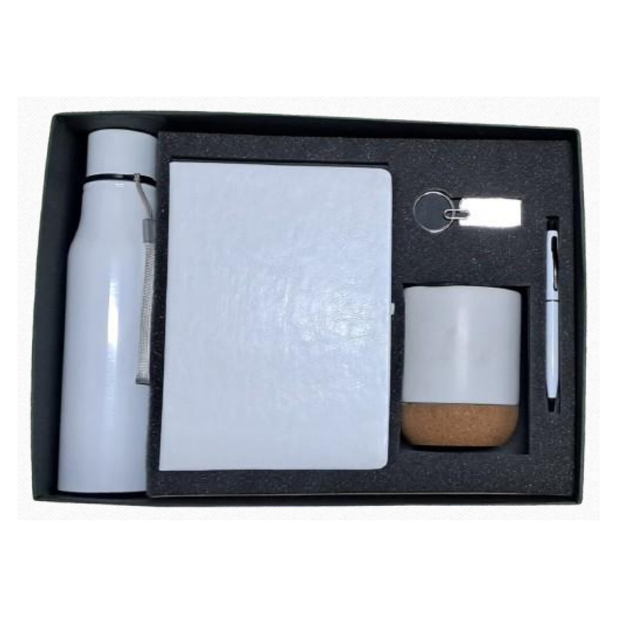  Diary, Pen, Keychain, Bottle & Mug Set  Durable 5-in-1 combo — diary, pen, keychain, bottle and mug.  ₹ 600 + 18% GST  Available colours: Black, White
ITEM NO. 27  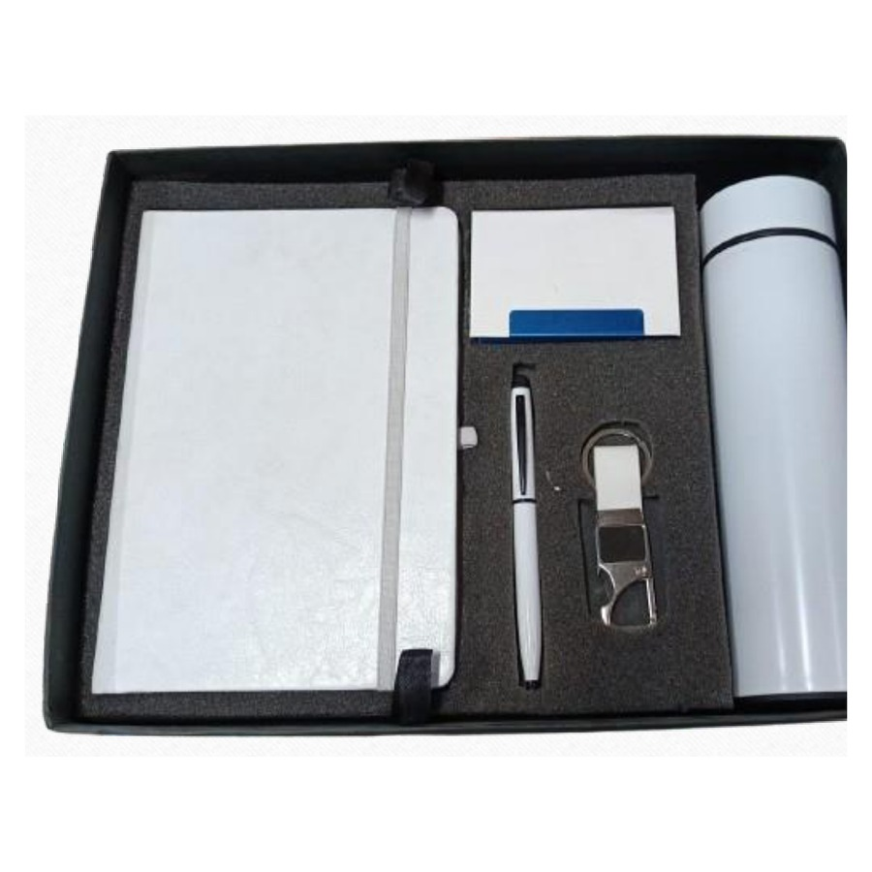  Diary, Pen, Bottle, Keychain & Cardholder Set  Smart 5-in-1 executive combo with diary, pen, bottle, keychain and cardholder.  ₹ 500 + 18% GST  Available colours: Black, Red, Blue, White |  | ITEM NO. 28  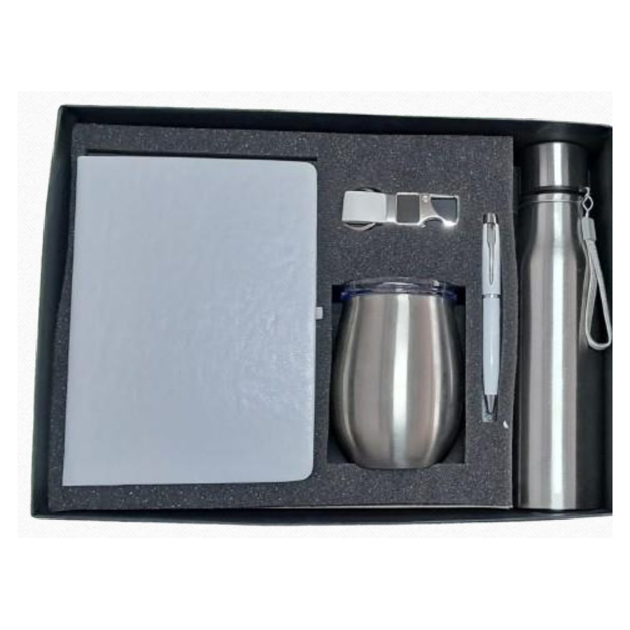  Diary, Pen, Keychain, Bottle & Mug Set  Signature 5-in-1 corporate gift — diary, pen, keychain, bottle and mug.  ₹ 625 + 18% GST

Thank you
for considering Robust Gifting

All items available for custom branding.
Minimum order quantities and lead times on request.
Prices are exclusive of 18% GST. Valid 2026.

