
ROBUST GIFTING

6-in-1 & 7-in-1 Corporate
Gift Combo Catalogue
Premium 6-in-1 & 7-in-1 Executive Gift Sets
Thoughtful gifting. Built to impress.
CURATED COLLECTION • VOLUME 02 • 2026

The 6-in-1 & 7-in-1 Collection
Twenty-nine ready-to-gift executive combos.
Every Robust Gifting 6-in-1 and 7-in-1 combo builds on the essential diary, pen and bottle core, adding a mug or flask, a keychain or cardholder, a mobile stand, a charging cable, a desk lamp or a power bank for combos that land beyond the ordinary. Each set arrives in a tailored presentation tray, ready to hand over on day one. Use this catalogue to choose the combination that best fits your brand and budget. Prices shown are exclusive of 18% GST.
All items available in bulk. Custom branding and packaging on request.
ITEM NO. 01  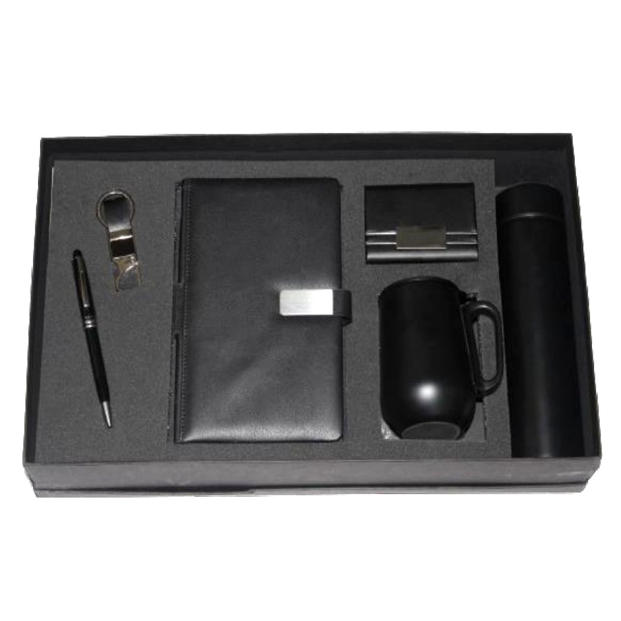  Diary, Pen, Keychain, Cardholder, Mug & Bottle Set  Executive 6-in-1 combo with diary, pen, keychain, cardholder, mug and bottle in a premium presentation tray.  ₹ 700 + 18% GST |  | ITEM NO. 02  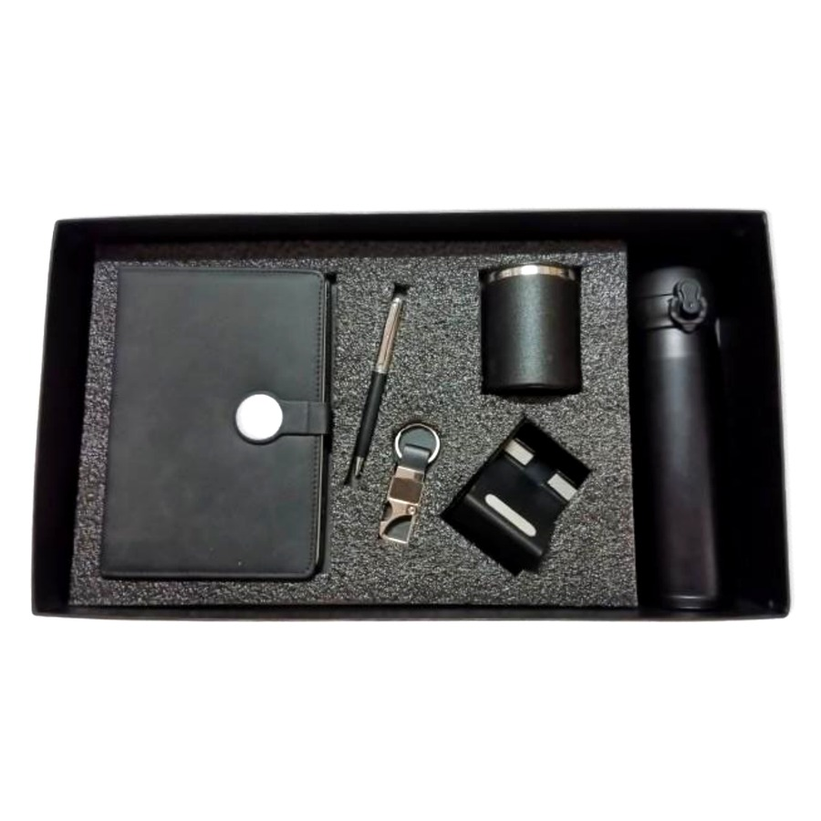  Diary, Pen, Keychain, Mobile Stand, Mug & Bottle Set  Desk-ready 6-in-1 combo featuring diary, pen, keychain, mobile stand, mug and bottle.  ₹ 650 + 18% GST
ITEM NO. 03  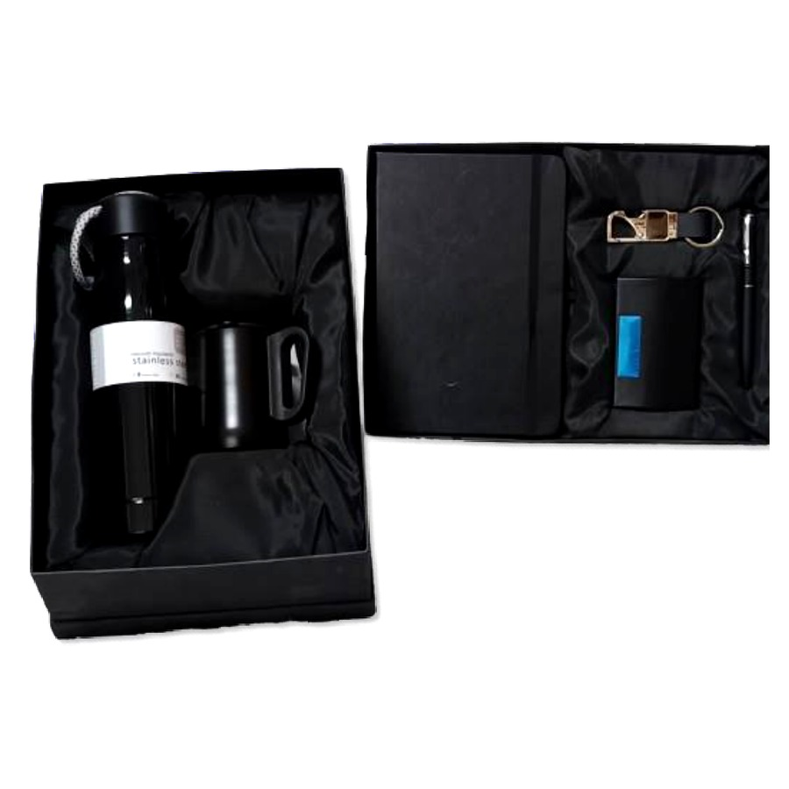  Diary, Pen, Cardholder, Keychain, Mug & Bottle Set  Classic corporate 6-in-1 gift set with diary, pen, cardholder, keychain, mug and bottle.  ₹ 725 + 18% GST |  | ITEM NO. 04  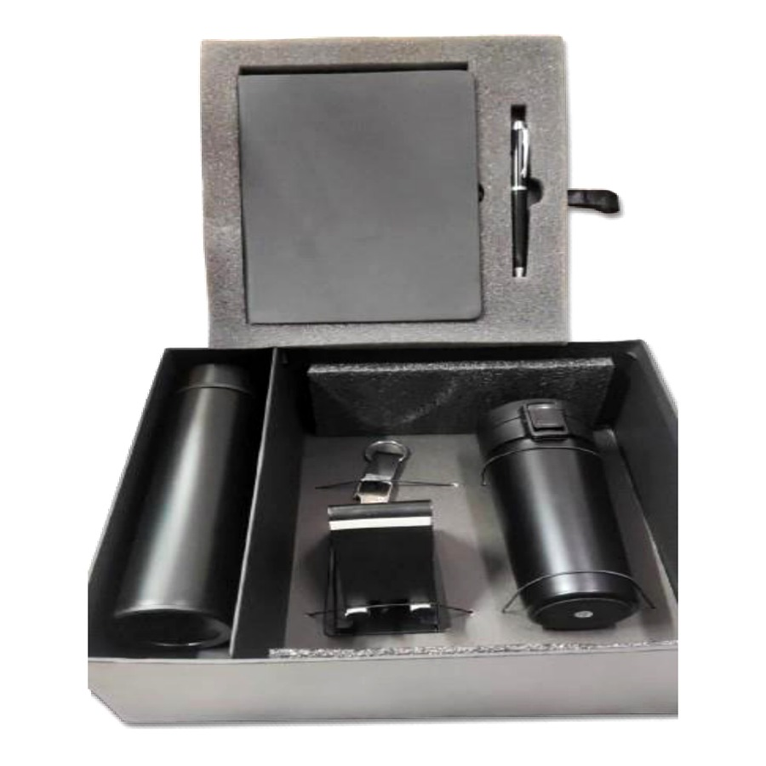  Diary, Pen, Bottle, Mobile Stand, Mug & Keychain Set  Work-from-anywhere 6-in-1 combo — diary, pen, bottle, mobile stand, mug and keychain in a fitted tray.  ₹ 725 + 18% GST
ITEM NO. 05  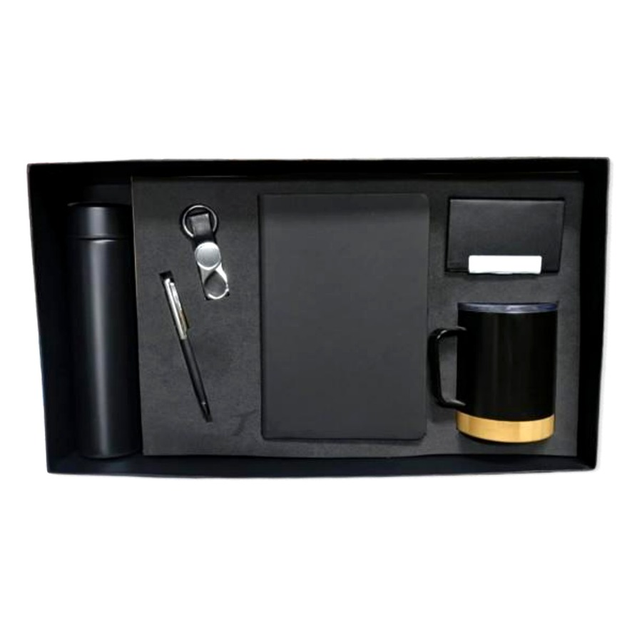  Diary, Pen, Keychain, Bottle, Cardholder & Mug Set  Premium 6-in-1 executive combo featuring diary, pen, keychain, bottle, cardholder and mug.  ₹ 750 + 18% GST |  | ITEM NO. 06  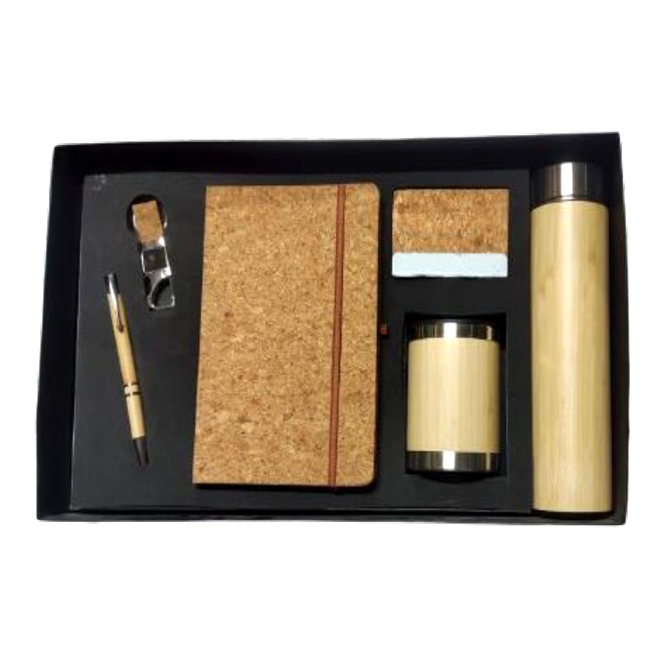  Diary, Pen, Bottle, Keychain, Cardholder & Mug Set  Deluxe 6-in-1 corporate gift — diary, pen, bottle, keychain, cardholder and mug presented in a tailored tray.  ₹ 850 + 18% GST
ITEM NO. 07  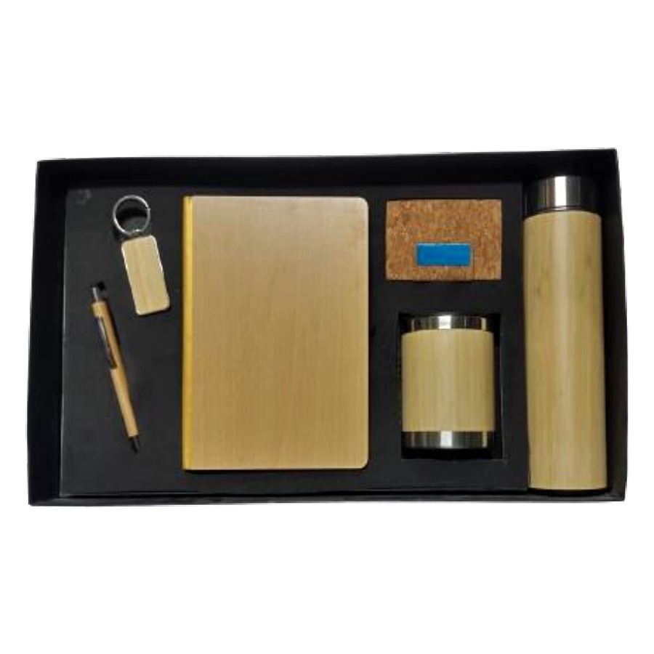  Diary, Pen, Keychain, Mug, Cardholder & Bottle Set  Refined 6-in-1 gift box with diary, pen, keychain, mug, cardholder and bottle.  ₹ 850 + 18% GST |  | ITEM NO. 08  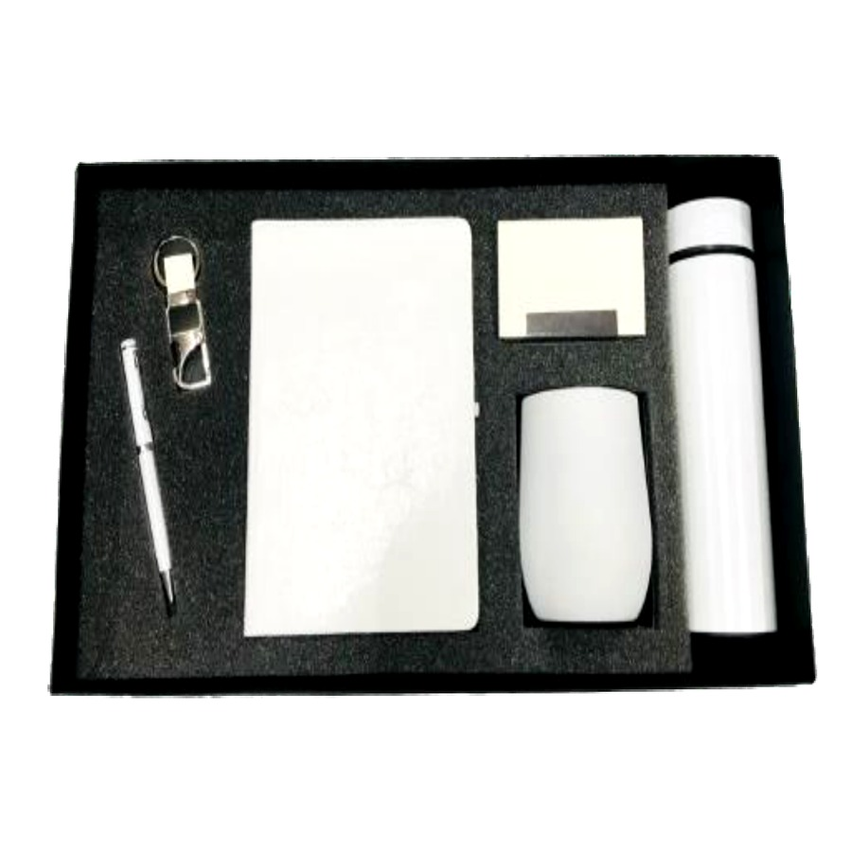  Diary, Pen, Keychain, Mug, Cardholder & Bottle Set  Smart 6-in-1 combo — diary, pen, keychain, mug, cardholder and bottle in a matte presentation tray.  ₹ 700 + 18% GST
ITEM NO. 09  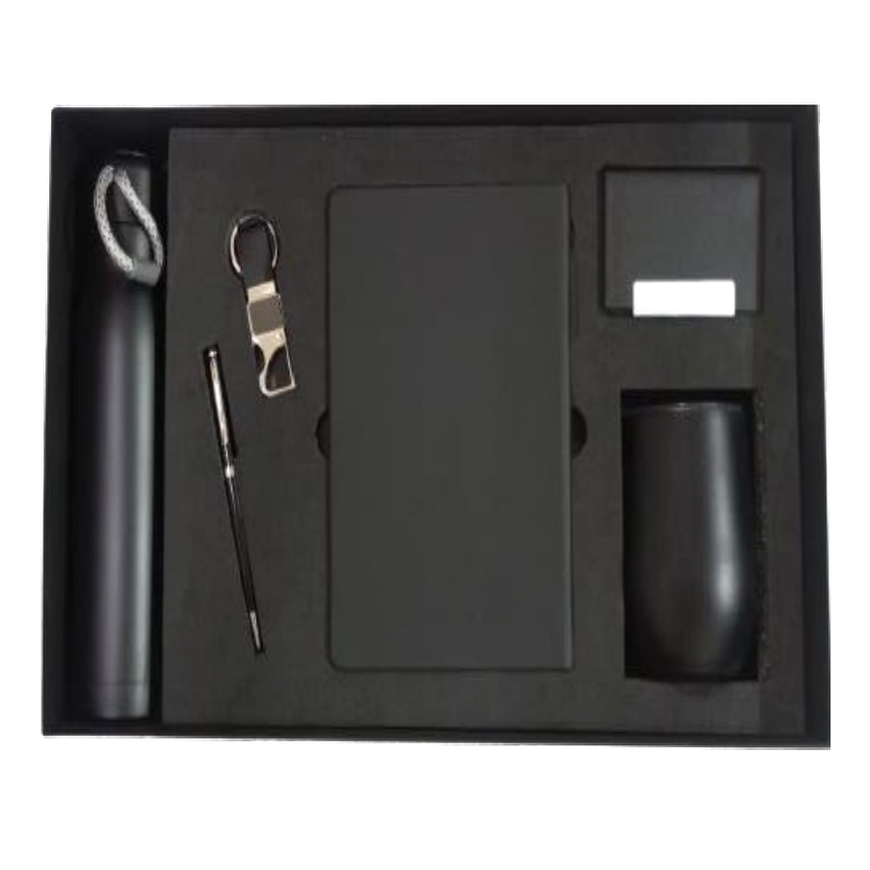  Diary, Pen, Bottle, Mug, Cardholder & Keychain Set  Professional 6-in-1 gift set with diary, pen, bottle, mug, cardholder and keychain.  ₹ 700 + 18% GST |  | ITEM NO. 10  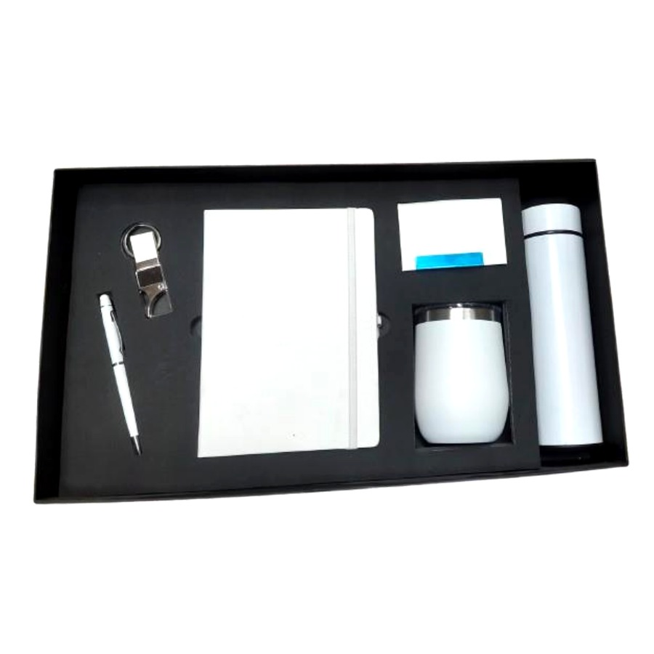  Diary, Pen, Bottle, Mug, Cardholder & Keychain Set  Clean-line 6-in-1 combo — diary, pen, bottle, mug, cardholder and keychain in a fitted tray.  ₹ 700 + 18% GST
ITEM NO. 11  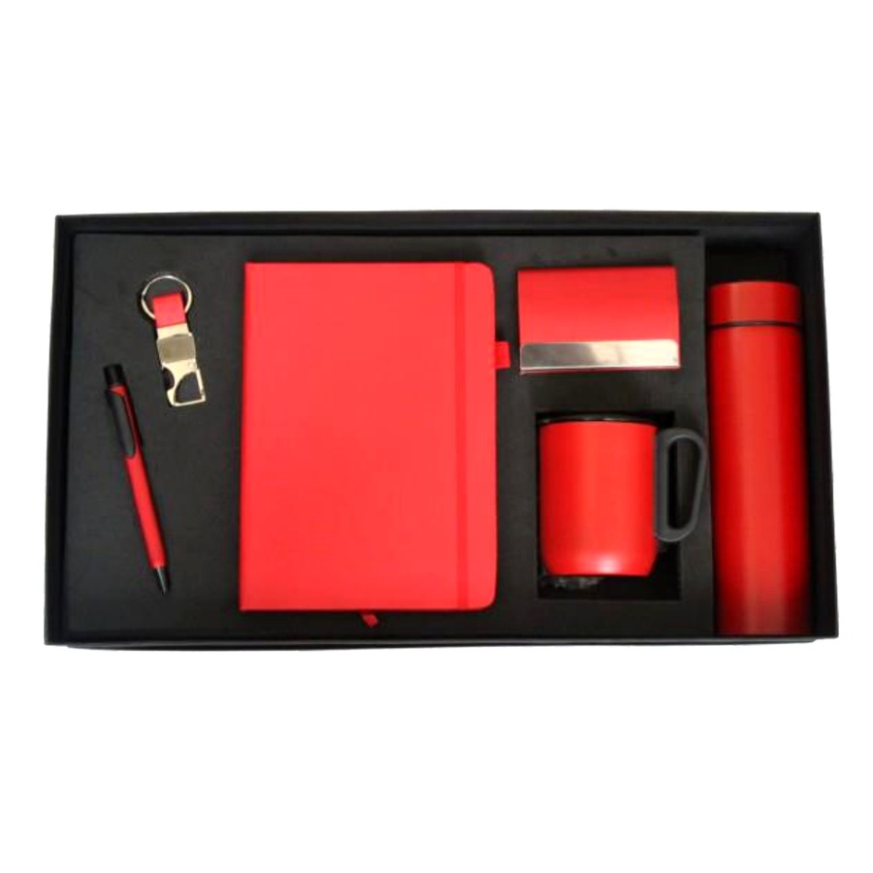  Diary, Pen, Bottle, Mug, Cardholder & Keychain Set  Essential 6-in-1 executive gift — diary, pen, bottle, mug, cardholder and keychain.  ₹ 650 + 18% GST |  | ITEM NO. 12  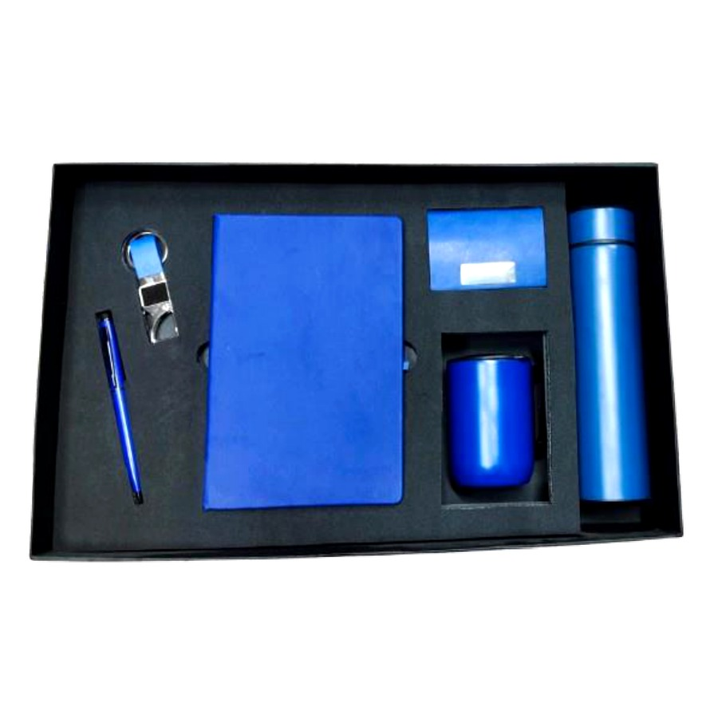  Diary, Pen, Keychain, Cardholder, Mug & Bottle Set  Everyday 6-in-1 corporate combo featuring diary, pen, keychain, cardholder, mug and bottle.  ₹ 650 + 18% GST
ITEM NO. 13  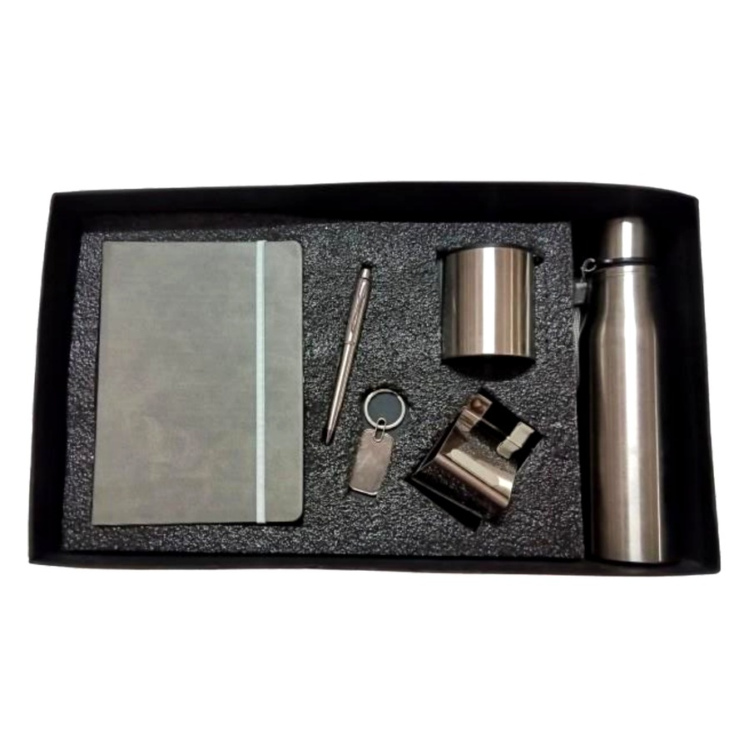  Diary, Pen, Keychain, Mug, Mobile Stand & Bottle Set  Compact 6-in-1 gift with diary, pen, keychain, mug, mobile stand and bottle — ideal for desk gifting.  ₹ 625 + 18% GST |  | ITEM NO. 14  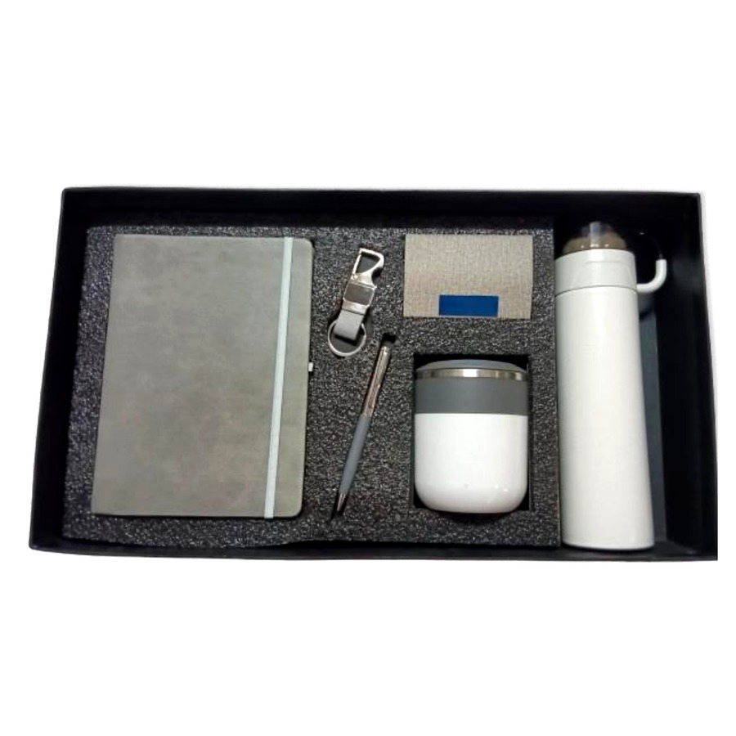  Diary, Pen, Keychain, Cardholder, Mug & Bottle Set  Signature 6-in-1 corporate gift — diary, pen, keychain, cardholder, mug and bottle.  ₹ 750 + 18% GST
ITEM NO. 15  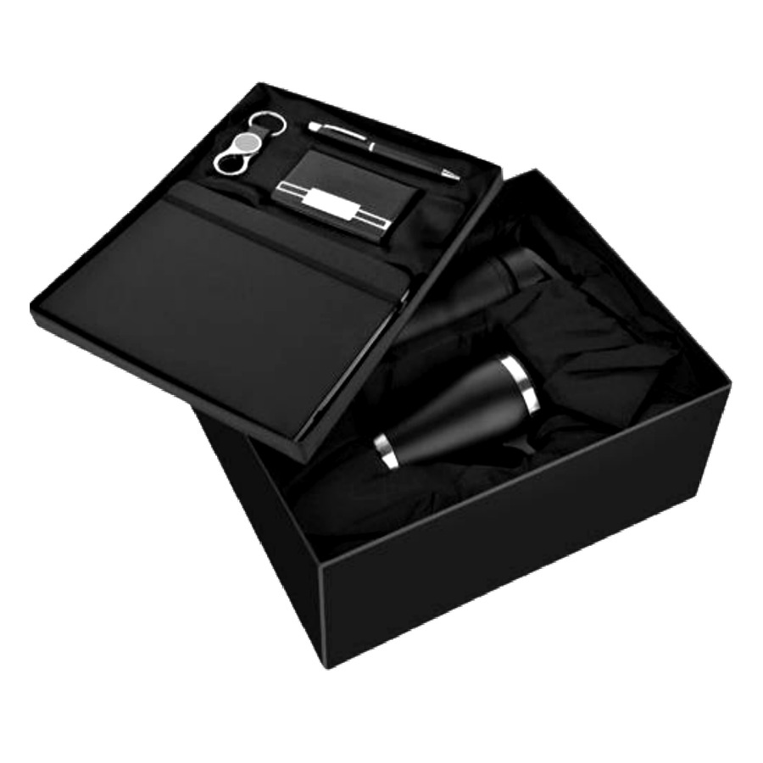  Diary, Pen, Keychain, Cardholder, Mug & Bottle Set  Elegant 6-in-1 combo with diary, pen, keychain, cardholder, mug and bottle in a premium tray.  ₹ 725 + 18% GST |  | ITEM NO. 16  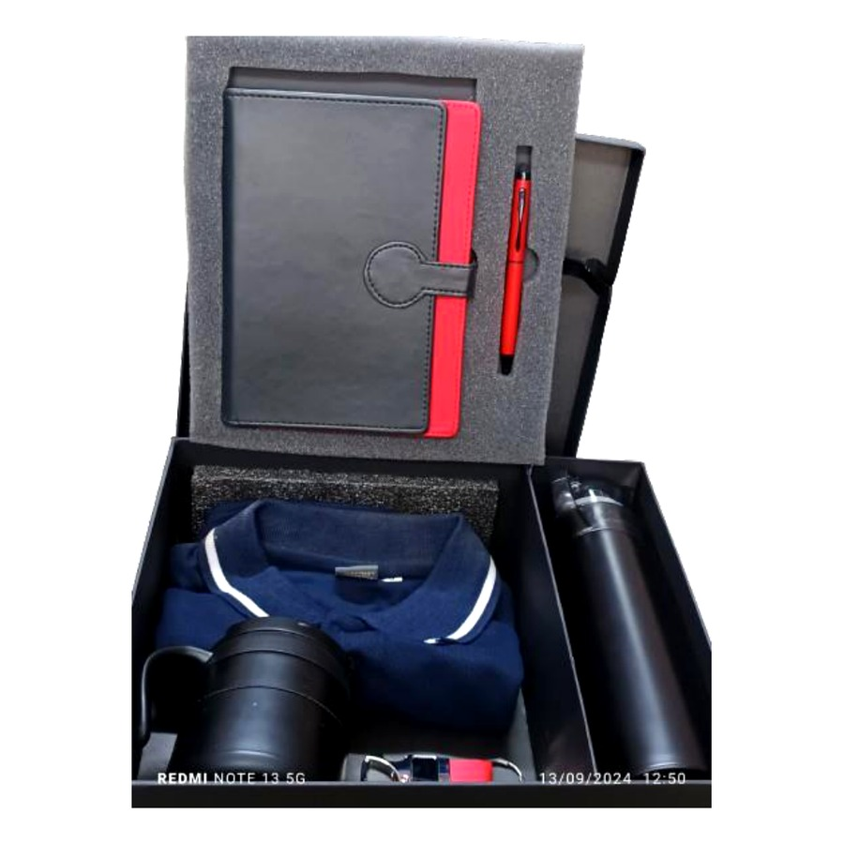  Diary, Pen, Bottle, Mug, Keychain & T-shirt Set  Brand-day 6-in-1 combo with diary, pen, bottle, mug, keychain and a co-branded T-shirt.  ₹ 1200 + 18% GST
ITEM NO. 17  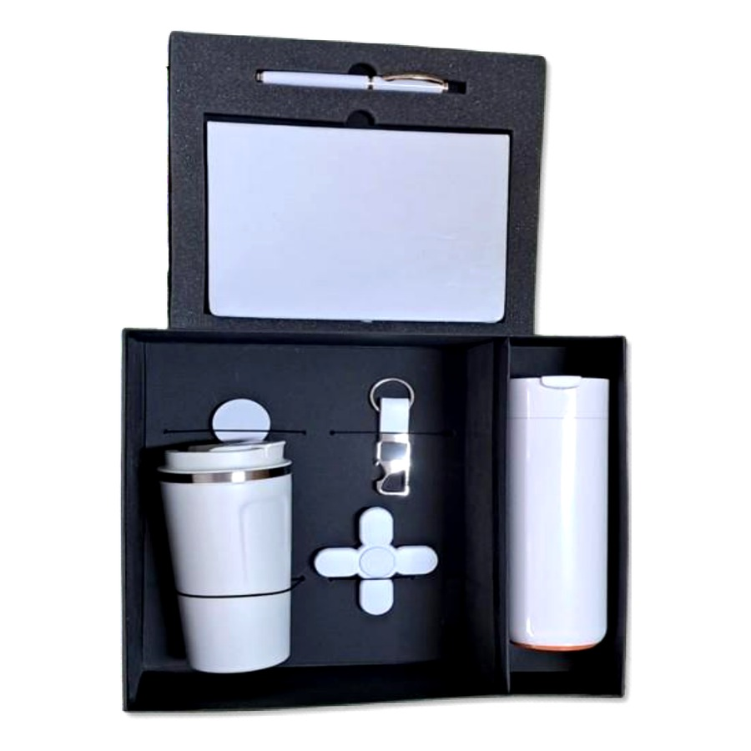  Diary, Pen, Keychain, Flask, Mug & Spinner Datacable Set  Premium 6-in-1 combo featuring diary, pen, keychain, vacuum flask, mug and spinner datacable.  ₹ 1250 + 18% GST |  | ITEM NO. 18  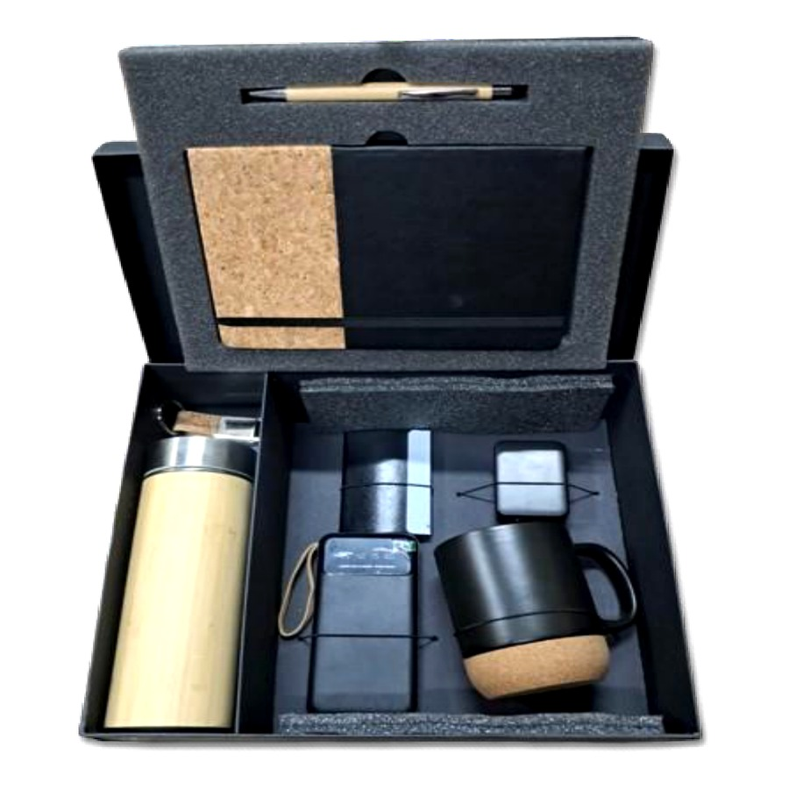  Diary, Pen, Keychain, Bottle, Mug, Cardholder, Power Bank & Adapter Set  Flagship 8-in-1 combo — diary, pen, keychain, bottle, mug, cardholder, 10,000 mAh power bank and adapter.  ₹ 1300 + 18% GST
ITEM NO. 19  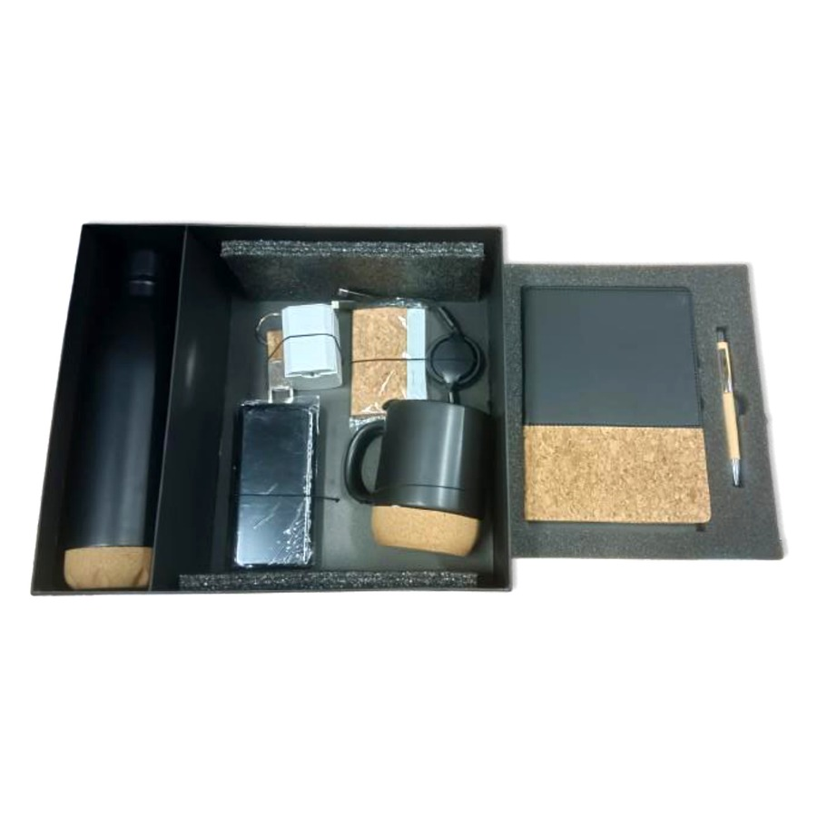  Diary, Pen, Keychain, Cardholder, Mug, Bottle, Charging Cable & Adapter Set  Premium 8-in-1 travel combo — diary, pen, keychain, cardholder, mug, bottle, charging cable and adapter.  ₹ 1550 + 18% GST |  | ITEM NO. 20  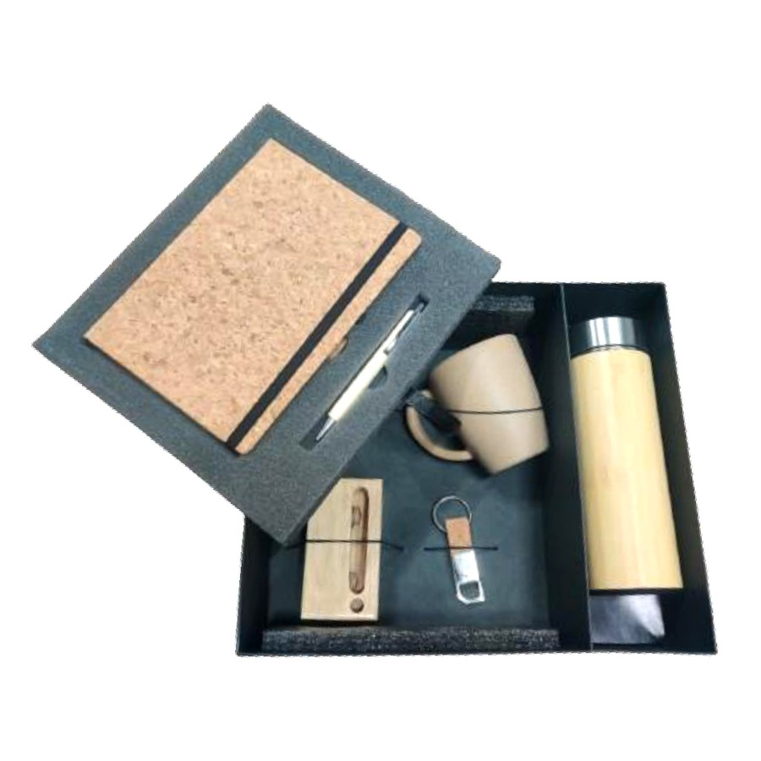  Diary, Pen, Keychain, Mug, Bottle & Pen Stand with Amplifier Set  Desk-statement 6-in-1 combo with diary, pen, keychain, mug, bottle and a pen stand with built-in amplifier.  ₹ 800 + 18% GST
ITEM NO. 21  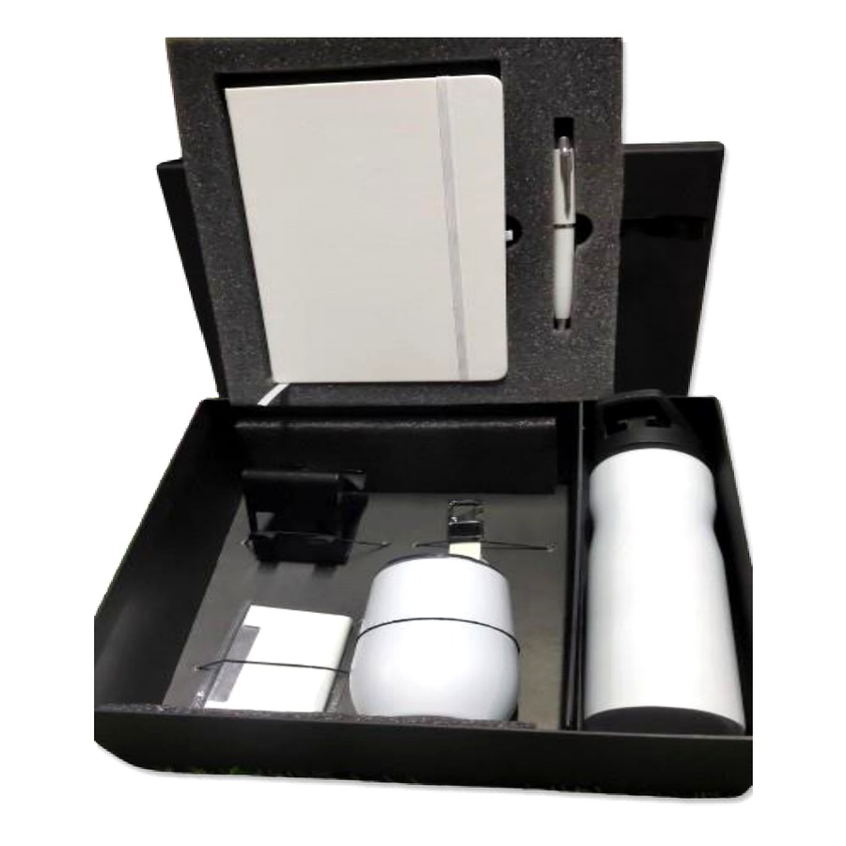  Diary, Pen, Bottle, Cup, Cardholder, Mobile Stand & Keychain Set  Full-office 7-in-1 combo featuring diary, pen, bottle, cup, cardholder, mobile stand and keychain.  ₹ 750 + 18% GST |  | ITEM NO. 22  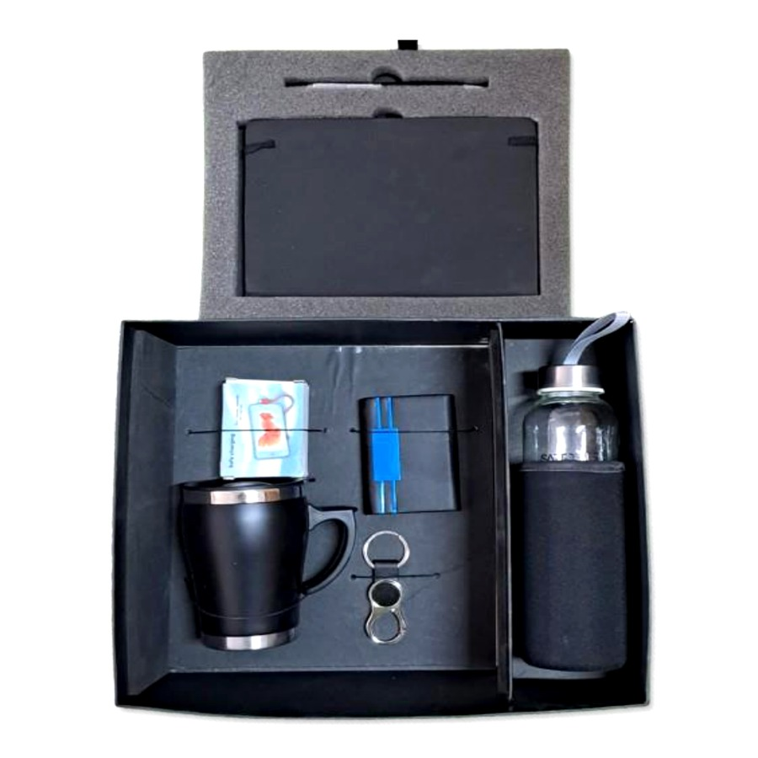  Diary, Pen, Keychain, Cardholder, Mug, Bottle & Charging Cable Set  Connected-exec 7-in-1 combo — diary, pen, keychain, cardholder, mug, bottle and charging cable.  ₹ 750 + 18% GST
ITEM NO. 23  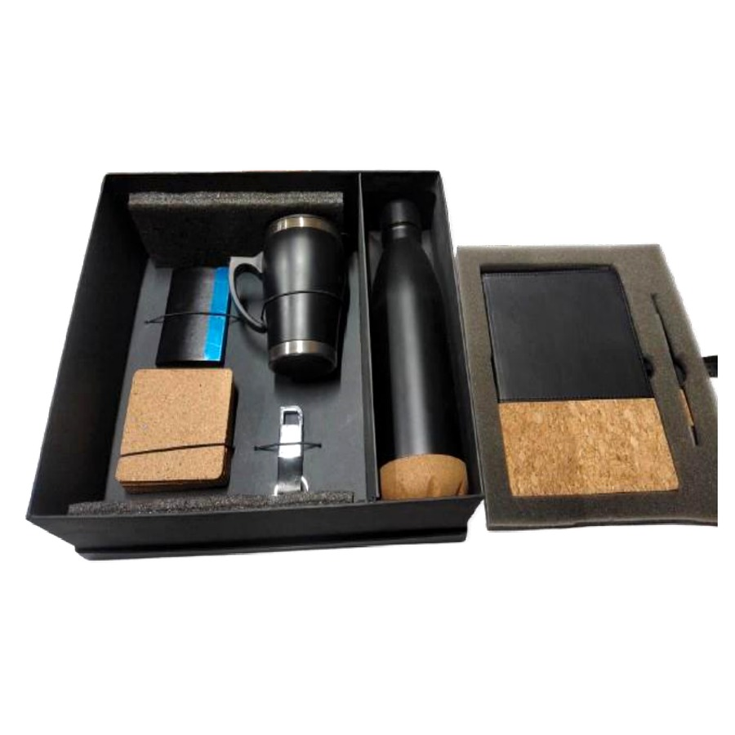  Diary, Pen, Keychain, Mug, Cork Tea Coasters, Bottle & Cardholder Set  Hospitality-ready 7-in-1 combo with diary, pen, keychain, mug, 4-piece cork tea coaster set, bottle and cardholder.  ₹ 850 + 18% GST |  | ITEM NO. 24  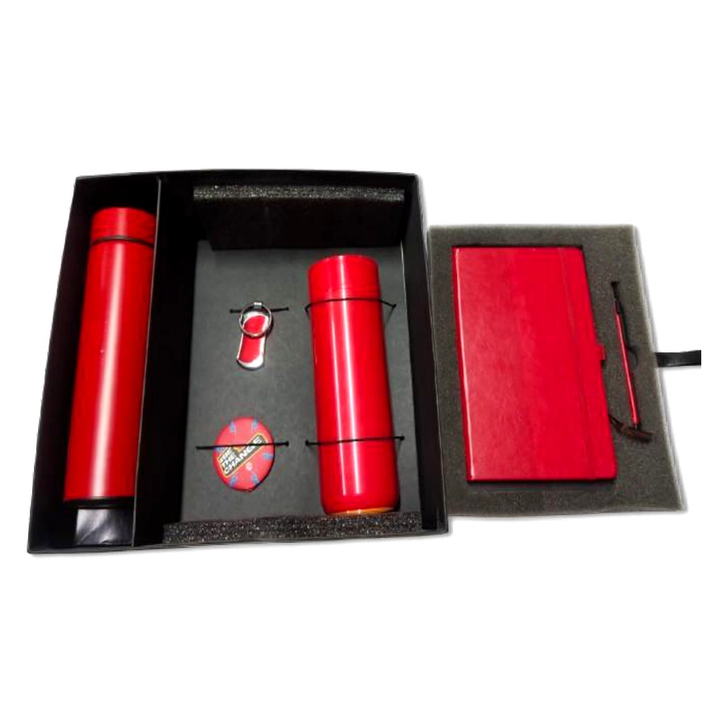  Diary, Pen, Keychain, Flask, Bottle & Tag Set  Travel-ready 6-in-1 combo with diary, pen, keychain, vacuum flask, bottle and luggage tag.  ₹ 950 + 18% GST
ITEM NO. 25  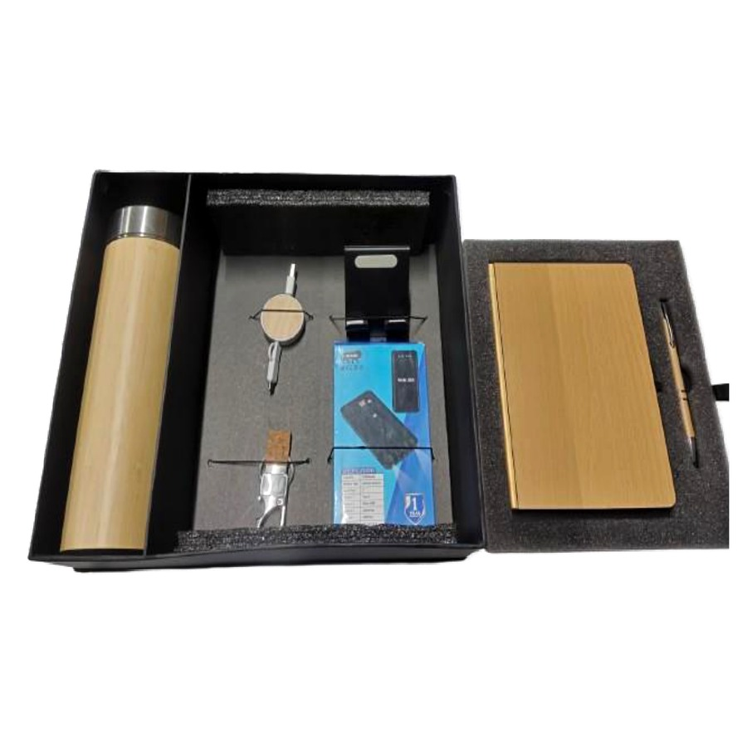  Diary, Pen, Keychain, Charging Cable, Mobile Stand, Power Bank & Bottle Set  Power-user 7-in-1 combo — diary, pen, keychain, charging cable, mobile stand, power bank and bottle.  Price on request |  | ITEM NO. 26  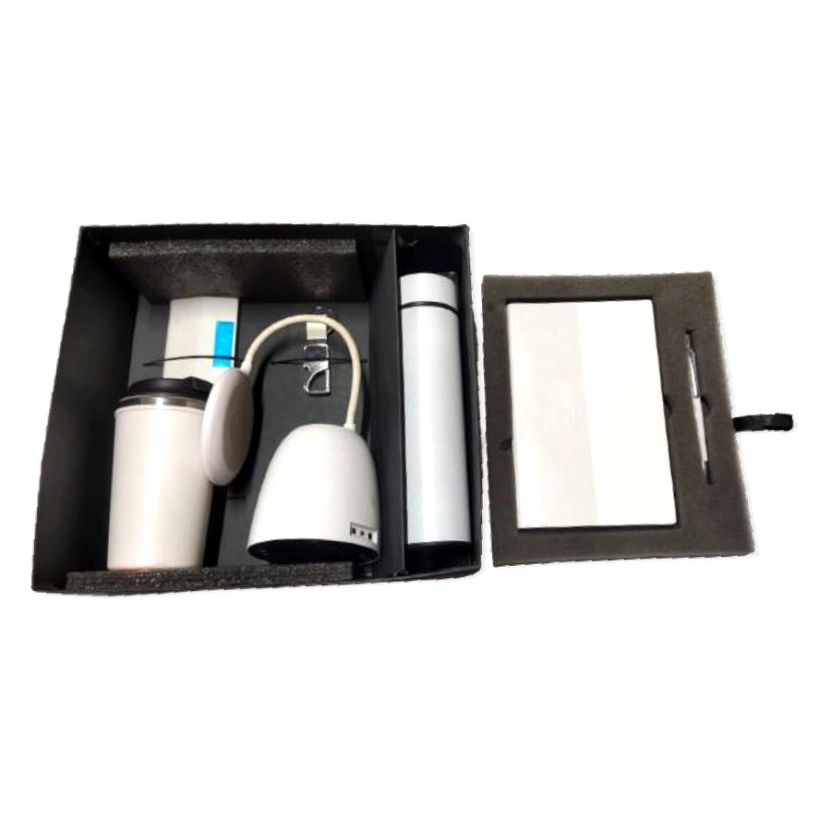  Diary, Pen, Bottle, Keychain, Cardholder, Mug & Desk Lamp Set  Premium 7-in-1 desk combo featuring diary, pen, bottle, keychain, cardholder, mug and a desk lamp.  ₹ 1200 + 18% GST
ITEM NO. 27  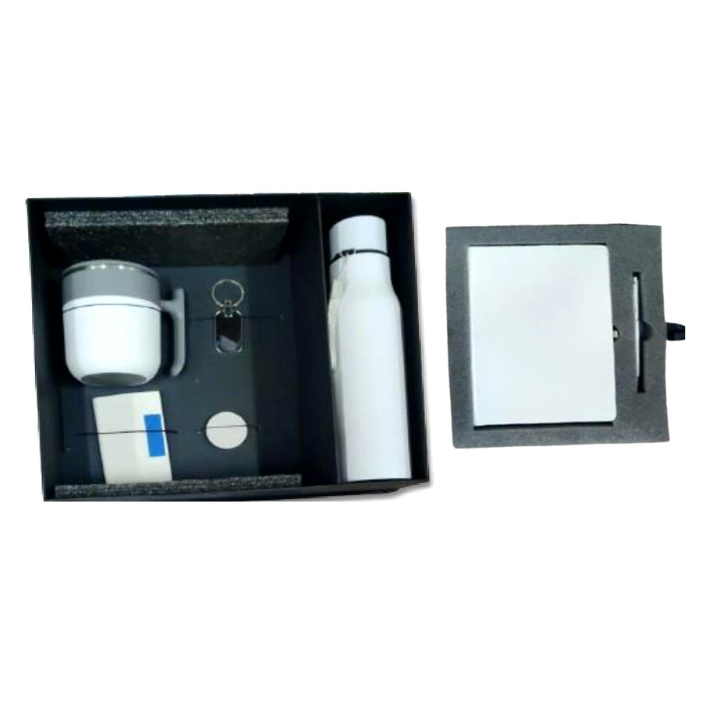  Diary, Pen, Bottle, Mug, Cardholder, Keychain & Pop Socket Set  Mobile-first 7-in-1 combo — diary, pen, bottle, mug, cardholder, keychain and phone pop socket.  ₹ 625 + 18% GST |  | ITEM NO. 28  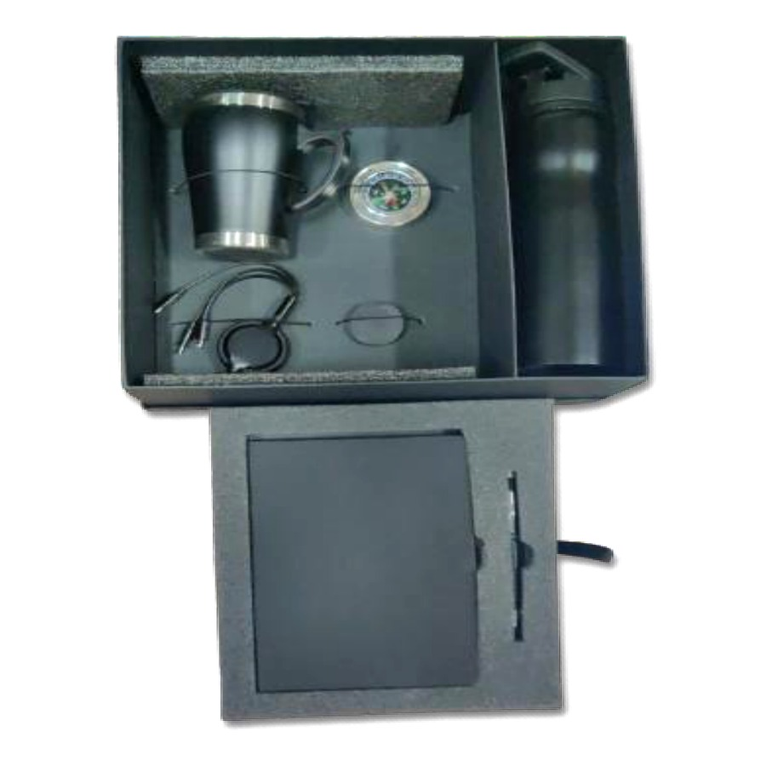  Diary, Pen, Bottle, Mug, Charging Cable & Compass Set  Adventurer's 6-in-1 combo with diary, pen, bottle, mug, charging cable and pocket compass.  ₹ 675 + 18% GST
ITEM NO. 29
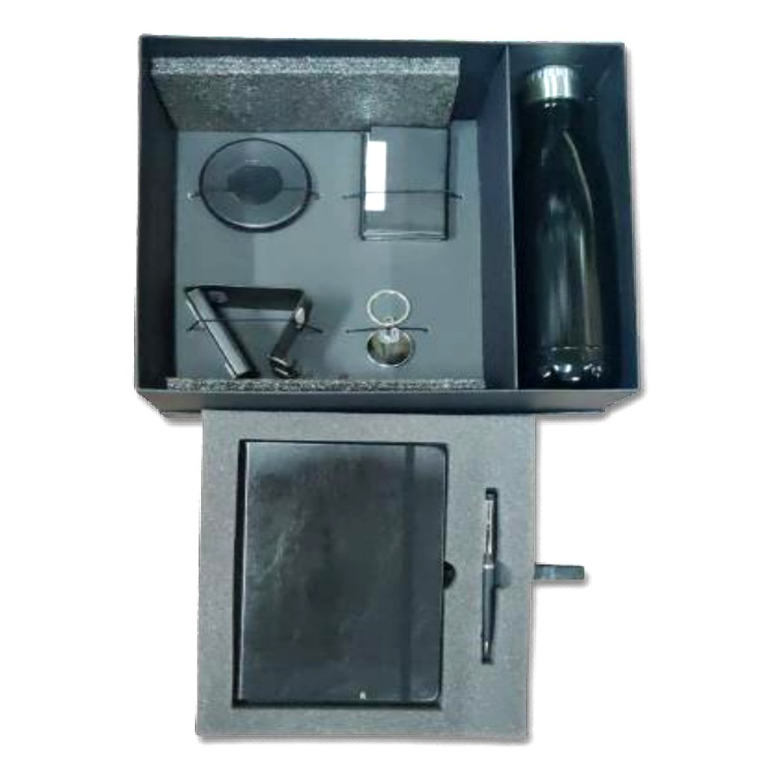
Diary, Pen, Bottle, Mobile Stand, Keychain, Cardholder & Cable Set
Everyday-carry 7-in-1 combo — diary, pen, bottle, mobile stand, keychain, cardholder and charging cable.
₹ 650 + 18% GST

Thank you
for considering Robust Gifting

All items available for custom branding.
Minimum order quantities and lead times on request.
Prices are exclusive of 18% GST. Valid 2026.

