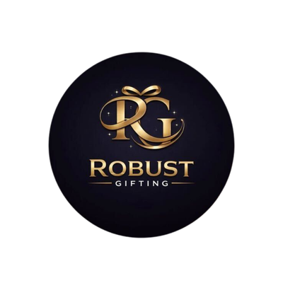
ROBUST GIFTING
Eco-Friendly Corporate Gifting Catalogue
Premium Sustainable Products | Wholesale Prices

33 Products | Gifts for Every Occasion

ECO-FRIENDLY GIFT KITS
Kit 01  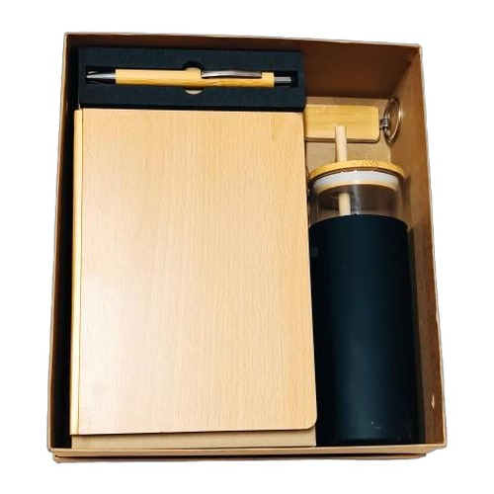  4-in-1 Eco Gift Set  Premium wooden diary, bamboo pen, glass bottle with wooden cap and wooden keychain — elegantly boxed.  Includes: Dairy · Pen · Bottle with Wooden Cap · Wooden Keychain  Material: Natural Wood & Bamboo  Colour: Natural / Black  ₹500 + 18% GST |  | Kit 02  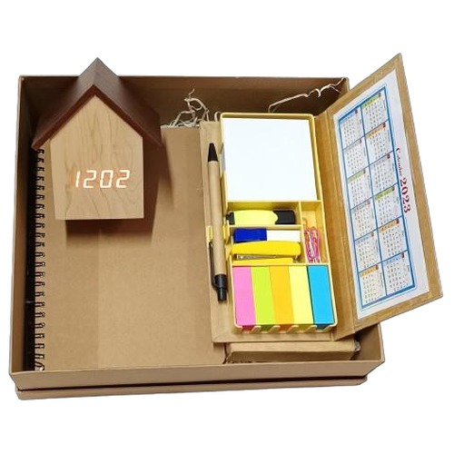  3-in-1 Desk Organizer Set  Cork notebook paired with a sticky notepad and paper pen — includes a handy digital calendar.  Includes: Notebook · Sticky Notebook · Paper Pen · Digital Calendar  Material: Cork & Recycled Paper  Colour: Natural Brown  ₹500 + 18% GST
Kit 03  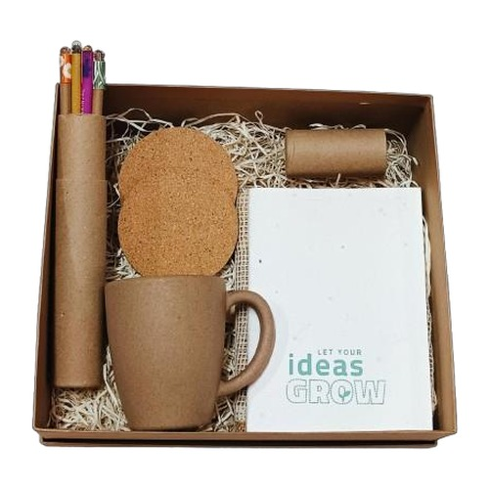  5-in-1 Nature Gift Kit  A fully plantable and eco-conscious set — seed pencils, cork coaster, seed notebook, husk mug and jute bag.  Includes: Seed Pencils · Cork Tea Coaster · Seed Notebook · Husk Mug · Jute Bag  Material: Seed Paper, Cork, Jute & Rice Husk  Colour: Natural / Beige  ₹500 + 18% GST |  | Kit 04  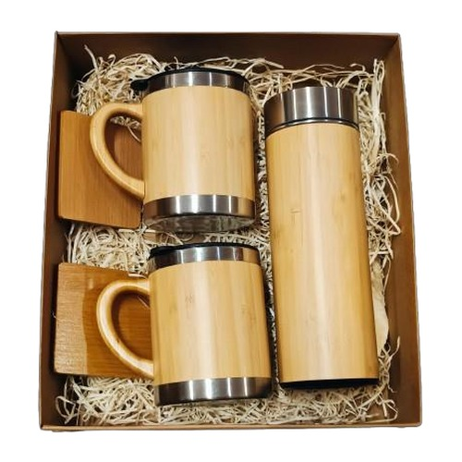  2-in-1 Bamboo Wellness Set  A sleek paired duo of a natural bamboo insulated bottle and matching bamboo mug.  Includes: Bamboo Bottle · Bamboo Mug  Material: Natural Bamboo  Colour: Natural Bamboo  ₹1,000 + 18% GST
Kit 05  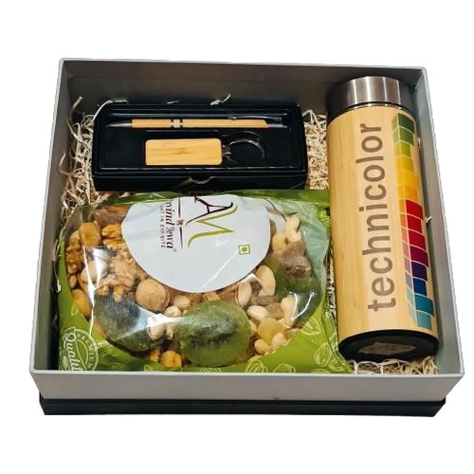  4-in-1 Premium Bamboo Gift Set  Bamboo bottle, dry fruits, a refined wooden pen and keychain — a thoughtful premium gift.  Includes: Bamboo Bottle · Dry Fruits · Wooden Pen · Wooden Keychain  Material: Bamboo & Natural Wood  Colour: Natural / Gold  ₹1,000 + 18% GST |  | Kit 06  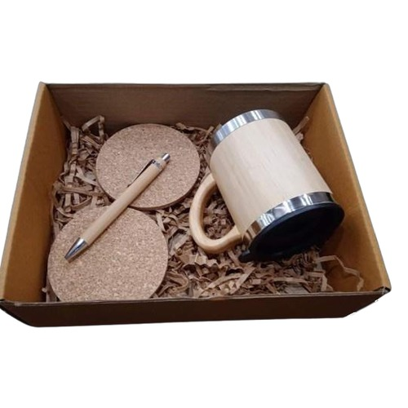  3-in-1 Cork & Bamboo Set  Sustainable bamboo mug, a round cork tea coaster and a smooth bamboo pen in one eco set.  Includes: Bamboo Mug · Cork Coaster · Bamboo Pen  Material: Bamboo & Cork  Colour: Natural  ₹500 + 18% GST
Kit 07  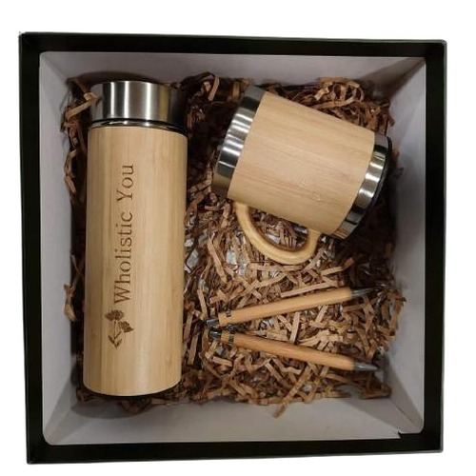  3-in-1 Bamboo Trio  A classic bamboo trio — insulated bottle, mug and pen — ideal for daily corporate use.  Includes: Bamboo Bottle · Bamboo Mug · Bamboo Pen  Material: Natural Bamboo  Colour: Natural Bamboo  ₹650 + 18% GST |  | Kit 08  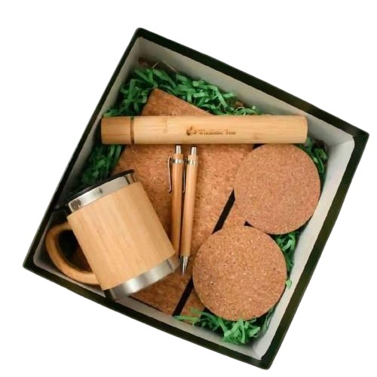  5-in-1 Bamboo Executive Kit  A complete executive eco-desk kit with mug, pen, tea coaster, cork diary and bamboo bottle.  Includes: Bamboo Mug · Bamboo Pen · Cork Tea Coaster · Cork Dairy · Bamboo Bottle  Material: Bamboo & Cork  Colour: Natural / Tan  ₹850 + 18% GST
Kit 09  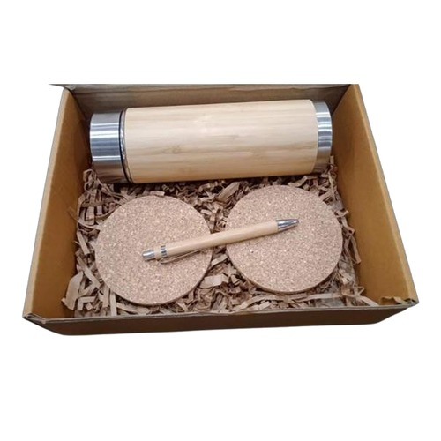  3-in-1 Craft Box Set  A bamboo bottle, two cork tea coasters and a bamboo pen arranged beautifully in a kraft gift box.  Includes: Bamboo Bottle · Cork Tea Coasters · Bamboo Pen  Material: Bamboo & Cork  Colour: Natural Bamboo / Cork  ₹500 + 18% GST |  | Kit 10  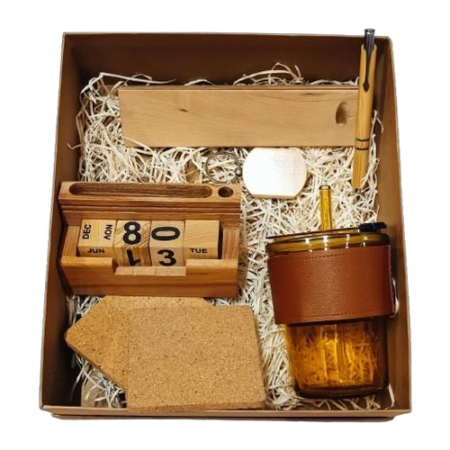  5-in-1 Wooden Desk Collection  A full wooden desk companion — mug, cardholder, stand, keychain and pen with stand.  Includes: Mug · Cardholder · Wooden Stands · Keychain · Wooden Pen with Stand  Material: Natural Wood & Cork  Colour: Natural Wood / Black  ₹500 + 18% GST
Kit 11  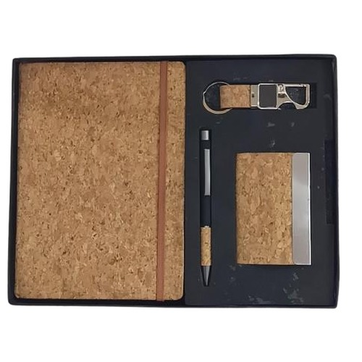  4-in-1 All-Cork Gift Kit  A curated all-cork set featuring a diary, metal-clasp keychain, cardholder and cork pen.  Includes: Cork Dairy · Cork Keychain · Cork Cardholder · Cork Pen  Material: 100% Cork  Colour: Natural Cork / Silver  ₹325 + 18% GST |  | Kit 12  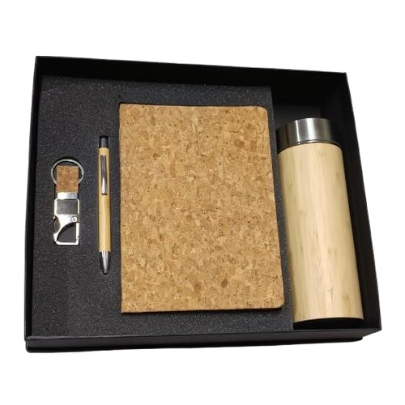  4-in-1 Cork & Bamboo Gift Box  A refined cork diary and keychain paired with a silver-clip wooden pen and bamboo bottle.  Includes: Cork Dairy · Cork Keychain · Wooden Pen with Silver Clip · Bamboo Bottle  Material: Cork, Wood & Bamboo  Colour: Natural Cork / Silver  ₹550 + 18% GST
Kit 13  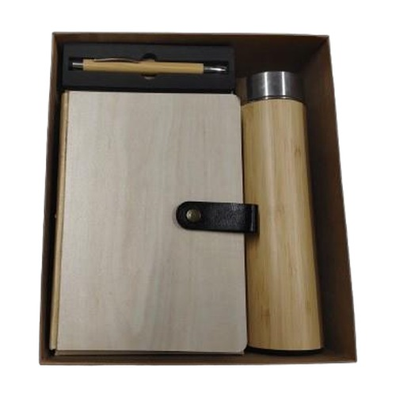  3-in-1 Wooden Classics  Timeless wooden diary, a precision wooden pen and a sleek bamboo bottle — a classic corporate gift.  Includes: Wooden Dairy · Wooden Pen · Bamboo Bottle  Material: Natural Wood & Bamboo  Colour: Natural Wood / Black  ₹500 + 18% GST |  | Kit 14  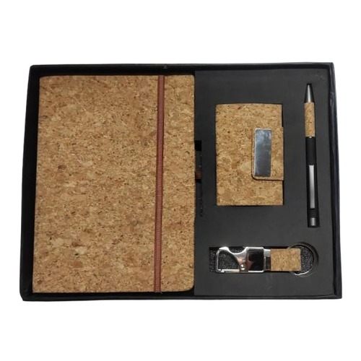  4-in-1 Cork Essentials  Everything in cork — a diary, cardholder, pen and keychain for a consistently eco aesthetic.  Includes: Cork Diary · Cork Cardholder · Cork Pen · Cork Keychain  Material: 100% Cork  Colour: Natural Cork  ₹350 + 18% GST
Kit 15  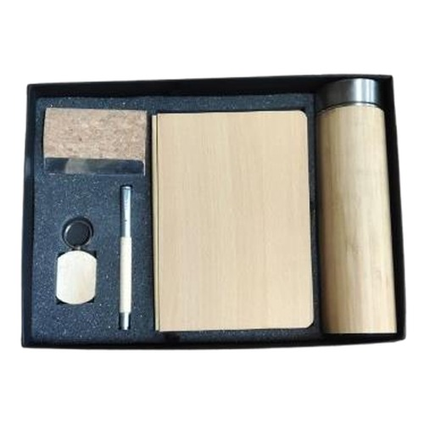  5-in-1 Executive Gift Set  A complete executive gifting solution with diary, pen, bottle, cardholder and keychain.  Includes: Dairy · Pen · Bottle · Cardholder · Keychain  Material: Bamboo & Natural Wood  Colour: Natural / Black  ₹600 + 18% GST |  | Kit 16  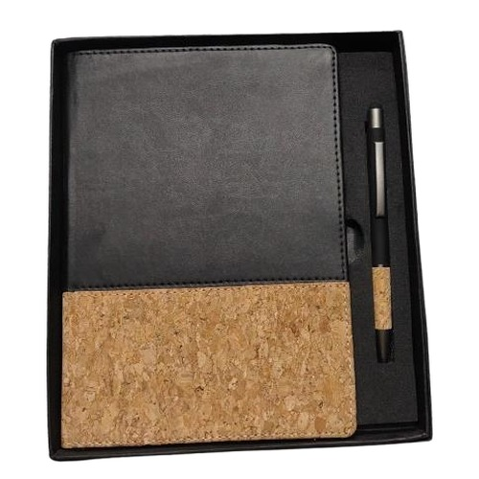  2-in-1 Cork Diary & Pen Set  A slim cork diary paired with a matching pen — available in three stylish color options.  Includes: Cork Diary · Bamboo Pen  Material: Cork & Bamboo  Colour: Black / White / Navy Blue  ₹175 + 18% GST
Item 01  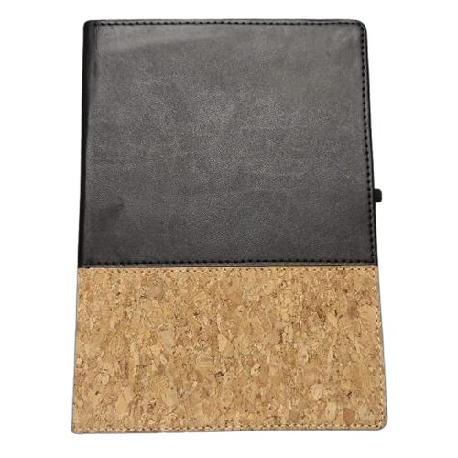  Cork Dairies  Classic two-tone cork and PU leather cover diary with elastic strap and pen loop.  Material: Cork & PU Leather  Colour: Black · White · Tan · Navy Blue · Red · Yellow  ₹110 + 12% GST |  | Item 02  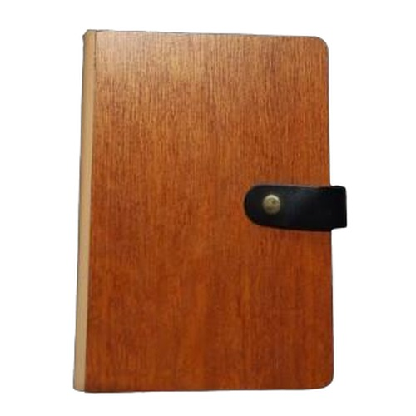  Wooden Dairies  Handcrafted wooden cover notebook diaries in three distinct styles and finishes.  Material: Natural Wood & Bamboo  Colour: Dark Wood · Light Bamboo · Pale Wood  ₹110 – ₹165 + 18% GST
Item 03  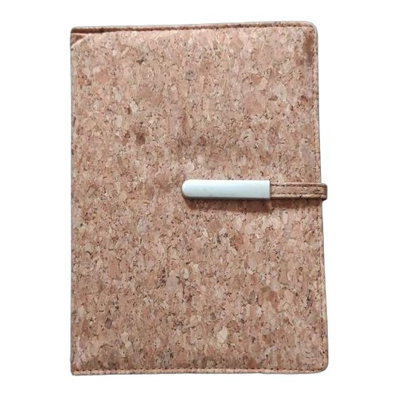  Cork Notebooks  Flexible A5 cork cover notebooks — available with and without pen holder in multiple finishes.  Material: Cork  Colour: Natural / Black / Navy  ₹110 – ₹165 + 12% GST |  | Item 04  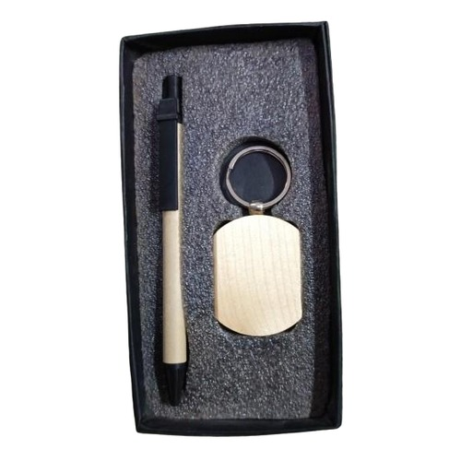  Pen & Keychain Gift Sets  Elegant eco pen paired with a wooden keychain, presented in a premium gift box.  Material: Wood & Bamboo  Colour: Natural / Black  ₹35 – ₹50 + 18% GST
Item 05  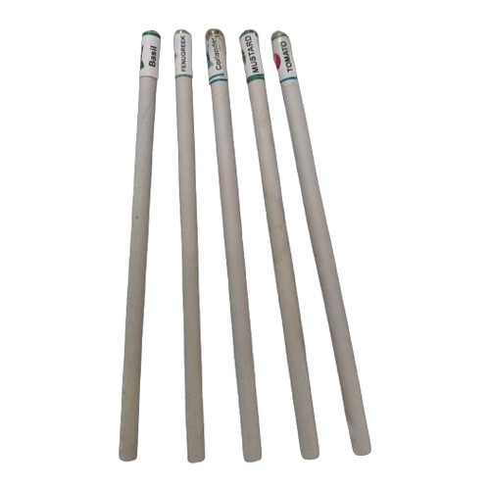  Seed Pens & Pencils  Plantable seed pens and pencils — write, use and grow herbs or flowers after use.  Material: Recycled Seed Paper  Colour: Natural  ₹7 – ₹100 + 18% GST |  | Item 06  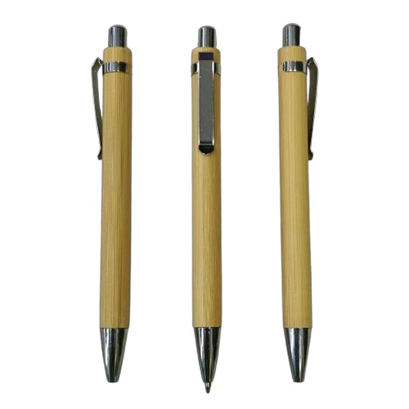  Eco Pens (Assorted)  A range of sustainable ballpoint pens in bamboo, wood and recycled paper materials.  Material: Bamboo, Paper & Wood  Colour: Natural / Black / Silver  ₹6 – ₹20 + 18% GST
Item 07  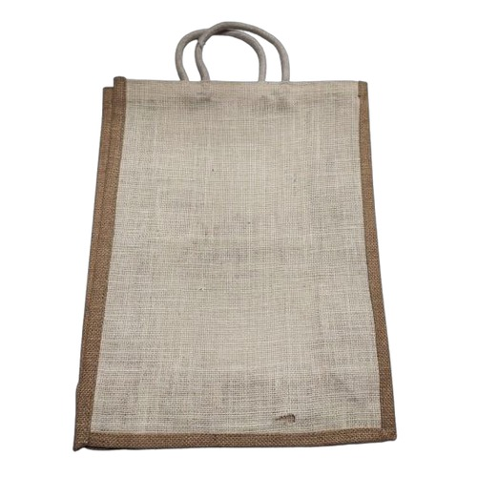  Jute Tote Bags  Handwoven natural jute tote bags in multiple sizes — sturdy and eco-friendly.  Material: 100% Natural Jute  Colour: Natural Beige  ₹65 – ₹85 + 18% GST |  | Item 08  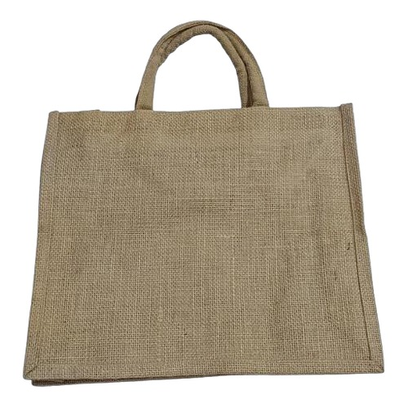  Jute Carry Bags (Large)  Spacious large-format jute bags ideal for gifting, events and everyday carry.  Material: 100% Natural Jute  Colour: Natural Beige  ₹60 – ₹100 + 18% GST
Item 09  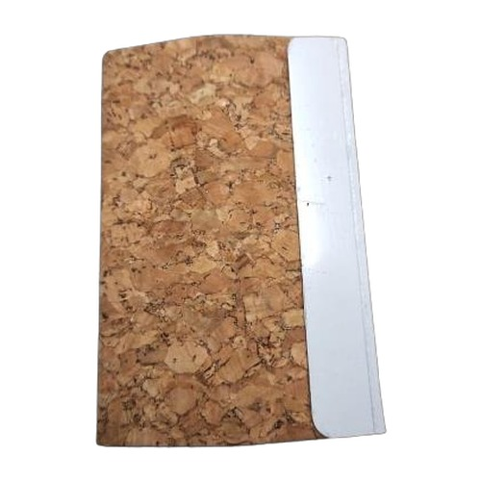  Cork Cardholders  Slim and stylish cork cardholders with a silver metal clasp for secure card storage.  Material: Cork & Silver Metal  Colour: Natural Cork / Silver  ₹60 – ₹75 + 18% GST |  | Item 10  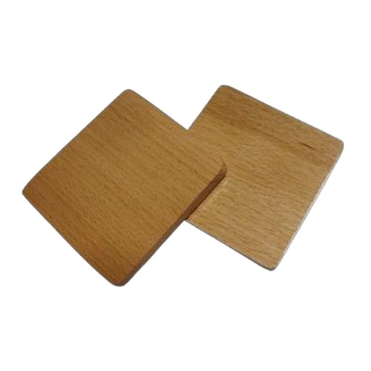  Tea Coasters  Round eco-friendly cork and bamboo tea coasters — heat resistant and naturally beautiful.  Material: Cork & Bamboo  Colour: Natural Cork / Natural Bamboo  ₹22 + 18% GST
Item 11  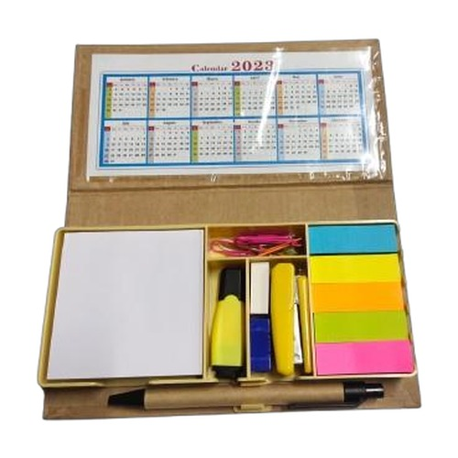  Sticky Notepads  Eco-friendly adhesive sticky notepad sets made from recycled and natural papers.  Material: Recycled Paper  Colour: Natural / Yellow / White  ₹55 – ₹150 + 18% GST |  | Item 12  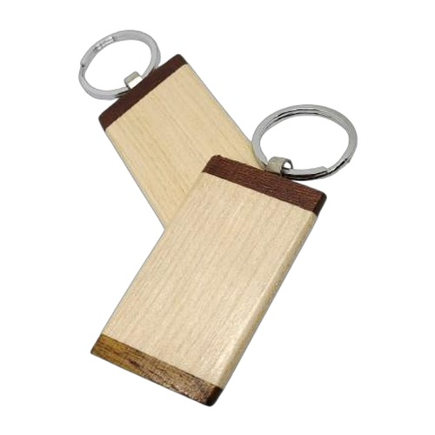  Wooden Keychains  Engraving-ready wooden keychain charms in assorted shapes and natural wood finishes.  Material: Natural Wood  Colour: Natural / Light Wood  ₹7.50 – ₹35 + 18% GST
Item 13  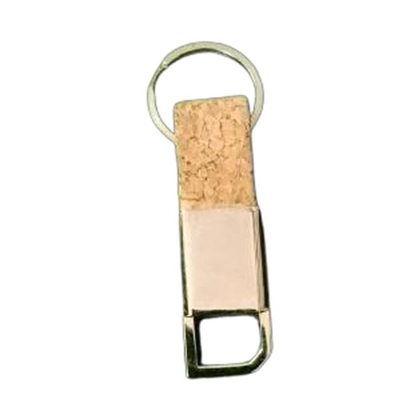  Cork Keychains  Lightweight and buoyant natural cork keychain tags — eco-friendly and durable.  Material: Cork  Colour: Natural Cork  ₹38 + 18% GST |  | Item 14  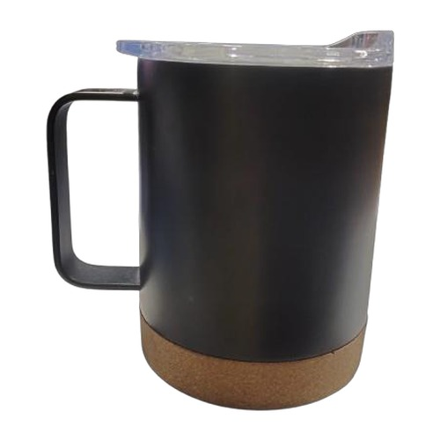  Ceramic Mugs  Classic white ceramic mugs — ideal for custom printing and everyday corporate gifting.  Material: Ceramic  Colour: White / Black  ₹150 – ₹255 + 18% GST
Item 15  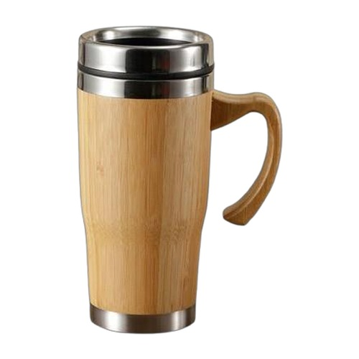  Wooden & Husk Mugs  Sustainable mugs handcrafted from carved wood and eco-processed rice husk fiber.  Material: Natural Wood & Rice Husk  Colour: Natural Wood / Off-White  ₹75 – ₹265 + 18% GST |  | Item 16  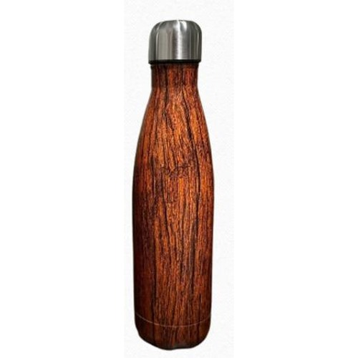  Insulated Bottles with Cork  Glass and steel insulated bottles finished with natural cork caps — leak-proof and elegant.  Material: Glass, Steel & Cork  Colour: Clear / Silver / Natural Cork  ₹125 – ₹285 + 18% GST
Item 17
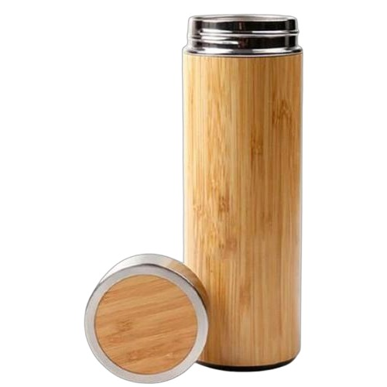
Bamboo Bottles
Vacuum-insulated stainless steel bottles with a natural bamboo finish — stylish and sustainable.

Material: Stainless Steel & Bamboo
Colour: Natural Bamboo
₹240 – ₹275 + 18% GST
Thank you
for considering Robust Gifting

All items available for custom branding.
Minimum order quantities and lead times on request.
Prices are exclusive of 18% GST. Valid 2026.

